Free amino acids in the Arctic snow and ice core samples: potential markers for paleoclimatic studies

Elena Barbaro¹, Andrea Spolaor², Ornela Karroca¹, Ki-Tae Park³, Tonu Martma⁴, Elisabeth Isaksoon⁵, Jack Kohler⁵, Jean Charles Gallet⁵, Mats P. Bjorkman⁶,David Cappelletti⁷, Roberta Zangrando², Carlo Barbante^{1,2}, Andrea Gambaro^{1,2}

¹Department of Environmental Sciences, Informatics and Statistics, Ca’ Foscari University of Venice, Via Torino 155, 30172, Venice-Mestre, Italy
² Institute for the Dynamics of Environmental Processes CNR, Via Torino 155, 30172, Venice-Mestre, Italy.
³Korea Polar Research Institute, 26 Songdomirae-ro, Yeonsu-gu, Incheon 406-840, Korea.
⁴ Institute of Geology, Tallin Univeristy of Technology, Ehitajate tee 5, 19086 Tallinn, Estonia.
⁵ Norwegian Polar Institute, Fram Centre, Hjalmar Johansensgt 14, 9296 Tromsø, Norway.
⁶University of Gothenburg, Department of Earth Sciences, Box 60, 40530 Göteborg, Sweeden
⁷Dipartimento di Chimica, Biologia e Biotecnologie, Università degli Studi di Perugia, 06123 Perugia, Italy

Corresponding author. Elena Barbaro, University of Venice, Via Torino 155, 30172, Venice, Italy
Phone: +390412348545 E-mail: barbaro@unive.it

Keywords: amino acids, ice core, biological marker, Svalbard.

Abstract
The investigation of new markers for paleoclimatic studies needs the development of new sensitive and selective analytical methods. The role of oceanic primary production on climate variability in the past as long debate. As it been hypothesized that the increasing of primary production, thanks to the mechanism known as iron fertilization process, could have increased the algae proliferation and the carbon dioxide sequestration and accelerated the temperature decline during the last glacial maxima. Defining the changes of oceanic primary production in the past epochs can help to better understand the role cover by marine algae explain part of the climate variability. From an ice core perspective methanesulfonic acid is the chemical marker used for assessing the changes in the primary production in past. However other compounds can be produced and emitted in the atmosphere during a phytoplanktonic bloom. Considering the correlation between the concentration of chlorophyll-a, marker of primary production in the ocean, and amino acids presence in the seawater, we begin a preliminary exploration on the use of these compounds as potential markers of primary production from ice cores archive. Amino acids are a class of organic molecules that can be produced and emitted during the phytoplankton bloom, and they can be transported and deposited into the ice cap in the polar region.
Amino acids in polar snow and firn samples were determined bya sensitive and selective analytical method based on liquid chromatography coupled with tandem mass spectrometry. Free L- and D-amino acids were determined at sub nanogram per gram level and the method developed was validated in terms ofaccuracy, precision and possible matrix effect, to assure a correct quantification.
The method for the determination free amino acids concentration was for the first time applied with shallow core samples collected in the Spitsbergen, Svalbard. In April 2015, a 5m shallow core was recovered from the summit of the Holtedahlfonna glacier, Svalbard (79° 09’N, 13° 23’E; 1150 m a.s.l). Glycine, alanine and proline, were detected and quantify in the shallow core samples and their concentration profiles, compared with the stable isotope, show a seasonal cycling with the higher concentration during the spring and summer time. Back-trajectories and Greenland sea chlorophyll-a concentration obtained by MODIS satellite measurements were compared with the amino acids profile obtained by ice core samples.

Graphical abstract
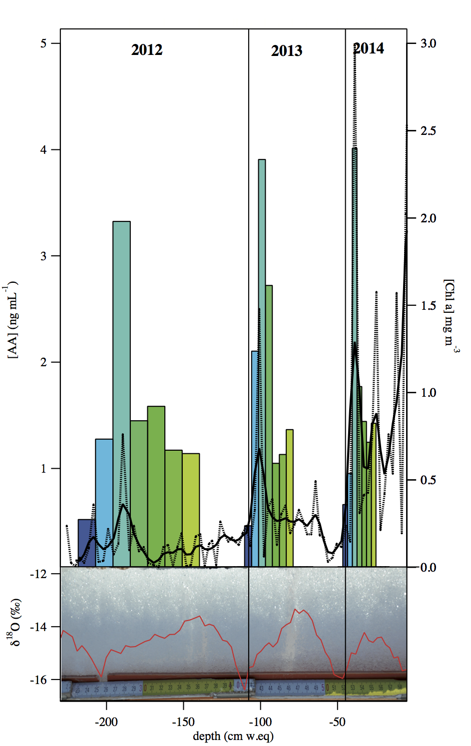

Introduction
Amino acids are ubiquitous compounds and recently they have been deeply studied in numerous scientific fields. In biology, these compounds were used as L-enantiomer during the biosynthesis of proteins and peptides (Voet and Voet, 1995) while D-enantiomers were found in extraterrestrial materials (i.e. meteorites) (Cronin and Pizzarello, 1997; Cronin and Pizzarello, 1999) or in the peptidoglycans, the main structural components of bacterial cell walls (Voet and Voet, 1995). Amino acids represent a fraction of organic matter in marine and freshwater ecosystems. They can use as nitrogen sources by bacteria and by numerous phytoplankton species (Berman and Bronk, 2003) and they are released from living phytoplankton or by cellular lysis of senescent algae (Bronk et al., 1994). Amino acids can be also produced and released by the terrestrial plants and from the organic matter present in the soil (Jonsson et al., 2007). Several research (Matos et al., 2016) were focalized on the characterization of free amino acids in atmospheric aerosols. Amino acids are an active component of the organic nitrogen atmospheric aerosol content due to their important role in the radiative forcing at the Earth’s surface and hence in the climate (Chan et al., 2005) because some of them have been shown to enhance the ice nucleating ability of atmospheric particles (Szyrmer and Zawadzki, 1997) or to act as cloud condensation nuclei (Kristensson et al., 2010). Different amino acids are found in the continental aerosol and they are mainly produced by plants, pollens and algae, as well as fungi and bacterial spores (Mace et al., 2003; Milne and Zika, 1993; Scheller, 2001; Zhang and Anastasio, 2003). The concentration of these compounds in the atmosphere could be influenced by additional and abioticsources, such as volcanic emissions (Scalabrin et al., 2012) or biomass burning (Chan et al., 2005; Mace et al., 2003). However one of the most important source of free amino acids in the atmosphere, and in particular in the polar areas, is the marine emission through bubble bursting and wave breaking. Polar regions are extraordinary laboratories to investigate the naturally sources of aerosol, and the connected process, due to their distance from anthropogenic and continental emission. The presence of pollutants from long range atmospheric transport is limited to compounds with a great atmospheric stability, such as black carbon (Eleftheriadis et al., 2009; Hegg et al., 2009) or persistent organic pollutants (Barbaro et al., 2016; Kallenborn et al., 2012; Vecchiato et al., 2015).
Amino acids in the Antarctic aerosol were investigated to characterize their presence in the water organic fraction of marine aerosol and in the particles emitted from the ocean. Particle size distribution obtained from the Antarctic aerosol suggested that these compounds could have the main source through marine emission. Additionally, thanks of the greater stability of amino acids such as glycine and alanine and their presence over the Antarctic plateau (Barbaro et al., 2015), have been suggested that these compounds could be used as biogenic markers to discriminate the long-range marine aerosols transport. To reinforce this hypothesis similar studies by Scalabrin et al. (2012) focused on Arctic aerosol samples, found similar results proposing that amino acid in the polar region might be mainly emitted from marine source, in particular during the spring season.
The snow deposition reflects the average atmospheric composition and, in absence of snow melting during the summer periods, they preserve the atmospheric information into the ice cap. In particular in the polar areas, ice cap is considered archive of the past atmospheric composition and the ice cores are the common way to extract the climate information from these archives. The advance in the analytical techniques is essential to discover and investigate new compounds (atmospheric markers) that can be used to describe specific environmental processes such as theoceanic primary production. Nowadays the methanesulfonic acid (MSA), an atmospheric oxidation product of dimethyl sulphide which is produced by marine biota, may indirectly reflect larger-scale changes in primary production and its concentration change in ice core archive may be used as a tracer to evaluate the past change in marine productivity (Isaksson et al., 2005; O'Dwyer et al., 2000). MSA is produced by the marine biota but its concentration could be influenced by other environmental parameters such as the changes in the sea ice extension (Curran et al., 2003; Isaksson et al., 2005). Additionally Abram et al.(2008) suggested that MSA is able to diffuse through solid ice cores although they demonstrated that its records variability and concentration were preserved even over storage periods of 15 years. The determination of another class of compounds, able to give an indication of past marine productivity, is crucial since the changes in primary production could influences the CO₂ sequestration into the ocean and hence affect the radiative forcing of the earth atmosphere. Amino acids are a class of compounds linked with the oceanic primary production and their discover in the Antarctic and Arctic aerosol suggests that they can be present in the ice archive and reflect the changes in the marine productivity.
The aim of this work was develop an analytical method based on a coupled method between liquid chromatography coupled with tandem mass spectrometry to determine amino acids in the snow and ice core samples. Amino acid determination in polar snow and ice samples is challenging since their concentration in the nanogram per gram level, and for its possible contamination due to the samples manipulation.
The method developed was applied to a shallow firn core recovered in April 2015 from the Holtedahlfonna glacier (Svalbard Islands) and to snow surface samplescollect close to the Ny-Alesund research facility, in order to evaluate theirbehaviour after the deposition into the snow surface. The shallow core have been dated using the δ¹⁸O profile and the glacier mass balance data suggesting a time coverage spanning from spring 2015 to the entire 2012. The amino acid shallow core results have been compared with the oceanic primary productivity of the Greenland sea, Barents sea and the sum of the ocean area surrounding the Svalbard archipelago. Results, obtained from surface snow samples, show that some amino acids, such as glycine, alanine and proline, are more stable in the snow layer because no evident changes or degradations are measured for these compounds.
Experimental section
Reagents and standard solutions
Ultrapure water (18.2 MΩ cm, 0.01 TOC) was produced using a PURELAB flex ultra system (Elga, High Wycombe, U.K). HPLC/MS-grade methanol was obtained from Romil Ltd. (Cambridge, UK) and formic acid (98%) was obtained from Fluka (Sigma Aldrich, Buchs, Switzerland).
Each amino acid standard solution [D- and L-alanine (D-/LAla),D- and L-arginine (D-/L-Arg), D- and L-asparagine (D-/L-Asn), D- and L-aspartic acid (D-/L-Asp), D- and L-glutamic acid (D-/L-Glu), glycine (Gly), D- and L-hydroxyproline (D-/L-Hyp), D- and L-histidine (D-/L-Hys), D- and L-isoleucine (D-/L-Ile), D- and L-leucine (D-/L- Leu), D- and L-methionine (D-/L-Met), D- and L-ornithine (D/L-Orn), D- and L-phenylalanine (D-/L-Phe), L-proline (L-Pro), D- and L-serine (D-/L-Ser), D- and L-threonine(D-/L-Thr), D- and L-tyrosine (D-/L-Tyr), and D- and L-valine(D-/L-Val)] was prepared from a solid standard (purity ≥98 %), and diluted in HCl0.1 M. The solid standards were purchased from SigmaAldrich®. Isotopically labelled¹³C amino acids (L-[¹³C₃] alanine(Ala*), L-[¹³C₄] aspartic acid (Asp*), L-[¹³C₅] glutamic acid and L-[¹³C₆] arginine (Arg*); purity of 98 %) were obtainedfrom Sigma Aldrich while L-[¹³C₁] leucine (Leu*), L-[¹³C₁] phenylalanine (Phe*), L-[¹³C₁] proline (Pro*) and L-[¹³C₁] valine (Val*) (purity ≥98 %)) were obtained from Cambridge Isotope Laboratories Inc. (Andover, MA, USA).
Sampling and samples processing
In April 2015, a 5 m firn core was recovered from the summit of the Holtedahlfonna glacier, Spitsbergen, Svalbard (79° 09’N, 13° 23’E; 1150 m a.s.l, figure 1) using a 4’’ aluminium auger powered by a battery electric drill.The core was drilled from the bottom of a 2.7 m snowpit, at the transition between the 2014 firn layer and the seasonal snowpack. The principal physical proprieties of each core section (length, density, ice lenses) were recorded. Stratigraphic snow samples were also collected, by inserting low density polyethylene (LDPE) vials perpendicularity into the snowpit with a spatial resolution of ~5cm down to a depth of 2.65m. The samples were collected using stringent anti-contamination cautions (i.e. Tyvek® coveralls, polyethylene gloves, glass). All sampling tools and LDPE vials were pre-cleaned throughultrasonically extraction with ultrapure water. At the beginning of sampling, the surface of snowpit wall was removed with a polyethylene scraper to avoid any areas that may have been contaminated during the digging. The mass of each snowpit sampling was from 66 g to 109 g, depending on the density of the sampled snow layer. The snowpack stratigraphy was recorded and physical parameters such temperature, snow density, grain shape and size, and hardness indexes (hand test and Swiss Rammesonde method) were measured. The form of the snow grains and their dimensions were established to the International Association of Cryospheric Science classification.
The firn core sections were processed on the glacierin order to avoid external contamination and the researchers were equipped with Tyvek® coveralls and polyethylene gloves. The samples were cut to 5 cm resolution with a commercial band saw that was carefully cleaned with methanol and ultrapure water before every use. The ceramic knife pre-cleaned with ultrapure water was used to remove the external contaminated ice layers. The decontaminated firn core samples were stored inLDPE pre-cleaned vials.
Snowpit and firn samples were transported directly to Ca’ Foscari University laboratories in Venice, then melted at room temperature under a clean laminar flow bench (class 100) inside a clean room. An aliquot of each melt sample (980 µL) was spiked with 20 µL of internal standard solution of ¹³C-labelled amino acids (average concentration of 100 ng mL⁻¹).

Instrumental analysis
The instrumental method to determine free L- and D- amino acids was an implementation of our previous developed method reported in recent paper(Barbaro et al., 2014). An Agilent 1100 Series HPLC Systems (Waldbronn, Germany; with binary pump, vacuum degasser, autosampler) was coupled with an API 4000 Triple Quadrupole Mass Spectrometer (Applied Biosystem/MSD SCIEX, Concord, Ontario, Canada) (HPLC-MS/MS) using a TurboV electrospray source that operated in positive mode by multiple reaction monitoring (MRM). Underivatized amino acids were separated using a Chirobiotic TAG column (2.1x250 mm, Advanced Separation Technologies Inc., USA) with an eluent flow rate of 0.15 mL min⁻¹. A binary gradient elution program with ultrapure water with 0.1% v/v formic acid (eluent A) and ultrapure methanol with 0.1% v/v formic acid (eluent B) was followed: 0-10 min, an isocratic step with 30% of eluent B; 10-12 min, a gradient step from 30 to 100% B; 12-17 min a cleaning step with 100% B; 17.1-30 min, re-equilibration to 30% eluent B. The injection volume was 100 µL. All details of monitored MRM transition and the parameters of mass spectrometer source were reported by Barbaro et al.(2014).
Data were collected in multiple reaction monitoring (MRM) mode. The first quadrupole (Q1) selected the precursor ion while the third quadrupole (Q3) selected the product ion of interest and both Q1 and Q3 were set at unit resolution with peak width of 0.7±0.1 amu at 50% of maximum peak height. Figure S1 reports the ion chromatograms related to the quantified ions used in the MRM method for a standard solution of amino acids.
Results
Method quality control
The instrumental method to determine amino acids was evaluated in terms of linear ranges, repeatability and detection limits. The internal standard method by isotope dilution was used to quantify amino acids and to compare the compound peak area with the ¹³C-labelled isotopomers. A ¹³C-labelled compound with similar chemical features was considered in the quantification when the specific ¹³C-labelled compound was not available (table S1). The linearity of calibration curves for the quantitative determination of amino acids with internal standards was evaluated using a series of standard solutions prepared in ultrapure water at average concentrations ranging between 0.005 and 500 μg L⁻¹ and a constant concentration for each internal standard (average concentration of 5 µg L⁻¹). Linearity values of R²≥0.9 for each compound were obtained (table S1), by considering the ratio between the concentration of native and labelled compounds and the ratio between the relative peak areas. The precision of injections was evaluated by considering the coefficient of variation (CV) at four average concentrations (0.01, 0.1, 1 and 10 µg L⁻¹) and the CV values were always lower than 10% for all analyzed compounds.
The instrumental limits of detection (LOD) and quantification (LOQ) were evaluated using the method of Bliesner (2006) who defined the LOD and LOQ as three and ten times thesignal-to-noise (S/N) ratio of a known absolute amountof the analyzed target compound in a standard solution. The LOD values of amino acids ranged from 4 ng L⁻¹ ( L-Glu) and 800 ng L⁻¹ (L-Met) (table S1). These values are lower than those obtained with the most sensitive method(Barbaro et al., 2014), mainly due to an improving of injection volume.
In order to ensure that our analytical method could be applied to real ice and snow samples, the analytical procedure was validated by calculation of accuracy and matrix effect, estimating the best quantification method. The accuracy of the analysis is often affected by the presence of matrix components that may cause enhancement or suppression of ions intensity. Matuszewski et al. (2003) suggested an efficient method to quantitatively evaluate the matrix effect (ME). We used a real snow samples where concentrations of amino acids were close to the method detection limit. This real matrix was spiked with amino acids to obtained a series of standard solutions similar to those of the calibration curve (see above) prepared in ultrapure water. ME was calculated for each compound by dividing the peak area of the standard present in the matrix by the area of the standard diluted in ultrapure water, and by expressing the result as a percentage. Using the real snow matrix, we can observe that no ME (values are about 100%) is observed for the most amino acids (Tables S2) at three different average concentrations (0.5, 1 and 5 µg L⁻¹). Some amino acids (i.e. Gly, Table S2) show ionisation suppression (ME<100%) both without internal standard (ME%-IS) and also using internal standard (ME%+IS).
The accuracy evaluation of our methods was determined as an error percentage (E%), calculated as (Q-T)/T %, where Q is the determined value and T is the “true” value. A known addition of standard amino acids minus the value previously determined in the real matrix was considered as “true” value. The error percentage calculated using the external calibration curve without internal standard (E% ECC, tables S4) were always above ±10% for amino acids, demonstrating that this quantification method should be avoided for these compounds. Considering that E%were below ±10% for the most amino acids, the quantification with internal calibration curve was used in the quantification of samples in the present work. Five D enantiomer of amino acids (D-Orn, D-Phe, D-Pro, D-Thr and D-Tyr) were excluded from the quantification because E% IS above ±10% were calculated (Table S2).
Evaluation of contamination during samples manipulation
The removal of the external layer is mandatory to remove the contaminated external part due to the drilling procedure but a possible contamination could occur during the entire samples manipulation process. Considering the minimal manipulation during the collection of snowpit samples, we considered the amino acids concentration determined in the ultrapure wateras blank values for snowpit samples (Table 1). As described in the “Sampling and samples processing” section, ice core samples were manipulated to cut with 5cm resolution and to eliminate the external contaminated ice layers. To quantify the contamination due to this type of sample processing, a bulk snow samples were collected from snowpit dug in the Holtedahlfonna glacier. The bulk samples have been melted and split in two aliquots. The aliquots have been refrozenwhere one has been manipulated with the same procedure used to prepare the shallow core sampleswhile the second one have been stored without any manipulation as background value. The differences in amino acids concentration between the two aliquots have been used to estimate the contribution in amino acid concentration due to sample preparation (Table 1). The ice core background value obtained by this difference and the method blank determined with ultra pure water was subtracted to each ice core and snowpit samples, respectively. Only the concentrations above method detection limit (MDL) were considered in the data discussion. MDL was obtained for each compound as three times the standard deviation of blank values.
Degradation test
The photochemical transformations of amino acids in fog waters droplets were investigated by McGregor et al. (2001), who suggested that similar reactions undoubtedly also occur in aqueousaerosol particles. These authors demonstrated that Gly is the most stable amino acids with half time of several months. Other proprieties of amino acids, such as hygroscopicity on the aerosol particle (Chan et al., 2005), were also investigated. To our knowledge, the behaviour and the reactivity of amino acids on the snow layer are unknown but they are essential to investigate these compounds on snow and ice samples because the unknown reactivity can affect the interpretation of results.
The degradation kinetic of each amino acid on the snow layer may be influenced by different parameters, such as atmospheric conditions(i.e. solar radiation) or chemical processes occurred in the air-snow interface. At the moment, a specific model to evaluate all real factors is not available.
In concomitance with the drilling spring campaign we carried out an experiment on the snow surface in the proximity of the Ny-Alesund research facility in order to verify the behaviour of amino acids on the real snow surface under close as possible natural condition. We built a device (figure S2) with a transparent polyethylene bag to solar radiation and on the upper face we inserted Eppendefor tips to prevent wind drift but to assure a gas exchange between snow and atmosphere. Superficial real snow was homogenized and inserted inside the device. This snow was previously deliberately contaminated (sample preparation without polyethylene gloves) to assure the presence of amino acids in a reliable amount.
A daily snow sample was collected for nine days into a polyethylene vial. The samples, spiked with ¹³C-labelled internal standards, were transported to Venice laboratories and analysed like the snow and ice core samples.
Fifteen amino acids (L-Ala, L-Arg, L-Asp, L-Asn, L-Glu, Gly, L/D-Hys, L-Leu, L-Orn, L-Phe, L-Pro, L/D-Ser, L-Thr, L-Tyr, L-Val) were determined in the snow samples (figure S3). We evaluated the percent difference between each sample and the first sample (initial condition). Eight amino acids (L-Ala, L-Asn, Gly, L/D-Hys, L-Leu, L-Pro, L-Thr, L-Val) were the most stable compounds because the mean percent difference varied between -10% (L-Pro) and 6% (L/D-Hys). The other amino acids had mean percent mean between -43% (L-Asp) and 25% (L-Glu). The main evidence obtained by this degradation test (figure S3) was that the concentrations of these amino acids were quite stable during the nine-days experiments and the small variation can be due to different spatial distribution, although the snow have been previously homogenized. This test should guaranteed that the trend of the amino acids determined in our core samples corresponds a real signal, excluded a signal misaligns by degradation.
Firn core chronology
Holtedahlfonna is a glacier located in the Spitsbergen region and, as almost all the glacier in this region, it has a net global negative mass balance (Østby et al., 2017). However thought the cumulative of the Holtedahlfonna glacier shows a negative trend the upper part still present positive accumulation. The drilling site was achieved at the top of Holtedahlfonna, though presences of ice lenses in the shallow core (red triangles in the figure 2) confirms that some melting and percolation can occurred. Melting events could alter the pristine climate signal preservein the glacier snow and ice. However Pohjola et al. (2002) have been demonstrated that,throughthese events could influence the distribution of chemical species and stable isotopes, they have only a marginal influence on the seasonal climatic signal determined from the δ¹⁸O signal. This is also confirmed by our results reported in figure 2, where the δ¹⁸O signal still preserves the seasonal variation. The chronology of the core was determined by using the seasonal variations of the δ¹⁸O signal and the annual mass balance at the summit of the Holtedahlfonna glacier estimate bymeasuring the difference between the snow height in Springtime (in general during April) and at the end melting periods (in general in September). Mass balance measurements have been carried out though an ablatometric stake (1120 m a.s.l.) at 40 m of the drilling site. The annual mass balance, indicated in cm w.eq as vertical blue bars in figure 2, and isotopic ratio signal suggested that the shallow core and the snowpit cover the period between spring 2012 and spring 2015.
Free amino acids concentration in the snow and ice core samples
Twenty-five free L- and D- amino acids were investigated in snowpit and ice cores samples collected at Holtedahlfonna glacier. Fifteen L-amino acids (L-Ala, L-Arg, L-Asn, L-Asp, L-Glu, Gly, L-Hys, L-Leu, L-Orn, L-Phe, L-Pro, L-Ser, L-Thr, L-Tyr, L-Val) had blank corrected concentrations higher than the MDLs (table S3) while all D-amino acids had values below MDLs. The total concentration of free amino acids, calculated as the sum of the compounds determined in each sample, had a median value of 0.51 ng mL⁻¹, ranged from 0.07 and 7.55 ng mL⁻¹. Considering that snowpit and ice core samples have been prepared using different process (snowpit samples do not need a decontamination procedure),different blank values were subtracted to the two type of samples. Snowpit and ice core data show a lognormal distribution (figure 3)where the median concentrations are 1.3 and 0.6 ng mL⁻¹, respectively for snowpit and ice core samples. The concentrations of amino acids in the snowpit samples are higher than those identified in the ice core samples, due to 1) higher value of blank subtracted to the firn samples because a manipulation and consequently a contamination of firn samples occurred and 2) snowpit samples had concentrations above MDL of further amino acids than firn samples, where only Gly, Pro and Ala were determined. In fact, a great difference of the composition between snowpit and ice core is shown in figure 3. The ice core samples were characterized by the presence of the most stable amino acids, such as Gly (with median concentration of 190 pg mL⁻¹, 55% of the total amino acids concentration), L-Ala (116 pg mL⁻¹, 33%) and L-Pro (40 pg mL⁻¹, 12%), according with the results obtained by our degradation test. Snowpit samples with a more complex amino acids composition represented snow deposition during the polar nightand the 2015 spring time, when the reactions of degradation were probably inhibited\limited by the absence of light and by lower temperature.
Oceanic Chlorophyll-a concentrations and Back trajectory calculation
The evolution of phytoplankton biomass surrounding Svalbard was obtained by calculating monthly mean chlorophyll-a (Chl-a) concentrations from the Level-3 product of Aqua Moderate Resolution Imaging Spectroradiometer (MODIS) at a 4 km resolution (figure S4-S6).
Backward air trajectories ending at drilling site were computed using Hybrid Single-Particle Lagrangian Integrated Trajectories (HYSPLIT) transport and dispersion models(Draxler and Rolph, 2013). The meteorological data used for computing all the backward trajectories were the NCEP/NCAR Global Reanalysis Data. 240-h of back-trajectories were calculated from April to August of each year using a vertical velocity model at 500 above ground level. Four runs were computed for every day at 6-h intervals and the resulting multiple trajectories were “mean-clustered aggregated” into seven group, based on the screen-plot analysis of total variance. These cluster mean back trajectories (figure S4-S6) allowed to evaluate which sea sector provided the most input of marine aerosol.
Discussion
The profile of total free amino acids in the ice core samples present three distinct peaks (S12, S13 andS14)mainly related to spring season (figure 4). Another sharp peak is detected at the snow\firn transition. This increase, considering the isotope and mass balance chronology, has occurred at the end of summer periods. Could be possible that the frequent rain events occur during winter and spring 2015 could have washed and reallocated the amino acids. The increase could be linked with the accumulation of these compounds between the snow\firn transition that is less permeable compare to upper snow. In light of that this increase is likely due to percolation artefact and will be not considered in the discussion.
Considering that Arctic region is generally a nutrient limited region (Dickerson, 1985) due to its long distance from the anthropogenic sources, the main origin of amino acids over the Svalbard glaciers may be the atmospheric aerosol come from the surrounding ocean or from continental areas through medium to long-range transport. Anthropogenic aerosol, derived mainly from a long range transport, was exposed by several chemical transformations that can mainly degrade amino acids(McGregor and Anastasio, 2001; Milne and Zika, 1993). For this reason, this type of source was probably minor respect to marine emissions. The presence of three peaks (S12, S13 and S14) in the amino acids profile of our shallow core suggests that marine source seems to be the most plausible source, because the spring increment of concentration may reflect the marine dynamics of primary production (Figures S4-S6). Hubberten et al.(1994) demonstrated that amino acids in seawater showed relationship between the increase of Chl-a and high concentrations of Gly, Asp, Glu, Ala, and Ser. In our ice core data, Gly, Ala and Pro were the only amino acids obtained with concentrations above MDL. Figure 5 shows the profiles of each amino acid, suggesting that Ala was the amino acid with the most evident seasonal trend with three peaks (S12, S13 and S14). During the period identified as 2013, Pro showed another peak probably during the summer season. The difference of the profile between Alaand Pro in the shallow core can suggest a different sources or different atmospheric transport processes. These compounds have different particle size distribution on the atmospheric aerosol because Ala, such as Gly, was mainly distributed on the fine fraction (<1µm) (Barbaro et al., 2015), suggesting a marine input though bubble bursting processes (O'Dowd et al., 2004), while Pro was distributed in particles with diameter >10 µm, probably due to a specific source by algal spores (Fisher et al., 2004). Several investigations (Kuznetsova et al., 2005; Matsumoto and Uematsu, 2005; Wedyan and Preston, 2008) confirmed the presence of amino acids in marine aerosols, supporting the hypothesis that amino acids deposited on the ice cap may reflect a marine input.
In order to verify a possible correlation of amino acids profile in the ice core samples with the oceanic primary production, backward air trajectories and Chl-a concentration in the Ocean basins around Svalbard, wereextracted by MODIS satellite data. Chl-a concentrations can be used as an indicator of the abundance of DMS-producing phytoplankton in polar oceans (Park et al., 2013) and a good tracer for phytoplankton biomass (Siegel et al., 2013). The results from the BT calculation suggest that air masses could arrived from different areas. In light of this we estimate the contribution of single basin considered. The air masses originated (crossing) from Greenland Sea (72N-81N, 25W-16E) had a percentage of 31% from April to August 2012, of 39% from April to August 2013 and of 44% from April to August 2014. Barents Sea (72N-81N, 16E-50E) contributed for 22% from April to August 2012, for 19% from April to August 2013 while for 7% from April to August 2014.
Chl-a concentration and amino acids in the shallow core have been synchronize using the isotope minima, a good approximation of the winter time (December-January) and maxima indicating the warmer summer time (July August). Figure 6 shows a comparison between the amino acids profile and the concentration of Chl-a extracted by MODIS satellite data. During 2012, the higher percentage of air masses from Barents Sea (22%) seems to directly influence the S12 peak in the ice core profile of amino acids. During 2013 and 2014, back-trajectories (figure S4-S6) suggests that marine aerosol emitted from Greenland Sea was the most contributor to the aerosol deposited on the Svalbard glacier. The higher concentrations of Chl-a on the Greenland Sea, as well the higher influences of this basinon the Spitsbergen atmospheric composition as revealed by BT calculation were determined in April and May 2013 and 2014. Considering the results obtained, the previous investigations conducted in the ocean, we could suggest that the spring primary production on the ocean surrounding the Svalbard Archipelago could influence the amino acid concentration as well their abundance in the Arctic atmosphere. The amino acids increase (the S12, S13 and S14) detected in the shallow core correspond to the spring, beginning of summer, period when the oceanic biological productivityis at the higher level (figure 6). In light of these considerations we could suggest that the amino acids concentration in the ice samples collected at the Holtedahlfonna glaciers could represent\reflect the changes in the oceanic primary production.

Conclusions and future prospective
A sensitive analytical method to determine free L- and D-amino acids in the snow and ice core samples was developed using a HPLC-MS/MS systems. To our knowledge, this is the most sensitive method to quantify these compounds with a median value of instrumental detection limits 5 pg mL⁻¹. This is the first study that investigate amino acids in the snow and ice samples. The analysis was performed by directly injection of samples in order to prevent possible contamination. Due to their ubiquitous presence of L-amino acids, blank values were accurately evaluated to conduct an accurate quantification. The validation of analytical method was performed by calculating the accuracy (as percent error) and matrix effect. The quantification using internal standard assure a error always below ±10% for the most of amino acids investigated. Matrix effect was negligible because values of ME similar to 100% were obtained at three different average concentrations.
A degradation test of amino acids on the real snow layer was conducted at Ny Alesund (Svalbard Islands)in order to evaluate the stability of these compounds in real environmental conditions (temperature, solar radiation and gas exchange between atmosphere and snow surface). The most stable compounds during 9-days experiment were L-Ala, L-Asn, Gly, L/D-Hys, L-Leu, L-Pro, L-Thr, L-Val.
The method was applied to a 5 m shallow firn core, recovered from the summit of the Holtedahlfonna glacier (Svalbard Islands, 79° 09’N, 13° 23’E; 1150 m a.s.l) in April 2015. The δ¹⁸O signal and the annual mass balance have been used to date the shallow core suggesting a time cover from spring 2012 to spring 2015. Fifteen L-amino acids (L-Ala, L-Arg, L-Asn, L-Asp, L-Glu, Gly, L-Hys, L-Leu, L-Orn, L-Phe, L-Pro, L-Ser, L-Thr, L-Tyr, L-Val) were found with a median value of 0.51 ng mL⁻¹. The ice core was only characterized by the presence of the most stable compounds, according with our degradation test: Gly (55%), L-Ala (33%) and L-Pro (12%).
The amino acids profile in the ice core showed three marked increase that could correspond to spring primary production blooms. The ice core profile have been compared with Chl-a concentration in the Arctic basins and back-trajectories were used to evaluate the predominantly air mass sources. Considering the correspondence between the aminoacids core profile with the Chl-a determine in the Arctic ocean we suggest a wider prospective of their use as possible tracer of marine primary production for paleoclimatic studies.
The main aim of this paper was to purchase a sensitive method to determine amino acids in ice core samples, with an accurate evaluation of contamination and degradation problems. Thoughthe short time spanning of the shallow core (3 years) we suggest a possible primary sources for amino acids as the oceanic primary production. Future investigations using longerice core records, and from other locations,mustbe provide to better assessthe applicability of amino acids as possible preserved tracer of oceanic primary production.
Acknowledges
We would like to thank all our colleagues at the CNR Dirigibile Italia Arctic Station who worked and helped us during the field campaign. The logistic support of the National Research Council—Department of Earth System Science and Environmental Technologies (CNR-DTA)is gratefully acknowledged. The authors thank Elga Lab water, High Wycombe UK for supplying the pure water systems used in thisstudy.

References
Abram NJ, Curran MAJ, Mulvaney R, Vance T. The preservation of methanesulphonic acid in frozen ice-core samples. Journal of Glaciology 2008; 54: 680-684.
Barbaro E, Zangrando R, Kirchgeorg T, Bazzano A, Illuminati S, Annibaldi A, et al. An integrated study of the chemical composition of Antarctic aerosol to investigate natural and anthropogenic sources. Environmental Chemistry 2016: -.
Barbaro E, Zangrando R, Vecchiato M, Piazza R, Cairns WRL, Capodaglio G, et al. Free amino acids in Antarctic aerosol: potential markers for the evolution and fate of marine aerosol. Atmospheric Chemistry and Physics 2015; 15: 5457-5469.
Barbaro E, Zangrando R, Vecchiato M, Turetta C, Barbante C, Gambaro A. D- and L-amino acids in Antarctic lakes: assessment of a very sensitive HPLC-MS method. Analytical and bioanalytical chemistry 2014; 406: 5259-70.
Berman T, Bronk DA. Dissolved organic nitrogen: a dynamic participant in aquatic ecosystems. Aquatic Microbial Ecology 2003; 31: 279-305.
Bliesner DM. Validating chromatographic methods A Practical Guide. Hoboken, New Jersey: John Wiley & Sons, Inc.,, 2006.
Bronk DA, Glibert PM, Ward BB. NITROGEN UPTAKE, DISSOLVED ORGANIC NITROGEN RELEASE, AND NEW PRODUCTION. Science 1994; 265: 1843-1846.
Chan MN, Choi MY, Ng NL, Chan CK. Hygroscopicity of water-soluble organic compounds in atmospheric aerosols: Amino acids and biomass burning derived organic species. Environmental Science & Technology 2005; 39: 1555-1562.
Cronin JR, Pizzarello S. Enantiomeric excesses in meteoritic amino acids. Science 1997; 275: 951-955.
Cronin JR, Pizzarello S. Amino acid enantiomer excesses in meteorites: Origin and significance. Life Sciences: Exobiology 1999; 23: 293-299.
Curran MAJ, van Ommen TD, Morgan VI, Phillips KL, Palmer AS. Ice core evidence for Antarctic sea ice decline since the 1950s. Science 2003; 302: 1203-1206.
Dickerson RR. REACTIVE NITROGEN-COMPOUNDS IN THE ARCTIC. Journal of Geophysical Research-Atmospheres 1985; 90: 10739-10743.
Draxler RR, Rolph GD. HYSPLIT (HYbrid Single-Particle Lagrangian Integrated Trajectory) Model access via NOAA ARL READY Website (http://www.arl.noaa.gov/HYSPLIT.php), NOAA Air Resources Laboratory, College Park, MD, 2013.
Eleftheriadis K, Vratolis S, Nyeki S. Aerosol black carbon in the European Arctic: Measurements at Zeppelin station, Ny-Alesund, Svalbard from 1998-2007. Geophysical Research Letters 2009; 36.
Fisher M, Cox J, Davis DJ, Wagner A, Taylor R, Huerta A, et al. New information on the mecanism of forcible ascospore discharge from Ascobolus immersus. Fungal Genetics and Biology 2004; 41: 698-707.
Hegg DA, Warren SG, Grenfell TC, Doherty SJ, Larson TV, Clarke AD. Source Attribution of Black Carbon in Arctic Snow. Environmental Science & Technology 2009; 43: 4016-4021.
Hubberten U, Lara RJ, Kattner G. AMINO-ACID-COMPOSITION OF SEAWATER AND DISSOLVED HUMIC SUBSTANCES IN THE GREENLAND SEA. Marine Chemistry 1994; 45: 121-128.
Isaksson E, Kekonen T, Moore J, Mulvaney R. The methanesulfonic acid (MSA) record in a Svalbard ice core. Annals of Glaciology, Vol 42, 2005 2005; 42: 345-351.
Jonsson A, Strom L, Aberg J. Composition and variations in the occurrence of dissolved free simple organic compounds of an unproductive lake ecosystem in northern Sweden. Biogeochemistry 2007; 82: 153-163.
Kallenborn R, Reiersen LO, Olseng CD. Long-term atmospheric monitoring of persistent organic pollutants (POPs) in the Arctic: a versatile tool for regulators and environmental science studies. Atmospheric Pollution Research 2012; 3: 485-493.
Kristensson A, Rosenorn T, Bilde M. Cloud Droplet Activation of Amino Acid Aerosol Particles. Journal of Physical Chemistry A 2010; 114: 379-386.
Kuznetsova M, Lee C, Aller J. Characterization of the proteinaceous matter in marine aerosols. Marine Chemistry 2005; 96: 359-377.
Mace KA, Artaxo P, Duce RA. Water-soluble organic nitrogen in Amazon Basin aerosols during the dry (biomass burning) and wet seasons. Journal of Geophysical Research-Atmospheres 2003; 108.
Matos JTV, Duarte R, Duarte AC. Challenges in the identification and characterization of free amino acids and proteinaceous compounds in atmospheric aerosols: A critical review. Trac-Trends in Analytical Chemistry 2016; 75: 97-107.
Matsumoto K, Uematsu M. Free amino acids in marine aerosols over the western North Pacific Ocean. Atmospheric Environment 2005; 39: 2163-2170.
Matuszewski BK, Constanzer ML, Chavez-Eng CM. Strategies for the assessment of matrix effect in quantitative bioanalytical methods based on HPLC-MS/MS. Analytical Chemistry 2003; 75.
McGregor KG, Anastasio C. Chemistry of fog waters in California's Central Valley: 2. Photochemical transformations of amino acids and alkyl amines. Atmospheric Environment 2001; 35: 1091-1104.
Milne PJ, Zika RG. Amino-acid nitrogen in atmospheric aerosols -occurance, sources and photochemical modification. Journal of Atmospheric Chemistry 1993; 16: 361-398.
Østby TI, Schuler TV, Hagen JO, Hock R., Kohler J, Reijmer CH. Diagnosing the decline in climatic mass balance of glaciers in Svalbard over 1957–2014. The Cryosphere; 2017, 11, 191–215.
O'Dowd CD, Facchini MC, Cavalli F, Ceburnis D, Mircea M, Decesari S, et al. Biogenically driven organic contribution to marine aerosol. Nature 2004; 431: 676-680.
O'Dwyer J, Isaksson E, Vinje T, Jauhiainen T, Moore J, Pohjola V, et al. Methanesulfonic acid in a Svalbard ice core as an indicator of ocean climate. Geophysical Research Letters 2000; 27: 1159-1162.
Park KT, Lee K, Yoon YJ, Lee HW, Kim HC, Lee BY, et al. Linking atmospheric dimethyl sulfide and the Arctic Ocean spring bloom. Geophysical Research Letters 2013; 40: 155-160.
Pohjola VA, Moore JC, Isaksson E, Jauhiainen T, van de Wal RSW, Martma T, et al. Effect of periodic melting on geochemical and isotopic signals in an ice core from Lomonosovfonna, Svalbard. Journal of Geophysical Research-Atmospheres 2002; 107.
Scalabrin E, Zangrando R, Barbaro E, Kehrwald NM, Gabrieli J, Barbante C, et al. Amino acids in Arctic aerosols. Atmospheric Chemistry and Physics 2012; 12: 10453-10463.
Scheller E. Amino acids in dew - origin and seasonal variation. Atmospheric Environment 2001; 35: 2179-2192.
Siegel DA, Behrenfeld M, Maritorena S, McClain CR, Antoine D, Bailey SW, et al. Regional to global assessments of phytoplankton dynamics from the SeaWiFS mission. Remote Sensing of Environment 2013; 135: 77-91.
Szyrmer W, Zawadzki I. Biogenic and anthropogenic sources of ice-forming nuclei: A review. Bulletin of the American Meteorological Society 1997; 78: 209-228.
Vecchiato M, Argiriadis E, Zambon S, Barbante C, Toscano G, Gambaro A, et al. Persistent Organic Pollutants (POPs) in Antarctica: Occurrence in continental and coastal surface snow. Microchemical Journal 2015; 119: 75-82.
Voet D, Voet JG. Biochemistry. New York, 1995.
Wedyan MA, Preston MR. The coupling of surface seawater organic nitrogen and the marine aerosol as inferred from enantiomer-specific amino acid analysis. Atmospheric Environment 2008; 42: 8698-8705.
Zhang Q, Anastasio C. Free and combined amino compounds in atmospheric fine particles (PM2.5) and fog waters from Northern California. Atmospheric Environment 2003; 37: 2247-2258.

Table 1. Blank values subtracted to the concentrations of each type of samples and related method detection limits (MDLs).
 | Snowpit samples |  | ice core samples
 | [blank]  pg mL⁻¹ | MDL  pg mL⁻¹ | [[blank]  pg mL⁻¹ | MDL  pg mL⁻¹
L-Ala | 21 | 37 | 18 | 187
L-Arg | 20 | 10 | 121 | 2
L-Asp | 72 | 35 | 217 | 200
L-Asn | 25 | 31 | 46 | 13
Gly | 137 | 101 | 75 | 335
L-Glu | 205 | 66 | 468 | 554
L/D-Hys | 30 | 17 | 59 | 41
L-Leu | 42 | 21 | 355 | 48
L-Orn | 86 | 241 | 604 | 25
L-Phe | 18 | 10 | 98 | 5
L-Pro | 17 | 35 | 4 | 44
L/D-Ser | 156 | 90 | 876 | 256
L-Thr | 27 | 12 | 46 | 48
L-Tyr | 5 | 22 | 79 | 3
L-Val | 923 | 19 | 179 | 23

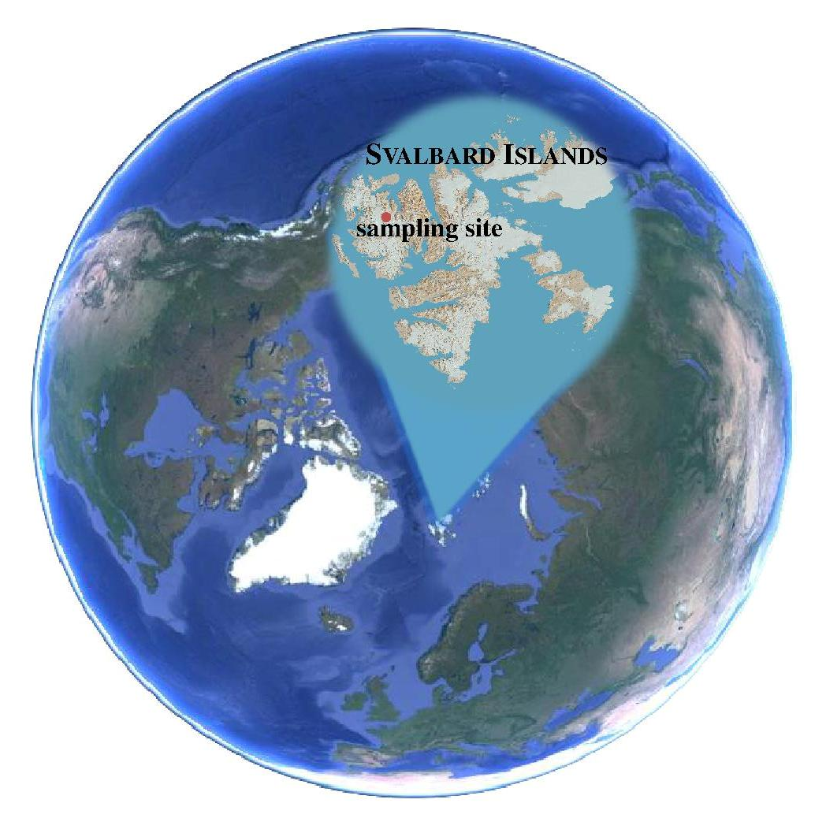
Figure 1. Map of drilling site (79° 19’ N, 13°23’E; 1150 m a.s.l.) at Holtedahlfonna glacier at Spitsbergen, Svalbard.

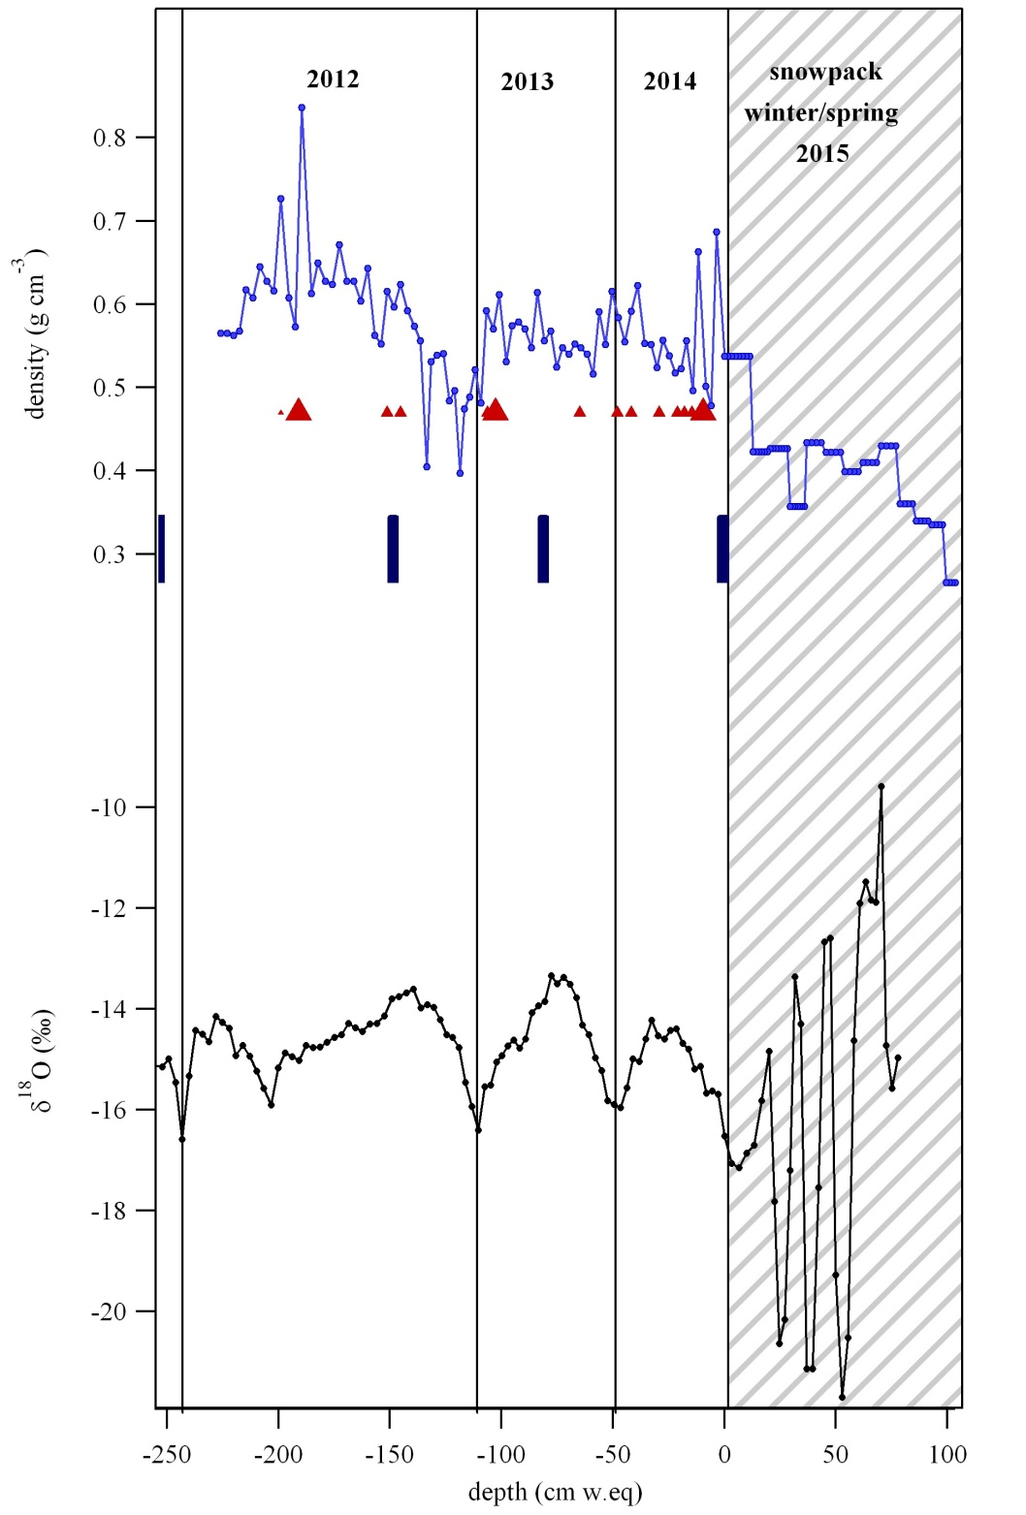
Figure 2. Density and ¹⁸O isotopic ratios profiles in the Holtedahlfonna firn core collected during 2015 Arctic expedition. The vertical blue bars represents mass balance measurements, performing at 40 m west of the drilling site in September of each year. Red triangles indicate the presence of ice lenses in the core; the dimension of triangle suggests the thickness of the lenses. The chronology of the core can be performed using these data.

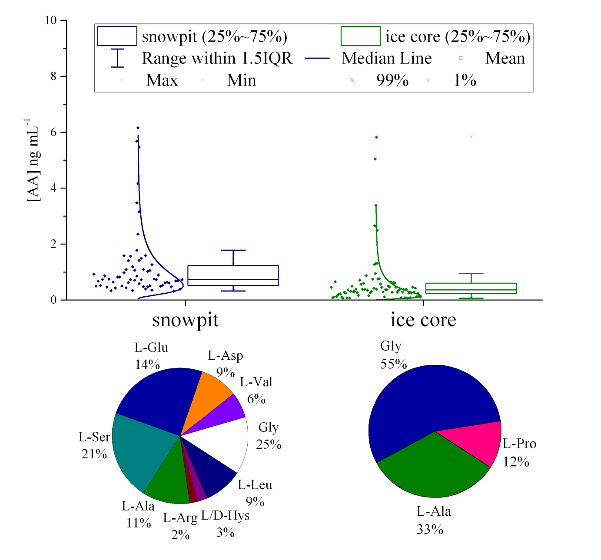
Figure 3. Box plots of total free amino acids concentration determined in the snowpit and ice core samples. Dots represent the real data, which have a lognormal distribution. Pie diagrams show the percent abundance of amino acids in each type of samples.

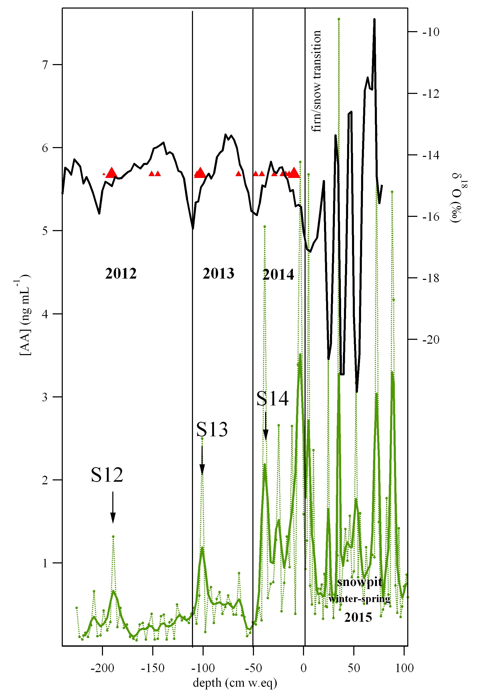

Figure 4. Profile of total free amino acids concentration (AA) is shown in green. Each measurement is reported in green dot, while the single green line represents a smoothing of measurement using a binomial algorithm. Black line corresponds to ¹⁸O isotopic ratios profile, respectively. Red triangles indicate the presence of ice lenses in the core; the dimension of triangle suggests the thickness of the lenses.

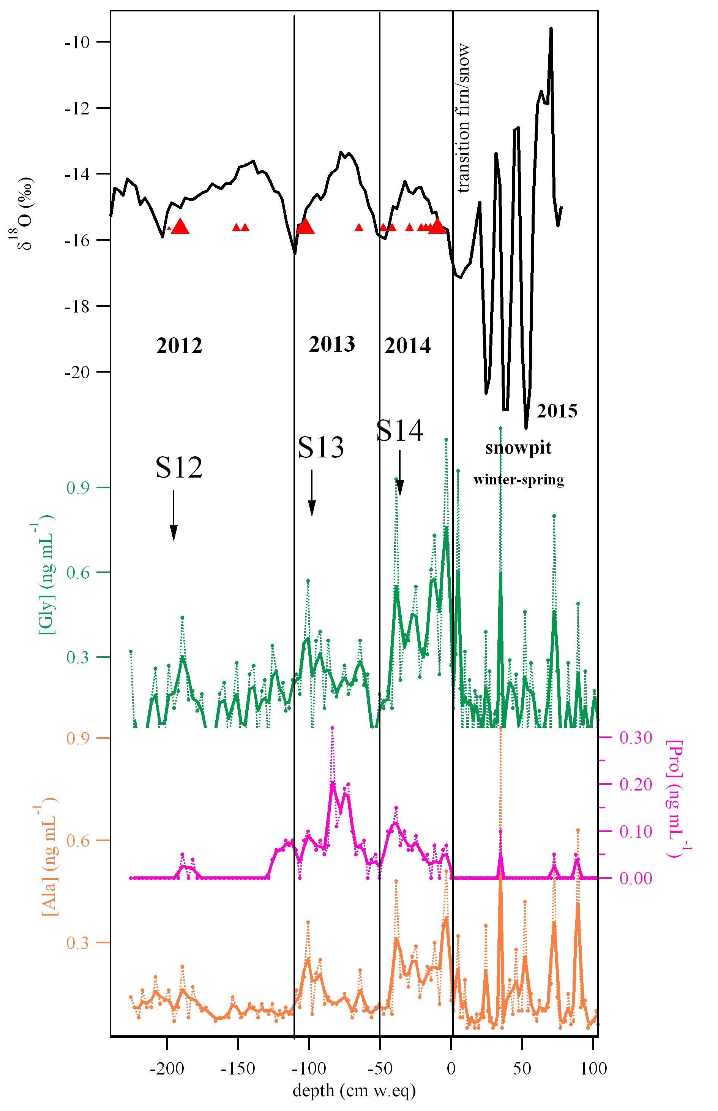
Figure 5. Comparison among the profiles of glycine (Gly), alanine (Ala) and proline (Pro). Each measurement is reported in each colour dot, while the single line represents a smoothing of measurement using a binomial algorithm. Black line corresponds to ¹⁸O isotopic ratios profile, respectively. Red triangles indicate the presence of ice lenses in the core; the dimension of triangle suggests the thickness of the lenses.

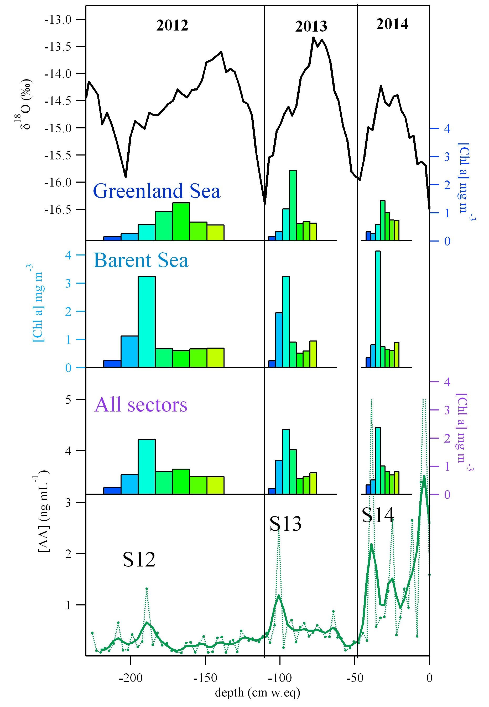

Figure 6. Profile of total free amino acids concentration (AA) in the ice core collected at Holtedahlfonna glacier. Black line corresponds to ¹⁸O isotopic ratios used to define chronology.
The bars represent the concentrations of Chl-a obtained with an extrapolation by MODIS data from Greenland Sea (72N-81N, 25W-16E), Barents Sea (72N-81N, 16E-50E) and all sector surrounding the Svalbard Islands (72N-84N, 25W-50E). The different colours of bars indicate the month between March (blue) and September (yellow).

