Supplementary Material

Towards Silica-free Compliance:
A Low-Viscosity Sample Pretreatment Methodology for Crystalline Quartz Quantification in Viscous Pastes

Giacomo Sivieroª, Michelle Buoso^{b}, Diego Andreola^{b}, Giulia Moro^{c}*

ª G.N.R. S.r.l. – Analytical Instruments Group, Via Torino 7, 28010 Agrate Conturbia, Italy

^{b} Ecoricerche S.r.l., Via Col di Grado 15/a, 36061 Bassano del Grappa, Italy

^{c} Department of Molecular Sciences and Nanosystems, Ca’ Foscari University of Venice, Via Torino 155, 30172 Venice, Italy

*Corresponding author

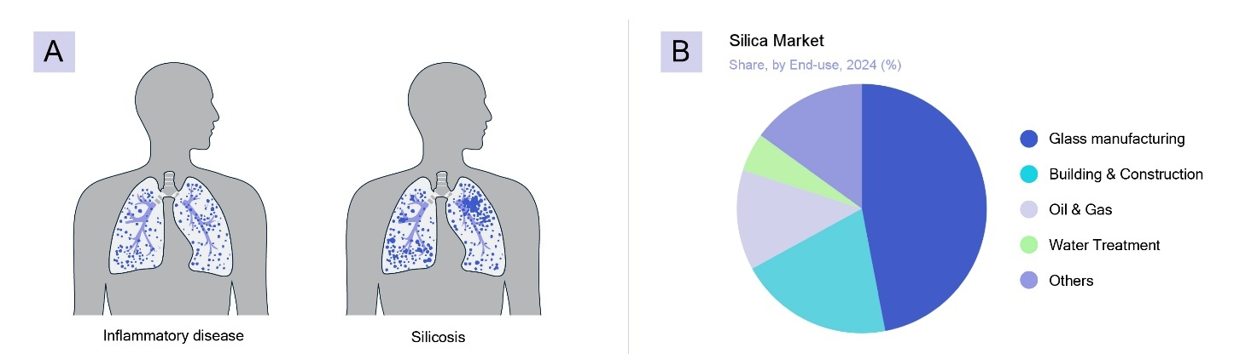
Fig. SM-1. A) Simplified visualization of the inflammatory diseases and the silicosis caused by the exposure to RCS, B) the main sectors involved in silica market inspired by the data reported in Silica Market (2024), ID: GVR-3-68038-064-4, https://www.grandviewresearch.com/industry-analysis/silica-market (Consulted the 22/11/2025 at 3.00 pm)

1. Paste composition
The polishing pastes are composed of a solid material that does the actual rubbing and polishing. These materials are chosen for their high hardness and crystalline structure, which provides sharp edges. The choice of crystal directly determines the paste's suitability: superabrasives (Diamond and CBN), for the hardest materials (Mohs 9-10); conventional Abrasives (SiC and Al₂O₃), for common industrial grinding and polishing; softer Abrasives (Mohs 7) (Silica, Tripoli), for light cleaning, gentle finishing, and softer materials. Silica is a much milder abrasive, used for softer metals (brass, copper), wood finishes, and as a gentle abrasive in polishing creams and toothpaste.
The composition of a silica abrasive paste is a deliberate balance between the micro- or nano-sized silica abrasive (chosen for its mildness and amorphous form) which are suspended in a complex liquid medium, or vehicle, to form the paste. This vehicle serves as a sophisticated liquid carrier designed to multiple purposes such as stability, lubrication, and pH control to achieve a precise and defect-free polishing action. Table SM-1 presents some of the most common components of the carrier and their functions in such medium.
Table SM-1
Component category | Purpose | Typical ingredients
Solvent | Dissolves other ingredients and  provides the liquid base. | Water (most common), used in alkaline aqueous solutions or wax emulsions., Propylene Glycol, Glycerin (or Sorbitol, especially in transparent pastes).  Fats and waxes: used as a binder, particularly in pastes for polishing metals.
Humectants | Prevents the paste from drying out  when exposed to air. | Glycerin, Sorbitol
Thickeners / Binders | Prevents the abrasive particles from settling out (stabilizes the paste) and controls the viscosity/texture for dispensing. | Sodium Carboxymethylcellulose (CMC), Xanthan Gum, Carrageenan, or sometimes a second, non-abrasive type of silica (e.g., fumed silica).
pH Regulators | Adjusts the pH for compatibility with  other ingredients and, in the case of colloidal silica, controls the chemical aspect of the polishing. | Acids or Bases (often for basic pH in CMP).
Other additives | Chemical specific to improve the performance of specific paste's final purpose. | Fluoride carriers (in toothpaste), corrosion inhibitors, emulsifiers, colorants, and fragrances;  Preservatives /antimicrobials: used in formulations like toothpaste or water-based pastes to prevent microbial growth.  For high performance: chemicals as aminosilanes or phosphorus-containing are compounds used for chemical-mechanical polishing of semiconductor wafers.

2. XRD intensity formula and quantitative analysis
If the following conditions are met:
-the sample is a multi-phase mixture of “(possibly) ideal powders”;
-the sample is loaded on the diffractometer as a flat-plate specimen of “infinite thickness”;
the integrated intensity of a reflection hkl (or α) belonging to a phase j in the mixture is given by

$$I_{(hkl)j}=\left[\frac{I_{0}λ^{3}}{32πr}\frac{e^{4}}{m_{e}^{2}c^{4}}\right]\left[\frac{M_{hkl}}{2V_{j}^{2}}{\left|F_{(hkl)j}\right|}^{2}e^{-2B{\left(\frac{sinθ}{λ}\right)}^{2}}\left(\frac{1+\cos^{2}2θ\cos^{2}2θ_{m}}{\sin^{2}θ cosθ}\right)\frac{1}{ρ_{j}}\right]\left[\frac{w_{j}}{μ_{s}}\right] (1)$$
where:
Instrument dependent |  | Sample dependent |  | Phase dependent
$$I_{(hkl)j}$$ | Integrated intensity of reflection hkl belonging to phase j | w_{j} | mass fraction of phase j | $$M_{hkl}$$ | Multiplicity of reflection hkl
 |  |  |  | V_{j} | Unit cell volume of phase j
$$I_{0}$$ | Incident beam intensity | $$μ_{s}$$ | Mass attenuation coefficient of the sample | $$F_{(hkl)j}$$ | Structure factor of reflection hkl of phase j
r | Distance from specimen to detector | $$μ_{s}$$ | Mass attenuation coefficient of the sample | 2θ | Diffraction angle for reflection hkl, phase j
λ | X-Ray wavelength |  |  | 2θ_{m} | Diffraction angle for monochromator. If not present, it 2θ_{m}=0
$$\frac{e^{4}}{m_{e}^{2}c^{4}}$$ | Square of classical electron radius |  |  | ρ_{j} | Density of phase j
 |  |  |  | B | Atomic displacement parameter (if isotropic).

By grouping Instrument dependent and Phase dependent terms together in 2 constants C and k we get:
$$I_{(hkl)j}=C_{Inst}k_{hkl,j}\frac{w_{j}}{μ_{s}}=K_{j,α}\frac{w_{j}}{μ_{s}} (2)$$
K_{j,α} is a global constant for reflection α(=hkl) and phase j, including the instrumental one (C_{Inst}), to make the notation simpler. The formula can be expressed as a function of the volume fraction of phase j by the relation:
$$\frac{w_{j}}{ρ_{j}μ_{S}}=\frac{w_{Vj}}{ρ_{S}μ_{S}}=\frac{w_{Vj}}{μ_{S,Lin}} (3)$$
where $w_{Vj}$ volume fraction of phase j, $μ_{S,Lin}$ linear attenuation coefficient of the sample, $ρ_{S}$ density of the sample.
For Rietveld refinement, a scale factor S_{j} for the whole crystalline phase is considered instead of its single reflections
$$S_{j}=\frac{C_{Inst}}{μ_{s}}\frac{w_{j}}{{\left(ZMV\right)}_{j}} (4)$$
where (ZMV)_{j} are structural parameters of the phase (Z=number of formula units in the unit cell, M=formula mass in a.m.u., V=unit cell volume).
The basic quantitative analysis assumes that all the phases in the sample are crystalline and identified. If not, a known amount of a crystalline internal standard can be added (m_{IS}) to the sample of mass M, realizing a new sample of mass M’=M+m_{IS}. The mass fractions of each phase in the original (w_{j}) and new sample (w_{j,T}’) are related by the equations below:
$$w_{IS,T}^{'}=\frac{m_{IS}}{m_{IS}+M}=\frac{w_{IS}}{w_{IS}+1} w_{j,T}^{'}=\frac{m_{j}}{m_{IS}+M}=\frac{w_{j}}{w_{IS}+1}=w_{j}\left(1-w_{IS,T}^{'}\right) (5)$$
Where the suffix T stands for “true”, referring to the actual mass fraction, taking into account possible unknown crystalline or amorphous phase in the sample.
The calculations for the mass fractions of the crystalline phases, including the internal standard, are carried out, by either RIR (eq. 6) or Rietveld analysis (eq. 7), assuming that all the phases are crystalline and identified. The first steps are: calculating the integrated net intensity (or area) I_{hkl,j} of a (hkl) peak belonging to a crystalline phase j (eq. 6) or its scale factor Sj (eq. 7) and providing phase dependent scattering factors, k_{hkl} (eq. 8) and (ZMV)_{j} (eq. 9). In case of RIR, the required phase dependent factors (k_{hkl}) are retrieved from tabulated RIRs factors (I/I_{C})_{j} (eq. 10), while for Rietveld refinement they are calculated from structural parameters.

$$I_{\left(hkl\right)j}=C_{Inst}k_{hkl,j}\frac{w_{j}^{'}}{μ_{s}} (6)$$
$$S_{j}=\frac{C_{Inst}}{μ_{s}}\frac{w_{j}^{'}}{{\left(ZMV\right)}_{j}} (7)$$

$$\sum_{k}{w_{k}^{'}}+w_{IS}^{'}=1=\left\{\begin{aligned}\frac{μ_{s}}{C_{Inst}}\left(\sum_{k}{\frac{I_{\left(hkl\right)k}}{k_{hkl,k}}}+\frac{I_{\left(h^{'}k^{'}l^{'}\right)IS}}{k_{h^{'}k^{'}l^{'},IS}}\right)\overset{⇒}{} w_{j}^{'}={\frac{I_{\left(hkl\right)j}}{k_{hkl,j}}}/{\left(\sum_{k}{\frac{I_{\left(hkl\right)k}}{k_{hkl,k}}}+\frac{I_{\left(h^{'}k^{'}l^{'}\right)IS}}{k_{h^{'}k^{'}l^{'},IS}}\right)} (8) \\ \frac{μ_{s}}{C_{Inst}}\left(\sum_{k}{S_{k}{\left(ZMV\right)}_{k}}+S_{IS}{\left(ZMV\right)}_{IS}\right)\overset{⇒}{} w_{j}^{'}={S_{j}{\left(ZMV\right)}_{j}}/{\left(\sum_{k}{S_{k}{\left(ZMV\right)}_{k}}+S_{IS}{\left(ZMV\right)}_{IS}\right)} (9)\end{aligned}\right.$$
$$k_{hkl,j}=\left(\frac{I_{(hkl)j}}{I_{(h'k'l')c}}\right)k_{h^{'}k^{'}l^{'},c}≡{\left(\frac{I}{I_{c}}\right)}_{j}k_{c} (10)$$

The relation between $w_{IS,T}^{'}$ and $w_{IS}^{'}$ is given by:
$$w_{IS,T}^{'}=\frac{m_{IS}}{m_{IS}+M}=\frac{m_{IS}}{m_{IS}+M-m_{A}+m_{A}}=\frac{\frac{m_{IS}}{m_{IS}+M-m_{A}}}{\frac{m_{IS}+M-m_{A}+m_{A}}{m_{IS}+M-m_{A}}}=\frac{w_{IS}^{'}}{\frac{m_{IS}+M}{m_{IS}+M-m_{A}}}=\frac{w_{IS}^{'}}{\frac{1}{1-w_{A}^{'}}} =w_{IS}^{'}\left(1-w_{A}^{'}\right) (11)$$

Similarly, for $w_{j,T}^{'}$ and $w_{j}^{'}$:
$$w_{j,T}^{'}=\frac{m_{j}}{m_{IS}+M}=w_{j}^{'}\left(1-w_{A}^{'}\right) (12)$$

where $w_{A}^{'}$ is the unidentified/amorphous fraction with respect to the sample M’.
Since the true value $w_{IS,T}^{'}$ is known, the ratio with its calculated value $w_{IS}^{'}$ provides the correction factor to retrieve $w_{j,T}^{'}$, after dividing equations (12) and (11)
$$w_{j,T}^{'}=w_{j}^{'}\frac{w_{IS,T}^{'}}{w_{IS}^{'}} (13)$$
where necessarily $w_{IS}^{'}≥w_{IS,T}^{'}$.

The mass fraction w_{j} with respect to the original sample (M) can be retrieved by eq. 5:
$$w_{j}=\frac{w_{j,T}^{'}}{1-w_{IS,T}^{'}} (14)$$
$$w_{A}=\frac{w_{A}^{'}}{1-w_{IS,T}^{'}} (15)$$

For further details see: Powder Diffraction Theory and Practice, edited by R.E. Dinnebier, S.J.L. Billinge, chapter 11 “Quantitative Phase Analysis”; B. D. Cullity, Elements of X-Ray Diffraction, Second Edition, chapter 14; International Tables for Crystallography (2019). Vol. H, Chapter 3.9, Quantitative Phase Analysis, pp. 344–373 https://doi.org/10.1107/97809553602060000954

3. Crystallinity estimation of quartz and zincite powders
The crystallinity of powders was estimated by means of the internal standard method and Rietveld refinement (equations 7 to 15), by using reference materials with certified crystallinity, NIST SRM 676a and 1879b. Refined diffraction patterns from Rietveld refinement (Profex) are reported in the figures below:

Quartz + NIST SRM 676a Corundum
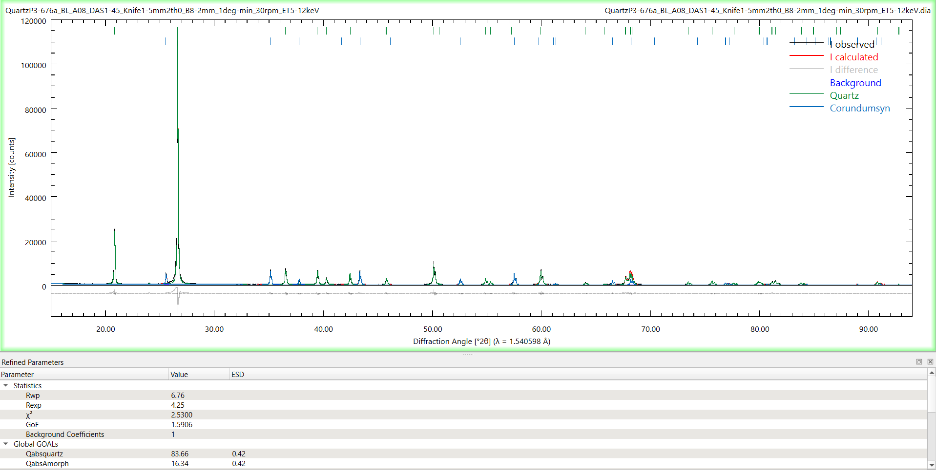

Quartz + NIST SRM 1879b Cristobalite
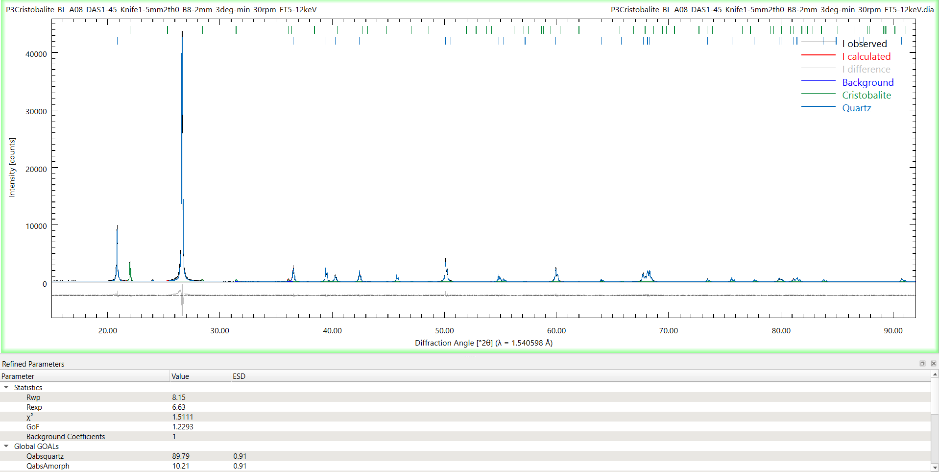

Zincite (ZnO) + NIST SRM 1879b Cristobalite
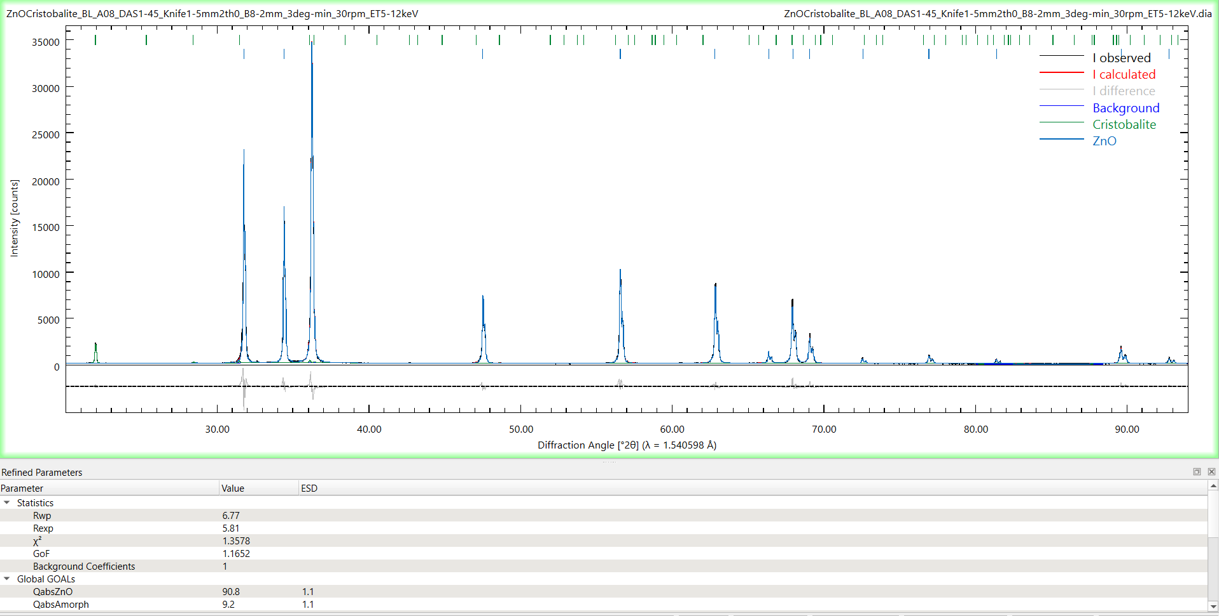

Zincite (ZnO) + NIST SRM 676a Corundum
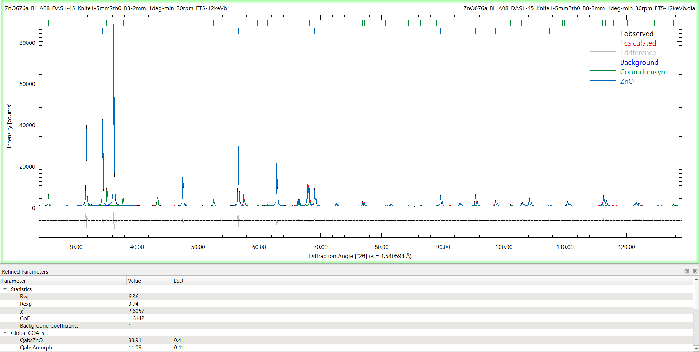

4. Standard additions
The method requires the spiking of a sample containing an unknown amount w_{j} (mass fraction) of phase j represented by its peak hkl=α:
$$I_{(hkl)j}=K_{j,α}\frac{w_{j}}{μ_{s}}=K_{j,α}\frac{{m_{j}}/M}{μ_{s}} (16)$$
A known amount m_{x} of phase j is added:
$$I_{α,j}^{x}=\frac{K_{j,α}}{μ_{s}^{x}}\frac{m_{j}+m_{x}}{M+m_{x}}=\frac{K_{j,α}}{μ_{s}^{x}}\left(w_{j}^{x}+c_{x}\right) (17)$$
where
$$w_{j}^{x}=\frac{m_{j}}{M+m_{x}}=\frac{w_{j}}{1+w_{x}} (18)$$
$$c_{x}=\frac{m_{x}}{M+m_{x}}=\frac{w_{x}}{1+w_{x}} (19)$$
$$w_{j}=\frac{m_{j}}{M}; w_{x}=\frac{m_{x}}{M} (20)$$
Assuming c_{x}<0.1, $μ_{s}^{x}$ can be considered constant:
$$I_{α,j}^{x}=\frac{K_{j,α}}{μ_{s}^{x}}\left(w_{j}^{x}+c_{x}\right)=\frac{K_{j,α}}{μ_{s}^{x}}w_{j}^{x}+\frac{K_{j,α}}{μ_{s}^{x}}c_{x}=a+bx (21)$$
By adding increasing amounts m_{x} (c_{x} increases), plotting c_{x} vs $I_{α,j}^{x}$ and performing the linear regression, it is possible to find where it intersects the x-axis:
$$I_{α,j}^{x}=0 ⇔x=-\frac{a}{b}=-w_{j}^{x}=S_{0} (22)$$
(S₀ is negative).
Thus $c_{x}=-w_{j}^{x}=S_{0}$, $w_{x}=\frac{c_{x}}{1-c_{x}}$ providing (eq. 18, 19):
$$w_{j}={-w}_{x}=-\frac{S_{0}}{1-S_{0}}=\frac{S_{0}}{S_{0}-1}$$
$$w_{j}\left(\%\right)=\frac{S_{0}}{S_{0}-1}*100$$

If Crystallinity w_{Cry} of standard is <100%, a correction factor must be taken into account, i.e.
$w_{j}\left(\%\right)=\frac{S_{0}}{S_{0}-1}*w_{Cry}$, see EN 17289 C.2.2.2

5. Linear regressions

$$y=a+bx$$
A. Weighted linear regression WLR for S1 (Figure 8d in the manuscript) (I. Hughes and T. Hase, Measurements and their Uncertainties: A practical guide to modern error analysis, Oxford University Press)
x_{i} | y_{i} | sy_{i} | w_{i} | w_{i}x_{i} | w_{i}x_{i}² | w_{i}y_{i} | w_{i}x_{i}y_{i} | Δ'
0 | 197.0894 | 2.768524 | 0.130468 | 0 | 0 | 25.71382 | 0 | 8.04565E-05
0.035042 | 292.2245 | 16.2119 | 0.003805 | 0.000133 | 4.67E-06 | 1.111857 | 0.038961396
0.070292 | 358.8556 | 11.40994 | 0.007681 | 0.00054 | 3.8E-05 | 2.756471 | 0.193756809
0.159542 | 642.1857 | 6.779904 | 0.021755 | 0.003471 | 0.000554 | 13.97055 | 2.228892817

Weighted Fit Parameters
a | s_{a} | b | s_{b} | Model | Residuals | Norm. Residuals
196.0333852 | 2.722542 | 2765.4991 | 45.10817 | 196.0334 | 1.056061 | 0.381452717
Scaled Weighted Fit Parameters |  |  |  | 292.9413 | -0.71674 | -0.044210504
a | s_{a} | b | s_{b} | 390.4248 | -31.5692 | -2.766814415
196.0333852 | 5.557356 | 2765.4991 | 92.07651 | 637.2472 | 4.938555 | 0.728410791

χ² | Reduced χ² | χ² test
8.333305 | 4.166652516 | 0.015504

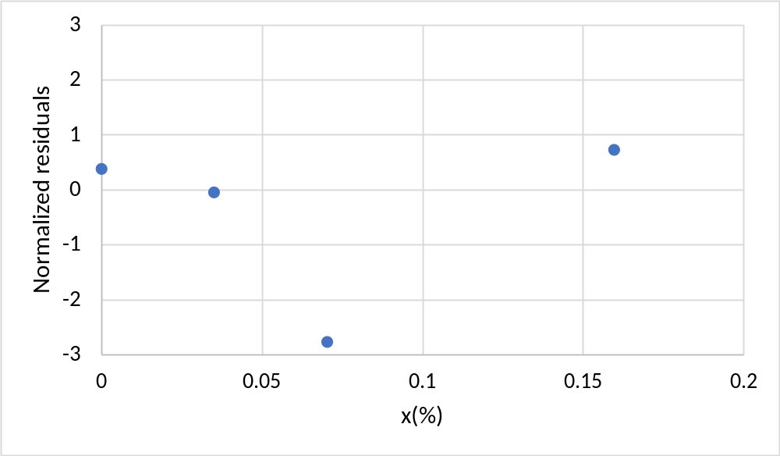

B. Lack of fit test (ISO 11095) for S1 (refer to figure 8d in the manuscript)
Cx (=x_{i}) | Peak area (=y_{i}) | mean_y | Model | Residuals | Norm. Residuals | yij_pred-yi | yij-yi
0.000 | 200.9 | 197.1 | 188.1218 | 12.7671 | 12.76710442 | 80.42 | 14.44
0.000 | 198.7 | 197.1 | 188.1218 | 10.55618 | 10.55617942 | 80.42 | 2.52
0.000 | 191.7 | 197.1 | 188.1218 | 3.579785 | 3.579785415 | 80.42 | 29.03
0.035 | 303.8 | 292.2 | 285.7381 | 18.07615 | 18.07614728 | 42.07 | 134.32
0.035 | 312.7 | 292.2 | 285.7381 | 26.91628 | 26.91627628 | 42.07 | 417.38
0.035 | 260.2 | 292.2 | 285.7381 | -25.5332 | -25.53315372 | 42.07 | 1025.25
0.070 | 381.4 | 358.9 | 383.9343 | -2.49623 | -2.496228377 | 628.94 | 509.97
0.070 | 344.7 | 358.9 | 383.9343 | -39.2132 | -39.21318438 | 628.94 | 199.78
0.070 | 350.4 | 358.9 | 383.9343 | -33.5267 | -33.52666838 | 628.94 | 71.37
0.160 | 633.1 | 642.2 | 632.5612 | 0.587267 | 0.587267013 | 92.63 | 81.67
0.160 | 655.5 | 642.2 | 632.5612 | 22.89804 | 22.89803601 | 92.63 | 176.18
0.160 | 637.9 | 642.2 | 632.5612 | 5.388439 | 5.388439013 | 92.63 | 17.94

a |  | s_{a} |  | b |  | s_{b}
188.1217566 |  | 9.875712855 |  | 2785.716967 |  | 111.0708308
n | c | MSLF | MSPE | F* | P(F>F*)
12 | 4 | 1266.1 | 334.9831 | 3.779593 | 0.06989>0.05
MSLF: Lack of fit mean square; MSPE: pure error mean square; F*=MSLF/MSPE

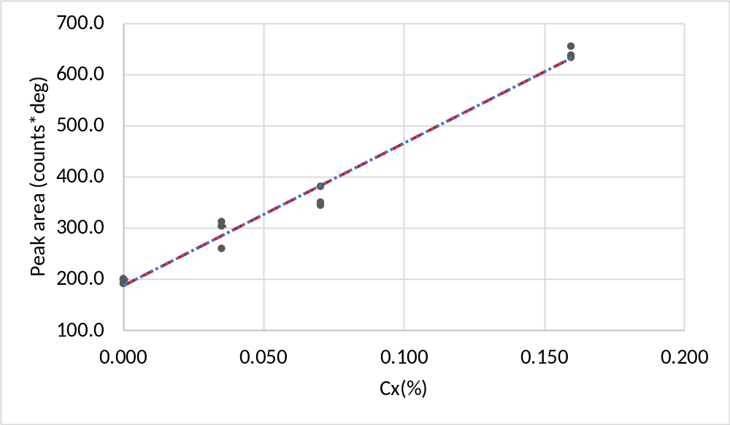
Following the same approach for samples S2 and S3, it is possible to compare the results obtained with the WLR (selected method in the manuscript) and simple linear regression (ISO 11095), taking into account the replicates. The corresponding estimated quartz content with the standard additions method is reported in Table SM-2, where the compatibility is good.

Table SM-2
Sample | Mass fraction  (%)
 | WLR | ISO 11095
S1 | 0.071±0.004 | 0.067±0.006
S2 | 0.059±0.003 | 0.065±0.006
S3 | 0.109±0.017 | 0.105±0.013

