Supplementary material to:
Boon and burden: economic performance and future perspectives of the Venice flood protection system

Carlo Giupponi ^{✉1,2}, Marco Bidoia ^{1,2}, Margaretha Breil ³, Luca Di Corato ¹, Animesh Kumar Gain ^{1,4}, Veronica Leoni ^{1,5}, Behnaz Minooei Fard ¹, Raffaele Pesenti ⁶, Georg Umgiesser ^{7,8}
✉ cgiupponi@unive.it
¹ Department of Economics, Ca’ Foscari University of Venice, Venice, Italy
² Fondazione Eni Enrico Mattei, Venice, Italy
³ Euro-Mediterranean Centre on Climate Change at Ca’ Foscari University of Venice, RFF-CMCC
European Institute on Economics and the Environment, Venice, Italy
⁴ School of Environmental and Conservation Sciences, Murdoch University, 90 South St, Murdoch, WA 6150, Australia.
⁵ Department of Applied Economics, University of Balearic Islands, Palma, Spain
⁶ Department of Management, Ca’ Foscari University of Venice, Venice, Italy
⁷ National Research Council of Italy, CNR-ISMAR, Venice, Italy
⁸ Marine Research Institute, Klaipeda University, Klaipeda, Lithuania

Contents
1. THE MODEL VARIABLES 3
2. THE MoSE MANAGEMENT MODULE 6
3. THE CITY MODULE 8
3.1 TOURISM 9
3.2 POPULATION 11
3.3 BUILDINGS 12
4. THE PORT MODULE 15
5. SENSITIVITY ANALYSIS 18
5.1 HISTORICAL RECORDS 18
5.2 FUTURE SCENARIOS 20

THE MODEL VARIABLES
This appendix provides a detailed description of the model presented in Figure 2 in the main paper and presents also the modules omitted there for brevity. The model is a discrete event model with time step of 6 hours, which allows to consider the two maximum and two minimum levels of the daily tidal cycles. It consists of three modules: MoSE management, the City, and the Port,
Throughout this appendix:
- in accordance with the UN World Tourism Organization glossary, we call excursionist a same-day visitor, we call tourist an overnight visitor that spend the night in a city dwelling.
- by *vessel(s)*, we refer to any kind of vessel, unless specified otherwise. In the model stock and flow diagram, the specific group of vessels is explicitly named, rather than generically employing the word *vessel*, e.g., Container(ship).
- by high tide, we refer to the higher values of lagoon water levels which appear twice a day, as a consequence of tidal cycles.
- by RCP, we refer to the Representative Concentration Pathway adopted by the IPCC. In particular, we consider the RCP 2.6 "very stringent" scenario likely to keep global temperature rise below 2 °C by 2100, and the RCP 8.5 scenario, generally taken as the worst-case climate change scenario.
- input data and parameters are shown in bold.
- state and output variables are shown in italics.

The model uses
- as main input data:
  - Lagoon Water Levels: either the 1983 – 2021 Venetian lagoon tide data in the form of two daily min and max, approximately sampled every 6 hours; or the 2022 – 2100 Venetian lagoon tide synthetic data in the form of two daily min and max, again approximately sampled every 6 hours. Under RCP 2.6 and 8.5 scenarios
  - Peak Time: hour associated with a peak in Lagoon Water Levels
  - Monthly Tourists: estimated number of tourists by month
  - Monthly Excursionists: estimated number of excursionists by month
  - Daily *Vessels*: estimated daily number of *vessel* calls to the port of Venice, according to the month, under baseline conditions
- as main parameters:
  - Cost per closure: total cost for each MoSE closure given by a combined sum of energy and labor costs
  - Closure level: high tide forecast threshold for MoSE closure
  - Tide Forecast Accuracy: historical standard deviation in cm of real water levels from forecasted one. Set to 20 cm
  - Percentage of Lost Tourists: percentage of Tourists which are expected not to come to Venice in the month following a high tide episode
  - Percentage of Lost Excursionists: percentage of Excursionists which are expected not to come to Venice in the month following a high tide episode
  - Average Expense per Tourist: average expense per tourist as computed by De Marchi et al. (2019)
  - Average Expense per Excursionist: average expense per excursionist as computed by De Marchi et al. (2019)
  - Children Population: total number of school age children (5 to 19 years old) living in Venice as reported by the Italian National Institute of Statistics (ISTAT).
  - Elderly Population: total population from 75 to 84 years living in Venice as reported by ISTAT.
  - Baby sitter unitary cost: hourly cost for assistance to minor children as reported by ISTAT multiplied by the estimated number of hours for which assistance service may be needed after a high tide episode.
  - Care giver unitary cost: hourly cost for assistance to elderly as reported by ISTAT multiplied by the estimated number of hours for which assistance service may be needed after a high tide episode.
  - Average Revenues per *Vessel*: average revenues for port operators coming from a freight *vessel* call.
  - Temporary Lost *Vessels*: percentage of freight *vessels* which are affected once by MoSE operations and are not going to come back before one year. Set to 10% for all freight *vessels*
  - Permanently Lost *Vessels*: percentage of freight *vessels* which are affected once by MoSE operations and are not going to come back forever. Set to 20% for all freight *vessels*
  - *Vessels* Lost per Closure: percentage of *vessel* calls expected to be immediately lost due to MoSE operations
  - *Vessel* Return Frequency: the number of times in which a *vessel* is expected to return to Venice yearly
- as main state variables:
  - MoSE Operation: binary variable equal to 1 on when the MoSE gates are closed.
  - Tide Forecast Error: Random error introduced in the time series of expected tide level to simulate forecast error. Represented by a random normal variable truncated between - Tide Forecast Accuracy and + Tide forecast accuracy.
  - Tide Forecast: the simulated tide forecast, computed as Lagoon Water Levels plus Tide Forecast Error
  - Max damage subs closure: the maximum damage avoided to the city considering the maximum water levels which may have occurred, when the MoSE is assumed to be closed for more than one subsequent time step.
  - Lost Monthly Tourists: number of Tourists which are expected not to come to Venice in the month following a high tide episode. Equal to Monthly Tourists multiplied by the Percentage of Lost Tourists
  - Lost Monthly Excursionists: number of Excursionists which are expected not to come to Venice in the month following a high tide episode. Equal to Monthly Excursionists multiplied by the Percentage of Lost Excursionists
  - Commercial Internal Walls Costs: the total cost of the damage caused by high tides to the walls of a commercial use building
  - Commercial External Walls Costs: the total cost of the damage caused by high tides to the internal walls of a commercial use building
  - Commercial External Walls Costs: the total cost of the damage caused by high tides to the external walls of a commercial use building
  - Commercial Internal Doors Costs: the total cost of the damage caused by high tides to the internal doors of a commercial use building
  - Commercial External Doors Costs: the total cost of the damage caused by high tides to the external doors of a commercial use building
  - Commercial Floor Costs: the total cost of the damage caused by high tides to the floors of a commercial use building, computed as number of commercial units affected under a certain tide height multiplied by the average floor cleaning cost for a commercial unit
  - Residential Internal Walls Costs: the total cost of the damage caused by high tides to the walls of a residential use building
  - Residential External Walls Costs: the total cost of the damage caused by high tides to the internal walls of a residential use building
  - Residential External Walls Costs: the total cost of the damage caused by high tides to the external walls of a residential use building
  - Residential Internal Doors Costs: the total cost of the damage caused by high tides to the internal doors of a residential use building
  - Residential External Doors Costs: the total cost of the damage caused by high tides to the external doors of a residential use building
  - Residential Floor Costs: the total cost of the damage caused by high tides to the floors of a residential use building, computed as number of residential units affected under a certain tide height multiplied by the average floor cleaning cost for a residential unit
  - Temporary Lost *Vessels*: number of *vessels* estimated not to come back to Venice for one year after being affected once by MoSE operations. Computed taking into account *Vessel* Return Frequency and Temporary Lost *Vessels* variables. Only in the case of freight *vessels*
  - Permanently Lost *Vessels*: number of *vessels* estimated not to come back to Venice forever after being affected once by MoSE operations. Computed taking into account *Vessel* Return Frequency and Permanently Lost *Vessels* variables. Only in the case of freight *vessels*
  - Daily *Vessels* Revised: estimated daily number of *vessels* calls to the port of Venice, according to the month, taking into account the temporary and permanent reduction (memory effects) due to the effect of MoSE operations. Only in the case of freight *vessels*
  - *Vessels* lost per day: number of *vessels* calls expected to be immediately lost due to MoSE operations, as result of the product between Daily *vessels* Revised and *Vessels* Lost per Closure variables
  - *Vessel* Immediate Costs: total economic losses for port operators associated with the loss of expected *vessels* calls immediately following MoSE operations
  - *Vessel* Memory Costs: total economic losses for port operators associated with the loss of expected *vessels* due to permanent and temporary memory effects of MoSE closures

The model returns as main output the values and the statistics of the following variables:
- City costs: stock variable whose value represents the Net Present Value (NPV) of the cumulative costs paid by the city over the years due to tides
- Port costs: stock variable whose value represents the NPV of the cumulative costs paid by the port over the years due to MoSE operations
- City Avoided costs: stock variable whose value represents the NPV of the cumulative costs avoided to the city by MoSE operations over the years, considering
- City avoided costs subs Closures: stock variable whose value represents the NPV of the cumulative costs avoided to the city by MoSE operations over the years, considering only once the Cost per closure in the case of subsequent closures
- Total costs: sum of City costs and Port costs to represent the final costs for the city
- Closures: stock variable accumulating the total number of MoSE closure within one year
- Lost tourists: stock variable accumulating the number of tourists lost due to high tides
- Lost Excursionists: stock variable accumulating the number of excursionists lost due to high tides
- Cumulated Tourist Costs: stock variable whose value represents the NPV of total economic losses due to high tides for the tourism sector. Considering both the number of excursionists and of tourists lost and their average expenditure
- Cumulated Population Costs: stock variable whose value represent the NPV of costs for assistance to elderly and children due to high tides
- Cumulated Commercial Costs: stock variable whose value represent the NPV of costs for restoration of commercial use buildings due to high tides
- Cumulated Residential Costs: stock variable whose value represent the NPV of costs for restoration of residential use buildings due to high tides
- Cumulated *Vessel* Costs: stock variable whose value represent the NPV of the cumulative costs paid by port operators over the years due to the loss of *vessel* calls. Four different cumulated stocks are computed for the four different macro-groups of vessels and aggregated in the final stock variable Port costs

THE MoSE MANAGEMENT MODULE
The MoSE management module (reported in Figure 2 of the main paper) operates on Lagoon Water Levels, that is a record of lagoon water levels data on the two daily maximum and minimum values of the tides. Its parameters were calibrated using the tide data from 1983 to 2021 that was retrieved from Venice municipality’s official website at the monitoring station of Venezia-Punta della Salute. In general, the records show 4 observations per day: two high tides and two low tides. In some cases, interference with meteorological conditions may alter the tidal cycle, either prolonging or shrinking the 6-hour intervals and thus resulting in three or five values per day. In order to have a consistent time series with four values (time steps) per day, the time series has been consolidated as follows:
- for days with more than four observations, only the two actual maxima and minima have been selected,
- for days with less than four observations, values were included approximately every six hours using linear interpolation on the immediate previous and following observations.
Three different datasets were generated, to be used for the different simulations:
- Historical records, for preliminary sensitivity analysis and calibration. These comprise all the data from January 1983 to September 2020. Thus excluding data after October 2020, when the MoSE started its operations (3rd October 2020).
- Year 2019, to evaluate the damages due to the extraordinary high tide events of November, for model validation purposes, as we could rely on the quantified damage estimates provided by the municipal administration.
- Two synthetic time series to simulate the sea level trend under the different scenarios. The original time series from 1996 to 2021 (26-year time series) was segmented in annual records, which have been randomly combined to form a new 78-year time series (from 2021 to 2100). The new time series was then used for generating the synthetic series of the two climate change scenarios by adding expected trends of average sea level, according to the following formula, calculated from the projections of relative sea level rise found in Lionello et al. (2021):

- $f\left(n\right)= a+b×e^{rn}$
Where $a$, $b$ and $r$ are parameters and $n$ is the number of years between 2023 and the year considered. This operation allowed to account for sea-level rise while retaining the information on the seasonality of tides.
At each time steps the model applies a forecast error to the scenario data sets as a random noise varying within the +/- Tide Forecast Accuracy interval. Each time the resulting forecast is above the predefined closure level, the MoSE system is activated. This procedure mimics the current criteria adopted by the competent administration to decide upon the MoSE operations. The Cost per closure is accounted as a lumped sum of energy and labor costs, following informal communications from the competent administration, but does not consider the total annual maintenance cost, because it is still unknown.
The MoSE barriers remain closed when sequences of water levels (either high or low tides) exceed the MoSE activation water level threshold, as observed during the first two years of operation. In terms of damage calculation, each of these prolonged closures is regarded as a single event. To account for the occurrence of these events, a specific variable memorizing costs, named City avoided costs subs Closures, was included.
When the variable MoSE Operation is equal to 1 for more than one consecutive time step, the Potential city damages are assessed iteratively computed and memorized in the variable Max damage subs closure. Then, the model ensures that this value is added only once to the final City avoided costs subs closures stock variable. For every time step of closure, being it subsequent or not, the MoSE Cost per closure is considered and therefore subtracted from the absolute values of the City Avoided costs and City avoided costs subs closures, to take into account the energy and labor costs of the persisting closures. City avoided costs subs closures can thus be compared with City costs.
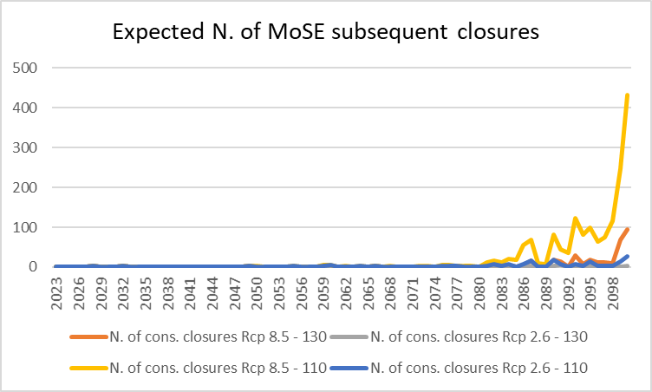
Fig A.1 Expected number of time steps of subsequent closures according to four different scenarios resulting from the combination of two climatic scenarios (Rcp 2.6 and 8.5) and two closure levels (110 and 130 cm).

THE CITY MODULE
This module was used to assess (i) the impact of high tide events on tourism activities (i.e., on the number of tourists and excursionists) and (ii) the impact of tides higher than 120 cm on the population (young and elderly). Moreover, it was used to investigate the impact of different water levels on buildings (including walls and doors), and floors.
If MoSE operates, the model adds its Cost per closure to the Total costs stock variable while the Potential city damages are added to the City Avoided costs stock variable. Otherwise, if the MoSE system is not activated, the Potential city damages are added to the City costs, and therefore also to the Total costs.

TOURISM

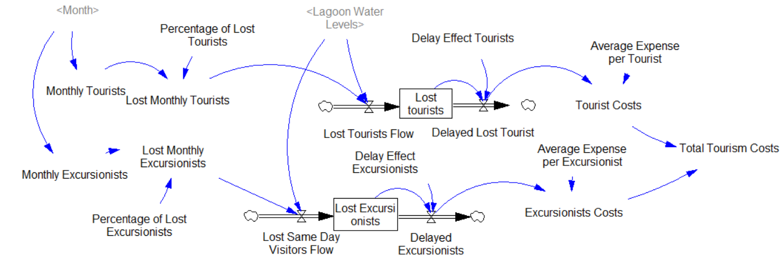
Fig A.2 Tourism stock and flow diagram

Following Fontini et al. (2010), we considered the effect of tide on tourism activities and we estimated the loss in tourists’ expenditures associated with high tide episodes. In our model we considered only water level events above 140 cm, because empirical evidence shows that the impacts on tourists depend on the information available in the media, which is usually provided only in cases of exceptional high levels, i.e., when the tide exceeds 140 cm. Given that the impacts typically consist in cancellations of planned trips to the city, which persist for some weeks after the extreme event, we adopted the following model:
- ${ln⁡(Tourism stays}_{t})=α+ β {HighWater}_{t}+ γYear+ δSeason+ ε_{t}$
Where $α$ is a constant term, ${High Water}_{t}$ is the number of high tide episodes occurred at month t. Year and Season account for the year and seasonal fixed effects, respectively, and $ε_{t}$ is a random error term. $β$ was the main parameter to be estimated, representing the percentage of change in tourism stays, as a result of a marginal increase in the number high tide level episodes.

Data on tourism stays were retrieved from the Official Statistic Bureau of Veneto Region. They include monthly tourist stays, thus considering only people staying overnight in official accommodation facilities, covering the period from January 2005 to December 2019. The use of more recent data has been dismissed to avoid biased estimates potentially associated with two confounding effects i.e., the outbreak of COVID-19 and the activation of MoSE barriers. Data on lagoon water levels have been downloaded from the Centro Maree website (the tide forecast center of the Municipal administration). This data enabled us to estimate that high tide episodes are associated with a decrease of approximately 6.3% in tourism stays. Percentage of Lost Tourists, was calculated on monthly average of tourist stays between 2017 and 2019.
Data on tourist stays were collected from the Veneto region’s official website. The estimated number of monthly tourists and excursionists are reported in Table A.1.
Month | Tourism stays estimate (avg. 2017-19) | Monthly exc. Estimate
1 | 567,781 | 836,197
2 | 694,583 | 1,022,945
3 | 861,379 | 1,268,593
4 | 1099836 | 1,619,780
5 | 1,176,856 | 1,733,211
6 | 1,218,355 | 1,794,329
7 | 1,339,594 | 1,972,883
8 | 1,341,391 | 1,975,530
9 | 1,280,292 | 1,885,546
10 | 1,251,538 | 1,843,199
11 | 784,527 | 1,155,410
12 | 634,749 | 934,824
Total | 12,250,879 | 18,042,448
Tab A.1 Estimated number of tourists and excursionists per month.

Data on high tide events per month during these periods was obtained from Venice municipality’s official website. Hence, it was possible to compute the number of high tide episodes per month (number of events > 140 cm, NAA_140).
This data allowed us to estimate the effect of high tide on tourism stays, as described in section 1.1, formula (1). To rule out the effect of seasonality and of yearly trends, time indicator variables have been included.
For completeness, the summary of the regression is available in Table A.2:
Observations: 180
Dependent variable: log(tourism_stays)
Type: OLS linear regression
F(18,161): 24.35
R²: 0.73
Adj. R²: 0.70

Est S.E. t val. p
Intercept 12.983 0.060 217.499 0.000
NAA_140 -0.065 0.037 -1.767 0.079
(year)2006 0.071 0.077 0.927 0.355
(year)2007 0.146 0.077 1.891 0.060
(year)2008 0.115 0.077 1.491 0.138
(year)2009 0.105 0.077 1.356 0.177
(year)2010 0.099 0.077 1.283 0.201
(year)2011 0.188 0.077 2.439 0.016
(year)2012 0.196 0.077 2.540 0.012
(year)2013 0.238 0.077 3.083 0.002
(year)2014 0.256 0.077 3.328 0.001
(year)2015 0.277 0.077 3.602 0.000
(year)2016 0.320 0.077 4.161 0.000
(year)2017 0.422 0.077 5.477 0.000
(year)2018 0.472 0.077 6.115 0.000
(year)2019 0.541 0.079 6.893 0.000
(season)2 0.515 0.040 12.945 0.000
(season)3 0.642 0.040 16.135 0.000
(season)4 0.218 0.041 5.324 0.000
Tab A.2 Results of tourism and high tide episodes’ regression as by Eq. (1).

Estimating the behavior of excursionists is generally quite complex, since they do not register in any official accommodation facilities. To estimate the Monthly Excursionists, we assumed that their annual growth rate is the same as the one of tourists between 2008 and 2017-19, and that their monthly distribution follows the same as that of tourists. Data on excursionists’ expenditures from De Marchi et al. (2019) were used to calculate damages following the same pattern as that of tourists, by applying the same percentage decrease computed with formula (1) for tourists’ stays to quantify the effect of high tides. According to De Marchi et al. (2019), 47.00 euros is the average daily expenditure for excursionists (same for Italians and foreigners) and 181.00 euros for tourists (weighted average between Italians and foreigners according to their relative share, as reported in the Venice Municipality Tourism Yearbook, 2019).

High-tide episodes lead to a decrease in the flow of Monthly Tourists, as computed in the variable Lost Monthly Tourists. This value accumulates in Lost tourists and it is gradually released during the month following the episode, to simulate the tail of cancellations following extreme events. The value of the variable Lost tourists is multiplied by the Average Expense per Tourist and accumulated in the final stock Cumulated Tourist Costs. The same algorithm is replicated for the excursionists.

POPULATION
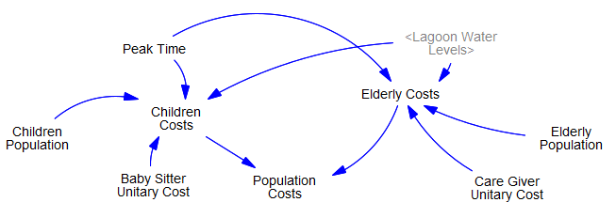
Fig A.3 Population stock and flow diagram

The Cumulated Population Costs stock takes into account the cost of assistance for Children Population and Elderly Population, following the work of Cellerino (1998).

The model checks the Peak Time. If a high tide episode occurs between 6:00 AM and 4:00 PM, both population groups are affected by the high tide and are expected to need special assistance. The young people face the Baby Sitter Unitary Cost and the old people face the Care Giver Unitary Cost. These costs are due to the fact that Children Population is prevented to go to school and Elderly Population is prevented to shop for its daily needs because of the flooding.

BUILDINGS
The Cumulated Residential Costs and Cumulated Commercial Costs include estimated damages on walls (internal and external), doors (internal and external), and floors of commercial and residential buildings. The number of residential and commercial units affected by flooding at a certain tide level, are multiplied by the average unitary cost per typology (e.g. Residential Internal Walls Costs). The module for calculating potential damages to buildings is presented in Figure A.4.
Damages to buildings caused by floods have been estimated using a database with information on the physical conditions of ground floor units of the historic center of Venice, and the elevation database of public spaces (RAMSES project), allowing to merge the information regarding the ground floor units with the information concerning ground and water levels and to apply the specific damage functions.
The computation of each component of the building costs is straightforward: we multiplied the estimated average cost per unit (according to the damage-cost function, based upon the difference between water and ground levels) by the number of flooded units.
The ground floor database has been created on the initiative of the City of Venice by COSES in two successive surveys initiated in 1999 and 2001. It considers doorways, courtyards, entrance halls, and several other components of the buildings. We extracted from this dataset a sample of residential and commercial units with detailed information on indoor characteristics (surface, indoor floor levels, no. of rooms, existence of protection measures). We used the sample for our estimates of the damages caused by tide to building structures. The sample created consists of a total of 2,598 observations regarding commercial units and 2,425 residential units surveyed (see Table A.3). For all units in the sample, information is available for physical parameters such as size, material, and floor levels concerning the local tidal reference point.
Type of units | Database | Sample | %
Residential use | 3140 | 2425 | 77.2%
Commercial use | 4709 | 2598 | 55.2%
Total number of units surveyed | 7849 | 5023 | 64.0 %
Tab A.3 Description of COSES survey sample.

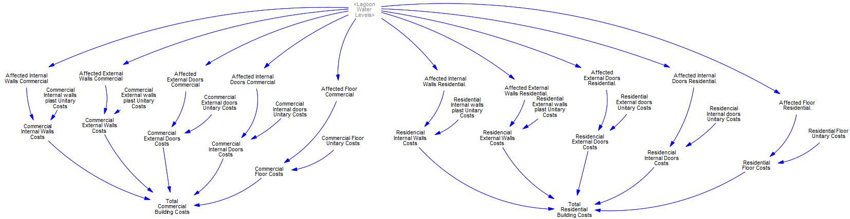
Fig A.4 Buildings stock and flow diagram

Estimates of costs to repair walls (plastering after a certain number of floods), doors (replacement after a certain number of floods), and floors (rinsing and cleaning), as well as their repair needs as a function of flood events were collected from expert judgment in previous research projects.
These costs depends on the frequencies of the contacts of the building elements with salt water. The survey of ground floor data provides also information about protection measures set in place to protect indoor spaces from flooding up to certain levels, depending on the flood level measured on the doorstep. In this work damage curves have been calculated per event, as a function of water lagoon levels and, hence, of the extension of the areas and of the number of the buildings flooded.
Average values derived from previous studies were adopted (see Table A.4). Damaged internal and external doors are substituted on average every 7.5 and 15 events, respectively, and that re-plastering of internal and external walls occurs every 5.7.
Type of damage | Lower bound | Upper bound
Internal doors | 5 | 10
External doors | 10 | 20
Internal walls commercial | 3 | 7
External walls commercial | 3 | 7
Internal walls residential | 3 | 10
External wall residential | 3 | 10
Tab A.4 Number of flood events after which substitution of the element is required.

The information regarding the indoor conditions of flood levels and in particular differences in floor levels inside single units allows us to compensate for the lack of information on private open surfaces that was deplored by Caporin and Fontini (2016) with respect to the RAMSES database. The costs for the interventions, originally expressed in Euro 2002, have been converted in euro 2017 to account for inflation. The index used in this conversion is ISTAT IPP (Construction cost index for residential buildings). This procedure provided a cumulative damage curve with number of buildings in the sample flooded according to the tide level. Using a proportion with the total number of buildings in the database it was possible to estimate the total number of units flooded and corresponding damage cost, and this procedure was repeated both for commercial and residential units (Table A.5 and A.6). Therefore, combining average costs and the cumulative number of units flooded it was possible to estimate a complete damage curve for each type of intervention
Building elements | Lower bound | Upper bound
External doors | 13.5 | 27.0
Internal doors | 149.7 | 299.3
Internal walls plastering | 863.8 | 1803.5
External walls plastering | 331.8 | 623.3
Floors (per m2) | 5.3 | 6.1
Tab A.5 Estimated costs per flood event and object of the damages for residential units (average costs per unit, euro 2017).
Building elements | Lower bound | Upper bound
External doors | 13.5 | 27.0
Internal doors | 225.2 | 737.5
Internal walls plastering | 709.2 | 1409.6
External walls plastering | 345.5 | 454.4
Floors (per m2) | 7.1 | 8.1
Tab A.6 Estimated costs per flood event and object of the damages for commercial units (average costs per unit, euro 2017).
Figure A.5 shows the overall City costs over time according to the four different scenarios considered.
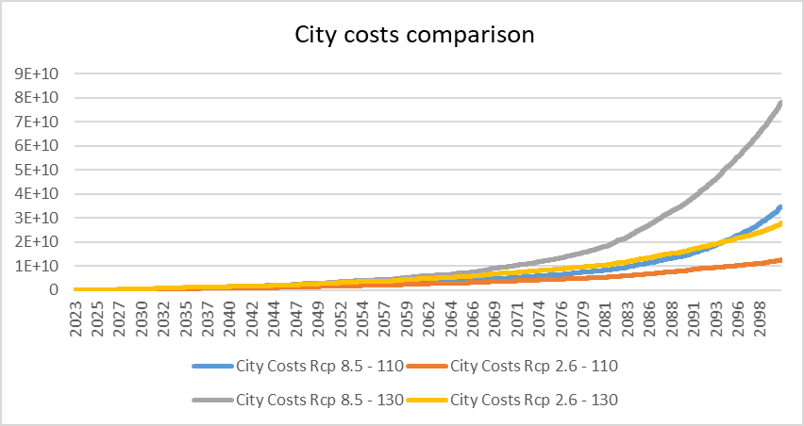
Fig A.5 City costs according to four different scenarios

THE PORT MODULE
The closure of the MoSE barriers causes losses of vessel calls and therefore of revenues for the port operators: Port Authority, agencies, workers\.
The Average Revenues per Vessel are estimated at roughly 70,000 euros according to the MTBS report provided by the Venice Port Authority. We also estimated the Daily *Vessels* parameter for four main ship categories: container, RoRo, other freight vessels, and passenger ships. This task was carried out elaborating data available on the Port Authority website.
We modelled these categories of ships taking into account that they are differentiated in the *Vessels* Lost per Closure parameter and that memory effects can be disregarded for passenger ships.
Once the Tide Forecast is higher than the Closure level, MoSE is activated. If MoSE operates and the Peak Time lies between 6:00 and 12:00 AM we compute the Port costs as the sum of the revenue losses of each category of *Vessels*. Figure A.6 shows the module developed for each of the four ship categories.
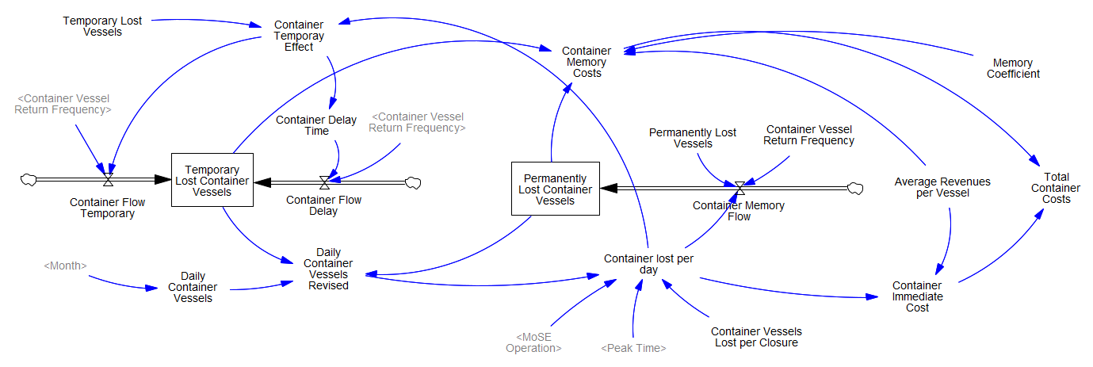
Fig A.6 Example of port stock and flow diagram: containers

We collected the data on monthly vessel movements (entries and exits) from 2009 to 2016, for specific types of vessels. Employing these information, it was possible to:
- aggregate this data according to the (macro-)categories of interest:
- Container vessels: Containership
- RoRo (freight) vessels: Ro-ro cargo ship
- Other freight vessels: Barge, Bulk carrier, Chemical tankship, Gas carrier, General dry cargo ship, Heavy load carrier, Oil tankship, Tankship, Other types of ship
- Ro-ro passenger vessel
- Passenger ship
- Dynamically supported craft
- compute, for each of these categories, the percentage of movements and the average monthly percentage movements.

The second step was to apply the category and monthly percentages of movements already computed on the average number of vessel calls, for which only yearly data was available. This had to be done because the focus was on the vessel calls lost as a result of MoSE operations, rather than on the vessel movements (for which monthly data was accessible).
By doing so, it was possible to estimate in detail the number of Daily *Vessels* for every category and month.

We used data from a collection of Venice port sailing lists between 2018 and 2021 to compute the, *Vessel* Return Frequency parameter.
The Average Revenues per *Vessel* parameter for a passenger ship were while for a freight vessel it was derived from the previously cited MTBS report. We computed an average between a lower and an upper bound for RoRo passenger and Passenger ships. Data is available in Table A.7.
Vessel category | Lower Bound | Upper bound
Freight vessel | 72207 | 72207
Passenger ship | 74434 | 89321
Ro-ro passenger vessel | 7071 | 8485
Dynamically supported craft | 1500 | 1500
Tab A.7 Estimated cost for the loss of different vessel categories (average costs per vessel, euro 2017).

In detail, the total losses of each of the 3 categories of freight vessels are given by the sum of:
- *Vessel* Immediate Costs, calculated as the number of *Vessels* lost per day multiplied by the Average Revenues per Vessel. We indeed assumed that a percentage of vessels (*Vessels* Lost per Closure) decides not to wait until the MoSE gates are opened and moves to another port, thus generating a loss of potential revenues.

- *Vessel* Memory Costs, added to account for the financial losses caused by memory effects. Certain vessels are anticipated to never return or only return after a year, having been compelled to redirect to another port due to MoSE operations. The quantity of permanently lost *vessels* and temporarily lost *vessels* is multiplied over time (either for all the simulation horizon or for one year) by the average revenues per vessel, taking into account the baseline parameters for vessel return frequency (i.e., the number of times a vessel would have returned under normal circumstances).
Concerning the passenger ships macro-category, we considered in detail three different sub-classes: passenger ships in the strict sense, RoRo passenger ships, and dynamically supported crafts. We accounted only for the *Vessel* Immediate Costs of passenger ships, because we assumed that Venice will maintain its attractiveness for passengers in the future, hence memory effect could be disregarded.
Figure A.2 shows the overall costs that will have to be borne by the Port over time under the four different scenarios considered.

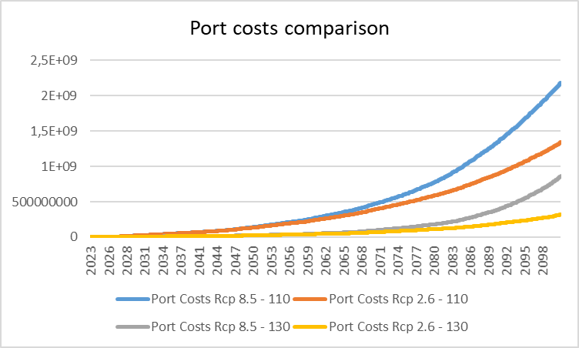
Fig A.7 Port costs according to four different scenarios

SENSITIVITY ANALYSIS

HISTORICAL RECORDS
Monte Carlo Analysis provided by the VensimTM modelling software was used to explore the sensitivity of the model to varying values of key parameters.
For this purpose, we concentrated on the +/- 25% variations of the values of the following parameters, adopted for the city cost module: Average Expense per Tourist, Average Expense per Excursionist, Baby Sitter Unitary Cost, Care Giver Unitary Cost, and Unitary Costs related to the different parts of the Building Costs including residential and commercial sectors as reported in Table A.8.
Parameters | actual level | lower bound | upper bound
Average Expense per Tourist | 181.29 | 136.00 | 227.00
Average Expense per Excursionist | 47.00 | 35.00 | 59.00
Baby Sitter Unitary Cost | 55.70 | 42.00 | 70.00
Care Giver Unitary Cost | 42.76 | 32.00 | 53.00
Commercial Internal walls plastering Unitary Costs | 1059.40 | 795.00 | 1324.00
Commercial External walls plastering Unitary Costs | 399.94 | 300.00 | 500.00
Commercial External doors Unitary Costs | 20.23 | 15.00 | 25.00
Commercial Internal doors Unitary Costs | 481.35 | 361.00 | 602.00
Commercial Floor Unitary Costs | 7.62 | 6.00 | 10.00
Residential Internal walls plastering Unitary Costs | 1333.63 | 1000.00 | 1667.00
Residential External walls plastering Unitary Costs | 477.56 | 358.00 | 597.00
Residential External doors Unitary Costs | 20.23 | 15.00 | 25.00
Residential Internal doors Unitary Costs | 224.49 | 168.00 | 281.00
Residential Floor Unitary Costs | 5.69 | 4.00 | 7.00
Tab A.8 Estimated parameters and related range of variation for sensitivity analysis.

We performed 200 simulations using a uniform random distribution of the parameters. Figures A.8, A.9 and A.10 report the results of the sensitivity analysis for changes in the parameters related to the building costs, tourism costs and population costs are considered separately.
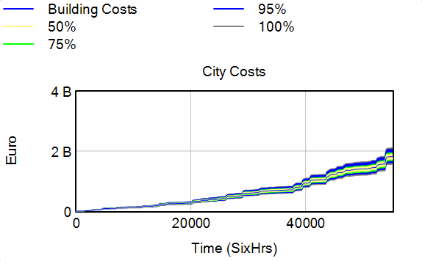
Fig A.8 Sensitivity analysis for change in parameters related to buildings (costs in billions of euros)
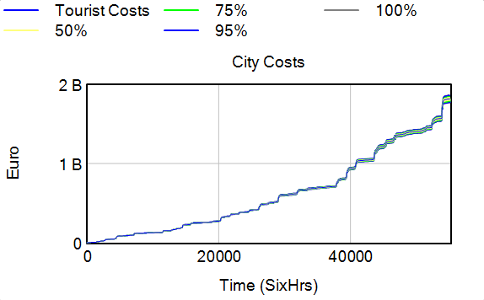
Fig A.9 Sensitivity analysis for change in parameters related to tourism (costs in billions of euros)
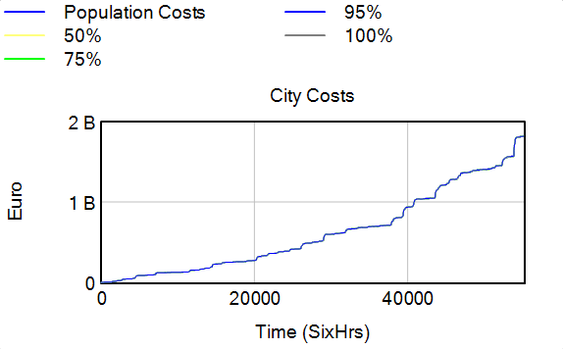
Fig A.10 Sensitivity analysis for change in parameters related to population (costs in billions of euros)
Finally, Figure A.11 shows that the results of the sensitivity analysis considering all the above parameters show robustness qualitatively, and their variabilities are observed within reasonable limits.
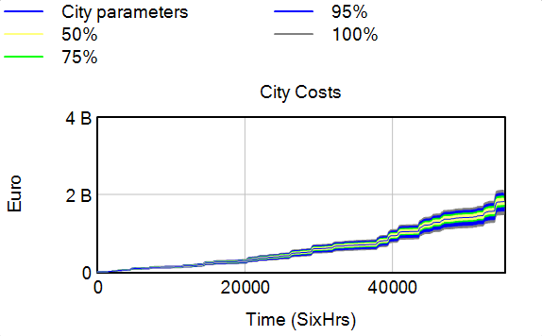
Fig A.11 Sensitivity analysis for change in all the analyzed parameters

FUTURE SCENARIOS
In this section, we investigate the sensitivity of city and port costs when Cost per closure and Closure level are varied considering RPC 2.6 and 8.5 scenarios.
For this purpose, in the first step, we set the lower bound of the parameter of Cost per closure, respectively the upper bound, equal to 30,000 euro, respectively 300,000 euro. The Cost per closure is set to 60,000 in the model
Results are illustrated in figures A.12 and A.13 for RCP 2.6 and 8.5.
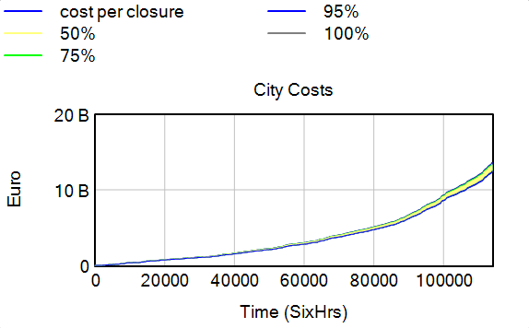
Fig A.12 Sensitivity analysis for change in Cost per closure RCP 2.6
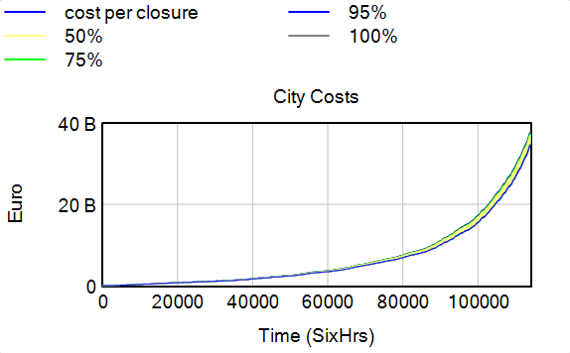
Fig A.13 Sensitivity analysis for change in Cost per closure RCP 8.5

The variability of outputs in terms of City costs in both scenarios are within reasonable limits.
In order to assess how city cost and port cost are sensitive to the Closure level, we set a range between 90 - 130 cm to run the test. Results are depicted in Figures A.14 to A.17.
Considering the significant effect of closure level on our results, Figures show confidence bounds for City costs and Port costs when the closure level is varied in both scenarios.
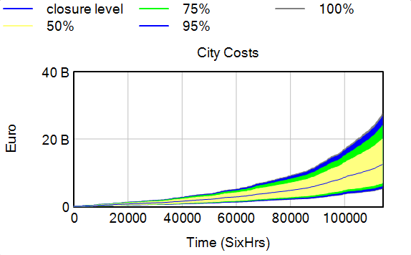
Fig A.14 Sensitivity analysis (City costs) for change in closure level RCP 2.6

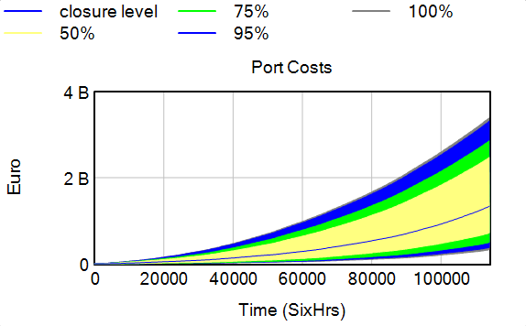
Fig A.15 Sensitivity analysis (Port costs) for change in closure level RCP 2.6

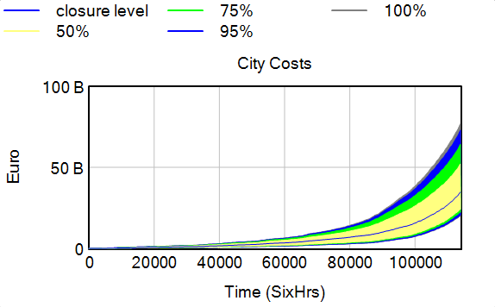
Fig A.16 Sensitivity analysis (City costs) for change in closure level RCP 8.5

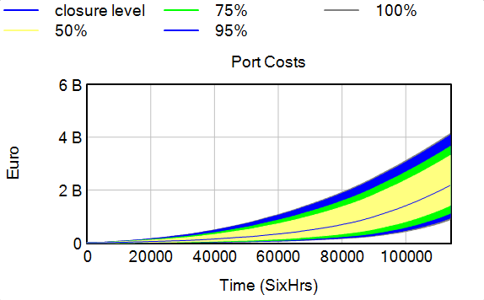
Fig A.17 Sensitivity analysis (Port costs) for change in closure level RCP 8.5

De Marchi, D., Manente, M., Mingotto, E. & Montaguti, F. Le Venezie turistiche. in Quattro Venezie per un Nordest. Rapporto su Venezia civitas metropolitana 2019, 171-208 (Fondazione di Venezia, Marsilio, 2019).
https://www.comune.venezia.it/node/6214.
The unit of measure is always centimetres in the following descriptions, sea levels are measured with respect to Punta della Salute tide gauge zero reference.
Lionello P, Nicholls RJ, Umgiesser G, Zanchettin D (2021) Venice flooding and sea level: past evolution, present issues, and future projections (introduction to the special issue). Nat Hazards Earth Syst Sci 21 (8):2633-2641. doi:10.5194/nhess-21-2633-2021.
For RCP 2.6 we considered an increase from 32 cm to 72 cm between 2023 and 2100 (with estimated parameters: $a=6.67$, $b=25.33,$ $r$ = 1.18e-002) and for RCP 8.5 an increase from 32 cm to 107 cm centimetres during the same period ($a=19.79$, $b=12.2,$ $r$ = 2.46e-002)
Fontini F, Umgiesser G, Vergano L. The Role of Ambiguity in the Evaluation of the Net Benefits of the MOSE System in the Venice Lagoon. Ecological Economics 69(10); 2010. p. 1964-1972. JRC56676
https://www.comune.venezia.it/it/content/grafici-e-statistiche
https://statistica.regione.veneto.it/banche_dati_economia_turismo_turismo6.jsp
https://www.comune.venezia.it/node/6145
Intercept captures year = 2005 and season = 1, season start from winter = 1 to autumn = 4
Cellerino, R., 1998. Venezia Atlantide: L’impatto Economico Delle Acque Alte. Franco Angeli, Milan
http://smu.insula.it/index.php@option=com_content&view=article&id=15&Itemid=111.html
http://coses.comune.venezia.it/fondaci/f_venezia10.html
Nunes, P.A.D.S., Breil, M. and Gambarelli, G., Economic Valuation of on Site Material Damages of High Water on Economic Activities Based in the City of Venice: Results from a Dose-Response-Expert-Based Valuation Approach (April 2005).
A limitation to protection levels has been assumed also in case of protection measures consisting of a complete water proofing of the ground floor, including the static enforcement of the floor, as the barrier to be inserted in the doorway cannot exceed a certain level of above the doorstep; otherwise the unit would remain inaccessible during the flood. In this case, a maximum level of 50cm for a mobile barrier has been adopted.
Notice that here lower and upper bound refers only to the number of events; it could be that different types of plastering results both in different number of events after which re-plastering is required and in different average costs.
Caporin, M. and Fontini, F.: Damages Evaluation, Periodic Floods, and Local Sea Level Rise: The Case of Venice, Italy, Handbook of Environmental and Sustainable Finance, Academic Press, 93–110, 2016.
http://dati.istat.it/Index.aspx?lang=en&SubSessionId=5f850764-96ef-4dbe-8a9e-2ae09a0ca208.
In this study we focus only on the costs of the operators of the port of Venice and we do not consider the losses faced by the shipping companies.
Final Report-Impact Assessment MOSE Project-Financial Impact During Construction Phase, Maritime & Transport Business Solutions B.V
https://www.port.venice.it/it/sailing-list.html
Tariffa generale 2019, edizione 0.1, Venezia Terminal Passeggeri s.p.a, 2019 and Tariffa generale 2020 per i servizi terminalistici, Venice Ro-Port MoS.
The MTBS report estimated the number of vessel calls lost due to MoSE construction works and the related economic values, under different scenarios, in 2014. Therefore, it was easy to compute the average economic loss per vessel lost under the baseline scenarios.

