SI.1: Criteria description and sources.
Criterion | Description spatial layer | Source of original variable
Wind fetch | This layer follows a continuous function in which suitability increases with greater wind fetch distance. | Wind fetch conditions were represented by simulating wave dynamics under two dominant wind scenarios, Bora (NE) and Scirocco (SE). For each scenario, spatial layers of significant wave height (hs) and wave-induced bottom stress were generated and subsequently rescaled to a 0–1 range to ensure comparability within the multi-criteria framework (calculations were performed by Causio and Federico).
Distance to main channels | The distance to main channels follows a sigmoid function, where suitability (ranging from 0 to 1) starts increasing at 260 meters from the channel. | Author’s elaborations based on the main channels of the lagoon: Atlante della laguna
Lost Salt marshes | Lost salt marshes is a binary layer where the presence of saltmarshes has a value of 1. | Author’s elaborations based on the difference between current saltmarsh distribution and from 100 years ago. Source of historic map of saltmarshes: Atlante della laguna
Proximity to other salt marshes | The proximity to other salt marshes is represented by an inverse distance function, where higher values indicate greater suitability. | Author’s elaborations based on the presence of saltmarshes (source salt marshes: EUNIS 2023).
Seagrass’ protection | The seagrass protection layer is a Boolean layer, with seagrass presence assigned a suitability value of 0. | Elaborations from Sfriso, Adriano (2024).
Proxy of costs in relation to the bathymetry | The restoration cost proxy is based on the volume of sediment required to reach the average seagrass height. Higher bathymetry levels correspond to increased restoration costs. | Bathymetry: Provveditorato Interregionale per le Opere Pubbliche per il Veneto, Trentino-Alto Adige e Friuli-Venezia Giulia (2023). Costs of sediments extracted from recent call for tenders and implementation reports.
Ecological Status of Water Zones | The ecological status of water zones is on the proxy Macrophyte Macrophyte Quality Index by Sfriso et al., 2024. | Sfriso et al., 2024.
SI.2: Workshop’s agenda and description of activities
Duration | Agenda Item | Activities
 | Pre-workshop | The pre-workshop questionnaire asked participants to provide comments or suggestions on the initial criteria selected from the Piano Morfologico. Participants were also invited to propose additional criteria. We analysed the responses one week before the workshop and incorporated an additional criterion based on their suggestions.
9:00-9:10 | Welcome and introductions | Valerio Volpe - Provveditorato Interregionale per le Opere Pubbliche per il Veneto, Trentino-Alto Adige e Friuli-Venezia Giulia
9:10-10:10 | Updates on the REST-COAST project and ongoing activities | Caterina Dabalà (CORILA) introduces the REST-COAST project, the ongoing activities and general updates. Giovanni Assalone (Provveditorato) presents further restoration activities in the Venice lagoon.
10:10-11:45 | The WaterLANDS project and the PMCA in the Venice lagoon | Jane Da Mosto (WaHV) presents the activities of WaterLANDS in the Venice lagoon.
10:10-11:45 | The WaterLANDS project and the PMCA in the Venice lagoon | Step 2: Weighting the criteria exercise.  Participants weight the importance of each the selected criteria in deciding the prioritization of areas to be restored in the context of Venice. Weights need to add up to 100.
10:10-11:45 | The WaterLANDS project and the PMCA in the Venice lagoon | Step 2: Discussion on the value function of optimal distance from channels. Subgroups of 2-3 people discuss the optimal distance from channels.
11:45-12:00 | Break
12:00-13:00 | Definition of adaptation pathways in Venice and its lagoon (REST-COAST) | Silvia Torresan (CMCC) introduces the concept of adaptation pathways in the city of Venice, including a list with the most pressing strategies.
12:00-13:00 |  | Adaptation pathways in Venice and its lagoon exercise. Participants were divided into 4 subgroups of 4-5 participants each, with one moderator per group. Participants identified: the most urgent pathways for adaptation, adaptation strategies and concrete actions and tipping points.
13:00-13:10 | Conclusions and acknowledgements | Pierpaolo Campostrini and Carlo Giupponi give an overview of main results from the different debates that took place during the workshop, Giupponi announced that results from the S-PMCA could be shared to participants in November-December 2024.
SI.3: Workshop Criteria Weighting Survey 14 October 2024.
Welcome to the second questionnaire of the multi-criteria analysis workshop!
The different criteria represent all the aspects that should be considered when deciding where to intervene. It is clear that not all criteria have the same importance, and each of us may hold different views on this matter. Therefore, in a participatory process, all knowledge holders and stakeholders should have the opportunity to express their preferences.
We need your opinion to determine the relative importance of the criteria. Specifically, we ask you to assign a score to each criterion, increasing according to its relevance. The total of all weights must equal 100. In practice, you have 100 points to distribute among the selected criteria.
Questions marked with a red asterisk are mandatory
Thank you for your valuable contribution!

Name (optional)

Affiliation / Organization (optional)

Please distribute 100 points among the following CRITERIA according to their relevance for salt marsh restoration. You may enter the weight as a number in the column provided or use the slider on the right. The system will display an error message if the total does not equal 100.
The error message is in English
• Proximity to main navigation channels: Salt marshes play an important role in protecting against wave action and counteracting erosion; therefore, those located along channels with higher water traffic should be particularly protected or restored. __________
• Wind fetch: Fetch is the distance over which the wind blows across the water surface without obstruction, thereby influencing wave formation and growth. A longer fetch allows wind to increase wave height and energy, intensifying coastal erosion. Salt marshes located in open lagoon areas can help reduce fetch, attenuating wave energy and thus limiting erosion. __________
• Areas formerly occupied by salt marshes: The surface area of salt marshes is declining; priority should be given to restoring lost marshes and consolidating those that are disappearing. __________
• Presence of seagrass: Vegetation in shallow lagoon areas plays a role similar to that of salt marshes in several respects, such as erosion protection and carbon sequestration. Restoration actions for salt marshes should avoid damaging seagrass meadows. __________
• Proximity to other salt marshes: Clusters of salt marshes contribute to a more connected and resilient ecosystem. Protection and restoration efforts should be prioritized in these areas. __________
• Ecological status of waters: The ecological status of the Venice Lagoon is classified into three categories: good (low levels of pollution); moderate (partially compromised but still recoverable); and poor (high levels of pollution). __________

On a scale from 1 to 5, how confident do you feel about the answers you provided in this questionnaire?
- Not at all confident
- Slightly confident
- Moderately confident
- Very confident
- Extremely confident
Confidence level
❏ ❏ ❏ ❏ ❏

Please leave your comments or suggestions:
SI.4 Differences Map: Optimistic minus Pessimistic Attitude Maps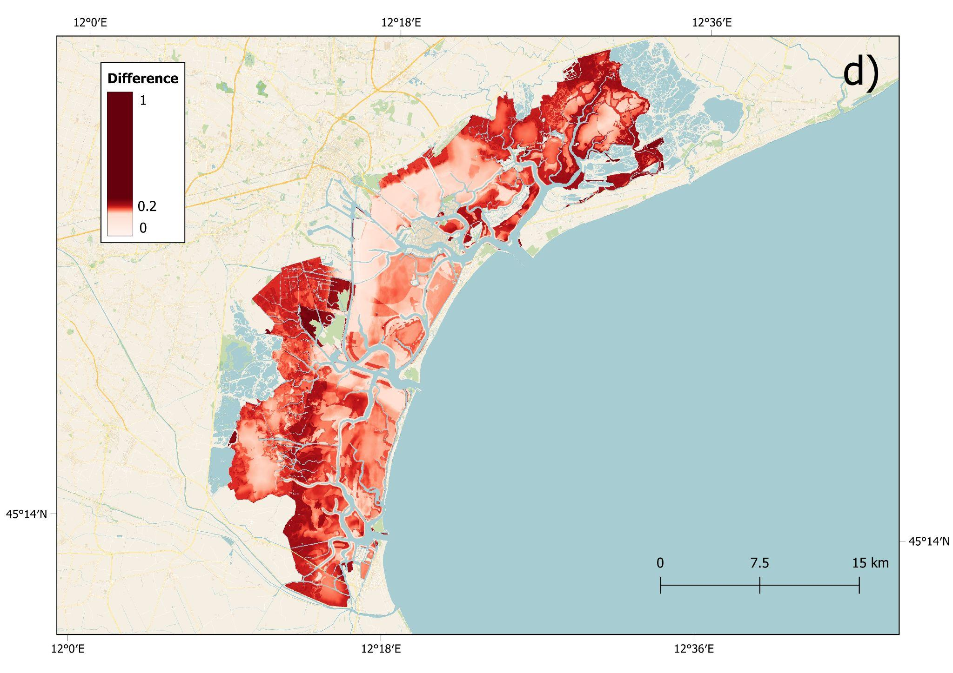
SI.5 Excluded areas from the suitability analysis, as well as the suitability score for saltmarsh rebuilding (values above 0.5)
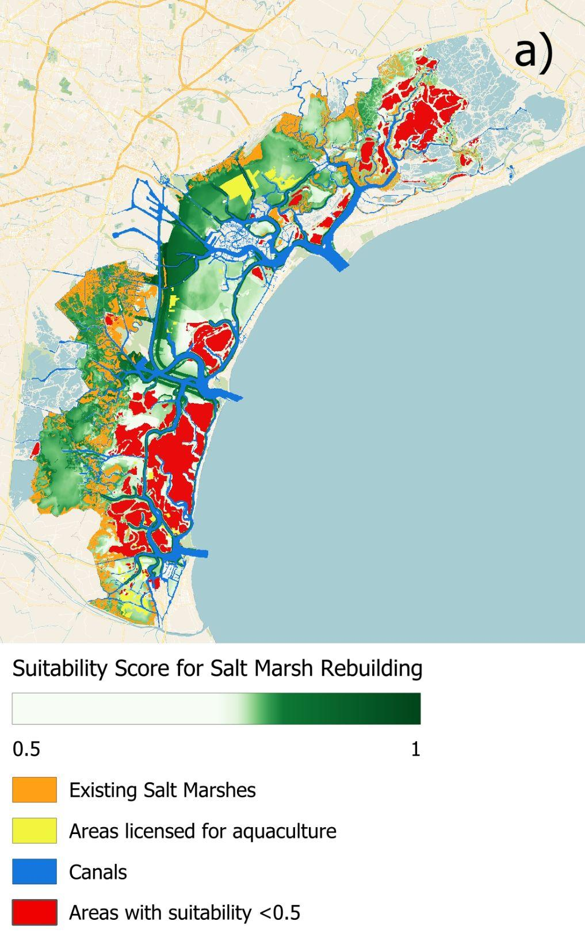
SI. 6. Results of three different risk approaches using OWA: Optimistic, Balanced and Pessimistic.
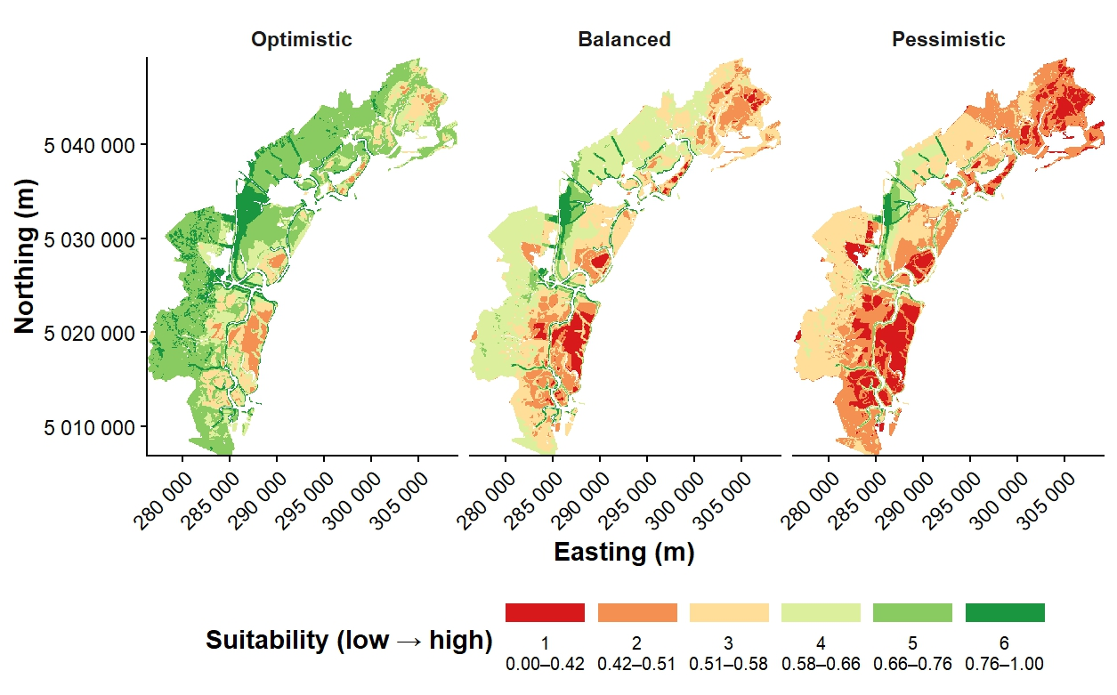
SI.7. Sensitivity Analysis Results performed in Terrset v.20.04
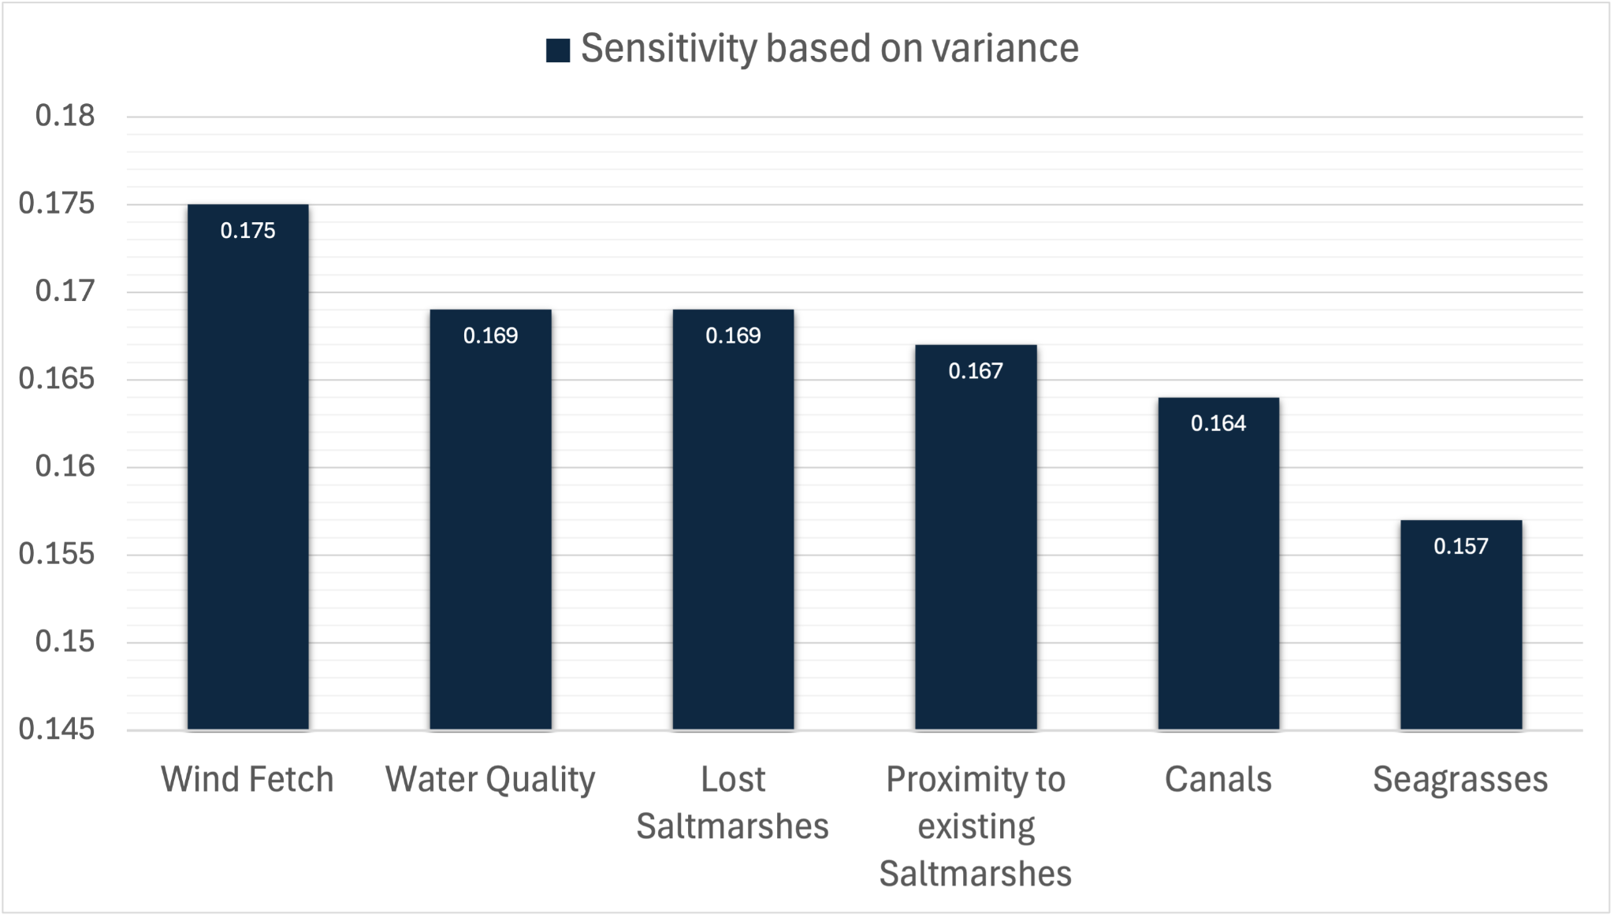
The sensitivity analysis evaluates the effect of varying one factor weight at a time by ±20%. The resulting sensitivity values based on variance are relatively homogeneous across all criteria, ranging between 0.157 and 0.175. This limited spread suggests that the prioritisation results are stable and not disproportionately driven by any individual criterion. Even when considering the most variable criterion, distance from canals, whose weighting varies by more than 50% across stakeholders, only localized changes are observed, particularly around the Malamocco–Marghera Canal. However, this represents the most extreme case.

