Article
Halloysite@polydopamine nanoplatform for ultrasmall Pd and Cu nanoparticles: suitable catalysts for hydrogenation and reduction reactions
Marina Massaro,¹ Chiara D’Acunzi,² Stefano Paganelli,^{2,3,}* Maria Laura Alfieri,⁴ Leonarda F. Liotta,⁵ Alberto Lopez-Galindo,⁶ Raquel de Melo Barbosa,⁷ Oreste Piccolo,⁸ Rita Sánchez-Espejo,⁷ César Viseras,^{6,7} and Serena Riela^{9,}*
Academic Editor: Firstname Lastname
Received: date
Revised: date
Accepted: date
Published: date
Citation: To be added by editorial staff during production.
Copyright: © 2025 by the authors. Submitted for possible open access publication under the terms and conditions of the Creative Commons Attribution (CC BY) license (https://creativecommons.org/licenses/by/4.0/).
¹ Dipartimento di Scienze e Tecnologie Biologiche, Chimiche e Farmaceutiche (STEBICEF), Università di Palermo, Viale delle Scienze, Parco d’Orleans II, Ed. 17, 90128 Palermo, Italy
² Università Ca’ Foscari Venezia, Dipartimento di Scienze Molecolari e Nanosistemi, via Torino 155, 30172 Venezia Mestre (VE), Italy.
³ Consorzio Interuniversitario Reattività Chimica e Catalisi (CIRCC), Via Celso Ulpiani 27, 70126 Bari, Italy.
⁴ Dipartimento di Scienze Chimiche, Università di Napoli Federico II, Via Cinthia 4, 80126 Napoli I, Italy
⁵ Istituto per lo Studio dei Materiali Nanostrutturati (ISMN)-CNR, Via Ugo La Malfa 153, Palermo 90146, Italy
⁶ Andalusian Institute of Earth Sciences, CSIC, 18100 Armilla, Granada, Spain.
⁷ Department of Pharmacy and Pharmaceutical Technology, Faculty of Pharmacy, University of Granada, Campus Universitario de Cartuja, 18071 Granada, Spain.
⁸ Studio di consulenza scientifica (SCSOP), Viale Trieste 35, Siena, 53100, Italy
⁹ Dipartimento di Scienze Chimiche (DSC), Università di Catania, Viale Andrea Doria 6, 95125, Catania, Italy.
* Correspondence: spag@unive.it, serena.riela@unict.it.
Abstract
The design of sustainable nanomaterials for catalysis is a key challenge in green chemistry. Herein, we report the synthesis of halloysite nanotube (Hal)-based nanomaterials selectively functionalized with a bioinspired polydopamine (PDA) coating, which enables the controlled anchoring of palladium and copper nanoparticles (PdNPs and CuNPs). This mild and ecofriendly strategy yields highly dispersed and ultrasmall (<5 nm) metal nanoparticles without the need for surfactants or harsh reagents. The resulting materials, Hal@PDA/PdNPs and Hal@PDA/CuNPs, were evaluated in two well-established model reactions commonly employed to probe catalytic performance: cinnamaldehyde hydrogenation and 4-nitrophenol reduction. Hal@PDA/PdNPs displayed complete conversion and >90% selectivity toward hydrocinnamaldehyde at low Pd loading (0.8 wt%) and maintained its efficiency over six catalytic cycles. Hal@PDA/CuNPs proved to be an excellent recyclable catalyst for the reduction of 4-nitrophenol, retaining high activity through eight consecutive runs. Overall, this study introduces a robust and modular approach to fabricate halloysite-based nanocatalysts, demonstrating their potential as green platforms for metal nanoparticle-mediated transformation.
Keywords: halloysite; polydopamine, heterogeneous catalyst, hydrogenation reaction, reduction reaction.

1. Introduction
The shift toward more sustainable and environmentally friendly catalytic systems has sparked a growing interest in the use of naturally abundant, low-cost materials as functional supports for metal nanoparticles [1]. Clay minerals are invaluable resources in material science, offering unique properties and cost-effective availability [2]. Among them, halloysite (Hal), a member of the kaolin group, stands out due to its distinctive hollow tubular structure and chemical versatility. This naturally abundant aluminosilicate mineral, with the formula Al₂Si₂O₅(OH)₄·nH₂O, features siloxane groups on its outer surface and aluminol groups within its lumen. The distinct chemical nature of these surfaces allows for selective functionalization, making halloysite an exceptional candidate for advanced material applications. The ability to modify halloysite’s surfaces through targeted functionalization has unlocked a plethora of possibilities in fields such as catalysis [3-7], drug delivery, and environmental remediation. In particular, the use of halloysite for catalytic purposes is a very promising strategy for stabilizing metal nanoparticles of small dimensions that can be reused for several consecutive runs without loss of catalytic activity.
Among various strategies, polymer-based functionalization has gained significant attention. Polydopamine (PDA), a bio-inspired eumelanin-like polymer rich in functional groups (e.g., hydroxyl, amine, and carboxyl), has emerged as a versatile coating material [8,9]. It provides a platform for immobilizing and stabilizing metal nanoparticles, further broadening the halloysite’s potential for application as a heterogeneous support material. In this context, for example, Hal coated with PDA were used for the immobilization of Fe²⁺ ions and the obtained material was successfully utilized as catalyst for the Fenton reaction to remove organic dyes [10]. Metal nanoparticles (NPs), particularly those based on Pd and Cu, are widely used in catalysis due to their high surface-to-volume ratio and excellent activity. However, their application is often limited by issues related to aggregation, leaching, or sintering. A key challenge remains the design of effective supports that ensure strong metal–support interaction and long-term stability [11].
In this study, we employ a site-specific PDA coating strategy, enabled by pre-decoration of Hal with ZnO nanoparticles [12] to create a robust Hal@PDA[13] nanoplatform for anchoring Pd and Cu nanoparticles. This approach leverages the basicity of ZnO nanoparticles anchored onto the halloysite surface to induce dopamine polymerization under mild conditions, avoiding bulk polymer precipitation [12]. Compared to traditional dip-coating methods, this strategy offers a cleaner, more controlled synthesis process, enhancing material stability. In addition, the presence of site-specific PDA coating onto Hal external surface could ensure stabilization of metal nanoparticles with small and uniform size, which could be beneficial for catalytic purposes. The synthesized Hal@PDA/PdNPs and Hal@PDA/CuNPs materials were thoroughly characterized by several techniques and tested in two model catalytic reactions: i) the hydrogenation of (E)-cinnamaldehyde, in the presence of isopropanol using substrate/MNPs molar ratio = 1000/1 at 50 °C, varying reaction time and H₂ pressure; ii) the reduction of 4-nitrophenol.
The two systems demonstrated complementary catalytic behavior: Hal@PDA/PdNPs exhibited high activity, selectivity, and recyclability in the hydrogenation of cinnamaldehyde, whereas Hal@PDA/CuNPs outperformed in the reduction of 4-nitrophenol. These results underline the versatility of the Hal@PDA architecture in stabilizing metal nanoparticles and tailoring their reactivity toward specific transformations. By combining selective surface functionalization with efficient nanoparticle anchoring, this study highlights the potential of Hal@PDA as a robust and tunable nanoplatform for the design of next-generation heterogeneous catalysts.

2. Results and Discussion

2.1. Synthesis and characterization of the Hal@PDA/supported metal nanoparticles.
The hybrid materials were synthesized through a two steps procedure as reported in Figure 1. Firstly, the site-specific functionalization of halloysite external surface by polydopamine was carried out as previously reported [13]. In brief, Hal were decorated with ZnONPs [12] with basic properties affording the Hal@ZnO nanomaterial that was used as scaffold to induce surface-specific polymerization and deposition of dopamine coatings at relatively low pH (6.5) under conditions hindering polymer precipitation in the bulk mixture.[13] As previously reported, the characterization of the nanomaterial showed that by adopting this strategy a polydopamine coating onto the basic sites, provided by the ZnO nanoparticles anchored onto Hal surface, with a thickness of ca. 1 nm, occurs [13]. This coating proved to be stable and does not desorb under normal conditions, as its removal occurs only in an alkaline environment combined with hydrogen peroxide.
The obtained Hal@PDA nanomaterial was then dispersed in water in the presence of Na₂PdCl₄ or CuCl₂, followed by reduction with NaBH₄ in ethanol leading to the final metal-based catalysts Hal@PDA/MNPs (Hal@PDA/PdNPs or Hal@PDA/CuNPs), affording nanomaterials with metal content of 3.6 and 0.62 wt% for Pd and Cu, respectively (see infra). Both catalysts have been characterized by means of TGA, XRD, XPS and TEM.
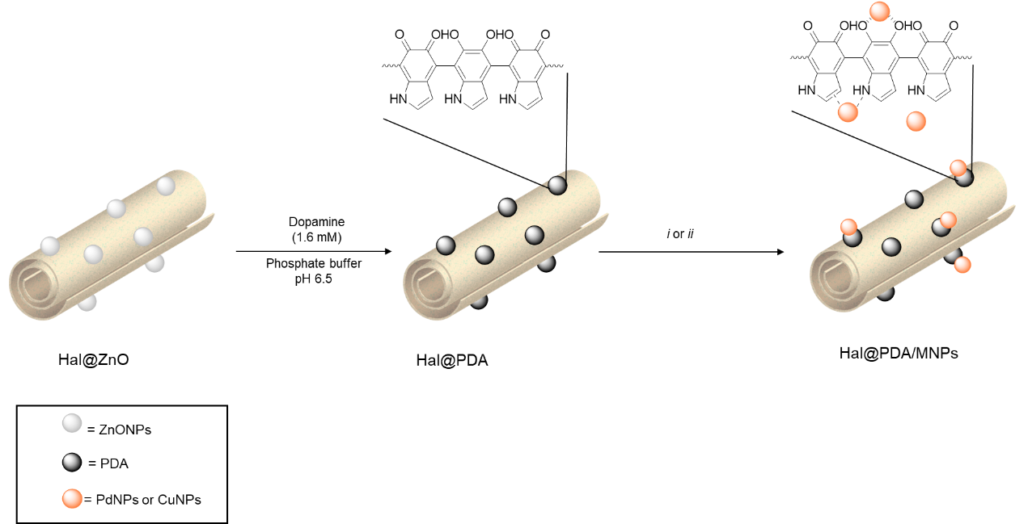
Figure 1. Schematic representation of the synthesis of Hal@PDA/MNPs nanomaterials obtained. i) (a) CuCl₂, H₂O, 25 °C, 16 h, (b) NaBH₄, EtOH, 25 °C, 6 h; ii) (a) PdCl₂, NaCl, H₂O, 25 °C, 16 h, (b) NaBH₄, EtOH, 25 °C, 6 h.
It should be noted that TGA analysis carried out under air flow resulted to be a very useful technique for the exact quantification of the Cu and Pd metal content. In Figure 2a the TGA curve of the starting Hal@PDA nanomaterial is compared with those of the Cu and Pd loaded samples. All curves show the typical mass loss of halloysite due to the removal of water molecules differently bonded, from the surface (100-300 °C) to the interlayer structure at higher temperatures, between ∼300-500 °C [14]. In the same range of temperature, the decomposition of the PDA polymer likely occurs [13].
According to the literature [15,16], the TG curve registered for the sample Hal@PDA/CuNPs takes into account for the formation of Cu₂O during the treatment under air flow, along with to the occurrence of the so far discussed halloysite modification and PDA oxidation. Therefore, based on the final mass value of 90% achieved at 1000 °C a loading of Cu₂O equal to 0.7 wt% was estimated (90.7-90%), corresponding to 0.62 wt% of Cu. For the sample Hal@PDA/PdNPs, based on the weight loss at around 800 °C equal to 0.54% corresponding to the decomposition of PdO (formed under oxidizing conditions) to metallic Pd, giving rise to O₂ evolution [17], a Pd loading of 3.6 wt% was calculated.
In Figure 2b are reported the XRD spectra of Hal@PDA, Hal@PDA/PdNPs and Hal@PDA/CuNPs nanomaterials. All nanomaterials showed the typical reflections of Hal,[18] namely the reflections at 2θ 12°, 20°, 25°, 35°, 54° and 62° corresponding to the planes (001), (100), (002), (100), (210) and (300) respectively, matching with the JCPD card no. 00–029-1487. In addition to these, the XRD pattern of Hal@PDA nanomaterial shows the reflection attributable to ZnONPs with wurtzite phase.[19] The XRD spectra of the Hal@PDA/PdNPs and Hal@PDA/CuNPs nanomaterials did not show any significant diffraction peaks attributable to the metal nanoparticles. It is well recognized that the XRD technique has limitations based on particle size; therefore, it is hypothesized that metal nanoparticles with a size smaller than 5 nm were obtained, resulting in no measurable signal [20].
Figures 2c-d show the XPS spectra of the Hal@PDA/PdNPs and Hal@PDA/CuNPs nanomaterials. As it is possible to note, the Pd3d spectrum (Figure 2c) shows the presence of two doublets due to the typical spin-orbit splitting (Pd3d_{5/2} and Pd3d_{3/2} components) and the concomitant presence of two species of palladium, namely Pd(0) and Pd(II). The relative amount of the components due to Pd(0) and Pd(II) species allowed us to estimate a degree of reduction of ca. 78%.
Similarly, the high–resolution Cu 2p spectrum of Hal@PDA/CuNPs (Figure 2d) shows the Cu 2p_{3/2} peak at ca. 931 eV that is deconvoluted in three main peaks. The peaks with a lower binding energy, at ~931 eV, were assigned to the Cu⁺/Cu⁰, considering that Cu⁺ and Cu⁰ possessed similar peak positions [21].
(a) 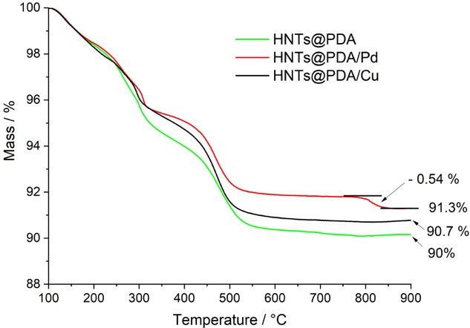(b) 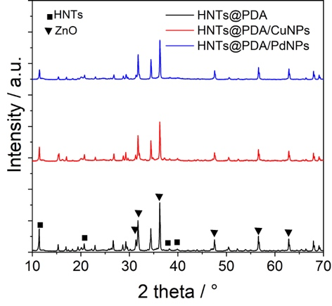
(c) 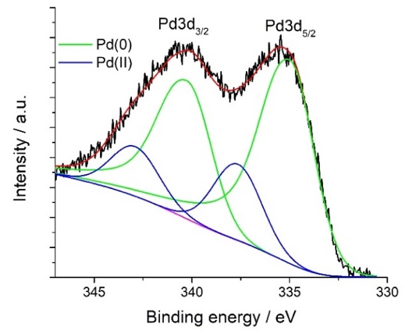(d) 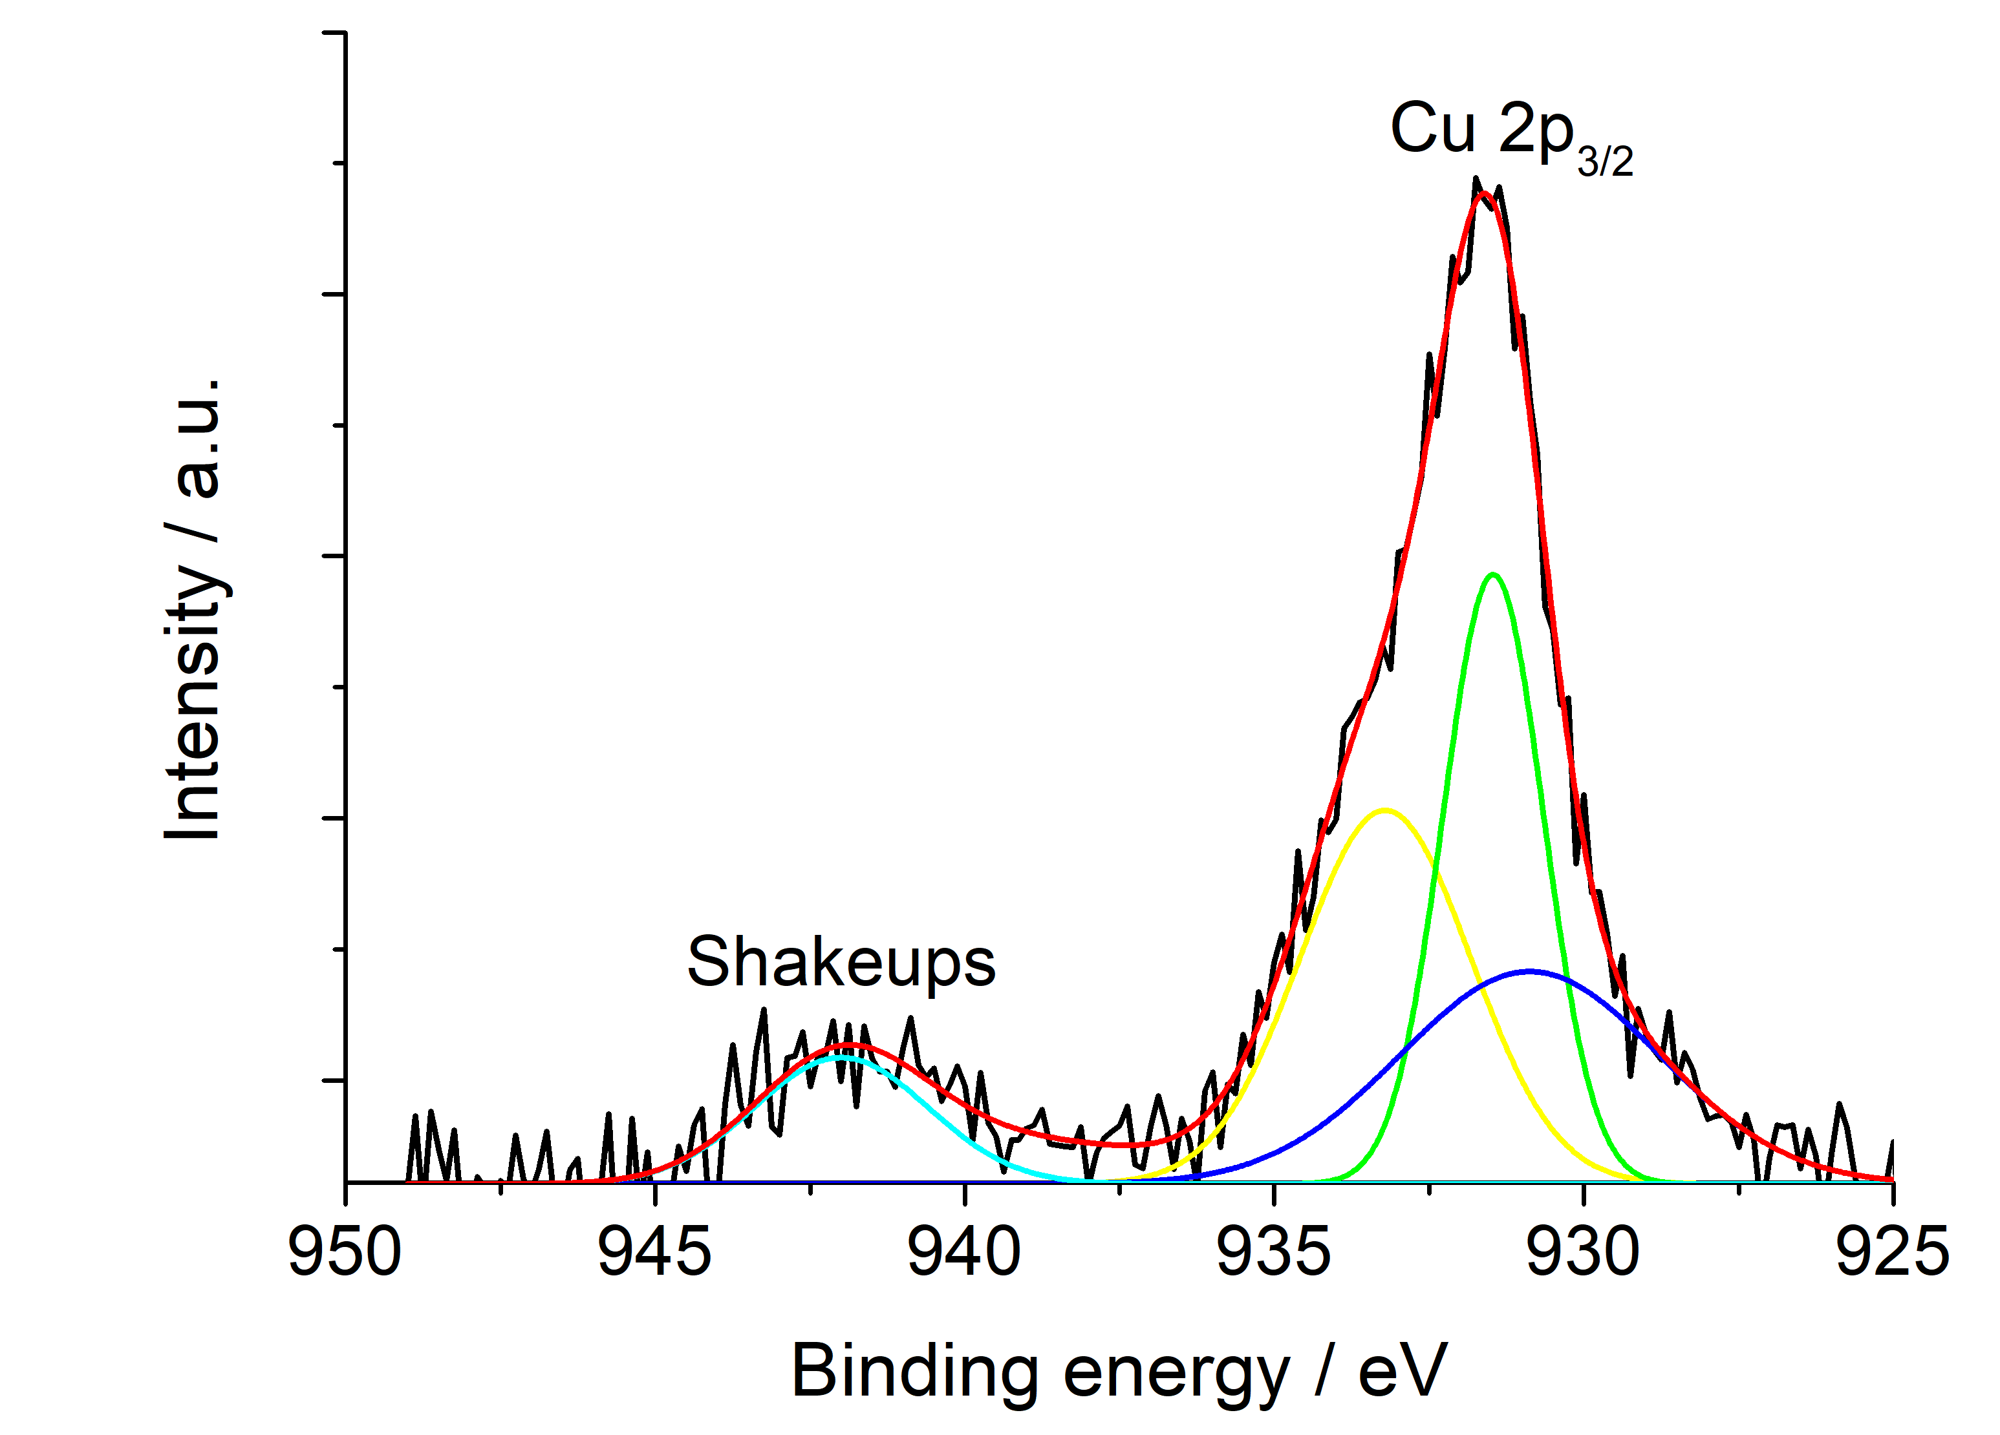
Figure 2. (a) Thermogravimetric curves, (b) XRD spectra of Hal@PDA, Hal@PDA/PdNPs and Hal@PDA/CuNPs nanomaterials; (c-d) high‐resolution X‐ray photoelectron spectroscopy (XPS) of (c) Hal@PDA/PdNPs and (d) Hal@PDA/CuNPs nanomaterials.
The other Cu 2p3/2 peak at ~934.6 eV was associated with the Cu²⁺ state. The satellite peak at 942 eV is attributed to the ligand-to-metal charge transfer that distinctly specifies the existence of Cu²⁺ species [22].
The morphology of the Hal@PDA/PdNPs and Hal@PDA/CuNPs nanomaterials was imaged by transmission electron microscopy (TEM) which showed the typical tubular structure of halloysite (Figure 3A) and the presence of Pd nanoparticles selectively distributed on the polydopamine spots onto Hal surface, as highlighted by the elemental mapping extrapolated by energy X-ray spectroscopy (Figure 3B). Fast Fourier transform on high‐magnification HR‐TEM showed nanocrystalline Pd nanoparticles with a d spacing of 0.23 nm corresponding to the (111) of planes of face-centered cubic (fcc) Pd[23] (Figure 3C). EDX spectrum on a selected area showed the presence of the Pd atoms beside the Al, Si, O, C and Zn ones related to the support (Figure 3D). From statistical analysis, the Hal@PDA/PdNPs nanomaterial showed the presence of small Pd nanoparticles with an average diameter of 3.8 ± 0.6 nm and narrow size distribution (Figure 3E).
Similar considerations can be made for Hal@PDA/CuNPs nanomaterial, in this case HR-TEM investigations showed the presence of Cu nanoparticles a d spacing of 0.22 nm corresponding to the (111) of planes of face-centered cubic (fcc) Cu (Figure 4B). From statistical analysis, the Hal@PDA/Cu nanomaterial showed the presence of small Cu nanoparticles with an average diameter of 4.9 ± 1.3 nm and narrow size distribution (Figure 4C).
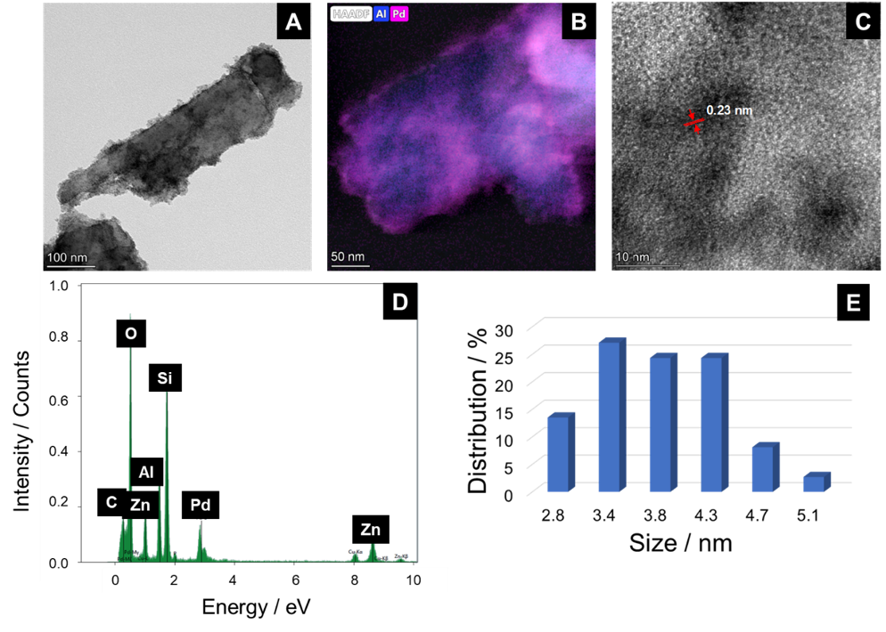
Figure 3. (A) TEM image, (B) EDX elemental mapping images; (C) HR-TEM image of the Hal@PDA/Pd nanomaterial; (D) EDS analysis on a selected area; (E) Hal@PDA/PdNPs diameter size distribution (number of counts = 80).
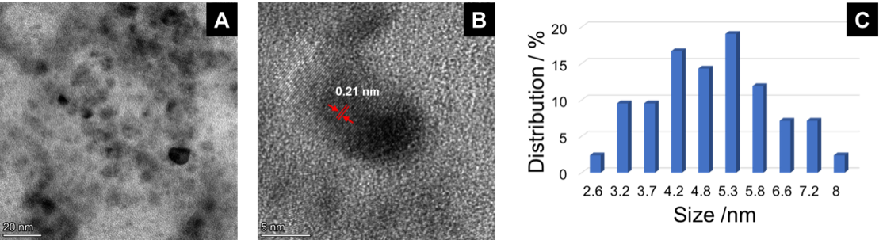
Figure 4. (A-B) HR-TEM image of the Hal@PDA/CuNPs nanomaterial; (C) Hal@PDA/CuNPs diameter size distribution (number of counts = 80).

2.2. Catalytic experiments
To evaluate the functional performance of the Hal@PDA-supported metal nanoparticles, two well-established model reactions were selected: the hydrogenation of (E)-cinnamaldehyde and the reduction of 4-nitrophenol.

2.2.1. Cinnamaldehyde hydrogenation
The hydrogenation of cinnamaldehyde is a pivotal reaction in the chemical industry, producing a range of valuable intermediates used in the manufacture of fine chemicals, pharmaceuticals, fragrances, and flavorings [24]. The challenge in the hydrogenation process lies in achieving high selectivity toward the desired product while maintaining efficiency and minimizing by-products. Therefore, to evaluate the catalytic activity and selectivity of the Hal@PDA/PdNPs and Hal@PDA/CuNPs nanomaterials in the hydrogenation reaction of (E)-cinnamaldehyde (I) some tests were performed in the presence of isopropanol, using substrate/MNPs molar ratio = 1000/1 at 50 °C. During the reduction reaction, hydrogen atoms can be added across either the C=C or the C=O bonds to form hydrocinnamaldehyde (II), hydrocinnamic alcohol (III), cinnamic alcohol (IV), respectively.[25] After the reduction reaction compound II could react with isopropanol alcohol affording the hemiacetal V (Table 1).
From a preliminary screening, it was found that the Hal@PDA/CuNPs catalyst turned out to be not efficient in this kind of reaction, probably due to leaching of metals from the support, and thus it was no further considered. On the contrary, the Hal@PDA/PdNPs nanomaterial showed good catalytic results, with satisfactory TOF values, as reported in Table 1, in line or in some case better than those reported in literature (Table 2). In all cases investigated, product IV was never produced.
Firstly, the catalyst with a PdNPs content of ca. 3.6 wt% was tested at a temperature of 50 °C in the presence of 0.5 MPa of H₂ (entry 1). In this case, the catalyst proved to be very active, giving complete substrate conversion and a greater selectivity towards the saturated aldehyde (II), even if the hydrocinnamic alcohol (III) was formed at about 30%. Noteworthy, both the activity and the selectivity remained practically unchanged in a recycling test (entry 1^{b}*).
Table 1. Hydrogenation of (E)-cinnamaldehyde (I) catalyzed by Hal@PDA/PdNPs at different Pd content, using isopropanol as solvent and a substrate/Pd molar ratio = 1000/1.
Entry | $$P_{H_{2}}$$  $$(MPa)$$ | t  (h) | Conv. (%)ª | II yield (%)ª | III yield (%)ª | V yield (%)ª | TOF  (s⁻¹)^{c}
1^{b} | 0.5 | 16 | 100 | 68 | 32 | / | 0.02
1^{b}* | 0.5 | 16 | 100 | 69 | 31 | /
2 | 0.5 | 5 | 100 | 77 | 17 | 6 | 0.06
2* | 0.5 | 5 | 100 | 86 | 14 | /
2** | 0.5 | 5 | 100 | 86 | 14 | /
2*** | 0.5 | 5 | 100 | 80 | 13 | 7
2**** | 0.5 | 5 | 100 | 83 | 9 | 8
2***** | 0.5 | 5 | 99 | 83 | 10 | 6
3 | 0.1 | 5 | 100 | 89 | 9 | 2 | 0.06
3* | 0.1 | 5 | 100 | 95 | 4 | 1
4 | 0.1 | 3 | 69 | 54 | 7 | 8 | 0.06
4* | 0.1 | 3 | 100 | 91 | 3 | 6 | 0.1
4** | 0.1 | 3 | 100 | 96 | 3 | 1
4*** | 0.1 | 3 | 100 | 91 | 6 | 3
ª Determined by GC analysis. Substrate (1.9 mmol); Solvent: isopropanol (5 mL); Substrate/Pd (molar ratio) = 1000/1.
^{b} Pd content in the catalyst: 3.6 wt%.
^{c} TOF = n_{p}/n_{c}t, where n_{p} and n_{c} are the moles of the product molecules and the catalyst during time t, respectively.
*Experiment carried out by using the catalyst recovered from the previous reaction.
Table 2. Different metal based catalysts for cynnamaldehyde hydrogenation.
Catalyst | TOF / s⁻¹ | Ref.
Ru/CNTs | 0.17 | [26]
Ru/TEGO | 0.033 | [27]
Ir/GA | 0.005 | [28]
Au-PVP/SiO₂-12UVO | 0.028 | [29]
Pd/BP | 0.014 | [30]
Ni-CNT | 0.0002 | [31]
Pt/SiO₂ | 0.013 | [32]
Pt-SnO₂/SiO₂ | 0.03 | [32]
Hal@PDA/PdNPs | 0.1 | This work
In the view of a more sustainable development, Hal@PDA/PdNPs nanomaterial with a lower PdNPs content was prepared and tested in the hydrogenation reaction. In particular, the content of PdNPs in the nanomaterial was reduced from ca. 3.6 wt% to ca. 0.8 wt% (see SI), as estimated by TGA (Figure S.1). By performing the reaction at 0.5 MPa of H₂ for 5 h a complete substrate conversion was achieved with the predominant formation of the saturated aldehyde (II) (entry 2). Recycling tests showed that the Hal@PDA/PdNPs catalyst retained both activity and selectivity for at least six consecutive runs (Table 1 and Figure 5). By reducing H₂ pressure to 0.1 MPa excellent results were obtained both in terms of activity and selectivity, even after one consecutive run (entries 3 and 3*). By decreasing the reaction time from 5 h to 3 h, a decrease both in the conversion and in the selectivity towards the aldehyde (II) was observed (entry 4). Surprisingly, recycling tests showed that after the first run, the catalyst recovers its catalytic performance affording a total conversion of (E)-cinnamaldehyde with high selectivity (greater than 90%) towards product (II). Most likely, after the first catalytic run, the catalyst underwent activation by hydrogen, remaining active and selective even in four consecutive runs (entries 4* - 4***).

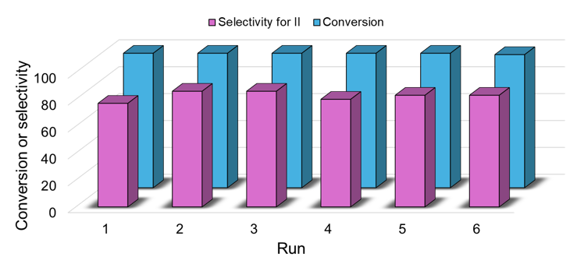
Figure 5. Conversion of (E)-cinnamaldehyde and its selectivity towards hydrocinnamaldehyde (II) after six consecutive runs.
Finally, the catalyst recovered after the first recycling test and after five consecutive runs was subjected to XPS analysis and the results were compared to the one of Hal@PDA/PdNPs (Figure 2c and Figure 6) in order to better understand the catalytic performance. As shown in Figure 6 the amount of Pd(0) slightly decreased after the first catalytic run (from 78% to 75%, Figure 6a), whereas it is strongly oxidized after five consecutive runs, where ca. 36% of Pd(0) was found by XPS analysis (Figure 6b). However, as shown by the catalytic tests (Table 1), the catalyst retains its catalytic activity and selectivity. Very probably, under the reaction conditions, hydrogen pressure can reactivate the catalyst so allowing it to maintain its activity practically unchanged.
(a) 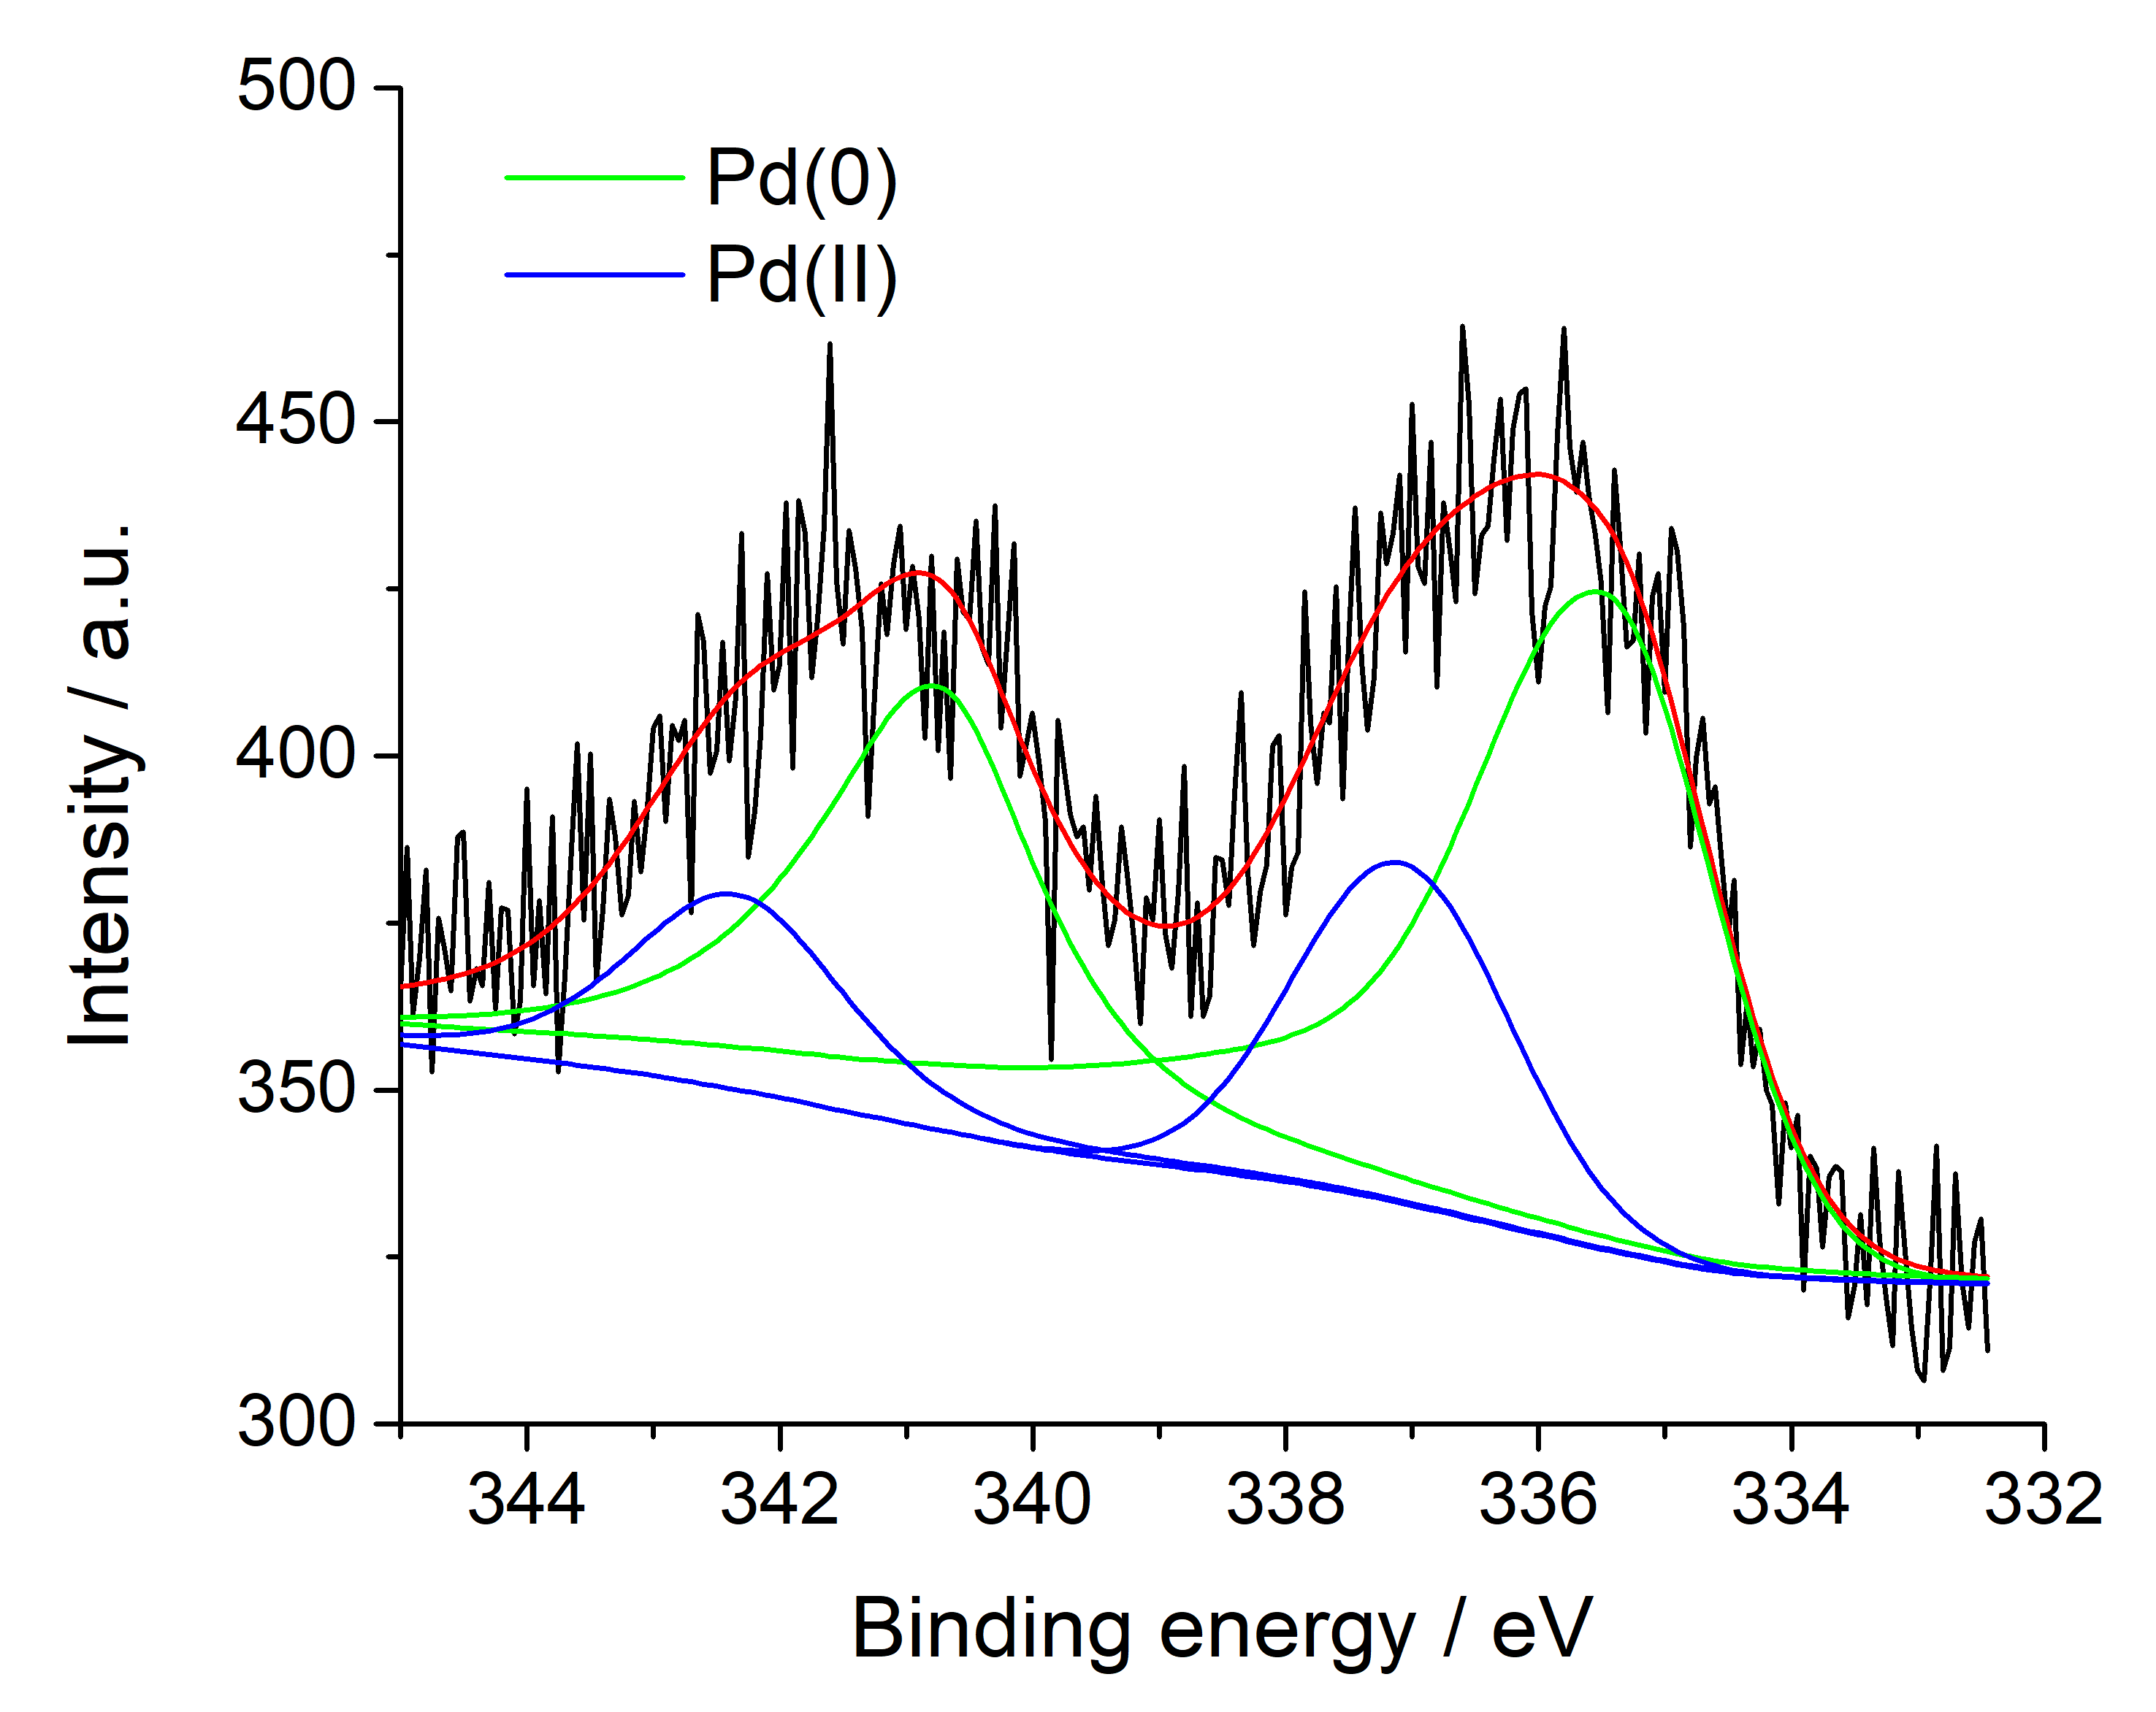(b) 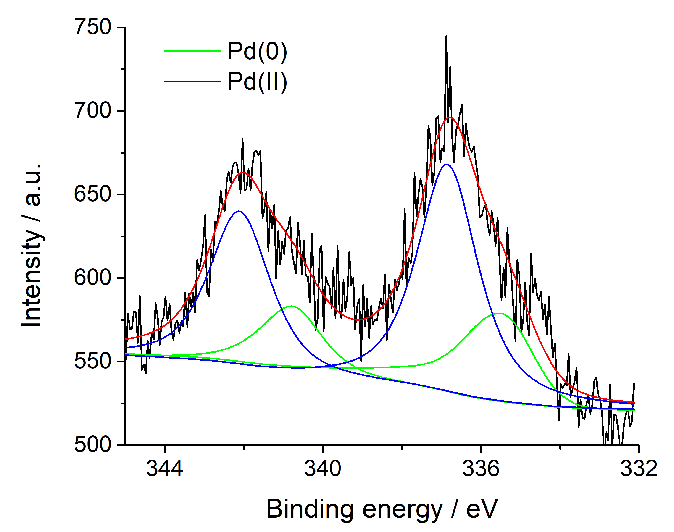
Figure 6. High‐resolution X‐ray photoelectron spectroscopy (XPS) of the Pd3d region of (a) after first and (b) five consecutive runs, Hal@PDA/PdNPs nanomaterial.

2.2.2. 4-Nitrophenol reduction
To further evaluate the catalytic performance of the Hal based catalysts obtained, the reduction of 4‐NP by NaBH₄, was studied, since this is the most used reaction to investigate the catalytic activity of metal nanoparticles in aqueous solution. The interest in this reaction is mainly because 4‐NP is a common reactant in pharmaceuticals and can be a hazardous byproduct that is inhibitory and toxic in nature; the product of the reaction, 4‐aminophenol (4‐AP), is used for black‐and‐ white films and for the production of acetaminophen. By adding both catalysts to an aqueous solution of 4-NP in the presence of NaBH₄ (100 mM), the absorbance value at ca. 400 nm, typical of 4-nitrophenolate ions, decreases as function of the time and the solution color faded from yellow green to transparent indicating that both nanomaterials can exert catalytic activity. No change in the 4-NP absorbance was observed without the catalysts and in the presence of Hal@PDA nanomaterial.
The reaction kinetics can be analyzed by plotting the absorbance value at 397 nm as a function of time. Figure 6 shows plots of ln(A_{t}/A₀) versus reaction time, where A_{t} is the absorbance at reaction time t and A₀ is the initial absorbance. The results indicate that ln(A_{t}/A₀) decreases linearly with reaction time, which is consistent with the pseudo‐first‐order kinetics of 4‐NP reduction by NaBH₄, in a concentration dependent manner.
(a)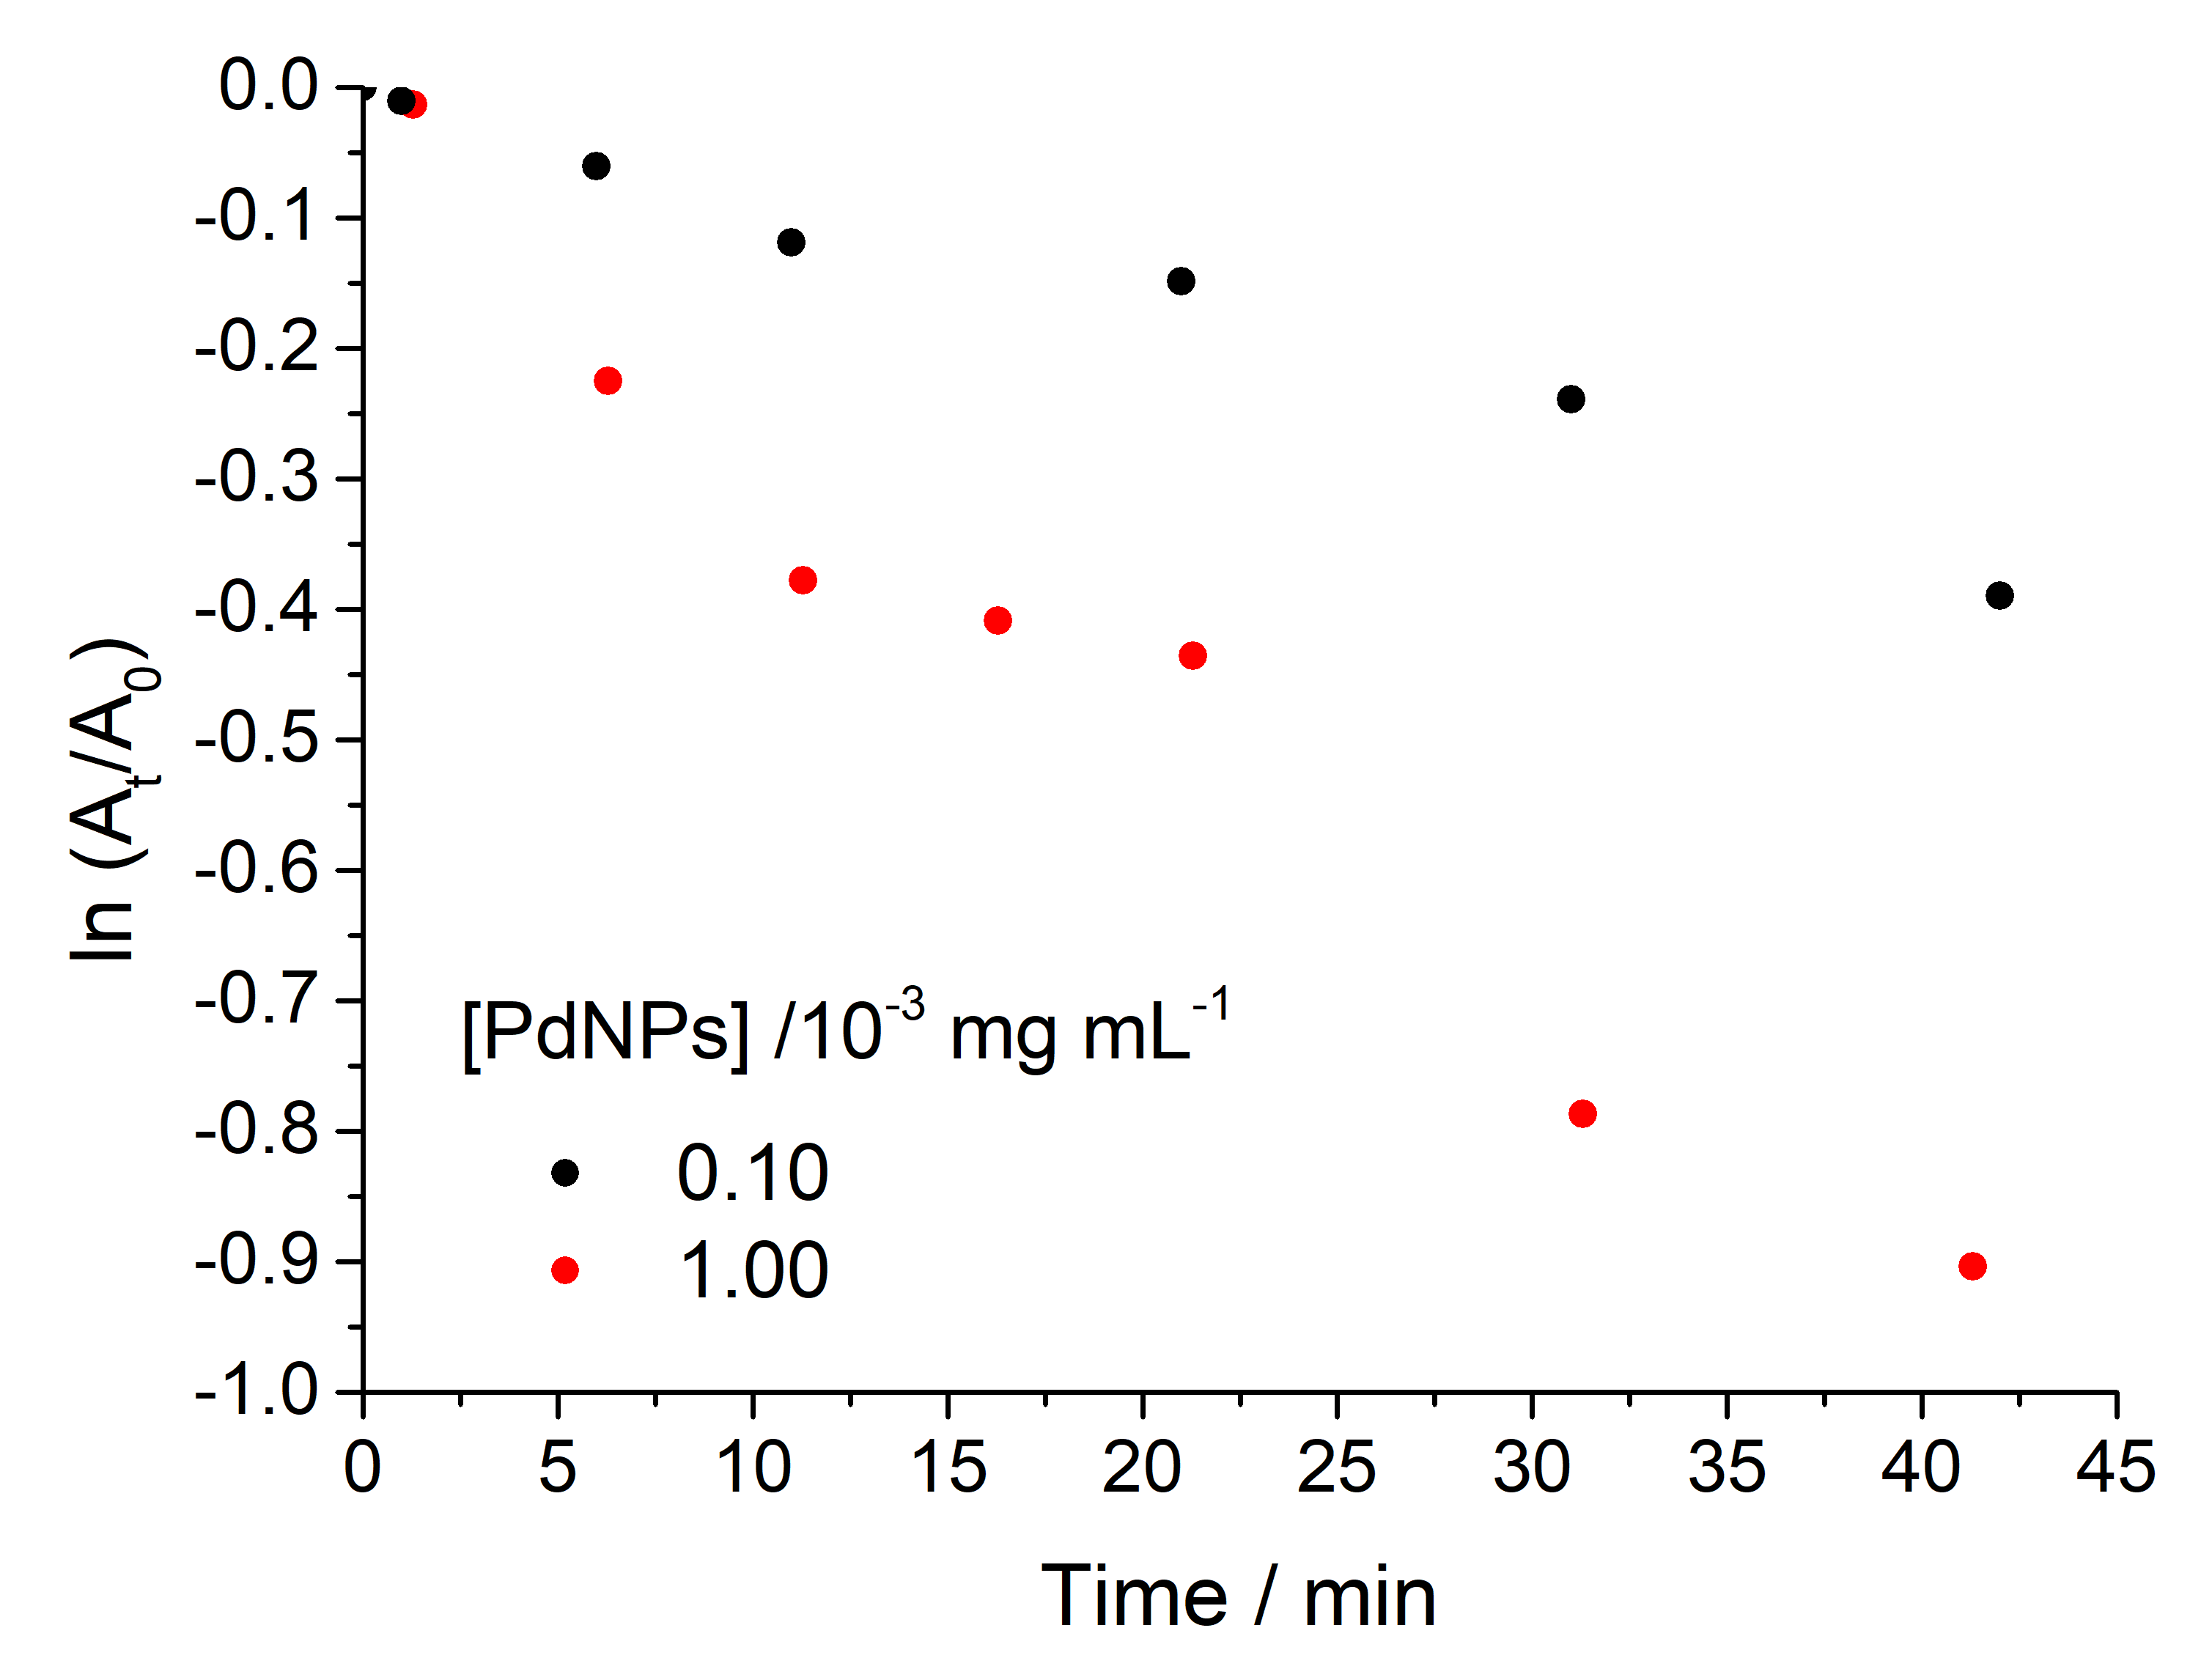(b)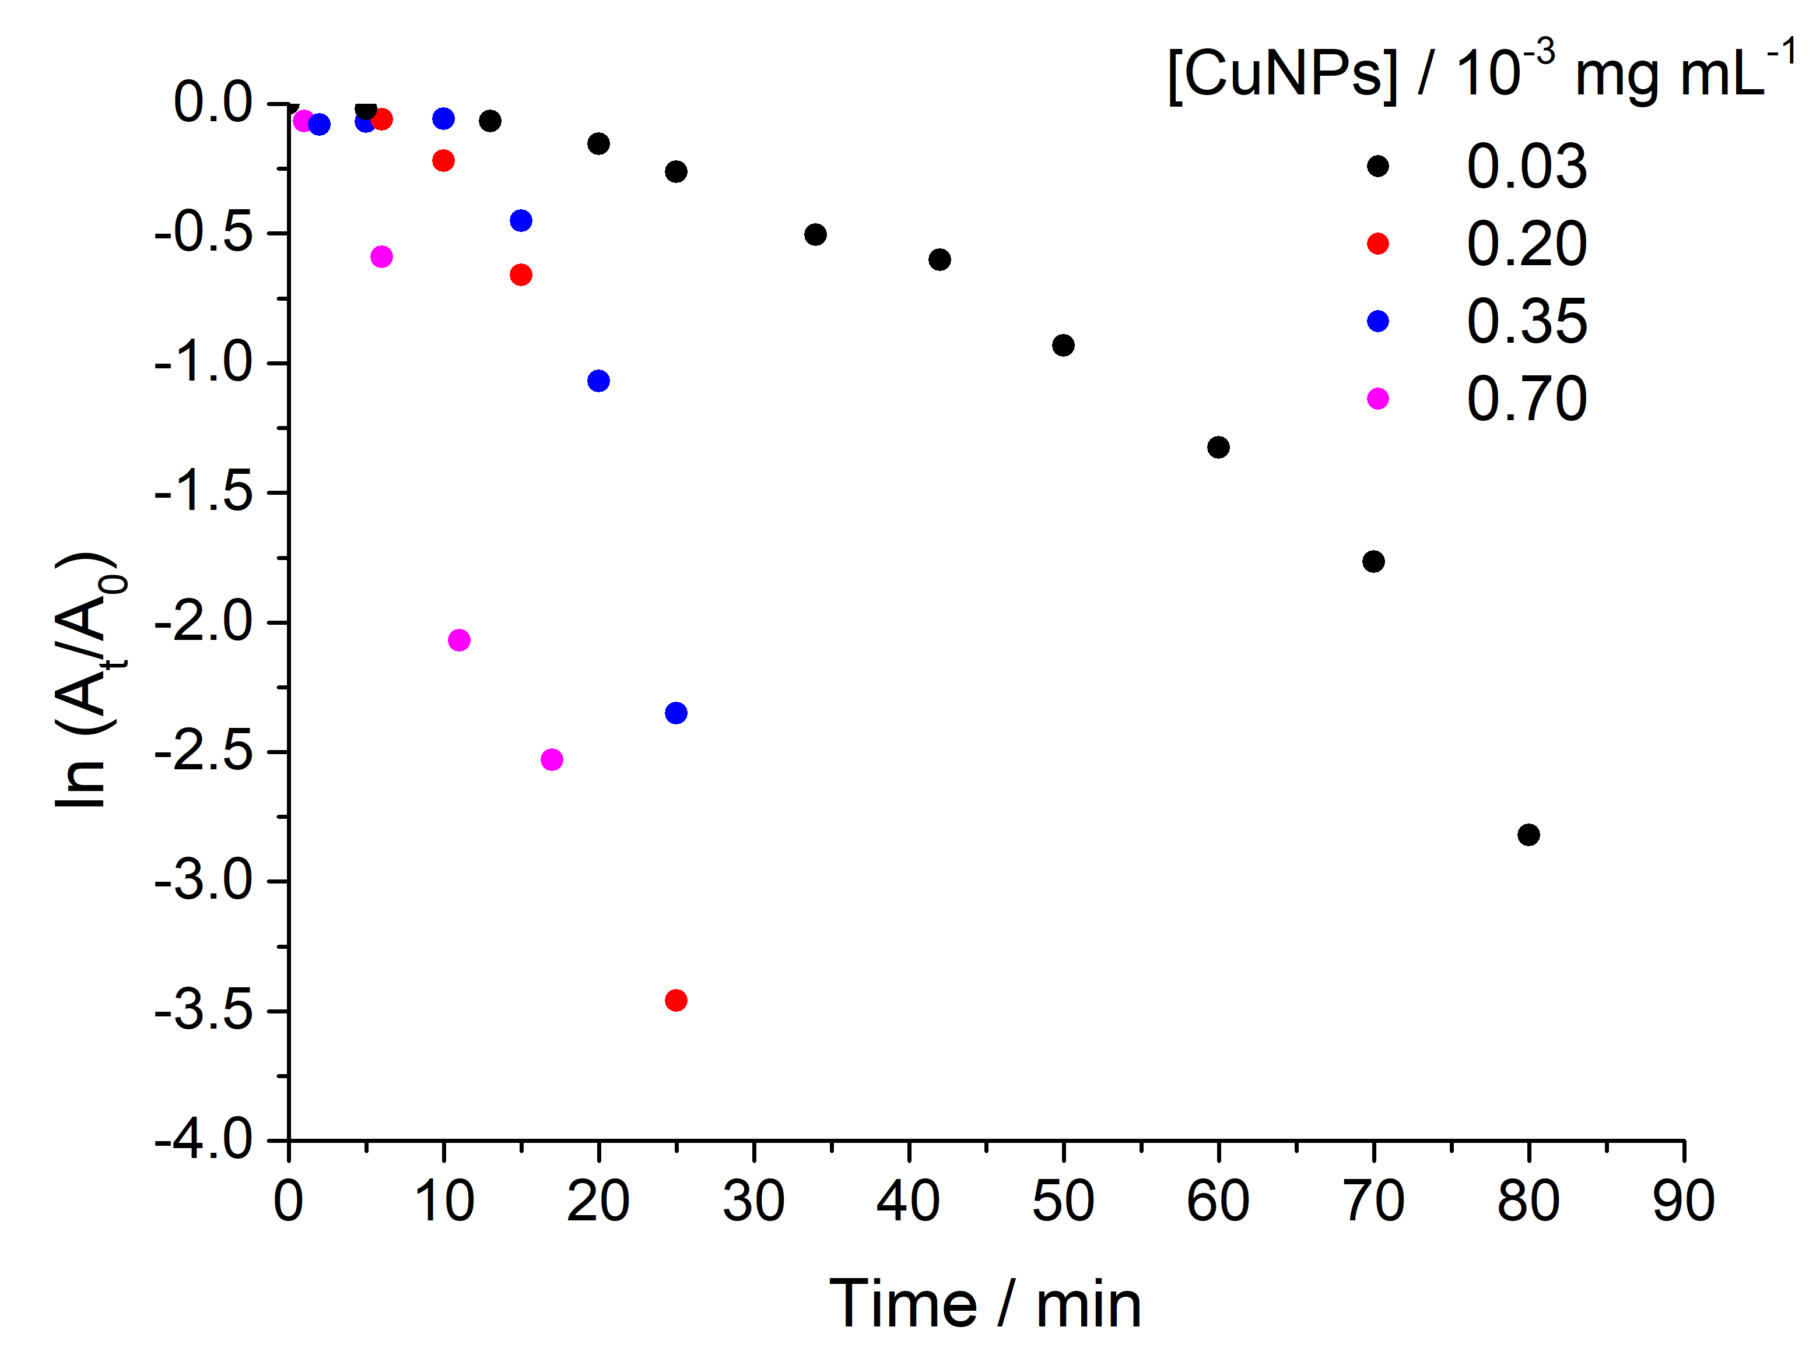
(c)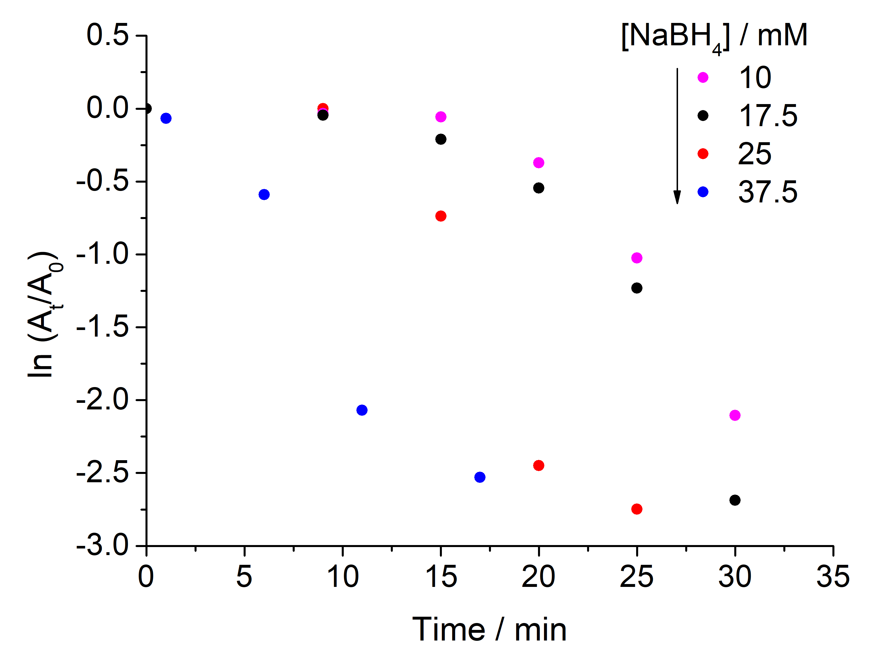
Figure 6. Plots of ln(A_{t}/A₀) versus time at various (a) Hal@PDA/PdNPs, (b) Hal@PDA/NPs and (c) NaBH₄, in the presence of Hal@PDA/CuNPs catayst, concentrations. The concentrations of 4‐NP and NaBH4 in (a) and (b) were 0.050 mM and 25 mM, respectively. The concentrations of 4-NP and Hal@PDA/CuNPs in (c) were 0.050 mM and 0.1 mg mL⁻¹ (corresponding to [CuNPs] = 0.7 ×10⁻³ mg mL⁻¹), respectively.
The apparent reaction time constant k_{app} (min⁻¹) was estimated by the linear fitting of the experimental results and the obtained data are listed in Table 3.
Table 3. Kinetic parameters of 4-NP reduction at different Hal@PDA based catalysts concentrations.ª
Entry | MNPs concentration /  × 10⁻³ mg mL⁻¹ | k_{app} / × 10⁻³ min⁻¹
Hal@PDA/PdNPs
1 | 1.00 | 22
2 | 0.10 | 8
Hal@PDA/CuNPs
4 | 0.70 | 160
5 | 0.35 | 80
6 | 0.20 | 70
7 | 0.03 | 31
ªReaction conditions: 0.050 mM of 4‐NP and 25 mM of NaBH₄.
As it is possible to observe from data reported in Table 3, the Hal@PDA/CuNPs nanomaterial results to be most active in the reduction of 4-NP in the presence of NaBH₄. For this reason, further investigations were performed with this nanomaterial.
The actual kinetic constant (k) can be easily determined from the slope of a plot of k_{app} versus [NaBH₄]. Thus, the influence of NaBH₄ concentration on the reduction reaction was evaluated and the obtained results are reported in Figure 6c, which shows that by increasing NaBH₄ concentration, an increase in the reaction rate occurs. The actual kinetic constant was calculated to be 0.003 min⁻¹ (Figure S2).
Finally, to study the recyclability of the Hal@PDA/CuNPs nanomaterial, the same catalyst was used to perform the same reduction reaction for consecutive runs. After each catalytic cycle, the catalyst (20 mg) was centrifuged, washed several times with water and dried for the next cycle of catalysis. The catalyst exhibits high activity in the same reaction time (30 min) after being used for 8 cycles without presumably leaching of CuNPs. XPS measurements on the catalyst after the recycling tests showed that the predominant species in the spent catalyst is the Cu²⁺ because of the presence of a peak centered at ca. 933.7 eV and the satellite one at ca. 943.4 eV (Figure 7).
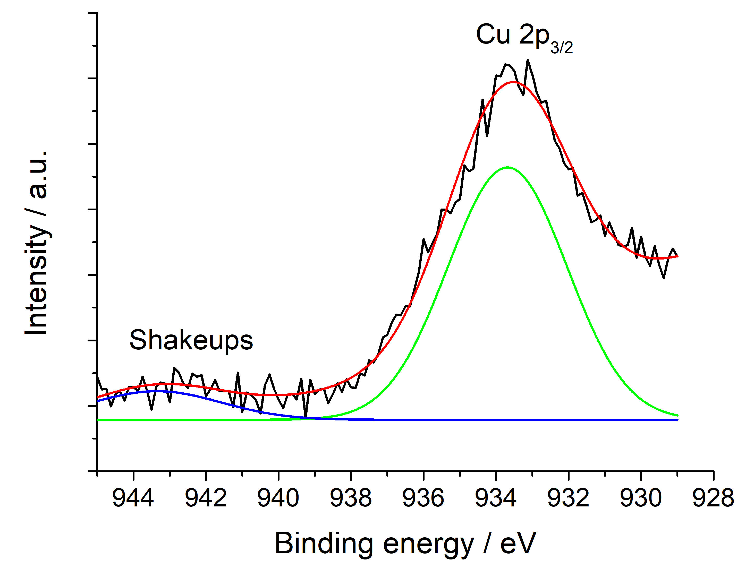
Figure 7. High‐resolution X‐ray photoelectron spectroscopy (XPS) of the Cu 2p_{3/2} region of spent Hal@PDA/CuNPs nanomaterial.

3. Materials and Methods
All reagents needed were used as purchased (Merck) without further purification.
Hal@PDA was synthetized as reported elsewhere [13].
The qualitative and quantitative analysis of the products was carried out by gas chromatographic methods. An Agilent Technologies 6850 series equipped with an HP-5 (Agilent) capillary column (30 m × 0.32 mm × 0.25 μm film thickness) and a flame ionization detector (FID) was used. The program used: initially the temperature was 100°C and maintained for 5 min, subsequently it was heated with a rising rate of 10 °C/min until reaching 250 °C. The injector pressure was 0.689 bar, with a nitrogen flow (carrier) of 7.2 mL / min.
Qualitative analysis of the products was performed by GC-MS. An Agilent Technologies 7820A GC System gas chromatograph equipped with an HP-5 capillary column (30 m × 0.32 mm × 0.25 μm film thickness) and interfaced to an Agilent Technologies 5977B MSD quadrupole mass spectrometer was used. The program adopted for the identifications was: initially the temperature was 100 °C and maintained for 5 min, subsequently it was heated with a rising rate of 10 °C/min until reaching 250 °C and maintained for 10 min; the delay was 4 min, and the injector temperature was 250 °C. The interface and the source both worked at 300 °C, with a helium flow (carrier) of 1 mL/min. The instrument for the identification of the injected products worked with a detector voltage of 70 eV, and the mass range was in the range between 50 and 500 u.m.a.
Hydrogenation experiments were carried out in a magnetically stirred stainless steel autoclave (total volume 150 mL) connected to a thermostatic bath in order to maintain the reaction temperature constant within ± 1 °C.
UV-vis spectra were acquired by a Beckman DU 650 spectrometer.
The thermogravimetric analysis (TGA) of the material was performed in a TGA/DSC1 STAR System from Mettler Toledo Inc. The sample (15 mg) was subjected to a pre-treatment in air flow (30 mL/min) from 25 °C to 100 °C with a heating rate of 10°C/ min and holding time at 100 °C for 30 min, to remove any eventual physiosorbed water. Then, the temperature increased from 100 to 1000 °C under air flow (30 mL/min).
Transmission electron microscopy (TEM) was performed using a FEI Titan G2 60–300 ultra-high resolution transmission electron microscope (FEI, Lausanne, Switzerland), with samples supported on a copper grid, and coupled with analytical electron microscopy (AEM) utilizing a SUPER-X silicon-drift windowless energy-dispersive X-ray spectroscopy (XEDS) detector. AEM spectra were acquired in STEM (scanning transmission electron microscopy) mode with a HAADF (high-angle annular dark field) detector.
X‐ray powder diffraction (XRPD) analysis was carried out using a diffractometer (X’Pert Pro model, Malven Panalytical, Madrid, Spain) equipped with a solid‐state detector (X’Celerator) and a spinning sample holder. The diffractogram patterns were recorded using random oriented mounts with CuKα radiation, operating at 45 kV and 40 mA, in the range 4–60 °2θ.
The X-ray photoelectron spectroscopy (XPS) analyses were carried out with a VG Microtech ESCA 3000 Multilab, equipped with a dual Mg/Al anode. As excitation source was used the Al Kα radiation
(1486.6 eV). The sample powders were mounted on a double-sided adhesive tape. The pressure in the analysis chamber was in the range of 10⁻⁸ Torr during data collection.

3.1. General procedure for the synthesis of Hal@PDA/PdNPs nanomaterial
PdCl₂ (4 mg, 0.023 mmol, 1 eq) and NaCl (27 mg, 0.46 mmol, 20 eq) in water (1 mL) were heated at 80 °C until the PdCl₂ was dissolved. The obtained clear reddish solution of sodium tetrachloropalladate (II) was cooled at room temperature and added dropwise to a suspension of Hal@PDA (50 mg) in water (2 mL). The suspension was left to stir at room temperature for 16 h, then filtered and washed several times with water to remove the unreacted materials. The solid obtained was re-suspended in ethanol (1 mL) and to the obtained dispersion a solution of NaBH₄ (6 mg, 0.161 mmol, 7 eq) in ethanol (1 mL) was added dropwise. The obtained dispersion was left to stir at room temperature for 6 h. After this time, the solvent was filtered off and the powder was washed several times with water and then dried overnight at 60°C. The amount of Pd in the nanomaterial was estimated by TGA to be as large as 3.6 wt%.
Using a similar procedure but reducing the content of Pd salt and proportionally the amount of the other reagents Hal@PDA/PdNPs with a content of 0.8 wt% of Pd catalyst was prepared (see SI).

3.2. General procedure for the synthesis of Hal@PDA/CuNPs nanomaterial
In a round bottom flask, CuCl₂ (7 mg, 0.052 mmol) and Hal@PDA (50 mg) were weighed, and 2 mL of water were added. The suspension was left to stir at room temperature for 16 h, then filtered and washed several times with water to remove the unreacted materials. The solid obtained was re-suspended in ethanol (1 mL) and to the obtained dispersion a solution of NaBH₄ (10 mg, 0.27 mmol) in ethanol (1 mL) was added dropwise. The obtained dispersion was left to stir at room temperature for 6 h. After this time, the solvent was filtered off and the powder was washed several times with water and then dried overnight at 60 °C. The amount of Cu in the nanomaterial was estimated by TGA as large as 0.6 wt%.

3.3. General procedure for the hydrogenation of cinnamaldehyde (I)
In a 50 mL test tube, equipped with a magnetic stir bar, 1.9 mmol of cinnamaldehyde (I), 0.0019 mmol of Pd-based catalyst (substrate (I)/Pd molar ratio 1000/1) and 5 mL of isopropanol were added under an inert nitrogen atmosphere. The tube was then transferred into a 150 mL stainless steel autoclave under nitrogen, pressurized with hydrogen and maintained under stirring at 50 °C for the due time (see Table 1 for the reaction conditions). The reactor was then cooled to room temperature and the residual gases were released. The reaction mixture was centrifuged at 5000 rpm for 20 min: the solution was removed with a Pasteur pipette and the solid was placed under a nitrogen flow until completely dry. The recovered catalyst was added to a solution of fresh substrate dissolved in 2-propanol and recycled by adopting the above-described procedure. The organic phase was analyzed by GC and GC-MS.
GC-MS m/z 3-Phenyl propanal (II): 134 [M]⁺; 105 [M-CHO]⁺; 91 [M-C₂H₃O]⁺; 78 [M-C₃H₄O]⁺.
GC-MS m/z Hydrocinnamic alcohol (III): 136 [M]⁺; 118 [M-H₂O]⁺; 105 [M-CH₂OH]⁺; 91 [M-C₂H₅O]⁺; 77 [M-C₃H₇O]⁺.

3.4 4-NP reduction reaction
Hal@PDA/PdNPs or Hal@PDA/CuNPs aqueous suspension (different volume to reach the desired catalyst amount) was added into a mixed aqueous solution of 2 mL containing 4-NP (0.05 mM) and NaBH₄ (from 10 to 37.5 mM) in a quartz cuvette, at room temperature and under stirring. The reduction process was monitored by recording the UV–vis spectra of the reaction mixture at different times. The reaction rate constant was determined by measuring the absorption intensity of the initially observed peak of the substrate as a function of time.

3.5. Recyclability of Hal@PDA/CuNPs catalysts
Hal@PDA/CuNPs (20 mg), 4‐NP (0.010 mM) and NaBH₄ (25 mM) were placed in a vial under constant stirring and at room temperature. After 30 min, the complete reduction was confirmed by measuring the absorption intensity at 397 nm. The reaction mixture was then centrifuged, and the supernatant was decanted; the residual solid was washed three times with water. The Hal@PDA/CuNPs nanomaterials was dried and reused in the same reaction for ten consecutive cycles.

4. Conclusions
In summary, two hybrid nanomaterials were developed by immobilizing palladium or copper nanoparticles onto halloysite nanotubes (Hal) selectively functionalized with polydopamine (PDA). The key innovation lies in the site-specific PDA coating strategy, enabled by the preliminary decoration of Hal with ZnO nanoparticles. This approach allows the controlled localization of the PDA layer exclusively on the outer surface of the nanotubes, creating a well-defined interface for metal nanoparticle anchoring. The resulting materials, Hal@PDA/PdNPs and Hal@PDA/CuNPs, feature uniformly distributed metal nanoparticles with sizes below 5 nm and strong surface interaction, as demonstrated by comprehensive structural and chemical characterization.
The amount of immobilized metal NPs on the support was estimated by TGA to be ca. 3.6 wt% and 0.7 wt% for PdNPs and CuNPs, respectively. Their performance in two model reactions, the E)-cinnamaldehyde hydrogenation and 4-nitrophenol reductions, showed distinct and complementary catalytic behavior, with both systems maintaining recyclability under the tested conditions.
As far as the cinnamaldehyde reduction, this reaction was performed in the presence of isopropanol using substrate/MNPs molar ratio = 1000/1 at 50 °C, varying reaction time and H₂ pressure. The results showed that the Hal@PDA/PdNPs nanomaterial provided good catalytic performance, with satisfactory TOF values comparable with literature. It showed high catalytic activity and selectivity toward hydrocinnamaldehyde even after six consecutive cycles. X-ray photoelectronic spectroscopy (XPS) on fresh and spent catalyst demonstrated that after six consecutive cycles, PdNPs on Hal@PDA/PdNPs were strongly oxidated. Despite this, the catalyst retained its catalytic activity and selectivity. Very probably, under the reaction conditions, hydrogen pressure can reactivate the catalyst so allowing it to maintain activity practically unchanged.
Conversely, although both catalysts show catalytic activity in the 4-nitrophenol reduction, the most promising one resulted to be the Hal@PDA/CuNPs nanomaterial, that shows increasing catalytic activity by increasing NaBH₄ and nanomaterial concentration. Recycling tests show that the catalyst can be used without loss in its catalytic activity for at least eight consecutive cycles. These findings highlight the effectiveness of the site-selective PDA functionalization in stabilizing metal nanoparticles and establish Hal@PDA as a versatile and tunable platform for the design of next-generation hybrid nanomaterials.
Supplementary Materials: The following supporting information can be downloaded at: https://www.mdpi.com/article/doi/s1, Synthesis of Hal@PDA/PdNPs nanomaterial with a Pd loading of 0.8 wt%, Figure S1: TGA of Hal@PDA/PdNPs nanomaterial with a Pd loading of 0.8 wt%, Figure S2: Recyclability of Hal@PDA/PdNPs catalyst, Figure S3: XPS after catalytic cycles, Figure S4 Plot of k_{app} versus [NaBH₄].
Author Contributions: Conceptualization, S.P. and S.R.; methodology, M.M., C.D’A., M.L.A., L.F.L., A. L.-G., R.d.M.B., O.P. and R.S.-E.; formal analysis, M.M., S.P., M.L.A., L.F.L., A. L.-G., R.S.-E., C.V. and S.R.; investigation, M.M., C. D’A., S.P., L.F.L., A. L.-G. and S.R.; resources, C.V.; writing—original draft, M.M., S.P., L.F.L. and S.R.; writing—review and editing, M.M., S.P., O.P. and S.R.
Data Availability Statement: No new data were created in this study.
Acknowledgments: This work was supported by Linea di Intervento 1 Progetti di Ricerca Collaborativa del “PIAno di inCEntivi per la RIcerca di Ateneo 2024/2026” of University of Catania with the project “Sviluppo di nanobiopesticidi basati su argille minerali per applicazioni in agricoltura”. XPS analyses were performed at the ATeN Center–University of Palermo.
Conflicts of Interest: The authors declare no conflicts of interest.

References
1. Ying, S.; Guan, Z.; Ofoegbu, P.C.; Clubb, P.; Rico, C.; He, F.; Hong, J. Green synthesis of nanoparticles: Current developments and limitations. Environmental Technology & Innovation 2022, 26, 102336, doi:https://doi.org/10.1016/j.eti.2022.102336.
2. Fan, W.K.; Tahir, M. Structured clay minerals-based nanomaterials for sustainable photo/thermal carbon dioxide conversion to cleaner fuels: A critical review. Science of The Total Environment 2022, 845, 157206, doi:https://doi.org/10.1016/j.scitotenv.2022.157206.
3. Das, S.; Jana, S. A tubular nanoreactor directing the formation of in situ iron oxide nanorods with superior photocatalytic activity. Environmental Science: Nano 2017, 4, 596-603, doi:10.1039/C6EN00570E.
4. Stavitskaya, A.; Rubtsova, M.; Glotov, A.; Vinokurov, V.; Vutolkina, A.; Fakhrullin, R.; Lvov, Y. Architectural design of core–shell nanotube systems based on aluminosilicate clay. Nanoscale Advances 2022, 4, 2823-2835, doi:10.1039/D2NA00163B.
5. Stavitskaya, A.; Glotov, A.; Pouresmaeil, F.; Potapenko, K.; Sitmukhanova, E.; Mazurova, K.; Ivanov, E.; Kozlova, E.; Vinokurov, V.; Lvov, Y. CdS Quantum Dots in Hierarchical Mesoporous Silica Templated on Clay Nanotubes: Implications for Photocatalytic Hydrogen Production. ACS Applied Nano Materials 2022, 5, 605-614, doi:10.1021/acsanm.1c03393.
6. Yaghoubi, S.; Sadjadi, S.; Zhong, X.; Yuan, P.; Heravi, M.M. Clay-supported bio-based Lewis acid ionic liquid as a potent catalyst for the dehydration of fructose to 5-hydroxymthylfurfural. Scientific Reports 2024, 14, 82, doi:10.1038/s41598-023-50773-2.
7. Casiello, M.; Savino, S.; Massaro, M.; Liotta, L.F.; Nicotra, G.; Pastore, C.; Fusco, C.; Monopoli, A.; D'Accolti, L.; Nacci, A., et al. Multifunctional halloysite and hectorite catalysts for effective transformation of biomass to biodiesel. Applied Clay Science 2023, 242, 107048, doi:https://doi.org/10.1016/j.clay.2023.107048.
8. Lan, Y.; Ma, Y.; Hou, Q.; Luo, Z.; Wang, L.; Ran, M.; Dai, T. Immobilization of palladium nanoparticles on polydopamine spheres with superior activity and reusability in Heck reaction. Journal of Catalysis 2024, 430, 115333, doi:https://doi.org/10.1016/j.jcat.2024.115333.
9. Liu, Y.; Ai, K.; Lu, L. Polydopamine and Its Derivative Materials: Synthesis and Promising Applications in Energy, Environmental, and Biomedical Fields. Chemical Reviews 2014, 114, 5057-5115, doi:10.1021/cr400407a.
10. Zhang, D.; Cui, Y.; Yang, G.; Liu, M.; Zhu, G.; Sheng, X.; Deng, F.; Zhou, N.; Zhang, X.; Wei, Y. Mussel-inspired fabrication of halloysite nanotube-based magnetic composites as catalysts for highly efficient degradation of organic dyes. Applied Clay Science 2020, 198, 105835, doi:https://doi.org/10.1016/j.clay.2020.105835.
11. Liu, J. Catalysis by Supported Single Metal Atoms. ACS Catalysis 2017, 7, 34-59, doi:10.1021/acscatal.6b01534.
12. Massaro, M.; Casiello, M.; D'Accolti, L.; Lazzara, G.; Nacci, A.; Nicotra, G.; Noto, R.; Pettignano, A.; Spinella, C.; Riela, S. One-pot synthesis of ZnO nanoparticles supported on halloysite nanotubes for catalytic applications. Applied Clay Science 2020, 189, 105527, doi:https://doi.org/10.1016/j.clay.2020.105527.
13. Alfieri, M.L.; Massaro, M.; d'Ischia, M.; D'Errico, G.; Gallucci, N.; Gruttadauria, M.; Licciardi, M.; Liotta, L.F.; Nicotra, G.; Sfuncia, G., et al. Site-specific halloysite functionalization by polydopamine: A new synthetic route for potential near infrared-activated delivery system. Journal of Colloid and Interface Science 2022, 606, 1779-1791, doi:https://doi.org/10.1016/j.jcis.2021.08.155.
14. Falanga, A.P.; Massaro, M.; Borbone, N.; Notarbartolo, M.; Piccialli, G.; Liotta, L.F.; Sanchez-Espejo, R.; Viseras Iborra, C.; Raymo, F.M.; Oliviero, G., et al. Carrier capability of halloysite nanotubes for the intracellular delivery of antisense PNA targeting mRNA of neuroglobin gene. Journal of Colloid and Interface Science 2024, 663, 9-20, doi:https://doi.org/10.1016/j.jcis.2024.02.136.
15. Yi, F.; DeLisio, J.B.; Nguyen, N.; Zachariah, M.R.; LaVan, D.A. High heating rate decomposition dynamics of copper oxide by nanocalorimetry-coupled time-of-flight mass spectrometry. Chemical Physics Letters 2017, 689, 26-29, doi:https://doi.org/10.1016/j.cplett.2017.09.066.
16. Zheng, C.; Cao, J.; Zhang, Y.; Zhao, H. Insight into the Oxidation Mechanism of a Cu-Based Oxygen Carrier (Cu → Cu2O → CuO) in Chemical Looping Combustion. Energy & Fuels 2020, 34, 8718-8725, doi:10.1021/acs.energyfuels.0c00941.
17. Gil, S.; Garcia-Vargas, J.M.; Liotta, L.F.; Pantaleo, G.; Ousmane, M.; Retailleau, L.; Giroir-Fendler, A. Catalytic Oxidation of Propene over Pd Catalysts Supported on CeO2, TiO2, Al2O3 and M/Al2O3 Oxides (M = Ce, Ti, Fe, Mn). Catalysts 2015, 5, 671-689.
18. Massaro, M.; Borrego-Sánchez, A.; Sánchez-Espejo, R.; Viseras Iborra, C.; Cavallaro, G.; García-Villén, F.; Guernelli, S.; Lazzara, G.; Miele, D.; Sainz-Díaz, C.I., et al. Ciprofloxacin carrier systems based on hectorite/halloysite hybrid hydrogels for potential wound healing applications. Applied Clay Science 2021, 215, 106310, doi:https://doi.org/10.1016/j.clay.2021.106310.
19. Al Abdullah, K.; Awad, S.; Zaraket, J.; Salame, C. Synthesis of ZnO Nanopowders By Using Sol-Gel and Studying Their Structural and Electrical Properties at Different Temperature. Energy Procedia 2017, 119, 565-570, doi:https://doi.org/10.1016/j.egypro.2017.07.080.
20. Wojcieszak, R.; Genet, M.J.; Eloy, P.; Ruiz, P.; Gaigneaux, E.M. Determination of the Size of Supported Pd Nanoparticles by X-ray Photoelectron Spectroscopy. Comparison with X-ray Diffraction, Transmission Electron Microscopy, and H2 Chemisorption Methods. The Journal of Physical Chemistry C 2010, 114, 16677-16684, doi:10.1021/jp106956w.
21. Zhang, J.; Zhang, X.; Sun, H.; Shi, L.; Wei, J.; Xu, D.; Zhang, S.; Zhang, J.; Wang, S.; Sun, H. Uncovering catalytic activity of Cu species on boron/nitrogen co–doped carbon nanotubes for efficient hydrogenation of nitroaromatics: beyond the size of metal active center. Composites Part B: Engineering 2025, 293, 112112, doi:https://doi.org/10.1016/j.compositesb.2025.112112.
22. Sanakal, S.I.; Das, A.; Babu, A.; Kar, P.; Nutalapati, V.; Datta, K.K.R.; Banerjee, S.; Maji, S. Alginate-aminoclay/CuO nanocomposite beads: A sustainable and green approach for catalytic reduction of toxic nitroaromatic compounds. Journal of Environmental Chemical Engineering 2025, 13, 115398, doi:https://doi.org/10.1016/j.jece.2025.115398.
23. Xu, X.; Ma, J.; Kui, B.; Zhu, G.; Jia, G.; Wu, F.; Gao, P.; Ye, W. Effect of Crystal Planes of Pd and the Structure of Interfacial Water on the Electrocatalytic Hydrogenation of Alkynes to Alkenes. ACS Applied Nano Materials 2023, 6, 5357-5364, doi:10.1021/acsanm.2c05491.
24. Wang, X.; Liang, X.; Geng, P.; Li, Q. Recent Advances in Selective Hydrogenation of Cinnamaldehyde over Supported Metal-Based Catalysts. ACS Catalysis 2020, 10, 2395-2412, doi:10.1021/acscatal.9b05031.
25. Patil, K.N.; Manikanta, P.; Srinivasappa, P.M.; Jadhav, A.H.; Nagaraja, B.M. State-of-the-art and perspectives in transition metal-based heterogeneous catalysis for selective hydrogenation of cinnamaldehyde. Journal of Environmental Chemical Engineering 2023, 11, 109168, doi:https://doi.org/10.1016/j.jece.2022.109168.
26. Wang, Y.; Rong, Z.; Wang, Y.; Zhang, P.; Wang, Y.; Qu, J. Ruthenium nanoparticles loaded on multiwalled carbon nanotubes for liquid-phase hydrogenation of fine chemicals: An exploration of confinement effect. J. Catal. 2015, 329, 95-106, doi:https://doi.org/10.1016/j.jcat.2015.04.034.
27. Wang, Y.; Rong, Z.; Wang, Y.; Qu, J. Ruthenium nanoparticles loaded on functionalized graphene for liquid-phase hydrogenation of fine chemicals: Comparison with carbon nanotube. J. Catal. 2016, 333, 8-16, doi:https://doi.org/10.1016/j.jcat.2015.10.021.
28. Li, L.; Gao, G.; Zheng, J.; Shi, X.; Liu, Z. Three-dimensional graphene aerogel supported Ir nanocomposite as a highly efficient catalyst for chemoselective cinnamaldehyde hydrogenation. Diamond Relat. Mater. 2019, 91, 272-282, doi:https://doi.org/10.1016/j.diamond.2018.12.018.
29. Zhong, R.-Y.; Sun, K.-Q.; Hong, Y.-C.; Xu, B.-Q. Impacts of Organic Stabilizers on Catalysis of Au Nanoparticles from Colloidal Preparation. ACS Catalysis 2014, 4, 3982-3993, doi:10.1021/cs501161c.
30. Fujiwara, S.; Takanashi, N.; Nishiyabu, R.; Kubo, Y. Boronate microparticle-supported nano-palladium and nano-gold catalysts for chemoselective hydrogenation of cinnamaldehyde in environmentally preferable solvents. Green Chemistry 2014, 16, 3230-3236, doi:10.1039/C4GC00383G.
31. Patil, K.N.; Manikanta, P.; M. Srinivasappa, P.; Jadhav, A.H.; Nagaraja, B.M. Exploring the confined space and active sites of Ni@OCNTs catalyst for chemoselective hydrogenation of cinnamaldehyde to hydrocinnamaldehyde. Journal of Environmental Chemical Engineering 2022, 10, 108208, doi:https://doi.org/10.1016/j.jece.2022.108208.
32. Wang, S.; Wu, B.; Zhang, Q.; Li, Y.; Zhu, L.; Yu, H.; Yin, H. Design of Pt@Sn core–shell nanocatalysts for highly selective hydrogenation of cinnamaldehyde to prepare cinnamyl alcohol. Chem. Eng. J. 2024, 488, 151019, doi:https://doi.org/10.1016/j.cej.2024.151019.
Disclaimer/Publisher’s Note: The statements, opinions and data contained in all publications are solely those of the individual author(s) and contributor(s) and not of MDPI and/or the editor(s). MDPI and/or the editor(s) disclaim responsibility for any injury to people or property resulting from any ideas, methods, instructions or products referred to in the content.

