Atmospheric pressure plasma jet polymerization of silicon-based coatings for the protection of glass from atmospheric alteration

Stefano Centenaro^{a,b}, Giulia Franceschin^{b,}*, Antonella Glisenti^{c}, Alessandro Patelli^{d}, Leonardo Puppulinª, Elti Cattaruzza^{a,}*

ª Dipartimento di Scienze Molecolari e Nanosistemi (DSMN), Università Ca’ Foscari Venezia, via Torino 155, 30172 Venezia-Mestre, Italia (stefano.centenaro@unive.it; leonardo.puppulin@unive.it; elti.cattaruzza@unive.it)
^{b} Center for Cultural Heritage Technologies (CCHT), Istituto Italiano di Tecnologia (IIT), via Torino 155, 30172 Venezia-Mestre, Italia (giulia.franceschin@iit.it)
^{c} Dipartimento di Scienze Chimiche (DiSC), Università degli Studi di Padova, via Marzolo 1, 35131 Padova, Italia (antonella.glisenti@unipd.it)
^{d} Dipartimento di Fisica e Astronomia (DFA), Università degli Studi di Padova, via Marzolo 8, 35131 Padova, Italia (alessandro.patelli@unipd.it)

* Corresponding authors

Keywords: glass protection; atmospheric plasma; thin film deposition; glass corrosion; glass surface

Abstract
Alternative methods to sol-gel coatings have gained considerable research attention in recent decades. Among these, plasma-polymerised coatings have proven to be effective in enhancing homogeneity, thinness and adhesion to treated surfaces. Due to these advantages, plasma technologies have also emerged as promising tools in the conservation field, particularly for treating fragile and specialised materials like glass. This study investigates the application of an atmospheric pressure plasma jet for depositing two silica-based coating on glass using two distinct precursors - the inorganic silane TEOS and the organo-silane HMDSO. In this context, plasma polymerisation refers to the plasma-induced fragmentation and recombination of precursor molecules, resulting in the formation of cross-linked inorganic or hybrid films. The relationship between plasma deposition parameters and coating properties was analysed to achieve precise control over film thickness and morphology. The barrier properties and the stability of the coatings were further evaluated under artificial ageing conditions, involving 70 °C and cycling relative humidity between 10% and 90%. Results revealed that while inorganic plasma-polymerised films provide some degree of protection by preventing precipitate formation on glass surface, their performance is limited by densification process that occurs during ageing. In contrast, hybrid plasma-polymerised coatings exhibited superior protective properties, attributed to the incorporation of organic groups that enhanced barrier performance and effectively prevented calcium leaching.
- Introduction

Glass is a unique witness of human skills, encompassing centuries of technological advancements and cultural achievements. Its preservation is essential for maintain a link with ancient technical knowledge, but glass is far from a permanent material. Despite its apparent stability, glass is susceptible to degradation due to environmental factors such as humidity, temperature and pH fluctuations [1]. These interactions induce chemical and physical changes that compromise its structural integrity and appearance [2]. Conservation science has long researched effective solutions to mitigate these processes, yet existing methods often pose limitations in terms of their invasiveness or effectiveness [3]. The need for refined, non-invasive techniques capable of providing durable protection to glass artifacts is therefore increasingly central in the field of material alteration research.
Traditional conservation methods have long relied on the application of protective coatings [4], with sol-gel technology emerging as a widely used solution due to its versatility and adaptability [5]. However, conventional sol-gel coatings are not without challenges. When applied to glass artifacts with complex shapes, such as goblets, vases or sculptures, achieving uniform coverage becomes problematic [6]. Techniques like dip-coating can lead to uneven layers, while brush application often result in overly thick coatings that alter the object’s original appearance. The need to balance effective protection with minimal intervention has become a central concern in modern conservation practices, where preserving the authenticity and integrity of original objects is central.
Recent advancements in materials science and plasma technologies have opened new pathways for addressing these challenges, ensuring improved homogeneity, thinness and adhesion across the surface, even in irregularly shaped objects. Among these innovations, atmospheric pressure plasma jet (APPJ) technology is an innovative approach used for surface treatment and coatings deposition [7].
In this context, APPJ technology offers a significant advancement by enabling the deposition of nanometric coatings in a non-invasive and solvent-free manner. Unlike conventional treatments, plasma-based methods operate at room temperature and without direct contact, which is particularly advantageous when working with fragile and irreplaceable museum glass. Plasma polymerisation refers to the process by which precursor molecules undergo plasma-induced fragmentation and form cross-linked, polymer-like thin films on the surface. Although structurally distinct from conventional organic polymers, these coatings adhere strongly to glass and can be finely tuned in composition and morphology. The resulting films exhibit robust barrier properties, effectively limiting degradation mechanisms such as moisture ingress and alkali leaching. As such, plasma technology represents not only an alternative but, in many cases, a superior solution to traditional treatments that may involve aggressive chemicals or present material compatibility issues, as seen with commonly used acrylic resins.
APPJ technology was first developed and studied for its ability to etch materials like polyimide, tungsten, tantalum and silicon dioxide [8], and to deposit silica films on silicon wafers [9]. While having been widely explored in fields such as electronics, biomedicine, and advanced manufacturing, its application in the conservation of cultural heritage artifacts remained relatively underdeveloped.
Several other commercial and experimental APPJ systems have been trialled also for a variety of conservation and restoration purposes. Pflugfelder et al. tested the ablation effects of a commercial plasma jet (Plasma-BLASTER MEF, Tigres GmbH) and of a patented plasma jet prototype for removing organic materials used as coatings for mural paintings and architectural surfaces [10]. Similarly, Boselli et al. used another commercial plasma jet source (kINPen 09, Neoplas Tools GmbH) to study the effectiveness of plasma treatment in removing tarnishing products while preventing damage to the surface of deteriorated 19th century daguerreotypes [11].
Previous studies have demonstrated the potential of plasma-assisted techniques to enhance surface properties such as hydrophobicity, scratch resistance, and chemical stability, providing a flexible way to apply functional coatings with a level of control that traditional methods could not achieve. Yan et al. investigated the use of a different commercial atmospheric pressure plasma jet system to plasma polymerise hexamethyldisiloxane (HMDSO) into a protective coating towards water penetration in paper-based relics [12]. These plasma-polymerised HMDSO based protective coatings were also applied on contemporary glass. Lin and Wang, for example, managed to deposit plasma-polymerised HMDSO based hydrophobic coatings that showed great potential for applications as barrier layers against water penetration [13]. Hossain et al. investigated mechanically resistant and stable hydrophobic coatings by plasma polymerisation of (3-aminopropyl)triethoxysilane (APTES) together with HMDSO. The durability of the coating was evaluated through natural and thermal ageing, while scratch tests were performed to evaluate the robustness of the coating [14].
Although several studies have explored plasma-assisted treatments and coatings for cultural heritage and glass protection, it is important to emphasize that the performance of plasma processes depends strongly on numerous parameters—including torch geometry, gas type and flow rate, plasma power, precursor chemistry, and substrate properties—which can greatly influence coating morphology, adhesion, and long-term stability. While prior works has demonstrated valuable functionalities such as hydrophobicity and surface cleaning, relatively few studies have systematically addressed the challenge of developing robust, durable coatings specifically tailored to protect fragile, historic-type glass from environmental degradation. In particular, the long-term protective behaviour and transparency of plasma-polymerized coatings on silica-soda-lime glass—a typical composition of many museum artifacts—remained underexplored.
This study aims to fill that gap by applying a controlled APPJ process to directly compare two widely studied silicon-based precursors—tetraethyl orthosilicate (TEOS) and hexamethyldisiloxane (HMDSO)—on silica-soda-lime glass. Table S1, available in the Supplementary Information, summarizes the comparison between this research and previously published works.
The selection of TEOS and HMDSO as precursors was guided by both practical and chemical considerations. Both compounds possess relatively high vapor pressures, making them suitable for atmospheric pressure plasma processes that require volatile precursors for efficient transport and uniform deposition. Chemically, TEOS, as an inorganic silane, forms dense silica-like networks primarily through hydrolysis and condensation mechanisms, while HMDSO, an organosilicon compound, introduces methyl groups that can tailor the coating's hydrophobicity and flexibility. Under plasma conditions, HMDSO undergoes fragmentation and complex reaction pathways that influence the final film’s structure and composition.[15] This dual selection allows a comparative evaluation of purely inorganic versus hybrid organic-inorganic coatings, providing insight into how precursor chemistry affects protective performance on glass substrates.
Through comprehensive surface analysis and accelerated aging tests, we assess not only deposition behaviour and surface characteristics but also the coatings’ ability to mitigate key deterioration mechanisms. By providing a comparative evaluation of inorganic versus hybrid organosilicon coatings in a conservation-relevant context, this work offers new insights into optimizing plasma-based protective treatments for glass heritage conservation and extends the practical applicability of APPJ technology to this sensitive and high-value field.

- Experimental section
  - Materials
Tetraethyl orthosilicate (TEOS) with purity ≥99%, hexamethyldisiloxane (HMDSO) with purity ≥98%, absolute ethanol (EtOH) with purity ≥99.8%, and 2-Propanol (IsoPrOH) with purity ≥99.8% were purchased from Sigma-Aldrich and were used as received without further purification.
Soda-lime microscope slides with dimensions of 75mm×27mm×1.2mm were purchased from VWR International. Prior to coating, silica-soda-lime glass slides were immersed in a 250 mL beaker containing 175 mL of deionized water and a small amount of high pH detergent (LABWASH® Premium USB 13, VWR). The cleaning process was conducted using an ultrasonic bath for a minimum of 10 minutes to ensure thorough surface cleaning. This procedure was subsequently repeated using MilliQ water, followed by absolute ethanol. A final rinse with isopropanol (IsoPrOH) was performed before allowing the samples to dry under ambient conditions.
  - Deposition of the film
Silica thin films were deposited using a commercially available APPJ device (Dual Frequency Plasma Jet, Nadir-Plasma and Polymers s.r.l.) based on a dielectric barrier discharge (DBD) system that consists of a double couple of electrodes, including a first upstream couple powered with a high voltage (HV) supply in the kilohertz regime (∼ 17 kHz) and a downstream couple in radio frequency (RF) at about 27 MHz. As shown in Figure 1, the electrodes are positioned externally and coaxially to an alumina tube through which the working gas (Ar) is flowed to ignite the plasma. The system is equipped with two additionally ducts: an inner duct for the introduction of precursors in vapor form and an outer duct to cool down the system and control the atmosphere around the plasma plume [16].

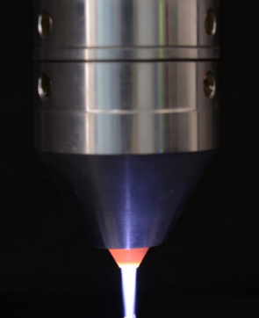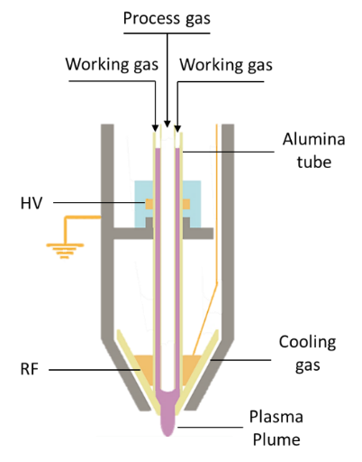

Figure 1. Photo of the atmospheric pressure plasma jet (© Nadir s.r.l. Plasma&Polymers) in use (left); graphical scheme of the main parts of the device (right).

This device can be operated like a pen, making it possible to deposit coatings on concave and convex surfaces uniformly and with minimal material use, thereby addressing the critical need for non-invasive conservation methods. It has demonstrated that room temperature operation does not generate electrodes deposition on the substrate, has high efficiency rates, is cost-effective for restoration works, is suitable for localised treatment, can be easily stopped by the restorer and can operate in-situ [16].
We intentionally chose this dual-frequency jet to achieve a higher density of reactive species on the surface and maintain a lower temperature compared to non-transferred arc configurations. This choice helps prevent inhomogeneity, localized heating from streamer discharges, and low substrate interaction seen in radiofrequency (RF) setups. Conversely, the dual-frequency configuration allows for controlling plasma propagation over dielectric surfaces within a diffused RF regime [17]. Thus, the device ensures its operation on glass surfaces primarily induces chemical activation, forming hydroxyl groups without morphological changes. Simultaneously, it facilitates the deposition of uniform and conformal nanoscale coatings at low temperatures [18], indicating promising barrier properties.
Upon contact of precursor vapours with the plasma plume, dissociation and fragmentation reactions occur. The products land on the substrate where surface reactions take place. Finally, through coalescence and aggregation phenomena, a nanostructured coating is formed on the substrate. More detailed representations of the device are available in the Supporting Information in Figures 1S and 2S.
As illustrated in Figure 2S, a nozzle-sample distance of 4 mm was used for all the depositions to have an adequate spreading of the plasma plume over the sample surface. A partial overlap between each line scan was applied to obtain an even deposition and a uniform coverage. Two different plasma operating conditions were explored, one at high RF power (30 W) and the other at low RF power (15 W).

Deposition parameters
To compare the performance of the plasma-polymerised coatings, plasma parameters were meticulously adjusted to achieve coatings with similar thicknesses. This was done considering that the vapour pressure of the precursor - and consequently the precursor flow rate - and the input RF power are two of the most important controllable parameters in plasma polymerisation, as they are strongly linked to the properties of the deposited film [19,20].
HMDSO has a high vapor pressure of approximately 60 hPa at ambient temperature [21], while TEOS has a considerably lower vapor pressure of around 2 hPa [22]. To account for this difference in volatility, the process gas flux was carefully modulated: for the less volatile TEOS, fluxes between 1 slm and 2 slm were used, whereas for the more volatile HMDSO, fluxes between 0.1 slm and 0.5 slm were employed (Table 1).
Regarding the RF power, it is well established that the input power significantly affects gas ionization and, consequently, the fragmentation reactions of the precursor molecules [23]. Therefore, to avoid wasting unreacted precursor, lower fluxes were applied when a low RF power was applied while higher fluxes were applied when high RF power was applied. However, increased RF power also results in higher process temperatures [24]. To counteract this effect, the speed of the plasma torch was increased when operating at high power settings, allowing for more efficient cooling of the substrate. This adjustment required a greater number of layers to deposit the same amount of material compared to depositions carried out at lower power levels, where the plasma speed was lower (Table 1).
Table 1. Plasma parameters employed for the deposition of coatings with comparable thickness.
Sample name | Precursor | RF  (W) | Working gas flux  (slm) | Process gas flux  (slm) | Scan speed  (mm/s) | n° of layers
TPL | TEOS | 15 | 9.0 | 1.0 | 4 | 3
TPH | TEOS | 30 | 8.0 | 2.0 | 8 | 6
HPL | HMDSO | 15 | 9.9 | 0.1 | 4 | 3
HPH | HMDSO | 30 | 9.5 | 0.5 | 8 | 6

  - Artificial ageing tests
The resistance to atmospheric alteration was assessed through artificial ageing tests. The testing protocol involved cycling the relative humidity between 90% and 10% every 48 hours over a duration of 22 days, while maintaining a constant temperature of 70°C.
For this procedure, glass slides were positioned vertically on a perforated ceramic disc at the centre of a glass desiccator and secured using coated tempered steel paper clamps. The relative humidity was adjusted by adding or removing MilliQ water from the base of the desiccator. Temperature control was achieved by placing the desiccator inside an oven, and both humidity and temperature were regularly monitored using a digital thermometer and hygrometer equipped with an external probe.

  - Characterization techniques
    - Surface profilometry
The coating thickness was measured using a mechanical stylus-based surface profiler (KLA-Tencor AlphaStep 500). A step was generated between the film and the substrate by masking a portion of the glass slide with duct tape. Following the deposition process, the tape was removed, and the exposed glass surface was cleaned by gently wiping with a low-lint cloth (Kimtech™ Science) moistened with ethanol. To determine the step height, at least three line-cans were performed at different locations, and the average value was calculated to provide the most accurate estimate. To avoid potential damage or scratching of the coating, the stylus force was kept below 7 mg.
    - Infrared spectroscopy
The chemical structure of the coatings was analysed using a portable FT-IR spectrometer (Bruker Alpha II) in both attenuated total reflectance (ATR-IR) and specular reflectance (SR-IR) configurations. Each spectrum was collected over a wavenumber range of 400 cm⁻¹ to 4000 cm⁻¹, with 128 scans recorded at a spectral resolution of 4 cm⁻¹. For SR-IR measurements, a gold mirror served as the reference standard, while air was used as the background for ATR-IR. To enhance the clarity of peaks in low absorbance bands that were initially obscured by noise, spectral smoothing was applied using the Savitzky-Golay algorithm.
    - X-ray photoelectron spectroscopy
X-ray photoelectron spectroscopy (XPS) analyses were conducted on both coated and uncoated glass samples using an ESCALAB QXi spectrometer (Thermo Fischer, Waltham, MA, USA), equipped with a monochromatic Al Kα source (15 kV, 20 mA) and a charge compensation gun to correct surface charging effects. Survey spectra were collected at a pass energy of 100 eV, with a 0.5 eV/step size and a dwell time of 50 ms/step, while detailed spectra were obtained at 20 eV pass energy, 0.1 eV/step size, and 25 ms/step dwell time. The analyzed area had a linear dimension of 0.9 mm. For each sample, we performed the analysis on at least three different points on its surface.
Charge compensation and binding energy (BE) calibration were initially based on the BE of the O1s band in silicate glass at 532.7 eV [25], as oxygen, due to its anionic nature, exhibits minimal sensitivity to chemical shifts. The consistency of charge compensation was further validated using the positions of the Si2p band (around 103.3 eV in silicate glasses). We preferred this charge correction procedure because, as is well known in the literature [24,25], the use of the C1s band of adventitious (hydro)carbon contamination as a reference for the binding energy scale is not without ambiguity and may lead to misjudgments of surface charging. Anyway, after the charging correction, the BE position of C1s band for adventitious carbon exhibited only small variations, remaining around 285.0 eV. Deconvolution of XPS signal components was carried out using Avantage software. Elemental quantification was performed by integrating the photoelectron bands for Si2p, O1s, C1s, Na1s, and Ca2p, following Shirley-type background subtraction.
    - Atomic force microscopy
The morphological and mechanical properties of the coatings were assessed using an atomic force microscope (Bruker Dimension Icon AFM) operating in PeakForce Tapping® (PFT) mode. This technique works by intermittently contacting the sample in a non-resonant mode, effectively combining the benefits of both contact mode and tapping mode imaging. PFT mode was used to minimise damaging lateral forces common to contact mode while avoiding the filtering effect and dynamics of the resonating system typical of TappingMode.
The measurements were carried out under ambient conditions at room temperature, with the microscope enclosed in an acoustic hood to reduce vibrational noise. Monolithic silicon AFM probes (Tap300Al-G, Budget Sensors) were employed to characterize both the morphology and mechanical properties of the film at the nanometer scale. Deflection sensitivity was calibrated on a sapphire surface, the spring constant was determined using the Sader method, and the tip radius was estimated by the relative method on Bruker’s polystyrene test sample.
The AFM probe cantilever was vertically oscillated at 1 kHz, a frequency well below its resonance, which helped avoid filtering effects. The peak-force amplitude was set to 30 nm, and a peak force set point of 15 nN was applied. A scanning rate of 0.601 Hz was used, and force-distance curves were recorded each time the AFM tip contacted the sample surface, corresponding to each pixel (image resolution = 256 px × 256 px). For each experiment, at least three measurements were performed on three distinct areas of the sample, with a representative result included in this thesis. The Young’s modulus was calculated by fitting a portion of the unloading curve using the Derjaguin–Muller–Toporov (DMT) model:
$$F-F_{adh}=\frac{4}{3}E^{*}\sqrt{R{(d-d_{0})}^{3}}$$
where $F-F_{adh}$ is the force on the cantilever relative to the adhesion force, $E^{*}$ is the reduced modulus, $R$ is the tip radius, and $d-d_{0}$ is the sample deformation.
The fit provides the reduced modulus $E^{*}$, which relates to the Young’s modulus of the sample through the following equation:
$$E^{*}={\left[\frac{1-ν_{s}^{2}}{E_{s}}+\frac{1+ν_{tip}^{2}}{E_{tip}}\right]}^{-1}$$
where $ν_{s}$ and $E_{s}$ are the Poisson’s ratio and the modulus of the sample, respectively, and $ν_{tip}$ and $E_{tip}$ represent the Poisson’s ratio and modulus of the tip. The value of $ν_{s}$ was set based on the recommended values from Bruker, as listed in Table 2.

Table 2. Poisson’s ratio values recommended by Bruker according to the elastic modulus range.
$$E_{s}$$ | $$ν_{s}$$
$$E_{s}≤100 MPa$$ | 0.5
$${0.1 GPa<E}_{s}≤1 GPa$$ | 0.4
$${1 GPa<E}_{s}≤10 GPa$$ | 0.3

    - Contact angle measurements
In this study, advancing contact angle (ACA) and receding contact angle (RCA) were measured under quasi-static conditions using the needle-in-sessile drop method graphically represented in Figure 3S. In this study, ACA and RCA were measured using the needle-in-sessile-drop method graphically schematized in Fig. 2. This technique involves the use of a motorized syringe to slowly pump water in and out of a needle located very close to the sample, so that the tip is embedded in the water drop. A video is recorded, and each frame is later analysed by performing a software-based fitting procedure to determine the contact angle at the right moment the image was captured. Then, contact angle values from all the images where the contact line is advancing or receding are averaged to obtain the ACA and the RCA, respectively.
To ensure reproducibility and mitigate potential issues arising from open-system equilibration, the advanced setup reported in Figure 2 was employed. The sample was positioned on a support within a plastic container partially filled with the liquid used for the contact angle measurements. The container was then sealed with a polymeric film (Parafilm), through which the syringe needle was inserted. This isolation provided conditions for the equilibration of the specimen surface with the vapours of the measurement liquid, addressing a commonly overlooked aspect critical for reliable contact angle data. Measurements were repeated on three different points for each sample.

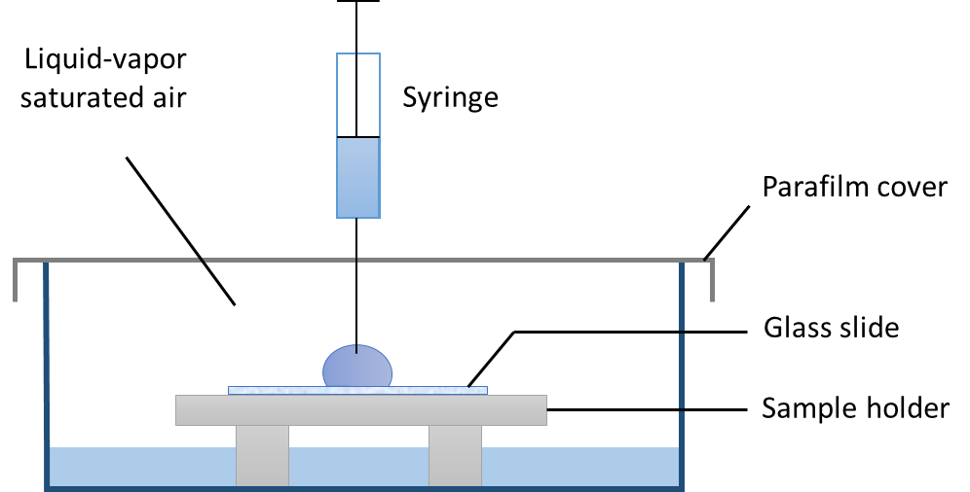
Figure 2. Graphical scheme of the experimental setup for contact angle measurements.
    - Optical microscopy
The surface appearance was characterized with an optical microscope (Olympus BX43) in transmitted brightfield configuration. The microscope was coupled with a 3.1-megapixel digital colour camera (Olympus LC30) and the image acquisition was realised through the CellSens entry software. Measurements were repeated three times on different points.
- Results and discussion
The various coatings produced through plasma deposition were studied using a correlative approach to evaluate how deposition parameters — such as the type of precursors, plasma power, and plasma torch scanning rate — affect the final chemical and physical properties of the films. Specifically, a comprehensive assessment was conducted using multiple techniques to characterize the coatings' barrier properties and their resistance to environmental ageing. In selecting the characterization methods, we prioritized techniques that are best suited for nanometric coatings on dense substrates such as glass. While we acknowledge the value of advanced structural analyses like solid-state NMR, Raman spectroscopy, or porosity measurements, these are either poorly suited to the amorphous and thin nature of our coatings, or not typically applied in this context due to technical limitations (e.g., insufficient sample mass or substrate interference). Instead, we adopted a correlative strategy more appropriate for assessing densification, chemical evolution, and functional performance in ultrathin plasma-deposited films.
An additional aspect of the coatings that was preliminarily assessed is their clarity and transparency. Upon visual inspection, the plasma-deposited thin films exhibit subtle structural colours that are barely noticeable to the naked eye when applied to glass slides. For further details on the optical properties and colorimetric spectra of the treated samples, please refer to Figure S5 in the Supporting Information.
  - Chemical properties in the as-deposited coatings: analysis and effects
Both the SR-IR and ATR-IR spectra of the plasma-polymerised silica thin films were analysed to investigate the structural differences arising from the use of HMDSO and TEOS.
The SR-IR spectrum of the pristine glass slide from 1250 cm⁻¹ to 400 cm⁻¹ shows two dominant peaks at ≈ 1060 cm⁻¹ and ≈ 466 cm⁻¹ and a smaller peak at ≈ 763 cm⁻¹ (Figure 3a). The peak at approximately 1060 cm⁻¹ is due to the stretching motion of the Si-O-Si bond in the silicate network, as demonstrated by theoretical calculations conducted by Bell [26]. These are referred to as bridging oxygen (BO) atoms because they connect neighbouring silicon atoms in the silicate network [27]. Later, Galeener suggested that the dominant peak at approximately 1060 cm⁻¹ is associated to the asymmetric Si-O-Si stretch, the weak band at ≈ 765 cm⁻¹ is due to the symmetric Si-O-Si stretch, and the ≈ 466 cm⁻¹ band arises from the rocking motion of Si-O-Si [28]. These assignments have been adopted in IR spectroscopy studies ever since [29–31].
The small shoulder observed at approximately 950 cm⁻¹ (Figure 3a) has been suggested to be associated with the stretching vibration of Si-OH or Si-O- species [32]. These species are known as non-bridging oxygen (NBO) atoms because they interrupt the network connectivity [33]. Historically, the 950 cm⁻¹ band was attributed to the vibration of Si-O of NBOs associated with modifier ions [34]. Recently, molecular dynamics simulations showed that the 950 cm⁻¹ shoulder could be the vibrations of the Si-O-Si network with a red-shift from the ≈ 1060 cm⁻¹ position due to the network disruption caused by NBOs rather than being a specific vibration of NBOs only [35].
Conversely, the SR-IR spectra of the plasma-derived TEOS coatings (Figure 3a) both at low (TPL) and high power (TPH) show a main peak attributed to the antisymmetric stretching vibrations of the Si-O-Si bond falling at approximately 1095 cm⁻¹ [36], blueshifted compared to the pristine glass spectrum. The position of this stretching peak shifts significantly to lower wavenumbers when considering plasma-polymerised HMDSO coatings both at low (HPL) and high power (HPH). This phenomenon is probably due to the increase in organic content within the deposited film [37], which has altered the silica network structure causing changes in the vibrational frequencies of the Si-O-Si bonds. Moreover, the SR-IR spectra of all the plasma-deposited films show the presence of a band between 990 cm⁻¹ and 945 cm⁻¹ related to the stretching vibrations of Si bonded to hydroxyl groups (Si-OH) [38], which decreases in intensity as a function of power. This trend can be explained considering that the power seems to favour a more inorganic character of the film (SiO₂-like) and likely promotes the condensation of vicinal silanol groups, to form Si–O–Si bridges (with loss of water) [39].
In the case of the hybrid films (HPL and HPH), bands related to the retention of methyl groups inside the coating were detected, confirming the plasma-induced incorporation of organic fragments. This spectral evidence, together with the appearance of Si–CH₃ and Si–O–Si structures, supports the formation of a cross-linked network consistent with plasma polymerisation processes. Specifically, the band at 800 cm⁻¹ is assigned to the CH₃ rocking vibrations in Si–(CH₃)₂ groups, the shoulder at 840 cm⁻¹ is attributed to Si–CH₃ rocking vibration in Si–(CH₃)₃ groups, and the 1260 cm⁻¹ peak is related to the CH₃ symmetric bending in Si–CH₃ bonds [40]. Further confirmation of the retention of the organic groups was provided by the ATR-IR bands at ≈ 2970 cm⁻¹ (CH₃ symmetric stretching) and ≈ 2910 cm⁻¹ (CH₃ asymmetric stretching), as well as the band at 1270 cm⁻¹ assigned to the CH₃ symmetric bending in Si–CH₃ bonds [41].
Considering the low wavenumber region in the ATR-IR measurements (Figure 3b), the main maximum at approximately 910 cm⁻¹ is attributed to the asymmetric Si-O-Si stretch of glass, while the shoulder at ≈ 1050 cm⁻¹ is assigned to the asymmetric stretching vibrations of the Si-O-Si groups in the inorganic plasma-polymerised coatings [42]. Similarly to what observed in SR-IR, this shoulder shifts towards lower wavenumbers as the organic content in the coating increases.
In the high wavenumber region (Figure 3c), the presence of water was confirmed by the band at ≈ 1650 cm⁻¹ which is due to bending vibrations of the water molecules. Additionally, a broad band from 2500 cm⁻¹ to 3700 cm⁻¹ associated to different OH stretching vibrations was observed [9,43]. Specifically, the prominent band around 3400 cm⁻¹ is attributed to the OH stretching vibrations of hydrogen-bonded Si-OH, while the shoulder at approximately 3650 cm⁻¹ is assigned to OH stretching vibrations of isolated Si-OH [44].
a
b
c
Figure 3. Comparison between the as deposited TPL, TPH, HPL, HPH plasma-polymerised films and pristine glass using SR-IR configuration (a), ATR-IR configuration in the range of low wavenumbers (b), and ATR-IR configuration in the range of high wavenumbers (c).
The adjustment of plasma polymerisation parameters was crucial for controlling the final thickness of the films. The coating thickness was measured to be approximately 100 nm across the different samples studied in this work (Table 3). Achieving these thickness values confirmed that the process requires twice the number of layers when plasma deposition is performed at high power, as initially hypothesized during parameter selection.
Table 3. Average thickness measured for the different coatings using surface profilometry.
Sample name | n° of layers | Thickness  (nm)
TPL | 3 | 110 ± 10
TPH | 6 | 115 ± 10
HPL | 3 | 105 ± 15
HPH | 6 | 120 ± 10

ACA and RCA measurements were conducted on the hybrid samples to verify from a macroscopic (and large-scale) point of view that the addition of organic groups does indeed promote hydrophobicity, as well as to indirectly assess the retention of the methyl groups in the plasma-polymerised coatings (as indicated by ATR-IR spectra) and to investigate the homogeneity of the depositions. The ACA and RCA results are reported in detail in the Supporting Information (Figure 4S) and summarised in Table 4.
The HPH thin film achieved an advancing contact angle of 98° and a receding contact angle of 80°, while the HPL coating reached an advancing contact angle of 98° and a receding contact angle of 87° (Table 4). According to the definition of hydrophobicity of a surface based on the contact angle being higher than 90° [45], both coatings can be classified as hydrophobic. Their similar ACA values, which align with findings in the literature [46], suggests that both low power and high power configurations successfully managed to incorporate methyl groups into the film structure.
However, the higher hysteresis observed in the HPL coating compared to the HPH coating indicates that the surface of the HPL film might be rougher, potentially creating more pinning sites where water droplets tend to stick. This increased roughness could be attributed to the lower power used during the deposition of the HPL coating. In contrast, higher plasma power typically results in greater energy density which can enhance cross-linking, therefore densification of the coating [47]. This process could lead to a smoother and more homogeneous surface, as in the case of the HPH coating. It was confirmed that the plasma power employed during deposition played a critical role in determining the surface characteristics of the coatings, affecting their wetting behaviour and overall performance.

Table 4. ACA and RCA values of the hybrid films with the calculated contact angle hysteresis.
 | ACA | RCA | Hysteresis
HPL | 98°±1° | 80°±1° | 18°±2°
HPH | 98°±1° | 87±1° | 11°±2°

  - Ageing resistance and barrier properties of the plasma-polymerised coatings
After accelerated ageing, the protective effect of both inorganic and hybrid coatings was readily evident through simple visual inspection, as shown in Figure 5S of the Supporting Information.
The differences between the treated and untreated areas were investigated by transmitted brightfield OM (Figure 4). The uncoated section exhibits numerous white spots and an overall foggy appearance, indicative of surface degradation from atmospheric alteration phenomena. In contrast, the sections coated with inorganic, and hybrid plasma-polymerised coatings showed no visible signs of deterioration, retaining their original appearance.
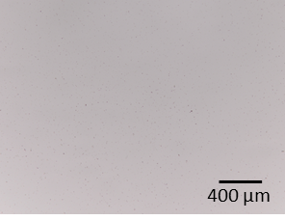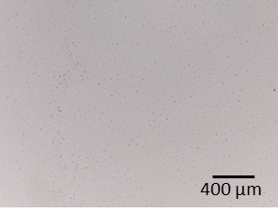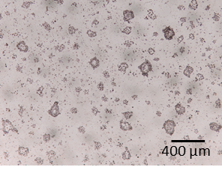
e
b
a
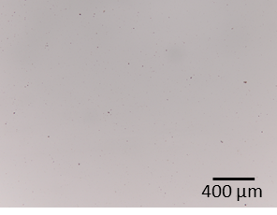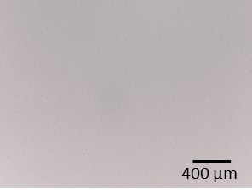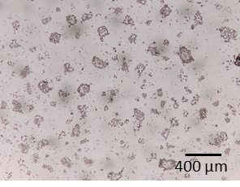
d
c
f
Figure 4. Optical microscopy images in transmitted brightfield mode of the TPL film (a), TPH film (b), HPL film (c), HPH film (d) and glass slide after artificial ageing tests (e, f).

Further details regarding the structural modifications induced by atmospheric alteration were obtained from SR-IR and ATR-IR spectra collected after artificial ageing.
In the inorganic plasma-polymerised coatings (TPL and TPH) no significant variations in the vibrational frequencies of the Si-O-Si bonds were detected in ATR-IR spectra (Figures 5a, b). However, the SR-IR spectra (Figure 5e) revealed a slight blueshift (≈ 6 cm⁻¹) in the main peak associated with the antisymmetric stretching vibrations of the Si-O-Si bond at approximately 1095 cm⁻¹. This shift suggests potential rearrangements within the silica network of the plasma-polymerised films. Additionally, a shoulder band near 1020 cm⁻¹ emerged, which likely corresponds to Si–O–Si asymmetric stretching at smaller bond angles [48]. This band was more pronounced in the TPL film compared to the TPH coating, indicating that the TPL film may have undergone more significant structural changes during the artificial ageing process.
For the hybrid plasma-polymerised films (HPL and HPH), the ATR-IR spectra of the high-power deposition (HPH) showed no significant changes in the vibrational frequencies of the Si-O-Si bonds (Figures 5c, d). Conversely, the low-power deposition (HPL) exhibits a shift in the shoulder around 1020 cm⁻¹ towards wavenumbers closer to those observed in the TPL and TPH. This shift suggests a transition towards a more inorganic-like character of the coating, possibly due to the lower polymerization efficiency under reduced plasma power.
In the SR-IR spectra (Figure 5f), both HPL and HPH coatings exhibited a slight blueshift (≈ 8 cm⁻¹) in the main Si-O-Si antisymmetric stretching peak. Notably, the HPL coating also showed a blueshift in the Si-OH stretching band, supporting the hypothesis of a greater degree of structural change towards a more inorganic nature in the low-power deposition. Despite these structural changes, the retention of organic methyl groups within both low and high-power hybrid plasma-polymerised coatings was confirmed by distinct spectral features. These include the band at 800 cm⁻¹ (CH₃ rocking vibrations in Si–(CH₃)₂ groups), the shoulder at 840 cm⁻¹ (Si–CH₃ rocking vibrations in Si–(CH₃)₃ groups) in the SR-IR spectra, and the bands at 2970 cm⁻¹ (CH₃ symmetric stretching), 2910 cm⁻¹ (CH₃ asymmetric stretching), and 1270 cm⁻¹ (CH₃ symmetric bending in Si–CH₃ bonds) in the ATR-IR spectra.
Low power plasma-polymerised coatings, both inorganic and hybrid, appeared more susceptible to structural modifications upon ageing. However, no signals attributable to carbonates were detected in either low power or high-power deposition, indicating that both plasma configurations could successfully polymerise films with a protective effect against degradation phenomena [49].
c
d
b
a
f
e
Figure 5. Comparison between the inorganic plasma-polymerised films before and after ageing in ATR-IR configuration (a, b); the hybrid plasma-polymerised films before and after ageing in ATR-IR configuration (c, d); the inorganic plasma-polymerised films before and after ageing in SR-IR configuration (e); the hybrid plasma-polymerised films before and after ageing in SR-IR configuration (f).

To complement the ATR-IR findings, XPS analysis were conducted following artificial ageing tests to evaluate the barrier properties of the inorganic and hybrid plasma-polymerised films against the leaching of modifier ions. As reported in Table 5, the XPS results indicated a lower concentration of sodium ions on the surface of the hybrid coatings after ageing, suggesting a more effective barrier against sodium ion migration compared to the inorganic films. This suppression was particularly pronounced in the HPH coating, likely due to the enhanced polymerization efficiency achieved through the higher power used during deposition. Additionally, the hybrid plasma-polymerised films appeared more effective in blocking calcium diffusion, whereas the inorganic coatings provided only partial protection against the leaching of calcium.

Table 5. Composition data (in atomic percentage) obtained by XPS analyses on the surface of the inorganic and hybrid plasma-polymerised thin films after artificial ageing tests compared to the glass slide after ageing. The small amount of C contamination was not considered. The suppression of Na and Ca leaching in coated samples after ageing confirms the barrier function of the plasma-polymerised films, particularly for hybrid compositions.

%at | Glass slide  pristine | Glass slide  aged | TPL aged | TPH aged | HPL aged | HPH aged
Si | 23.4 | 12.8 | 19.0 | 18.0 | 29.2 | 32.9
O | 67.7 | 69.4 | 65.8 | 66.4 | 62.7 | 63.6
Na | 7.1 | 8.8 | 11.8 | 11.0 | 8.1 | 3.5
Ca | 1.8 | 9.0 | 3.4 | 4.6 | / | /

To better understand the differences in protective behaviour between the inorganic and hybrid plasma-polymerised films, as indicated by XPS analyses, morphological and mechanical analyses at the nanometric scale were performed using AFM.
As shown in Figure 6, AFM analysis revealed substantial changes in the surface morphology of both coating compositions after ageing. In the inorganic samples, the initial smoother texture evolved into a different structure characterized by the presence of aggregated nanoparticles of varied sizes. In the TPH film, these nanoparticles were observed to have smaller diameters (less than 100 nm) and be densely packed into clusters approximately 500 nm in diameter. Conversely, the TPL film exhibited larger nanoparticles, with diameters exceeding 100 nm, which were less densely packed and distributed more randomly across the surface. This transformation in surface morphology is likely due to crosslinking and densification processes induced by temperature during the artificial ageing tests. Similar behaviours have been documented in the literature during the curing process of TEOS-based films polymerised by plasma, where elevated temperatures drive the crosslinking reactions, resulting in changes to the film’s microstructure [50]. These densification phenomena may have caused uncontrolled shrinkage of the film, leading to the formation of fissures that likely served as preferential sites for water attack. This could have contributed to the leaching of alkaline ions, explaining the higher concentration of Na and Ca detected by XPS on inorganic coatings after ageing (Table 5).

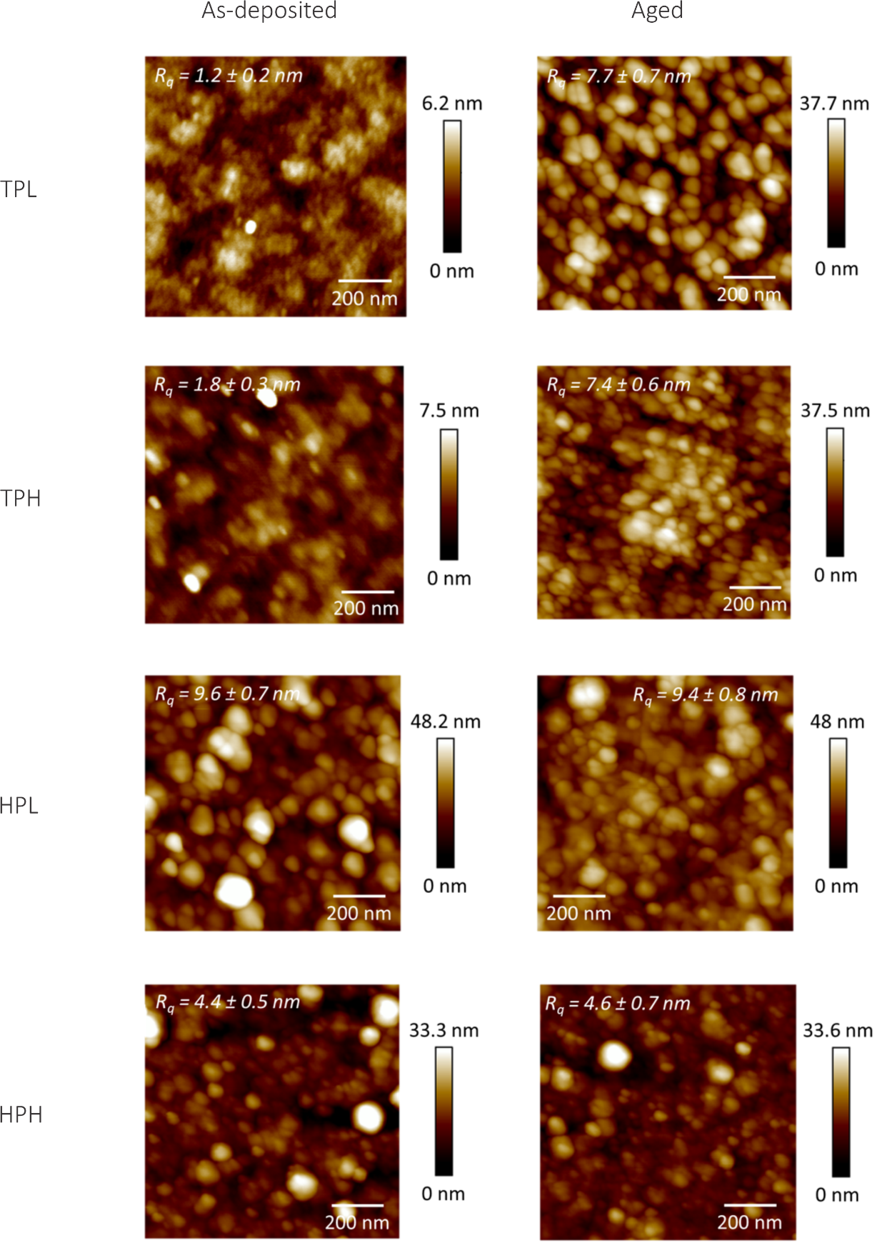
Figure 6. Comparison between the inorganic (TPL, TPH) and hybrid (HPL, HPH) plasma-polymerised films before and after ageing with AFM analysis. The line scan recorded along the lines marked in each AFM image are reported in the Supporting Information in Figure 6S.
In the case of the hybrid compositions, both HPL and HPH films presented a granular surface immediately after deposition. This result was expected as it is a consequence of the low precursor’s concentration introduced into the plasma during deposition. This deposition condition promotes a high degree of monomer fragmentation, which in turn leads to film growth primarily through the adsorption and recombination of the generated radicals on the substrate surface. The process results in the formation of a film with a high degree of cross-linking and, from a morphological perspective, nanoscale structuration [51].
Considering the surface parameters, the root mean square (R_{q}) roughness of the HPL coating is higher compared to the one of the HPH film. This increase in R_{q} in the HPL coating could be attributed to the lower degree of crosslinking resulting from the reduced power of the plasma during deposition.
After ageing, the surface morphology and roughness of both HPL and HPH coatings remained mostly unchanged, indicating that the nanoscale structures were retained despite the artificial ageing process. This suggested a robust nano-structural texture of the coating that does not degrade over time.
For reference, the roughness and morphology of the untreated glass are markedly different from those of the treated samples, as shown in Figure 7S of the Supplementary Information.
In terms of mechanical properties, both HPL and HPH coatings initially exhibited an elastic modulus of approximately 1 GPa, consistent with the values reported in literature for similar plasma-polymerised films [49]. However, following artificial ageing, a divergence in their performance was observed, as reported in Table 6. The elastic modulus E of HPL coating doubled, suggesting that the ageing process may have led to partial degradation or volatilization of the organic groups, resulting in a denser, more rigid inorganic network. Conversely, the HPH coating maintained its initial elastic modulus, implying that the film had stronger crosslinking, which effectively anchored the organic components, thereby preserving the mechanical integrity of the coating over time.
Although elastic modulus provided valuable insight into the internal cohesion and rigidity of the coatings, it does not fully assess interfacial adhesion strength, which also depends on chemical bonding at the coating-substrate interface. Further studies focusing on adhesion and peel resistance would be valuable to fully characterize the mechanical durability of these coatings, as has been performed in similar studies on silica-based plasma-polymerized coatings deposited on glass [52].
However, the presence of a nanostructured, continuous coating and its mechanical differentiation from the substrate, confirmed by AFM imaging and mechanical analysis, further demonstrate the formation of a robust plasma-polymerised film capable of acting as a protective barrier.
Table 6. Elastic modulus values of the hybrid plasma-polymerised coatings before and after ageing.
 | E_{HPL}  (GPa) | E_{HPH}  (GPa)
As dep | 1.0 ± 0.1 | 0.9 ± 0.2
After ageing | 2.2 ± 0.2 | 1.0 ± 0.2

- Conclusion
This study investigated the use of an atmospheric pressure plasma jet to deposit protective coatings on glass surfaces. While this technology is widely recognised as an innovative and promising method for controlled film deposition, its application for coating cultural heritage glass remains largely unexplored.
The coatings were successfully deposited under two distinct plasma operating conditions - low RF power (15 W) and high RF power (30 W) - at atmospheric pressure and room temperature. Key plasma parameters, including precursor flow rate, plasma torch speed, and the number of deposited layers, were shown to influence the morphology and thickness of the coatings when carefully optimised. This enabled the production of coatings with different compositions while maintaining comparable thicknesses.
Inorganic plasma-polymerised films, despite their advantages, exhibited only a limited degree of protection. ATR-IT and SR-IR analyses revealed that, while these coatings can prevent precipitate formation on glass surface, their performance is hindered by densification processes that occur during ageing. This densification accelerates the leaching of alkaline and alkaline-earth elements, compromising their protective capabilities. AFM morphological maps further confirmed the presence of densification phenomena in inorganic films, highlighting structural degradation. XPS analysis supported these findings, showing that the inorganic coatings offer only partial protection against leaching of modifier ions.
In contrast, hybrid plasma-polymerised coatings demonstrated superior protective properties, likely due to the incorporation of organic groups that enhanced barrier performance and effectively prevented or limited alkaline and alkaline-earth leaching. XPS analysis revealed the improved environmental resistance of these hybrid films, while AFM morphological maps confirmed the stability of their structural features and surface roughness parameters over time, even after ageing. These findings highlight the durability of hybrid coatings. However, ATR-IR spectra and elastic modulus measurements indicated a loss of organic content in the low-power hybrid coating, attributed to a lower degree of crosslinking achieved under reduced plasma power. This emphasizes the importance of optimising plasma conditions to achieve the desired film properties.
The findings of this work demonstrated that plasma-polymerised thin films - formed through precursor fragmentation and recombination under plasma - offer a promising alternative for protective surface treatments on glass, yielding transparent, highly adherent coatings that contribute to the preservation of this fragile and unique material and paving the way for more effective preservation strategies for cultural heritage objects and a broad range of other applications.

References

[1] O. Majérus, P. Lehuédé, I. Biron, F. Alloteau, S. Narayanasamy, D. Caurant, Glass alteration in atmospheric conditions: crossing perspectives from cultural heritage, glass industry, and nuclear waste management, Npj Mater Degrad 4 (2020) 1–16. https://doi.org/10.1038/s41529-020-00130-9.
[2] R. Zanini, G. Franceschin, E. Cattaruzza, A. Traviglia, A review of glass corrosion: the unique contribution of studying ancient glass to validate glass alteration models, Npj Mater Degrad 7 (2023) 1–17. https://doi.org/10.1038/s41529-023-00355-4.
[3] S. Centenaro, G. Franceschin, E. Cattaruzza, A. Traviglia, Consolidation and coating treatments for glass in the cultural heritage field: A review, Journal of Cultural Heritage 64 (2023) 132–143. https://doi.org/10.1016/j.culher.2023.09.006.
[4] S. Davison, R.G. Newton, Conservation and Restoration of Glass, 2nd ed., Routledge, London, 2003. https://doi.org/10.4324/9780080569314.
[5] R. Bertoncello, L. Milanese, J.C. Dran, A. Bouquillon, C. Sada, Sol–gel deposition of silica films on silicate glasses: Influence of the presence of lead in the glass or in precursor solutions, Journal of Non-Crystalline Solids 352 (2006) 315–321. https://doi.org/10.1016/j.jnoncrysol.2005.12.005.
[6] G. Injeti, Applied Surface Science, 2019. https://doi.org/10.5772/intechopen.78198.
[7] A. Uricchio, F. Fanelli, Low-Temperature Atmospheric Pressure Plasma Processes for the Deposition of Nanocomposite Coatings, Processes 9 (2021) 2069. https://doi.org/10.3390/pr9112069.
[8] J.Y. Jeong, S.E. Babayan, V.J. Tu, J. Park, I. Henins, R.F. Hicks, G.S. Selwyn, Etching materials with an atmospheric-pressure plasma jet, Plasma Sources Sci. Technol. 7 (1998) 282. https://doi.org/10.1088/0963-0252/7/3/005.
[9] S.E. Babayan, J.Y. Jeong, V.J. Tu, J. Park, G.S. Selwyn, R.F. Hicks, Deposition of silicon dioxide films with an atmospheric-pressure plasma jet, Plasma Sources Sci. Technol. 7 (1998) 286. https://doi.org/10.1088/0963-0252/7/3/006.
[10] C. Pflugfelder, N. Mainusch, I. Hammer, W. Viöl, Cleaning of Wall Paintings and Architectural Surfaces by Plasma, Plasma Processes and Polymers 4 (2007) S516–S521. https://doi.org/10.1002/ppap.200731218.
[11] M. Boselli, C. Chiavari, V. Colombo, M. Gherardi, C. Martini, F. Rotundo, Atmospheric pressure non-equilibrium plasma cleaning of 19th century daguerreotypes, Plasma Processes and Polymers 14 (2017) 1600027. https://doi.org/10.1002/ppap.201600027.
[12] X. Yan, G.-S. Liu, J. Yang, Y. Pu, S. Chen, H.-W. He, C. Wang, Y.-Z. Long, S. Jiang, In Situ Surface Modification of Paper-Based Relics with Atmospheric Pressure Plasma Treatment for Preservation Purposes, Polymers 11 (2019) 786. https://doi.org/10.3390/polym11050786.
[13] Y.-C. Lin, M.-J. Wang, Fabrication of hydrophobic/hydrophilic HMDSO films by atmospheric pressure plasma jet deposition, Jpn. J. Appl. Phys. 58 (2018) SAAC01. https://doi.org/10.7567/1347-4065/aaea6c.
[14] Md.M. Hossain, Q.H. Trinh, D.B. Nguyen, M.S.P. Sudhakaran, Y.S. Mok, Robust hydrophobic coating on glass surface by an atmospheric-pressure plasma jet for plasma-polymerisation of hexamethyldisiloxane conjugated with (3-aminopropyl) triethoxysilane, Surface Engineering 35 (2019) 466–475. https://doi.org/10.1080/02670844.2018.1524037.
[15] A. Sonnenfeld, T.M. Tun, L. Zajíčková, K.V. Kozlov, H.-E. Wagner, J.F. Behnke, R. Hippler, Deposition Process Based on Organosilicon Precursors in Dielectric Barrier Discharges at Atmospheric Pressure—A Comparison, Plasmas and Polymers 6 (2001) 237–266. https://doi.org/10.1023/A:1014414016164.
[16] A. Patelli, E. Verga, L. Nodari, S.M. Petrillo, A. Delva, P. Ugo, P. Scopece, A customised atmospheric pressure plasma jet for conservation requirements, IOP Conf. Ser.: Mater. Sci. Eng. 364 (2018) 012079. https://doi.org/10.1088/1757-899X/364/1/012079.
[17] A. Patelli, S.G. Scaltriti, A. Popoli, E. Martines, A. Cristofolini, Plasma-substrate interaction in a dual frequency APPJ, Plasma Sources Sci. Technol. 34 (2025) 025010. https://doi.org/10.1088/1361-6595/adb514.
[18] A. Patelli, F. Mussano, P. Brun, T. Genova, E. Ambrosi, N. Michieli, G. Mattei, P. Scopece, L. Moroni, Nanoroughness, Surface Chemistry, and Drug Delivery Control by Atmospheric Plasma Jet on Implantable Devices, ACS Applied Materials & Interfaces 10 (2018) 39512–39523. https://doi.org/10.1021/acsami.8b15886.
[19] S. Kurosawa, B.-G. Choi, J.-W. Park, H. Aizawa, K.-B. Shim, K. Yamamoto, Synthesis and characterization of plasma-polymerized hexamethyldisiloxane films, Thin Solid Films 506–507 (2006) 176–179. https://doi.org/10.1016/j.tsf.2005.08.210.
[20] B. Akhavan, K. Jarvis, P. Majewski, Tuning the hydrophobicity of plasma polymer coated silica particles, Powder Technology 249 (2013) 403–411. https://doi.org/10.1016/j.powtec.2013.09.018.
[21] S.S. Ussenkhan, B.A. Kyrykbay, Y. Yerlanuly, A.T. Zhunisbekov, M.T. Gabdullin, T.S. Ramazanov, S.A. Orazbayev, A.U. Utegenov, Fabricating durable and stable superhydrophobic coatings by the atmospheric pressure plasma polymerisation of hexamethyldisiloxane, Heliyon 10 (2024) e23844. https://doi.org/10.1016/j.heliyon.2023.e23844.
[22] M. Sun, A. Yerokhin, A. Matthews, M. Thomas, A. Laukart, M. von Hausen, C.-P. Klages, Characterisation and Electrochemical Evaluation of Plasma Electrolytic Oxidation Coatings on Magnesium with Plasma Enhanced Chemical Vapour Deposition Post-Treatments, Plasma Processes and Polymers 13 (2016) 266–278. https://doi.org/10.1002/ppap.201500059.
[23] Atmospheric Plasma Surface Modification Effects, in: Atmospheric Pressure Plasma for Surface Modification, John Wiley & Sons, Ltd, 2012: pp. 55–79. https://doi.org/10.1002/9781118547519.ch3.
[24] N. Gomathi, A.K. Chanda, S. Neogi, Atmospheric Plasma Treatment of Polymers for Biomedical Applications, in: Atmospheric Pressure Plasma Treatment of Polymers, John Wiley & Sons, Ltd, 2013: pp. 199–215. https://doi.org/10.1002/9781118747308.ch7.
[25] NIST X-ray Photoelectron Spectroscopy Database - SRD 20, (2012). https://catalog.data.gov/dataset/nist-x-ray-photoelectron-spectroscopy-database-srd-20-40d6f (accessed January 24, 2025).
[26] R.J. Bell, P. Dean, Atomic vibrations in vitreous silica, Discuss. Faraday Soc. 50 (1970) 55–61. https://doi.org/10.1039/DF9705000055.
[27] J. Serra, P. González, S. Liste, C. Serra, S. Chiussi, B. León, M. Pérez-Amor, H.O. Ylänen, M. Hupa, FTIR and XPS studies of bioactive silica based glasses, Journal of Non-Crystalline Solids 332 (2003) 20–27. https://doi.org/10.1016/j.jnoncrysol.2003.09.013.
[28] F.L. Galeener, Band limits and the vibrational spectra of tetrahedral glasses, Phys. Rev. B 19 (1979) 4292–4297. https://doi.org/10.1103/PhysRevB.19.4292.
[29] P. McMillan, Structural studies of silicate glasses and melts—applications and limitations of Raman spectroscopy, American Mineralogist 69 (1984) 622–644.
[30] F. Gervais, A. Blin, D. Massiot, J.P. Coutures, M.H. Chopinet, F. Naudin, Infrared reflectivity spectroscopy of silicate glasses, Journal of Non-Crystalline Solids 89 (1987) 384–401. https://doi.org/10.1016/S0022-3093(87)80280-6.
[31] W.R. Taylor, Application of infrared spectroscopy to studies of silicate glass structure: Examples from the melilite glasses and the systems Na2O-SiO2 and Na2O-Al2O3-SiO2, Proc. Indian Acad. Sci. (Earth Planet Sci.) 99 (1990) 99–117. https://doi.org/10.1007/BF02871899.
[32] R.M. Almeida, T.A. Guiton, C.G. Pantano, Characterization of silica gels by infrared reflection spectroscopy, Journal of Non-Crystalline Solids 121 (1990) 193–197. https://doi.org/10.1016/0022-3093(90)90130-E.
[33] J. Serra, P. González, S. Liste, S. Chiussi, B. León, M. Pérez-Amor, H.O. Ylänen, M. Hupa, Influence of the non-bridging oxygen groups on the bioactivity of silicate glasses, J Mater Sci Mater Med 13 (2002) 1221–1225. https://doi.org/10.1023/a:1021174912802.
[34] D.M. Sanders, W.B. Person, L.L. Hench, Quantitative Analysis of Glass Structure with the Use of Infrared Reflection Spectra, Appl. Spectrosc., AS 28 (1974) 247–255.
[35] H. Liu, S.H. Hahn, M. Ren, M. Thiruvillamalai, T.M. Gross, J. Du, A.C.T. van Duin, S.H. Kim, Searching for correlations between vibrational spectral features and structural parameters of silicate glass network, Journal of the American Ceramic Society 103 (2020) 3575–3589. https://doi.org/10.1111/jace.17036.
[36] C. Martinet, R.A.B. Devine, Analysis of the vibrational mode spectra of amorphous SiO2 films, Journal of Applied Physics 77 (1995) 4343–4348. https://doi.org/10.1063/1.359459.
[37] K. Aumaille, C. Vallée, A. Granier, A. Goullet, F. Gaboriau, G. Turban, A comparative study of oxygen/organosilicon plasmas and thin SiOxCyHz films deposited in a helicon reactor, Thin Solid Films 359 (2000) 188–196. https://doi.org/10.1016/S0040-6090(99)00883-4.
[38] F. Hamelmann, U. Heinzmann, A. Szekeres, N. Kirov, T. Nikolova, Deposition of silicon oxide thin films in TEOS with addition of oxygen to the plasma ambient : IR spectra analysis, Journal of Optoelectronics and Advanced Materials 7 (2005) 389–392.
[39] M. Creatore, F. Palumbo, R. d’Agostino, Diagnostics and insights on PECVD for gas-barrier coatings, Pure and Applied Chemistry 74 (2002) 407–411. https://doi.org/10.1351/pac200274030407.
[40] E. Grimoldi, S. Zanini, R.A. Siliprandi, C. Riccardi, AFM and contact angle investigation of growth and structure of pp-HMDSO thin films, Eur. Phys. J. D 54 (2009) 165–172. https://doi.org/10.1140/epjd/e2009-00117-6.
[41] A. Lazauskas, J. Baltrusaitis, V. Grigaliūnas, D. Jucius, A. Guobienė, I. Prosyčevas, P. Narmontas, Characterization of Plasma Polymerized Hexamethyldisiloxane Films Prepared by Arc Discharge, Plasma Chem Plasma Process 34 (2014) 271–285. https://doi.org/10.1007/s11090-013-9516-y.
[42] D. Trunec, L. Zajíčková, V. Buršíková, F. Studnička, P. Sťahel, V. Prysiazhnyi, V. Peřina, J. Houdková, Z. Navrátil, D. Franta, Deposition of hard thin films from HMDSO in atmospheric pressure dielectric barrier discharge, J. Phys. D: Appl. Phys. 43 (2010) 225403. https://doi.org/10.1088/0022-3727/43/22/225403.
[43] K. Sano, S. Hayashi, S. Wickramanayaka, Y. Hatanaka, High quality SiO2 depositions from TEOS by ECR plasma, Thin Solid Films 281–282 (1996) 397–400. https://doi.org/10.1016/0040-6090(96)08701-9.
[44] J.A. Theil, D.V. Tsu, M.W. Watkins, S.S. Kim, G. Lucovsky, Local bonding environments of Si–OH groups in SiO2 deposited by remote plasma‐enhanced chemical vapor deposition and incorporated by postdeposition exposure to water vapor, Journal of Vacuum Science & Technology A 8 (1990) 1374–1381. https://doi.org/10.1116/1.576885.
[45] B. Bhushan, Y.C. Jung, Natural and biomimetic artificial surfaces for superhydrophobicity, self-cleaning, low adhesion, and drag reduction, Progress in Materials Science 56 (2011) 1–108. https://doi.org/10.1016/j.pmatsci.2010.04.003.
[46] L. Zhou, G.-H. Lv, H. Pang, G.-P. Zhang, S.-Z. Yang, Comparing deposition of organic and inorganic siloxane films by the atmospheric pressure glow discharge, Surface and Coatings Technology 206 (2012) 2552–2557. https://doi.org/10.1016/j.surfcoat.2011.11.011.
[47] J. Carneiro de Oliveira, A. Airoudj, P. Kunemann, F. Bally-Le Gall, V. Roucoules, Mechanical properties of plasma polymer films: a review, SN Appl. Sci. 3 (2021) 656. https://doi.org/10.1007/s42452-021-04655-9.
[48] A. Grill, D.A. Neumayer, Structure of low dielectric constant to extreme low dielectric constant SiCOH films: Fourier transform infrared spectroscopy characterization, Journal of Applied Physics 94 (2003) 6697–6707. https://doi.org/10.1063/1.1618358.
[49] N.J. Janowicz, H. Li, F.L. Heale, I.P. Parkin, I. Papakonstantinou, M.K. Tiwari, C.J. Carmalt, Fluorine-Free Transparent Superhydrophobic Nanocomposite Coatings from Mesoporous Silica, Langmuir 36 (2020) 13426–13438. https://doi.org/10.1021/acs.langmuir.0c01767.
[50] M. Pantoja, N. Encinas, J. Abenojar, M.A. Martínez, Effect of tetraethoxysilane coating on the improvement of plasma treated polypropylene adhesion, Applied Surface Science 280 (2013) 850–857. https://doi.org/10.1016/j.apsusc.2013.05.074.
[51] R.A. Siliprandi, S. Zanini, E. Grimoldi, F.S. Fumagalli, R. Barni, C. Riccardi, Atmospheric Pressure Plasma Discharge for Polysiloxane Thin Films Deposition and Comparison with Low Pressure Process, Plasma Chem Plasma Process 31 (2011) 353–372. https://doi.org/10.1007/s11090-011-9286-3.
[52] Md. Mokter Hossain, Q.H. Trinh, M.S.P. Sudhakaran, L. Sultana, Y.S. Mok, Improvement of mechanical strength of hydrophobic coating on glass surfaces by an atmospheric pressure plasma jet, Surface and Coatings Technology 357 (2019) 12–22. https://doi.org/10.1016/j.surfcoat.2018.09.071.

