Acid catalyzed synthesis of dimethyl isosorbide via dimethyl carbonate chemistry
Davide Dalla Torre, Mattia Annatelli¹ and Fabio Aricò
Department of Environmental Sciences, Informatics and Statistics, Ca’ Foscari University of Venice, Scientific Campus Via Torino 155, 30170 Venezia Mestre, Italy;
email: fabio.arico@unive.it; phone +39 (0)412348669.
ABSTRACT: Dimethyl isosorbide (DMI) is a bio-based solvent that can be used as green alternative for conventional dipolar media (dimethyl sulfoxide, dimethylformamide, and dimethylacetamide). The main synthetic procedures to DMI reported in the literature are based on the methylation of isosorbide employing different alkylating agents including toxic halogen compounds such as alkyl halides. A more sustainable alternative would be to employ dimethyl carbonate (DMC), a well-known green reagent and solvent, considered one of the most promising methylating agents for its good biodegradability and low toxicity. Indeed, in recent years, DMC-promoted methylation of isosorbide has been extensively exploited although mostly in the presence of a base or an amphoteric catalyst. In this work, we report for the first time a comprehensive investigation on the synthesis of DMI via DMC chemistry promoted by heterogeneous acid catalyst (Amberlyst-36 and Purolite CT275DR). Reaction conditions were optimized and then applied for the methylation of isosorbide and its epimers, isoidide and isomannide. Considerations on the related reaction mechanism were reported highlighting the difference in the preferred reaction pathways among this new synthetic approach and the previously reported base-catalyzed procedures.
- Introduction
Organic solvents are the main waste deriving by chemical transformations; they are used in large amount being essential for the synthesis, separation and purification of the desired target molecule both at industrial and laboratory scale. Most organic media are obtained from fossil fuel sources and are classified as dangerous and/or toxic to the environment and human health, thus their use represents a major issue for chemical industries.[1] As an example, organic solvents are employed in large amount by pharmaceutical companies for the production and purification of active pharmaceutical ingredients (APIs).[2] In this prospect, the gradual replacement of typical aprotic and halogenated organic solvents is considered a key research areas of Green Chemistry for the pharmaceutical manufacturers.[3]
Ideally the best decision in selecting a green solvent for a chemical process would be not to use any solvent. However, the development of solvent-free processes, especially on large scale, is quite challenging due to the mass transfer, viscosity and reagent melting points issues, thus solvents still play a pivotal role in organic synthesis.
Although the choice of the best green media depends on the specific process or chemical transformation investigated, general aspects that must be taken into consideration include large scale availability, competitive price, low toxicity and biodegradability.[4] Biomass-derived media (Figure 1), most of which are classified as green solvents, incorporates the majority of these aspects being intrinsically biocompatible. In recent years the library of solvents from renewable resources has expanded and their applications in chemical transformation, as well as in product purification, extraction, or preparation of materials (polymers) have been extensively exploited.
For example, p-cymene, limonene, and terpinene - monoterpene unsaturated hydrocarbons with low polarity – have found applications in extraction processes as alternative to non-polar petroleum derived solvents.[5] Eucalyptol - a bicyclic ether monoterpene soluble in ether and ethanol – was used as an alternative to common organic solvents for palladium-catalyzed cross-coupling reactions, i.e. Suzuki–Miyaura and Sonogashira– Hagihara reactions.[6]
Figure 1. Examples of biomass-derived solvents
Glycerol,[7] glyceryl ethers (solketal), [8] low-melting mixtures of carbohydrates, [9] furfuryl alcohol/water mixture,[10] esters of lactic acid [11] and gluconic acid aqueous solution (GAAS)[12] demonstrated to be efficient as polar protic solvents in different condensation reactions. Very recently Gevorgyan and co-workers showed that vegetable oils can also be used as media in numerous reaction such as Suzuki–Miyaura, Hiyama, Stille, Sonogashira and Heck cross-couplings.[13] Similarly, 2-MeTHF,[14] and 2,2,5,5-tetramethyloxolane (TMO)[15] were exploited as polar solvents in several chemical transformations.
Strong polar high boiling solvents γ-valerolactone (GVL), Cyrene™ and dimethyl isosorbide (DMI) are particularly interesting media in organic and pharmaceutical chemistry, as well as in polymer preparation, as substitutes of dimethyl sulfoxide (DMSO), dimethylformamide (DMF) and dimethylacetamide (DMAc), etc. widely used for their remarkable polarity and wide range substrates solubility.[16]
Among them DMI has been the focus of increasing attention in the last years in consideration of its chemical-physical properties – i.e. high boiling point (236 °C), high solubility in water and good polarity – that render it a suitable substitute for commonly used dipolar aprotic solvents.
DMI is mostly synthetized via methylation of 1,4:3,6-dianhydro-D-glucitol, namely isosorbide, an anhydro sugar readily obtained through D-sorbitol dehydration reaction (Figure 2).[16c] Isosorbide is a well know bio-based platform chemical utilized for the synthesis of pharmaceuticals, cosmetics, green solvents, plasticizers, surfactants and monomers for polymers.[4][17] It should also be mentioned that isosorbide has a peculiar V-shaped rigid structure that incorporates four oxygens in β-position between them, conferring to the two secondary hydroxyl groups an exceptional high reactivity.
Dimethyl isosorbide has been used as green media in Pd-catalyzed cross coupling reactions as alternative to 1,4-dioxane and DMF.[18] Besides, it was recently employed in the preparation of membranes from poly(vinylidene fluoride) (PVDF) and poly(ether sulfone) (PES) with potential applications in water treatment processes.[19]
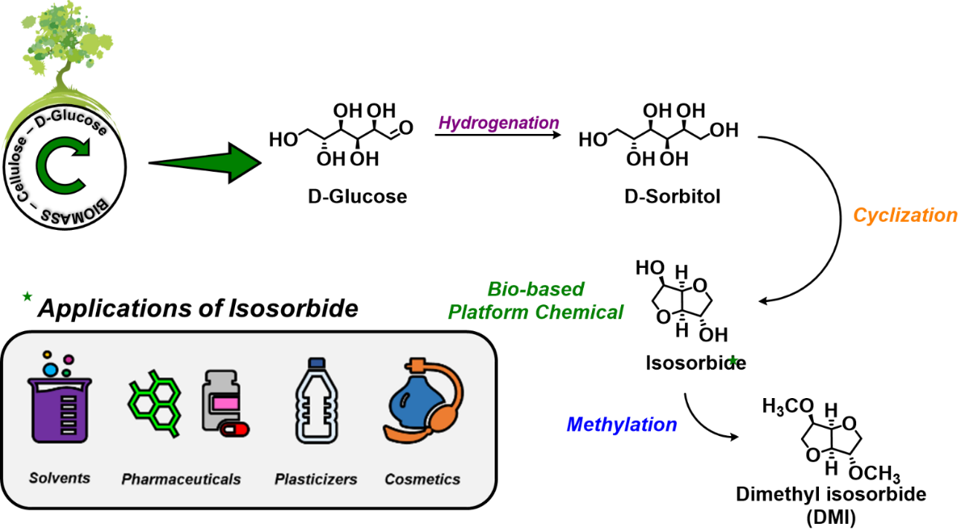
Figure 2. Conversion of biomass into dimethyl isosorbide (DMI)
Despite the great interest in DMI, only a limited number of synthetic procedures for its preparation can be found in literature. Currently, the main synthetic pathway adopted involves the use of alkylating agents, including toxic halogen substances such as alkyl halide. [20]
An alternative reported procedure demonstrated that DMI can be obtained - in a fair amount (ca 20%) - using methanol as solvent/reagent in the presence of different polyacids, zeolites and zirconia-based catalyst.[21] Another synthetic approach involves the methylation of isosorbide using methylphosphates in the presence of Lewis acid catalysts.[22] Furthermore, high yielding preparation of DMI (80%) was achieved employing heteropolyacids and using 1,2-dimethoxyethane as reagent/solvent.[23]
Our research group has extensively investigated the synthesis of DMI using dimethyl carbonate (DMC) as methylating agent.[24] This synthetic approach to DMI is very appealing since it combines the advantages of isosorbide (bio-based starting material) with a green solvent and reagent (DMC) [25] leading to a sustainable alternative for conventional dipolar solvents.
In the DMC-promoted methylation reaction of isosorbide (Scheme 1), two equivalents of DMC are consumed to form DMI; CO₂ and MeOH are the only by-products formed.

Scheme 1. Base catalyzed DMI synthesis via DMC chemistry.
The methylation of isosorbide can be promoted by a strong base such as NaOMe at 90 °C the reflux temperature of DMC. DMI was isolated in quantitative yields, although the procedure requires a large excess of sodium methoxide that has to be freshly prepared from metallic sodium and methanol.[26]
Hydrotalcite KW2000 (Mg_{0.7}Al_{0.3}O_{1.15}) was efficiently used as an heterogenous amphoteric catalyst for the synthesis of dimethyl isosorbide at high pressure in autoclave (at 200 °C).[24] DMI was isolated in 90% although purification of the product was carried out via column chromatography. Furthermore, to ensure a good catalyst performance Hydrotalcite KW2000 must be calcinated at 400 °C.
The direct conversion of D-sorbitol to DMI was also investigated; nitrogen superbase 1,5,7-triazabicyclo[4.4.0]dec-5-ene (TBD) resulted the best catalyst among the ones investigated. The reaction was performed in autoclave at high pressure in the presence of TBD as the homogenous catalyst leading to DMI in 70% selectivity.[27]
Recently, we reported a new DMC-promoted synthetic procedure where isosorbide was converted into DMI in high yield (85%) employing N-methyl pyrrolidine (NMPy) as a homogenous nitrogen organocatalyst.[28]
In the best-found reaction conditions (0.5 eq. mol NMPy, 200 °C, 12 hours) isosorbide and its epimers isoidide and isomannide were converted in the methylated product in high yields and preliminary scale-up tests showed that this procedure can be applied up to 10 grams of isosorbide.
Furthermore, all the seven intermediates, forming by the combined reactivity of isosorbide and DMC (Scheme 2), were identified and isolated for the first time allowing to propose a possible reaction mechanism.
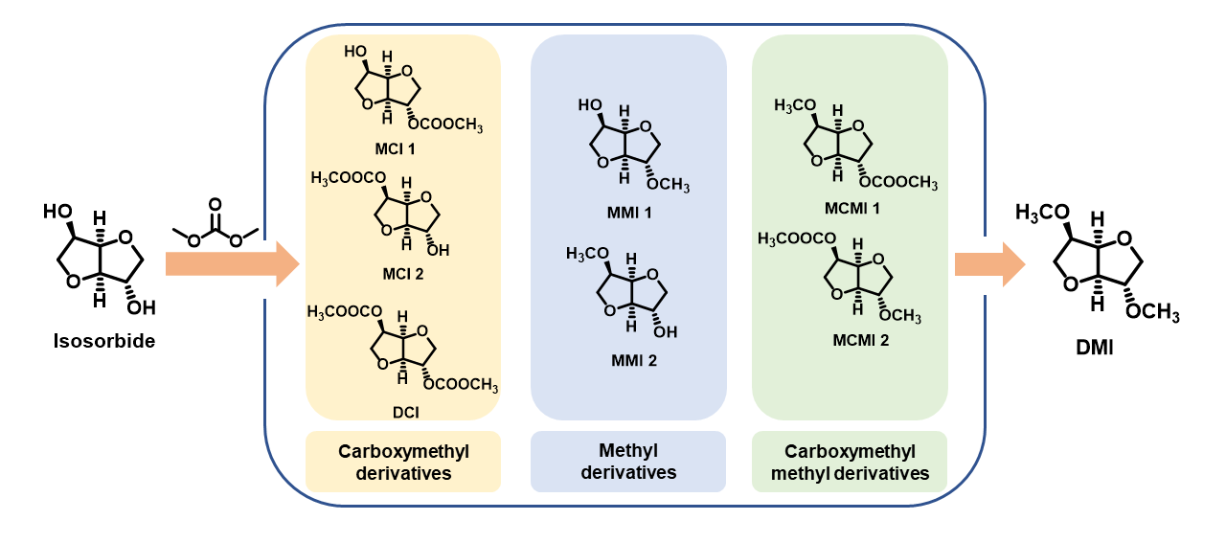
Scheme 2. Methylation of isosorbide via DMC chemistry: all observed reaction intermediates.
Following the increasing interest of DMI as a green polar high boiling solvents and our new findings on the intricated reaction mechanism behind the methylation of isosorbide, herein we report for the first time an investigation on isosorbide methylation promoted by an acidic heterogenous catalyst. Reaction conditions were optimized, and product purification assessed. Compared to the previously reported studies, this acid catalyzed procedure requires a reduced reaction time, i.e., 6 hours. Furthermore, a different preferred reaction pathway was observed in comparison with the one promoted by NMPy highlighting, once again, the complexity of the DMC-promoted isosorbide methylation.

- Results and Discussion
2.1 Optimization of the acid catalyzed synthesis of DMI
Methylation of isosorbide was performed in a stainless-steel autoclave using DMC as solvent and reagent; several commercially available and inexpensive acid catalysts were investigated in order to assess their efficiency in promoting DMI formation (Scheme 3). Conversion of isosorbide, as well as the selectivity toward DMI, monomethyl (MMI 1-2), (di)methoxycarbonyl (DCI, MCI 1-2) and methyl methoxycarbonyl (MCMI 1-2) compounds were evaluated by GC-MS analysis. The correct identification of each intermediate in the reaction mixture was assessed using as references pure samples of the compounds previously synthetized in our laboratories.[28]
Scheme 3. Synthesis of dimethyl isosorbide in the presence of an acid catalyst
In a typical reaction, isosorbide was reacted with DMC in the presence of an heterogenous or homogenous acid catalyst (1.0:1.0 wt. or 1.0:1.0 mol ratio) at 200 °C (Table 1). In all experiments the oven employed for the autoclave was preheated to 160 °C.
Homogenous acids selected for this study included oxalic acid, formic acid, and acetic acid (#1-3; Table 1). Data collected showed in all cases low conversion of isososorbide and high selectivity toward methoxycarbonyl methyl compounds MCMI 1-2. None of the homogenous catalysts was capable to promote DMI formation in high yield.
Amberlyst and Purolite catalysts, all incorporating acidic sulfonic groups, were then tested as promoters in the methylation of isosorbide (#4-10; Table 1).
Purolites employed for this investigation are characterized by similar acidity, but different surface area (see Supporting Information -SI, Table S1). Among them, Purolite CT151 - a microporous polystyrene crosslinked with divinylbenzene - has the lowest surface area; Purolite CT269 - a microporous catalyst with very good mechanical resistance - has the highest surface area. Finally, Purolite CT275 - a microporous catalyst showing excellent accessibility of active site - has an intermediate value of surface area. Purolites CT269DR and CT275DR have the same chemical structure of CT269 and CT275 respectively, however they have been thorough dried by the suppling company so to achieve a negligible residual humidity (< 3%).
Amberlyst-15 and Amberlyst-36 are ion exchange resin based on macroreticular polystyrene with strongly acidic sulfonic group usually employed in esterification, etherification, alkylation and condensation reactions. Among them, Amberlyst-15 has a larger surface area and pore volume than Amberlyst-36, but the latter is more acidic.
Table 1. Isosorbide methylation in acid environment via DMC chemistry.ª
# | Catalyst | P | Conv | GC-MS Selectivity [%]
# | Catalyst | bar | % | MMI 1 | DMI | MMI 2 | MCI 1-2 | MCMI 1-2 | DCI
1 | Oxalic acid | 17 | 12 | 28 | 11 | 4 | 43 | 12 | 2
2 | Formic acid | 13 | 10 | 24 | 21 | 5 | 36 | 22 | 1
3 | Acetic acid | 15 | 15 | 12 | 7 | 3 | 45 | 28 | 5
4 | CT151 | 70 | 100 | 20 | 68 | 5 | 7 | 0 | 0
5 | CT269 | 68 | 100 | 21 | 66 | 5 | 3 | 5 | 0
6 | CT275 | 75 | 100 | 19 | 70 | 5 | 6 | 0 | 0
7 | CT269DR | 65 | 100 | 18 | 46 | 9 | 3 | 24 | 0
8 | CT275DR | 86 | 100 | 21 | 78 | 1 | 0 | 0 | 0
9 | Amberlyst-15 | 60 | 100 | 24 | 60 | 7 | 3 | 6 | 0
10 | Amberlyst-36 | 85 | 100 | 23 | 76 | 1 | 0 | 0 | 0
ªReaction condition: 0.5 g of isosorbide dissolved in 30 mL of DMC and in presence of 100% wt or mol acid catalyst at 200 °C for 6 h.
Table 1 report the data collected for wet (#4-6; Table 1), dry Purolites (#7-8; Table 1) and the two types of Amberlyst tested (#9-10; Table 1). In all trails analysis via GC-MS showed a quantitative conversion of isosorbide, meanwhile DMI selectivity varied depending on the catalyst employed. Amberlyst-36 and Purolite CT275DR resulted the best preforming catalysts leading to DMI in 76% and 78% yield respectively. These two solid catalysts differ in terms of pore volume and average pore diameter, but they both possess comparable acidity and surface area which, most probably, equally contributed to enable isosorbide methylation (SI, Table S1).
A high autogenous pressure was observed in all the experiments conducted in the presence of a solid catalyst (#4-10; Table 1). Most probably at this high operating temperature (200 °C), the acid catalysts were capable to promote the decarboxylation of DMC forming CO₂, methanol and dimethylether (Me₂O) leading to a noticeable pressure rise. A similar outcome was already observed in the one-pot synthesis of furan dicarboxylic esters (FDCE) from glucaric acid via DMC chemistry catalyzed by the same type of catalyst.[29]
In order to prove this theory a blank experiment was conducted by reacting DMC with Purolite CT275DR employing the same reaction conditions used for the synthesis of DMI. Heating the autoclave at 200 °C for 6 hours, led to a recorded pressure value of 95 bar. Furthermore, after cooling down the autoclave and releasing the pressure only ca 10 mL of DMC were recovered. This result confirms that also in the experiments for isosorbide methylation, DMC constantly decarboxylates while the methylation of isosorbide takes place causing a drastic increase in the autogenous pressure (see SI).
To optimize the good preliminary results achieved using Amberlyst-36 and Purolite CT275DR, the influence of the catalyst amount, reaction time and temperature on the methylation outcome was further investigated.
Experiments conducted lowering the amount of the best performing solid catalysts from 100 wt. % to 50 and 25 wt.% showed a gradual decreasing in DMI selectivity (Figure 3a, see also Table S2-S3 in SI).

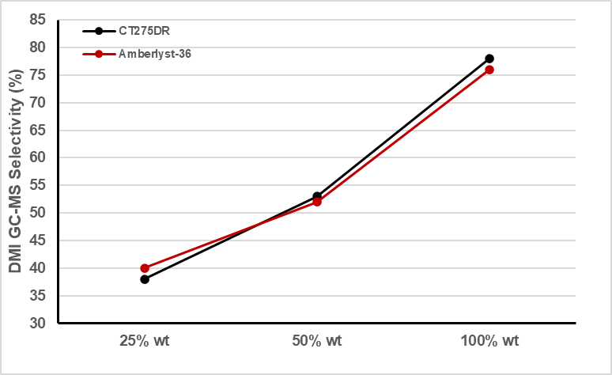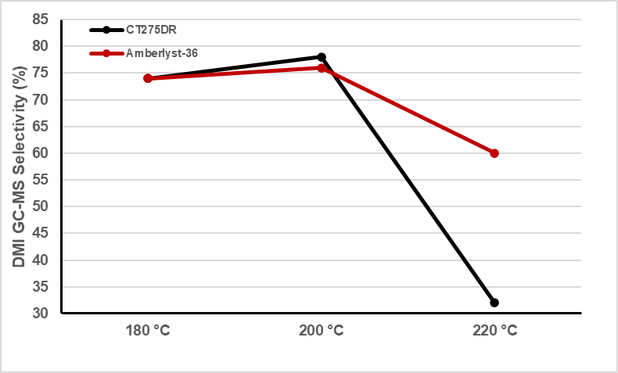
(a) (b)
Figure 3. (a) DMI synthesis using different amount of catalyst (0.5 g of isosorbide, 30 mL of DMC) at 200 °C for 6 h; (b) DMI synthesis at different temperature (0.5 g of isosorbide, 30 mL of DMC, 100% wt of catalyst) for 6 h. In all experiments isosorbide conversion was quantitative.
Diminishing the reaction temperature from 200 °C to 180 °C showed a slight reduction in the yield of the desiderd product (Figure 3b, Table S2-S3). Moreover, when the reaction was performed at 220 °C, isosorbide methylation resulted less efficent. Most probably, the high temperature in combination with the acid environment favours the decomposition of DMI. In this view, a trial was conducted where DMI was dissolved in DMC in the presence of Purolite CT275DR and the solution was heated 6 hours at 220 °C in an autoclave. Analysis of the recovered crude mixture via GC-MS and NMR spectroscopy showed that DMI was present only in traces confirming its gradual decomposition due to the combined effect of the high temperature and acid catalysts (see SI).
Some experiments were also carried out evaluating the effect of the reaction time (Figure 4, Table S2-S3) for both CT275DR and Amberlyst-36. Trials were performed at 180 and 200 °C. In all cases when the reaction was carried out for 2 or 4 hours the selectivity towards DMI was moderate, suggesting that a prolonged reaction time, i.e. 6 hours, was necessary for the methylation of the isosorbide. Extending the reaction time to 8h resulted in an autogenous pressure exceeded 100 bar, the operating limit of the apparatus, thus the experiments must be stopped.
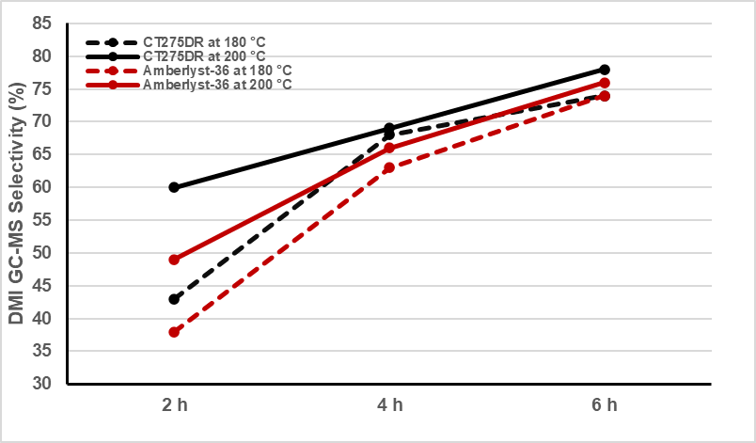
Figure 4. Different time and temperature (0.5 g of isosorbide, 30 mL of DMC, 100% wt of catalyst) in preheated autoclave (T = 160 °C). In all experiments isosorbide conversion was quantitative.
In Table 2 are summarized the best-found reaction conditions and the related isolated yields of DMI achieved after purification via column chromatography. Unfortunately, performing the reaction in small scale rendered the distillation impractical.
The lower yields achieved in acid conditions, compared to our previous results in basic conditions, are most probably due to the abovementioned partial decomposition of DMI. However, this different result might also be ascribed to a different preferred reaction mechanism in the acid-catalyzed reaction where some reactions might be less efficient (see section 2.2.).

Table 2. Optimal condition for DMI synthesis. ª
# | Catalyst | T | P | GC-MS Selectivity [%] |  |  | DMI Yield ^{b}
# | Type | °C | bar | MMI 1 | DMI | MMI 2 | [%]
1 | CT275DR | 180 | 82 | 24 | 74 | 2 | 50
2 | Amberlyst-36 | 180 | 85 | 21 | 74 | 5 | 52
3 | CT275DR | 200 | 86 | 21 | 78 | 1 | 49
4 | Amberlyst-36 | 200 | 85 | 23 | 76 | 1 | 47
ª Reaction condition: 0.5 g of isosorbide dissolved in 30 mL of DMC in presence of 100% wt. catalyst. Isosorbide conversion was quantitative; ^{b} Purification via column chromatography (DCM/MeOH 98:2).
Some trails were also conducted to evaluate the effect of the substrate concentration on DMI selectivity and yield. In order to avoid a high autogenous pressure, the experiments were performed at 180 °C instead of 200 °C; CT275DR was selected as catalyst for this study.
Reaction carried out at higher substrate concentration showed a decrease in the selectivity towards DMI and subsequently in the isolated yields (Table 3, #3-5). Similarly, when a lower concentration of isosorbide was employed, the selectivity of the DMI diminished and the presence of monomethoxycarbonyl (MCI 1-2) and methoxycarbonyl methyl (MCMI 1-2) derivatives was detected (Table 3, #1).

Table 3. Isosorbide concentration effect.
# | Isosorbide | P | GC-MS Selectivity [%] |  |  | DMI Yield ^{b}
 | g (M) | bar | MMI 1 | DMI | MMI 2 | [%]
1^{c} | 0.25 (0.057) | 55 | 9 | 41 | 2 | 30
2 | 0.5 (0.114) | 82 | 24 | 74 | 2 | 50
3 | 1.0 (0.228) | 90 | 35 | 61 | 4 | 21
4 | 2.0 (0.456) | 92 | 38 | 60 | 2 | 15
5 | 3.0 (0.684) | 95 | 38 | 59 | 3 | 10
ª Reaction condition: Isosorbide dissolved in 30 mL of DMC in presence of 100% wt. CT275DR, at 180 °C for 6h. Isosorbide conversion was quantitative; ^{b} Purification via column chromatography (DCM/MeOH 98:2) ^{c} Other products: MCI 1-2 28%, MCMI 1-2 20%.
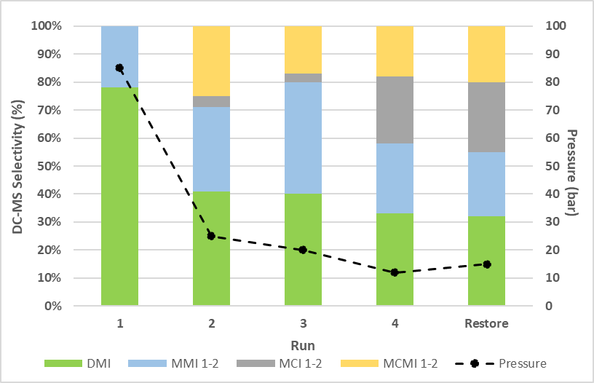
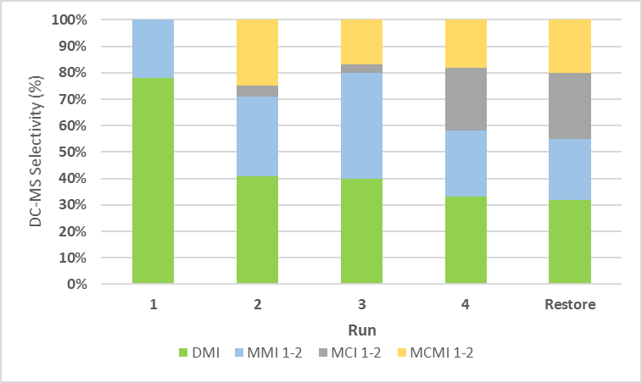
Since CT275DR and Amberlyst-36 are in the form of solid beads that can be easily recovered from the reaction mixture and recycled their eventual recycling was also taken into consideration (Figure 5). The reaction performed in the presence of CT275DR at 200 °C for 6 hours (Table S4; SI) was selected as reference for this investigation.
At the end of each experiment, CT275DR was recovered, washed with the minimum amount of methanol, dried overnight at 100 °C and reused in another trial. According to the data collected, the conversion of isosorbide was always quantitative, but already at the first reuse of the catalyst, a clear decrease in the selectivity of DMI (ca 40%) was observed. Very similar results were achieved when a second and third cycle were performed. An attempt to restore the Purolite CT275DR acidic sites was conducted by immersion of the recovered beads in a solution of H₂SO₄/methanol overnight. After washing and drying in the oven overnight, the catalyst was reused in the best-found reaction conditions (#3; Table 2) still attaining a moderate yield of DMI (#5, Table S4). This result was attributed to surface poisoning of the catalyst and/or to the decomposition of the Purolite structure caused by high temperatures and reaction pressures.
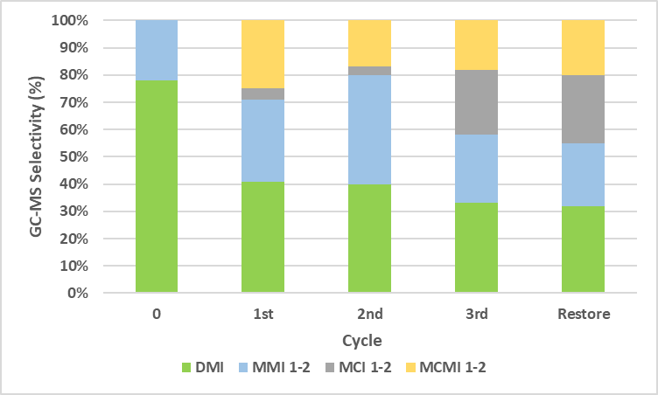
Figure 5. Study on Purolite CT275DR recycling; isosorbide conversion was always quantitative.
Finally, the methylation of isosorbide epimers, isomannide and isoidide was also investigated (Scheme 4). Reactions were performed in an autoclave at 200 °C starting from 0.5 g of the two anhydro sugar using CT275DR as catalyst. Dimethyl isomannide and dimethyl isoidide in fact were achieved in good selectivity 85% and 80% respectively, in both cases isolated yields was moderate (ca 40%).

Scheme 4. Acid catalyzed synthesis of dimethyl isomannide and dimethyl isoidide
2.2 Considerations on the reaction pathway
The methylation of isosorbide via DMC chemistry takes place following an intricate mechanism that include numerous thermodynamically and kinetically controlled reactions. Overall, in previous investigations[28] three possible chemical transformations were identified, methoxycarbonylation via B_{Ac}² mechanism, methylation via B_{Al}² mechanism and decarboxylation; their contribution to the overall reaction pathway is strictly dependent on the catalyst used and on the reaction conditions. In this view we decided to investigate the reaction pathway leading to DMI in acid conditions in order to highlight the difference with our previous observation for the reaction promoted by NMPy.
Several experiments were conducted under the best reaction conditions (Table 2, #3) and monitored over time (0 - 6 h). The zero time was conventionally fixed when the autoclave reached the operating temperature.
Figure 6 shows the percentage selectivity of products against the time. Using CT275DR as catalyst, the methylation reaction took place very quickly. In fact, after only 40 minutes the selectivity towards the DMI is already 44%. The trend of DMI selectivity is characterized by an initial rapid increase that then slowly reaches the maximum value (78%) after 6 hours. Low amount ​​of monomethoxycarbonyl (MCI 1-2) and methoxycarbonyl methyl (MCMI 1-2) derivatives were always observed, meanwhile DCI was never present in the reaction mixture.
Figure 6. Methylation of isosorbide over time.

As observed in our previous work[28], due to the different reactivity of the two hydroxyl groups (endo and exo), the formation and conversion of MMI 2 (hydroxyl group endo methylated), is faster than MMI 1 (hydroxyl group and exo methylated) despite the fact that the endo hydroxyl group being involved in a strong hydrogen bonding should be the less reactive.
To further investigate the impact of the decarboxylation reaction on the overall reaction pathway leading to DMI, several trials were conducted studying the reactivity of a pure sample of DCI in acidic environment (Table 4).
Table 4. DCI conversion into DMI ª
# | Solvent | P | Conv. | GC-MS Selectivity [%]
 |  | bar | % | MMI 1 | DMI | MMI 2 | MCI 1-2 | MCMI 1-2
1 | DMC | 95 | 100 | 12 | 23 | 21 | 44 | 0
2 | 2 Me-THF | 20 | 0 | 0 | 0 | 0 | 0 | 0
3 | Acetonitrile | 15 | 40 | 0 | 0 | 0 | 50 | 50
4 | n-Hexane | 17 | 0 | 0 | 0 | 0 | 0 | 0
5 | Dioxane | 10 | 0 | 0 | 0 | 0 | 0 | 0
6 | CPME | 45 | 100 | 27 | 30 | 15 | 2 | 26
ª Reaction condition: 0.9 g of DCI dissolved in 30 mL of solvent in presence of 100% wt. CT275DR, at 200 °C for 6h.

In a first experiment, DCI was reacted with Purolite CT275DR in DMC (Table 4; # 1) and GC-MS analysis of the crude reaction mixture showed a quantitative conversion of DCI but a low selectivity (23%) towards DMI. The same experiment previously conducted in the presence of basic catalyst NMPy resulted in 86% selectivity toward DMI.[27] Further tests were performed in presence of other organic solvents (Table 4, #2-6). In most cases, DCI conversion was negligible or moderate (Table 4, #2-5) and the only products observed were MCI 1-2 and MCMI 1-2. Only in one case (Table 4, #6), the conversion was quantitative with the presence of almost all isosorbide derivatives with a low DMI selectivity (30%).
Decarboxylation of DACs has been previously reported in the literature although investigations are rather limited.[30] Generally, these reactions are performed at a high temperature (180° - 250 °C), using hydrotalcites or Faujasites as amphoteric catalysts leading to the formation of symmetrical and asymmetric ethers. Most probably the presence of basic as well as acid sites render these catalysts more active toward the decarboxylation reaction. This consideration in combination with our results in the presence of an acid catalysts seem to suggest that the latter are more efficient in promoting the direct methylation reaction via an acid catalyzed alkylation pathway (A_{Al}2).
The impact of the thermodynamically driven methoxycarbonylation reaction on the methylation of isosorbide in acidic conditions was also further explored. Isosorbide was reacted with DMC in the presence of CT275DR at the reflux temperature (90 °C) to evaluate the formation of (di)methoxycarbonyl derivatives (DC, MCI 1-2). After 24 hours the reaction was cooled down and analyzed via GC-MS and NMR spectroscopy; isosorbide was the only product observed.
Basing on the results collected, it is thus plausible to suggest that in the presence of acid catalyst such as CT275DR and Amberlyst-36 methylation reaction by activation of the soft site of DMC is predominant on methoxycarbonylation. Furthermore, decarboxylation reactions only partially contribute to the formation of DMI. Monomethoxycarbonyl (MCI 1-2) and methoxycarbonyl methyl (MCMI 1-2) derivatives observed in small amounts in several trails form most probably due to the reaction of isosorbide and DMC at high temperature without any support from the acidic catalyst.
Figure 7 reports an overview of the overall reaction mechanism highlighting (in dark black line) the efficiency of the methylation via A_{Al}² mechanism over methoxycarbonylation (via A_{Ac}² mechanism) and decarboxylation to the formation of DMI in acidic conditions.
It is finally interesting to note that the herein investigated acid catalysts although not effective in promoting DCI decarboxylation are capable to efficiently decarboxylate DMC. This latest result deserves further investigations.
Figure 7. Possible reaction mechanism from isosorbide to DMI via DMC. Dark black lines are used to highlight the preferred reaction pathways.

- Conclusion
Dimethyl isosorbide is an extensively investigated green media as alternative solvents to DMSO and DMF in numerous reactions and polymerization procedures. In this work, we reported the first systematic investigation on a DMC-based methylation of isosorbide in acidic conditions. It should be mentioned that DMC chemistry, extensively investigated in basic conditions, is only scarcely studied in acid-catalyzed reactions.[31]
In the reported procedure, several homogenous and heterogenous acids were tested for DMI preparation. Purolite CT275DR and Amberlyst-36 both resulted promising catalyst in promoting the methylation of isosorbide.
Reaction conditions were optimized taking into consideration catalyst loading, temperature, time and substrate concertation. In the best-found procedure, isosorbide was reacted with DMC in the presence of 1:1 weight ratio of the selected catalyst at 180 °C or 200 °C for six hours, resulting in high yield formation of DMI (>75%). The pure product was purified via column chromatography and fully characterized.
Compared to the previously reported DMC-based procedure the herein proposed synthesis is faster (6 hours instead of 12 hours) although it poses some issue related to the partial decomposition of DMI due to the combined effect of the high temperature and the acid environment.
Investigation on the reaction pathway highlighted that acid catalyst such as Purolite or Amberlyst mainly promote methylation reaction, meanwhile methoxycarbonylation and decarboxylation reactions are less facilitated.
As final remark it should be mentioned that the use of inexpensive solid catalysts – as the ones reported in this case study – is highly desirable as they can pave the way to further exploitation of this procedure in a continuous-flow apparatus.
Experimental Section
General
All the reagents and solvents have been purchased by Sigma-Aldrich and employed without any further purification. Purolite-type catalysts were kindly provided by Purolite®. All the solid heterogenous catalyst were dried in the oven at 100 °C overnight before use. Reactions have been conducted in a silicon oil bath or in a Drysyn at the required temperature. Reactions have been monitored by GC-MS Agilent Technologies (GC System 6890 N; Agilent Technologies Mass Selective Detector 5973) with a silica column (HP-5MS). Compounds have been injected through a Hamilton micro-syringe (10 μL). NMR spectra have been acquired through a spectrometer Bruker 400 MHz in CDCl₃.

Synthesis Dimethyl isosorbide (DMI) with CT275DR
In a typical reaction in autoclave, 0.5 g of isosorbide (3.42 mmol, 1 mol. eq) was reacted with CT275DR (0.5g, 100% w/w.) and DMC (30 mL, 0.35 mol, 109 mol. eq), at 200 °C (or 180 °C) for 6 h. The oven employed for the autoclave was preheated at 160 °C. The autogenous pressure reached the value of 86 bar at 200 °C (82 bar at 180 °C). After cooling, the reaction crude was filtered on a paper filter to remove the solid catalyst and concentrated under vacuum via rotavapor. The resulting mixture was analyzed via GC-MS to evaluate conversion of the substrate and products selectivity. DMI was obtained as pure via chromatographic column (DCM/MeOH 98:2; Rf = 0.50). The pure compound was isolated as a light-yellow liquid in 52% yield (0.31 g) at 200°C – 50% yield at 180 °C (0.30g). ¹H NMR (400 MHz CDCl₃) δ ppm = 4.64 (t, 1H), 4.54 (d,1H), 3.89–3.88 (m, 4H), 3.85 (m, 1H), 3.61–3.53 (m, 1H), 3.49 (s, 3H), 3.40 (s, 3H). ¹³C NMR (100 MHz, CDCl³) δ ppm = 85.8, 81.7, 79.9, 72.9, 69.7, 58.1, 57.1.

Synthesis Dimethyl isosorbide (DMI) with Amberlyst-36.
In a typical reaction in an autoclave, 0.5 g of isosorbide (3.42 mmol, 1 mol. eq) was reacted with Amberlyst-36 (0.5g, 100% w/w.) and DMC (30 mL, 0.35 mol, 109 mol. eq), at 200 °C (or 180 °C) for 6 h. The oven employed for the autoclave was preheated at 160 °C. The autogenous pressure reached the value of 85 bar both 200 °C and 180 °C. After cooling, the reaction crude was filtered on a paper filter to remove the solid catalyst and concentrated under vacuum via rotavapor. The resulting mixture was analysed via GC-MS to evaluate conversion of the substrate and products selectivity. DMI was obtained as pure via chromatographic column (DCM/MeOH 98:2; Rf = 0.50). The pure compound was isolated as a light-yellow liquid in 47% yield (0.28 g) at 200 °C – 49% yield at 180 °C (0.29g).

Synthesis Dimethyl isomannide (DMIm) with CT275DR
In a typical reaction in an autoclave, 0.5 g of isomannide (3.42 mmol, 1 mol. eq) was reacted with CT275DR (0.5g, 100% w/w.) and DMC (30 mL, 0.35 mol, 109 mol. eq), at 200 °C for 6 h. The oven employed for the autoclave was preheated at 160 °C. The autogenous pressure reached the value of 98 bar. After cooling, the reaction crude was filtered on a paper filter to remove the solid catalyst and concentrated under vacuum via rotavapor. The resulting mixture was analysed via GC-MS to evaluate conversion of the substrate and products selectivity. DMIm was obtained as pure via chromatographic column (Et₂O/n-hexane 6/4; Rf = 0.40). The pure compound was isolated as a light-yellow liquid in 38% yield (0.23 g). ¹H NMR (400 MHz CDCl3) δ ppm = 4.53 (m, 2H), 4.01 (t,2H), 3.90 (m, 2H), 3.63 (t, 2H), 3.40 (s, 6H).¹³C NMR (100 MHz, CDCl³) δ ppm = 81.9, 80.3, 70.9, 58.3.

Synthesis Dimethyl isoidide (DMIi) with CT275DR
In a typical reaction, 0.5 g of isoidide (3.42 mmol, 1 mol. eq) was reacted with CT275DR (0.5g, 100% w/w.) and DMC (30 mL, 0.35 mol, 109 mol. eq), at 200 °C for 6 h. The oven employed for the autoclave was preheated at 160 °C. The autogenous pressure reached the value of 89 bar. After cooling, the reaction crude was filtered on a paper filter to remove the solid catalyst and concentrated under vacuum via rotavapor. The resulting mixture was analysed via GC-MS to evaluate conversion of the substrate and products selectivity. DMIi was obtained as pure via chromatographic column (Et₂O/n-hexane 1/1; Rf = 0.30). The pure compound was isolated as a light-yellow liquid in 34% yield (0.20 g). ¹H NMR (400 MHz CDCl3) δ ppm =
4.61 (s, 2H), 3.91–3.83 (m, 6 H), 3.40 (s, 6H).¹³C NMR (100 MHz, CDCl³) δ ppm = 85.1, 84.9, 71.8, 57.2.
Decarboxylation of DCI with CT275DR
In a typical reaction in an autoclave, 0.9 g of DCI (3.43 mmol, 1.00 mol eq.) was reacted with 30 mL of dimethyl carbonate (0.35 mol, 50.0 mol eq.) in presence of 0.9 g of CT275DR (100% w/w), at 200 °C for 6 h. The oven employed for the autoclave was preheated at 160 °C. The autogenous pressure reached the value 95 bar. After cooling, the reaction crude was filtered on a paper filter to remove the solid catalyst and concentrated via rotavapor. The resulting mixture was analysed via GC-MS to evaluate conversion of the substrate and products selectivity.

Methoxycarbonilation of isosorbide with CT275DR
In a 100 mL bottom round flask equipped with condenser, 0.5 g of isosorbide (3.42 mmol, 1 mol. eq) was reacted with CT275DR (0.5g, 100% w/w.) and DMC (30 mL, 0.35 mol, 109 mol. eq), at 90 °C for 24 h. After cooling, the reaction crude was filtered on a paper filter to remove the solid catalyst and concentrated via rotavapor. The resulting mixture was analysed both via GC-MS and ¹H NMR showing only the presence of isosorbide.

Author Contributions
Dr. Mattia Annatelli and Davide Dalla Torre: investigation, data curation and some Conceptualization. Prof F. Aricò: conceptualization, visualization and writing.

Acknowledgements
This work was financially supported by the Organization for the Prohibition of Chemical Weapons (OPCW); Project Number L/ICA/ICB/218789/19. The authors want to thank Purolite® for kindly providing all the Purolite-type catalysts.

References
- (a) F. Gao, R. Bai, F. Ferlin, L. Vaccaro, M. Li and Y. Gu, Green Chem., 2020, 22, 6240–6257; (b) A. Jordan, P. Stoy and H. F. Sneddon, Chem. Rev., 2021, 121(3), 1582–1622; (c) A. Gevorgyan, K. H. Hopmann and A. Bayer, ChemSusChem 2020, 13, 2080– 2088.
- R. A. Sheldon, Green Chem., 2017, 19, 18–43
- M. C. Bryan, P. J. Dunn, D. Entwistle, F. Gallou, S. G. Koenig, J. D. Hayler, M. R. Hickey, S. Hughes, M. E. Kopach, G. Moine, P. Richardson, F. Roschangar, A. Steven and F. J. Weiberth, Green Chem., 2018, 20, 5082- 5103.
- Y. Gu and F. Jérôme Chem. Soc. Rev., 2013, 42, 9550-9570.
- (a) M. Virot, V. Tomao, C. Ginies, F. Visinoni and F. Chemat, J. Chromatogr., A, 2008, 147, 1196–1197; (b) P. K. Mamidipally and S. X. Liu, Eur. J. Lipid Sci. Technol., 2004, 106, 122-125; (c) M. Aissou, Z. Chemat-Djenni, E. YaraVarón, A.-S. Fabiano-Tixier and F. Chemat, C. R. Chimie, 2016, 20, 346-358; (d) G. Paggiola, S. Van Stempvoort, J. Bustamante, J. M. Vega Barbero, A. J. Hunt and J. H. Clark, Biofuels, Bioprod. Biorefin., 2016, 10, 686-698.
- J. F. Campos, M.-C. Scherrmann and S. Berteina-Raboin, Green Chem., 2019, 21, 1531-1539.
- C. Vidal and J. García-Álvarez, Green Chem., 2014, 16, 3515-3521.
- L. Moity, A. Benazzouz, V. Molinier, V. Nardello-Rataj, M. Kamal Elmkaddem, P. de Caro, S. Thiébaud-Roux, V. Gerbaud, P. Marione and J.-M. Aubry, Green Chem., 2015, 17, 1779-1792.
- C. Rußa and B. König, Green Chem., 2012, 14, 2969-2982.
- D. Rasina, A. Lombi, S. Santoro, F. Ferlin and L. Vaccaro, Green Chem., 2016, 18, 6380-6386.
- S. Paul, K. Pradhan and A. R. Das, Current Green Chemistry, 2016, 3, 111-118.
- A. Gevorgyan, K. H. Hopmann and A. Bayer, Green Chem., 2021, 23, 7219-7227.
- B. Zhou, J. Yang, M. Lia and Y. Gu, Green Chem., 2011, 13, 2204-2211.
- (a) V. Pace, P. Hoyos, A. R. Alcántara, W. Holzer ChemSusChem, 2013, 6, 905-910; (b) V. Pace, P. Hoyos, M. Fernandez, J. V. Sinisterra, and A. R. Alcantara, Green Chem., 2010, 12, 1380–1382.
- (a) F. Byrne, B. Forier, G. Bossaert, C. Hoebers, T. J. Farmer, J. H. Clark, A. J. Hunt, Green Chem. 2017, 19, 3671−3678; (b) B. R. Trowse, F. P. Byrne, J. Sherwood, P. O’Brien, J. Murray, and T. J. Farmer, ACS Sustainable Chem. Eng. 2021, 9, 17330−17337.
- (a) F. Gao, R. Bai, F. Ferlin, L. Vaccaro, M. Li and Y. Gu, Green Chem., 2020, 22, 6240- 6257; (b) J. Sherwood, M. De bruyn, A. Constantinou, L. Moity, C. R. McElroy, T. J. Farmer, T. Duncan, W. Raverty, A. J. Hunt and J. H. Clark, Chem. Commun., 2014, 50, 9650-9652; (c) F. Aricò, Curr. Opin. Green Sustain. Chem., 2020, 21, 82–88.
- M. Rose and R. Palkovits, ChemSusChem, 2012, 5, 167–176.
- A. Watson, K. Wilson, J. Murray, H. Sneddon and C. Jamieson, Synlett, 2018, 29, 2293–2297.
- F. Russo, F. Galiano, F. Pedace, F. Aricò and A. Figoli, ACS Sustainable Chem. Eng., 2020, 8, 659–668.
- (a) P. Fuertes and V. Wiatz, WO 2007/096511 Al, 2007; (b) A. East, M. Jaffe, Y. Zhang and L. H. Catalani, US2008/0021209 A1, 2008; (c) S. Chatti, M. Bortolussi and A. Loupy, Tetrahedron, 2001, 57, 4365–4370; (d) S. Chatti, M. Bortolussi and A. Loupy, Tetrahedron Lett., 2001, 41, 3367–3370.
- M. Ibert, N. Essayem, C. Feche and A. Perrard, US9321783, 2016.
- M.-C. Duclos, A. Herbinski, A.-S. Mora, E. Métay and M. Lemaire, ChemSusChem, 2018, 11, 547–551.
- P. Che, F. Lu, X. Si and J. Xu, RSC Adv., 2015, 5, 24139–24143.
- F. Aricò and P. Tundo, Beilstein J. Org. Chem., 2016, 12, 2256–2266
- P. Tundo, M. Musolino and F. Aricò, Green Chem., 2018, 20, 28–85
- P. Tundo, F. Aricò, G. Gauthier, L. Rossi, A. E. Rosamilia, H. S. Bevinakatti, R. L. Sievert and C. P. Newman, ChemSusChem, 2010, 3, 566–570.
- F. Aricò, A. S. Aldoshin and P. Tundo, ChemSusChem, 2017, 10, 53–57.
- M. Annatelli, D. Dalla Torre, M. Musolino, F. Aricò, Catal. Sci. Technol., 2021, 11, 3411–3421
- G. Trapasso, M. Annatelli, D. Dalla Torre, F. Aricò, Green. Chem., 2022, DOI: https://doi.org/10.1039/D1GC04408G
- (a) P. Tundo, F. Arico, A. E. Rosamilia, S. Memoli, Green Chem., 2008, 10, 1182-1189; (b) M. Selva, M. Fabris and A. Perosa, Green Chem., 2011,13, 863-872.
- S. Jin, A. J. Hunt, J. H. Clark and C. R. McElroy, Green Chem., 2016, 18, 5839-5844.

These authors equally contributed to this work.

