IRON-GALLS INKS: PREPARATION, STRUCTURE AND CHARACTERISATION
Salvatore Caterinoª, Nicolò Pajerª, and Claudia Crestini^{*a}
ª claudia.crestini@unive.it Department of Molecular Sciences and Nanosystems, Ca’ Foscari University of Venice, Venezia-Mestre, Via Torino 155, 30172
Abstract:
The formation of dark complexes due to the interaction between polyphenols and iron has been empirically exploited since the XII century for the production of the so-called iron-gall inks (IGI), which have been widely used for the production of manuscripts both in Europe and Middle East. Being part of the cultural heritage, these manuscripts are currently objects of interests which have to be carefully preserved. In this paper the current knowledge on IGI is reviewed focusing on the variety of ingredients used for their preparation, the available models describing the formation of the polyphenols-iron complexes, and their degradation patterns. Additionally, the range of instrumental techniques nowadays available for their characterisation is critically discussed highlighting for every technique the most important features for the study of IGI.
Keywords: iron gall inks, polyphenols, tannins, iron complexes, conservation science
- Introduction
Manuscripts are documents of great historical, cultural and artistic value. According to the current legislations and the current views, cultural and historical heritage includes also the archivistic heritage,¹ which is generally composed of a massive number of hand-written documents. Behind each manuscript there is an intricate socio-cultural environment, as well as a precise technological development in the use and the transformation of natural materials. The scientific study of manuscripts and their constituents is therefore important from both a conservative point of view, as well as to better understand the technological improvements or modifications in the paper, parchment, pigments, dyes and ink productions.
IGI have been widely used for centuries in almost every geographical area: there are several evidences of usage of this type of inks related to the antiquity, especially in the Middle-East,^{2,3} but their success in Europe and in the Western Countries is generally more associated to the XII-XIX centuries.⁴ Consequently, it is not difficult to conceive the huge variety of historical recipes for IGI preparation.^{4,5} Despite of this variability, in all the historical recipes at least three main components are mentioned: an extract rich in hydrolysable tannins, an iron salt and an organic binder. In general, galls or other tannins sources were treated to obtain a polyphenolic extract rich in hydrolysable tannins.⁵ The iron(II) salt was added to the extract in order to obtain the iron-polyphenol complexes responsible for the dark bluish colour. Finally, an organic binder was used to keep the already formed insoluble iron-polyphenol complexes dispersed in an aqueous medium.
Despite the relative simplicity of the historical procedures for the synthesis of IGI,⁵ not much is currently reported in scientific literature about their structure and chemistry. The present effort, critically reviews current knowledge on the preparation of IGI, on the mechanisms of their formation and the most common degradation patterns. Finally, an overview of the most relevant instrumental techniques used for their characterisation is presented offering the relative advantages and disadvantages.
- The general composition of iron-gall inks
The main components of IGI are the iron-polyphenolic complexes resulting from the interaction of a tannin source and an iron(II) salt. Other materials, such as additives and binders, have been commonly used to implement the chemo-physical properties of the inks depending on the recipe considered. In the following paragraphs, the description of the sources of the starting materials for IGI production is reported.
  - Tannins: structure, sources and extraction
    - Structure and classification of tannins
The major source of polyphenolic compounds for the preparation of IGI is represented by galls, which are rich in tannins.^{5,6} Tannins constitute an abundant class of polyphenols available in almost every plant, characterised by molecular weight comprised between 500 and 30000 Da and an highly hydroxylated structure.^{7–9} Being secondary metabolites, as many other polyphenolic species, they have a protective role for plants against reactive oxygen and nitrogen species, UV light, plant pathogens, parasites, and predators.^{7,8,10} Tannins are well known for both as their beneficial effects on human heath (such as anti-inflammatory, antibacterial and anticancer properties^{8,10–12}) both as their interactions with bio-macromolecules. For instance, the strong interaction between tannins and collagen is fundamental in leather tanning.^{13,14} According to the most recent classifications, tannins can be divided at least in four main categories: condensed tannins (CT), hydrolysable tannins (HT), complex tannins and phlorotannins.^{7,9,10} Gallotannins (GT), important sub-group of HT, are known to be abundant in oak gallnuts^{15,16} while ellagitannins (ET), another sub-category of HT, and in particular punicalagin,^{7,17} are quite concentrated in pomegranate peel, an additive mentioned in several ancient IGI preparation recipes.⁵ This additive,¹⁸ as well as other elements of ancient historical recipes such as white wine,^{5,19,20} may be seen as a source of a small amount of condensed and complex tannins. However, due to the poor solubility in water of high-molecular-weight tannins,^{8,11} it is reasonable to expect that aqueous extracts are richer in oligomeric structures with a medium to low molecular weight, together with other simple polyphenolic compounds, as further discussed. In order to better appreciate the structural variability of the possible polyphenols actually involved in the IGI formation, in the following paragraphs a brief description of the different classes of tannins is reported.

      - Hydrolysable tannins
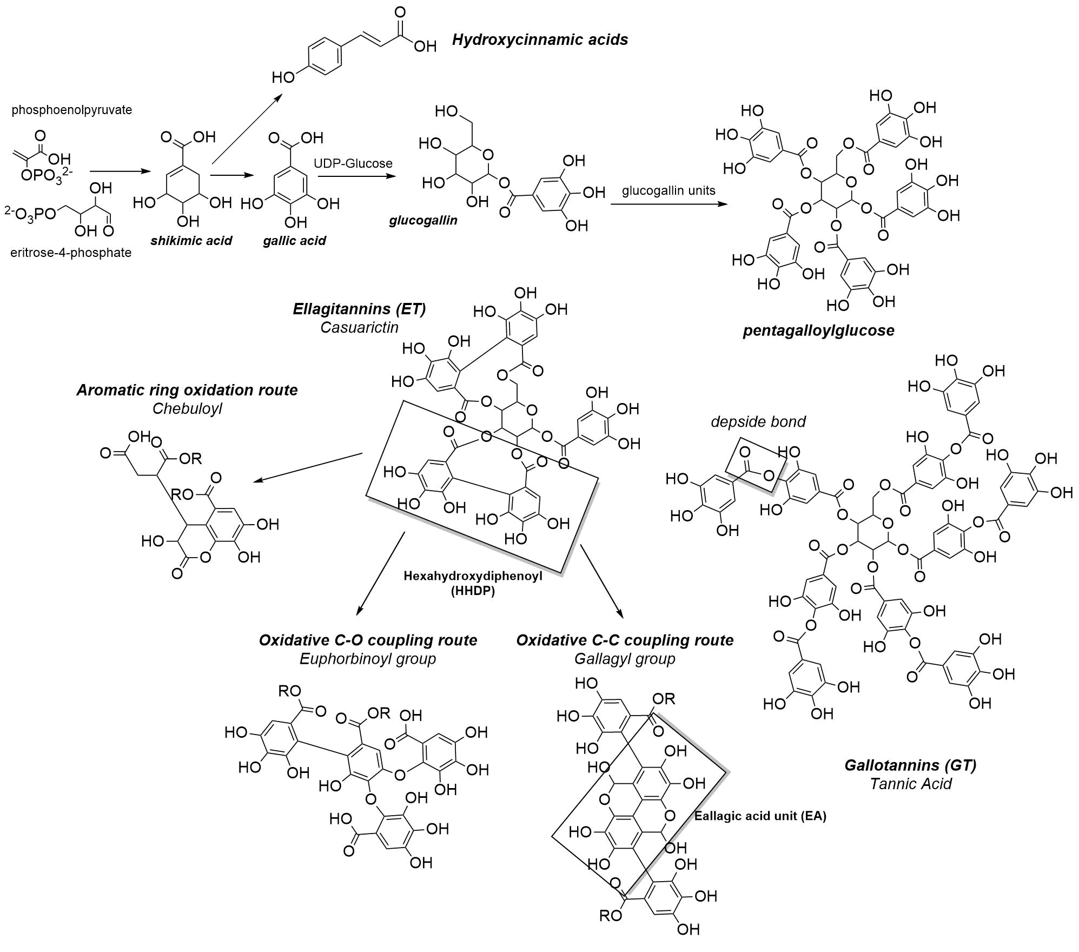
In general terms, HT can be considered as gallic acid (GA) oligomers or polymers in which GA (or its derivatives) units or are esterified around a polyol core, generally a carbohydrate such as D-glucose. All these polyphenolic compounds are bio-synthetized in plants via the shikimic acid pathway,¹⁰ which is synthetically described below and schematised in Figure 1. Shikimic acid is actually the precursor of different simple phenols such as hydroxycinnamic acids, such as caffeic acid, ferulic acid and p-cumaric,⁸ which can be then converted to p-coumaryl, coniferyl and sinapyl alcohols, the monomers driving to the formation of lignin.²¹ In this bio-synthetic route, β-glucogallin is the first important intermediate and it works as galloyl-group donor. However, the key metabolite in the biosynthesis of most of the HT is the β-1,2,3,4,6-pentagalloylglucose (PGG).^{10,22,23} The metabolism of this precursor, results into the two groups of HT: gallotannins (GT) and ellagitannins (ET). On one hand, GT, such as tannic acid and its derivatives, are formed from addition of galloyl moieties on PGG free hydroxyl groups (both in meta and/or para position) through depside bonds.^{8,9,22} ET, on the other hand, are formed properly via enzyme-mediated oxidative couplings of the galloyl groups of PGG.^{10,22,24} ET constitute actually a relevant group of HT including more than 500 different compounds.²² One reason of such variability is that hexahydroxydiphenyl, the first oxidative coupling product, and dehydro digalloyl groups, can undergo subsequent oxidative couplings reactions, both C-C and C-O, and/or aromatic ring oxidations resulting in a series of various structures.^{22,23,25–28} Other elements, such as the stereochemistry²² and the diversity of possible polyols cores,⁹ should be considered to better understand the variability of this class of polyphenolic compounds.
Figure 1. Synthetic scheme of the HT biosynthesis in the shikimate route.
      - Condensed tannins
This class of tannins, also known as proanthocynidins, is mostly composed of flavonoid oligomers or polymers which are generally abundant in the bark of trees.^{7,29} They are formed by sequential condensation or coupling of flavan-3-ol units which can occur between the C4 of the first unit with the C8 or C6 of the second unit (B-type proanthocynidins). In some cases an additional ether bond between the C2 and the C7 is observed (A-type proanthocynidins).^{7–9,30,31} The biosynthesis of flavan-3-ol units can be considered as an alternative to shikimate bio-synthetic route; in fact, malonyl-CoA units and p-cumaric acid, an hydroxycinnamic acid synthetized from shikimic acid (as reported in Fig. 1), undergo a series of enzymatically-mediated condensations resulting in the formation of naringenin, a flavanone which is one of the key intermediates in this biosynthetic route.^{31,32} This reaction mechanism is briefly schematised in Figure 2.
The B-type CT represents an abundant class of molecules which can be classified according to the hydroxylation pattern of the chain-extender units. Procyanidins, prodelphins, prorobinetidins, profisetidins are the most common B-type CT classes (Figure 2), while propelargonidins, proteracacinidins, promelacacinidins, procassinidins and probutinidins are less common sub-groups.^{7,31,33} The stereochemistry of the C3 hydroxy group as well as the regiochemistry of polymerization, are additional variability elements of these compounds. Finally, certain positions of proanthocyanidins may sometimes be esterified with gallic acid or, in some cases, with sugars (glucosides).^{7,33}
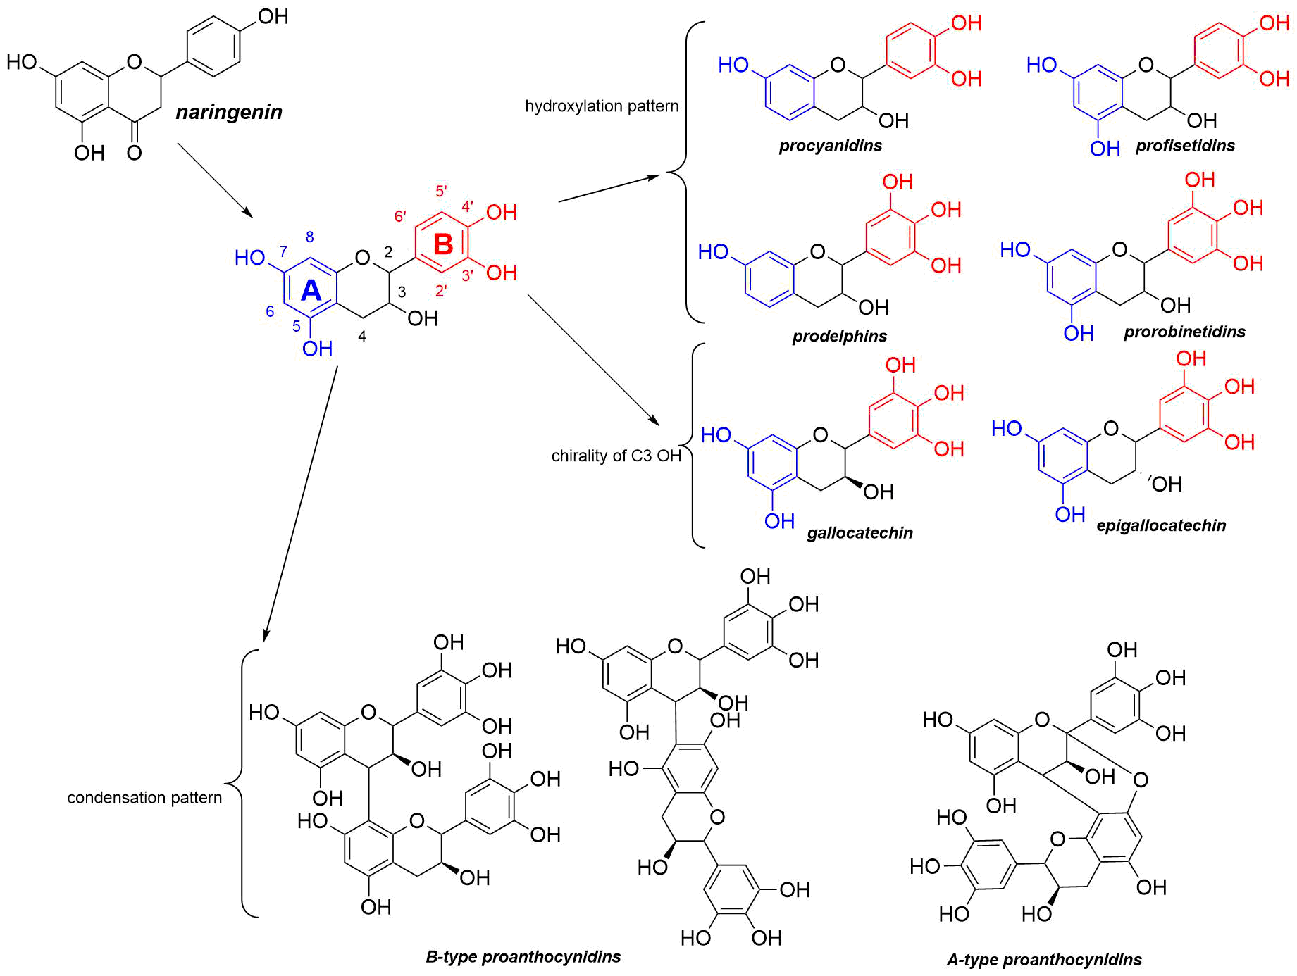
Figure 2. Main elements of variability in proanthocyanidins group. Just the main subgroups and elements of variability are displayed.
      - Complex tannins
These polyphenols embrace the structural and chemical features associated with both HT and CT groups.^{9,22} They are probably synthesized via the interaction of the anomeric transient carbocation of an open-chair HT(such as vescalagin) with the electron rich A-ring of a flavan-3-ol unit (Figure 3a).^{22,34} Since the first demonstration of their natural occurrence, a considerable number of these secondary metabolites have been identified³⁴ in different natural sources containing both high amount of HT and CT.²⁵
      - Phlorotannins
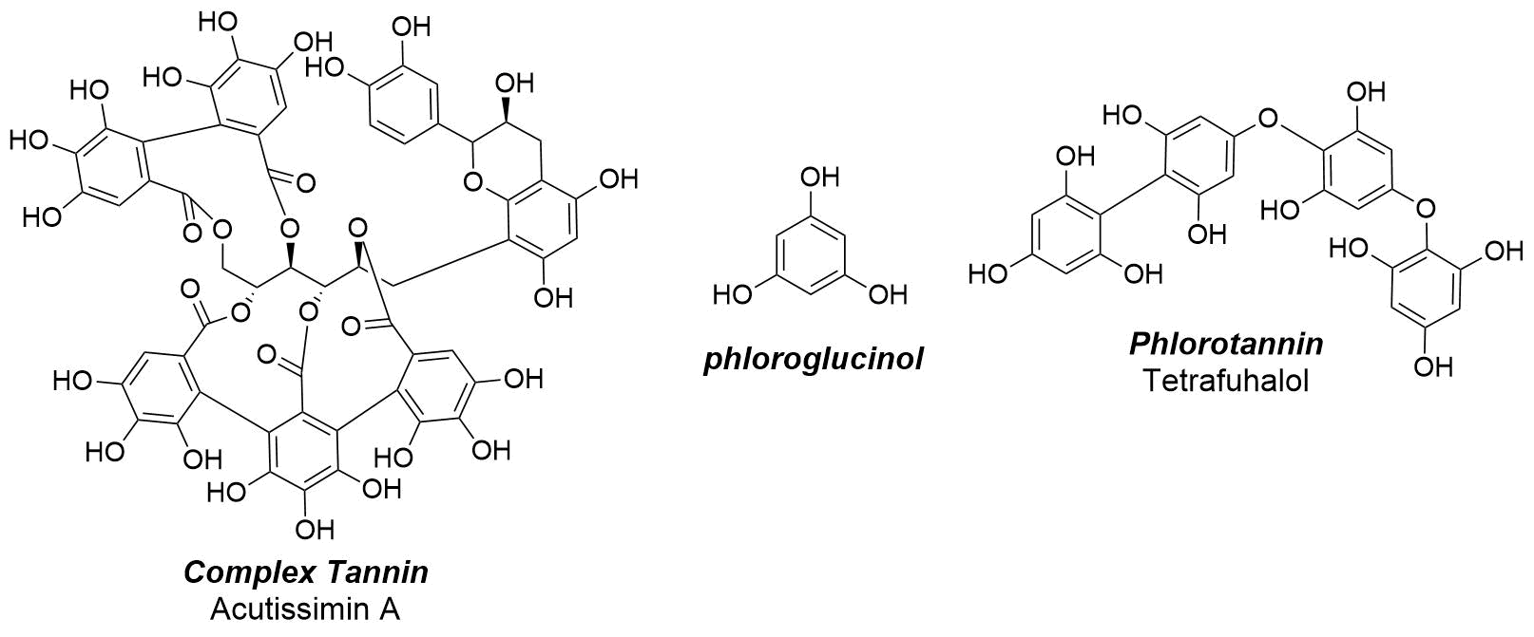
They are often omitted in the literature related to tannins since they can be isolated just from marine brown algae.⁷ Phlorotannins are oligomeric or polymeric phloroglucinol derivatives in which phloroglucinol units are connected by biphenyl bonds (fucols), diaryl-ether bonds (phlorethols, hydroxyphlorethols, fuhalols) or both (fucophlorethols) (Figure 3b).^{7,12}
a)
b)
Figure 3. a) Structure of one flavanol-ellagitannin (Complex tannin); b) Structure of phloroglucinol and of one phlorotannin
2.1.2 Tannin sources and polyphenolic-rich extracts preparation
In historical recipes, polyphenols-rich extracts represent the major element of variability. Not only the vegetal matrices used for the extraction, but also the extraction methods display significant geographical variability. The most commonly used vegetal matrices in historical recipes are oak galls.⁴ Galls, more properly called cecids, represent the biochemical response of the plant to the attack of a parasite. They can be found on the leaves, on the branches or on the trunk of trees; their shape and size vary according to the type of parasite that induced their formation (bacteria, fungi, insects, mites or other plant organisms).⁴ It has been also observed the galls-former, especially in the case of arthropods, can control the levels of nutrients like sugars, amino acids, and secondary compounds like polyphenols,^{36,37} which actually vary during the ripening of the galls, as demonstrated in different studies.^{36,38} With respect to that, it is interesting to notice that condensed and hydrolysable tannins display different accumulation pattern in the studied gallnuts. In fact, the genes expression involved in the biosynthesis of these polyphenols strongly increase from June to August, and it starts decreasing during September and October, which is not surprising considering that tannin production is also associated with the defensive reaction of plants against parasites.³⁸
Generally, the galls used the most for the preparation of IGI derive from various oak species (in particular Quercus Infectoria) as a response to the attack of Cynipis hymenopters. These structures produced by the host plant are entirely beneficial to Cynipis itself as they provide nourishment, shelter, and protect the cynipids larvae from fungal pathogens, hyper-parasites, leaf herbivores and some pathogenic factors.³⁹ Quercus galls are characterized by a high content in hydrolysable tannins.^{39,40} Among the various Quercus galls used in the ink production, the Aleppo gallnuts used to be considered as the best. Moreover, other important types of galls used are the Morea gall, the Smyrna gall, Mar- mora, gall and Istrian gall, and other good quality galls available in France, Hungary, Italy, Senegal and Barbary. Chinese and Japanese galls are also mentioned in some recipes.⁶ Other sources of tannins reported in historical recipes are: Pistacia Terebintus galls (Middle-Eastern Mediterranean area), bark or other parts rich in tannins of spruce, more properly known as Picea Abies, (European and Asian mountain regions), mulberry juice (Syrian area) and, probably as additive source of tannins, pomegranate peels (Mediterranean region).^{3,5,41,42}
Generally, the tannin-rich matrix used to be crushed and macerated in an aqueous solution for a variable time in order to extract the polyphenolic compounds.^{3,5,42} When water has been used, the extraction generally involved a first step in which the matrix was macerated (with a variable water volume to galls’ weight) at room temperature. In some cases, the system was exposed to sunlight. The second step involved heating of the extracting mixture for a given time or to achieve a significant reduction of the extract volume.^{4,42} This stage has been probably performed to both facilitate the extraction of the room temperature water-insoluble of polyphenols and concentrate the infuse via solvent evaporation. The extracting mixtures used were not limited to water. White wine and vinegar were also used, while in most recent recipes, dated back to the end of the XIX century, ethanol is mentioned too.^{5,43–45}
  - Iron(II) salt as inorganic component of the iron-gall inks
The addition of an iron(II) salt to polyphenolic-rich extracts allows the formation of the complexes responsible for the dark colour of iron-gall inks. In most of the historical recipes, “green vitriol”, or simply “vitriol”, have been used to refer to iron(II) sulphate heptahydrate (FeSO₄·7H₂O). Actually, other sulphates such as copper and zinc sulphate used to be referred as vitriols.^{3,5,42} Additionally to the green vitriol commonly used at that time, “copper green”, copper(II) hydroxycarbonate (Cu₂(OH)₂CO₃) was also added. Consequently, the presence of other cations, especially copper(II), can be detected in iron-gall inks. This aspect is relevant and should be considered while evaluating their conservative treatment and the degradation patterns. Another factor to bear in mind is represented by the wight ratio of vitriol and galls. In particular, an extremely variable range, from a slight excess of galls weight to a huge excess of iron salt one, is reported.^{3,5,42,46}
  - Binder and additives
Other additional constituents of IGI are binders and additives. The most commonly used binders in the ink preparation were chosen to not be affected by a relevant volume reduction after the drying process (commonly known as light binders). In IGI historical recipes, Gum Arabic is the most commonly mentioned binder.^{3–5,42} From a chemical point of view, Gum Arabic is a vegetal polysaccharidic extract, rich in galactose, arabinose, rhamnose, containing also glucuronic acid. The amount of this binder is extremely variable in historical recipes with respect to the amount of galls and iron salts. Interestingly, it has been observed that Gum Arabic is able to reduce the pH dropping and to increase the stability of the ink with time.⁴⁷ The binders used for the production of inks vary according to the availability of materials in the geographical area and the final desired characteristics for the ink. It is therefore not surprising that the use of other vegetable gums, such as tragacanth and mastic gum (or mastic), or other substances such as animal jellies, animal glues, egg white, mucilage and in some cases even honey is documented too.³ Additionally, the amount of Gum Arabic used was extremely variable with respect to the iron sulphate and gall one.⁴⁶
Additives were used to modulate the final properties of the ink. For instance, dyes and pigments were used in small quantities in some cases to modulate the colour or, even in relevant quantities, defining the final inks as "composite inks".⁴ In some archivistic studies on Spanish recipes, hematite ⁴⁶ and indigo⁵ resulted as commonly used pigments The addition of carbon black, gold scraps,³ lapis lazuli, Prussian blue⁴⁵ or other colorants is well documented too. Urine, potassium nitrate (saltpetre), alum (in particular rock alum) and other organic and inorganic materials were frequently added because of their etchant properties.^{5,14,41} Tannins too were well known for their etchant capability; in fact, it can be assumed that a secondary source of tannins was useful in this sense. While the primary source was necessary for the complex formation, the secondary one enabled a better fixing of the pigment to the support.^{3,5,42} Other additives were added also to modulate the viscosity of the ink. The most common ones were sugar and honey.^{3,42} However in one article published in Harper's Bazar at the end of the Nineteenth century, a recipe elaborated by some chemists mentions the use of glycerine as a secondary binder, and phenol or chopped cloves as anti-fermentative.⁴⁴
The general procedure for the preparation of IGI is shown in Figure 4. Table 1 reports the details of some of the ancient recipes nowadays available in literature in their original form. The most critical aspect regarding the translation of the recipes deals with the conversion of units since their actual value in standard units would require a proper and detailed archivistic study.
Table 1. Schematic chart of some of the recipes available in their original form.^{3,43–45,48} For the conversion of the metrics it has been used the Apothecaries system for the mass units (1 pound/Libra = 12 ounces = 96 drachms = 5760 grains = 373.2 grams) and the British Imperial Liquid system for the volume units (1 quart = 40 fluid ounces = 0.25 gallons = 1.14 litres).
Recipe general description | Galls | Extraction Solvent | FeSO₄∙7H₂O | Medium | Additives | Final processing | Ref.
Northern Africa (Tunisia and Algeria), 1031-1108.  “Description of ink for religious books” | 1 part of pressed “green” gallnuts. | 5 parts of water and cook until it comes to 1½ parts or 1 part. | 1 part of a vitriol solution previously prepared using vitriol and water in same amount and leaving it in the sun for 3/4 days. | 2 parts of a previously prepared solution of Gu Arabic | For a darker colour add 1.5 parts of pulverized galena (PbS) | / | ³
Northern Africa (Tunisia and Algeria), 1031-1108  “Description of an ink for the people of the sword” | One part of gallnuts | 3 parts of water. Boil until it returns 1 part | green vitriol in 2 parts of water. Stir the solution for three days | / | 1 part of yellow myrobalan pressed without its seed in three parts of water. Then boil until it returns 1 part. | / | ³
Italy, 1610  “A Far inchiostro, ‘o tinta da scriuere in tutta perfettione” | ~373.2g of gall- nuts | Abundant white whine | ~248.8g of well crushed vitriol | ~186.6g of well crushed Gum Arabic | / | Set in the sun and boiling step if necessary | ⁴³
Italy, 1525  “Recetta da fare inchiostro fino” | ~31.1g of crushed gall-nuts | ~373.2 of rain water. Then boiling until it becomes ca. 248.8g | ~7.8g of German vitriol (interpreted as a quart of the galls weight) | ~15.6g of Gum Arabic previously soaked in vinegar | / | / | ⁴⁸
Portugal, 1464  Chancelaria de Braga | ~31.1g of crushed gall-nuts | ~373.2g of water and white vinegar solution. Boil until the volume is reduced of two parts | ~7.8g of vitriol (interpreted as a quart of the galls weight) | ~15.6g of Gum Arabic
France, 1469-1480  Faculty of Medicine of Montpellier | ~559.8g of medium size galls | ~3.42L of water. After 3 days heating up until 1/3 volume reduction | ~31.1g of vitriol | ~31.1g of Gum Arabic | / | /
England, 1870  Fine black ink | ~124.4g of crushed Aleppo galls | ~1.14L of pure water. At least 10 days of maceration. | ~46.7g of iron sulphate (or green copper) well crushed | ~38.9g of Gum Arabic dissolved in about 100mL of white wine | ~15.6g of sugar | Agitate occasionally  for 2 or 3 days, when the ink may be decanted  for use; but it is better if left to digest together  for 2 or 3 weeks. | ⁴⁵
England, 1870  Cooley’s superior black ink | ~4.5kg of crushed Aleppo galls | ~27.3L of water, boiling for 1h. Filtration and another extraction with 18.2L of water boiling for 1h . Filtration and a third extraction with 9.12L of water boiling for 30mins. | ~1.5kg of powdered iron sulphate (or green copper) well crushed | ~1.3kg of crushed Gum Arabic | / | Fine filtration | ⁴⁵
America, 1870  Black steel pen ink | ~1.3kg of crushed Aleppo galls | ~9.12L of distilled or rain water | ~ 560g of iron sulphate without copper impurities | ~ 466.5g of Senegal gum | ~11.7g of diluted NH₃ and of 746g of ethanol | / | ⁴⁵
America, 1880  Preparation of black ink | ~1kg of crushed Aleppo galls | ~1.9L alcohol at 104 or 140° and when half of it is evaporated, then add ~2.9L of water. Stirring and then fine filtration. | ~500g of iron sulphate previously dissolved in water. | ~250g of Gum Arabic and 250g of glycerine. | As anti-fermentative it can be used a small amount of mercury chloride (HgCl₂), few drops of phenol, or few crushed cloves | / | ⁴⁴

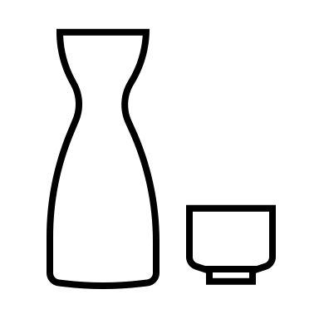




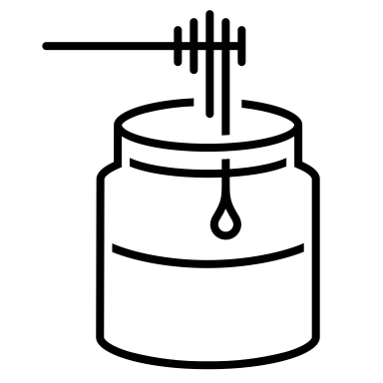
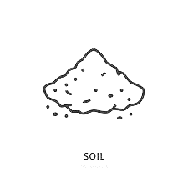
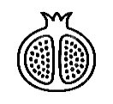




Galls
Extraction solvent
Polyphenolic extract
Green vitriol
Gum Arabic
Additives
Iron-gall Ink
Figure 4. General preparation procedure for iron-gall inks.
- The chemistry of iron-gall complexes
An overview of the most relevant studies about the structural features of iron-polyphenol complexes, and in particular iron-gallate ones, is reported in the following paragraphs. Additionally, a short section is dedicated to some of the most commonly observed degradation patterns affecting IGI.
  - General aspects on the formation of iron-polyphenols complexes
The formation of iron-gall complexes is generally described as a two-step mechanism²:
- HT and their hydrolysis products initially bind the Fe²⁺ mainly via catechol and galloyl groups instantaneously forming the dark soluble complexes. The formation of the Fe(II)-polyphenolic complexes is generally faster than the free Fe(II) cations autoxidation and therefore the polyphenols typically bind preferentially these cations instead of Fe(III) ones.⁴⁹ Due to its octahedral geometry, Fe²⁺ can coordinate up to three catechol or galloyl groups.⁴⁰ With this respect, it is important to underline that this complexation is strongly pH-dependent; in fact, the variation of the pH of an aqueous solution of a polyphenolic ligands results in the modification of its coordination centres depending on its hydrolysis degree,^{50–53} determining the actual stoichiometry of the final complex (Fig. 5a).^{15,40,53–56} Various studies on gallates and catecholates^{40,54,55} have highlighted that when the pH of a ligand solution is below 4, resulting in a structure fully protonated (GAH₄),^{50,51,57} the stoichiometry of complexes is 1 : 1 ( iron : ligand). Differently, when GA is partially deprotonated, in a pH range between 4.5 and 6.5, the formed are characterised by 1:2 and 1:3 iron to GA stoichiometries. However, it has also been demonstrated that in the pH range between 3.5 and 5.5 GA-iron complexes are still characterized by a 1:1 stoichiometry with the most reactive protonation form being GAH₂.⁵⁴ Lastly, under alkaline conditions, when GA is predominantly deprotonated (HGA³⁻ and GA⁴⁻), it tends to form 1:3 iron to ligand complexes.⁴⁰ These different iron to gallic acid ratios result in different hues of the final complexes, ranging from blue-green (1:1) to purple (1:2) and dark red-brownish colours (1:3).^{40,58} It is remarkable that the complexation itself drives to the ligand deprotonation.
The mentioned studies are generally conduced in buffer solutions, which are quite far from the medieval ink preparation conditions. For this reason, a strong acidic pH and consequently 1:1 iron to polyphenolic ligands ratio is generally expected.^{5,54,59,60}
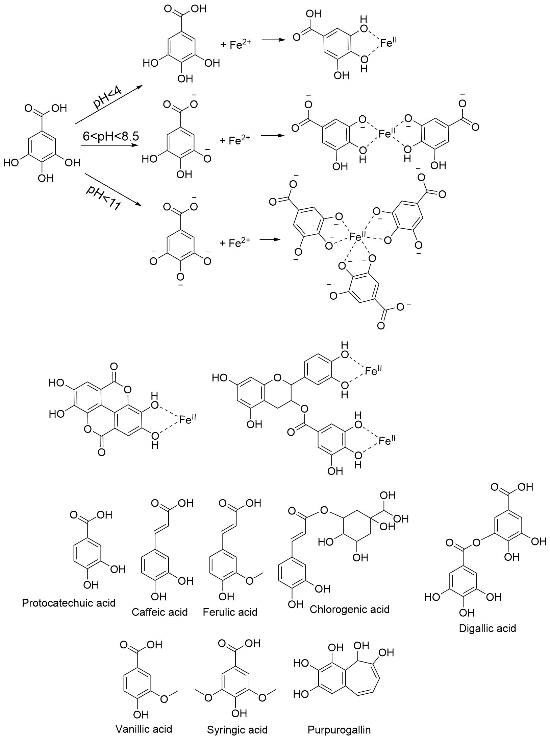
It is relevant to underline that the mentioned studies are referred to simple systems in which model polyphenolic compounds are used. It will be therefore important to investigate the pH dependence in the iron-polyphenols complexes formation also in the case of more complicated polyphenolic structure eventually present in gall extracts such as PGG, tannic acid and condensed or complex tannins. For instance, it has been demonstrated that epicatechin-gallate and epigallocatechin, in strong acidic environment (pH range 1-3) are capable to form 2:1 iron to polyphenols complexes with Fe(III) due to their multiple binding sites.^{56,61} Ellagic acid and catechins behaviour seems to be quite similar to the gallic acid one (Fig. 5b).⁵⁵ Moreover, the most commonly studied iron-polyphenolic complexes in literature are the Fe(III)-catechol ones, and only very few studies are focused on the chemistry upon the Fe(II) galloyl complexes formation.^{54,62} More specifically, the role of the carboxylic acid of gallic acid in the complex formation should be better defined. In fact, the proposed complexation mechanism does not involve the carboxylic group, which instead seems to cooperate in the formation of the final structural models which will be further discussed below.^{56,63–66}
a)
b)
Figure 5 a) Formation of mono, bis and tris catecholates complexes of Fe²⁺at different pH conditions; b) mono-dentate complexes of ellagic acid and epicatechingallate. Coordinated water molecules are not shown.

Being a crucial point, it is important to underline that most of the complexation reactions between polyphenols present in the gall extracts and transition metal cations are strongly pH dependent. For instance, the complexation of Cu²⁺ and 2,3-dihydorxybenzoic acid, which can actually act as salicylate and catecholate, independently from the molar ratios between the two reagents, results in different complexes according to the pH (Figure 6).^{67,68}

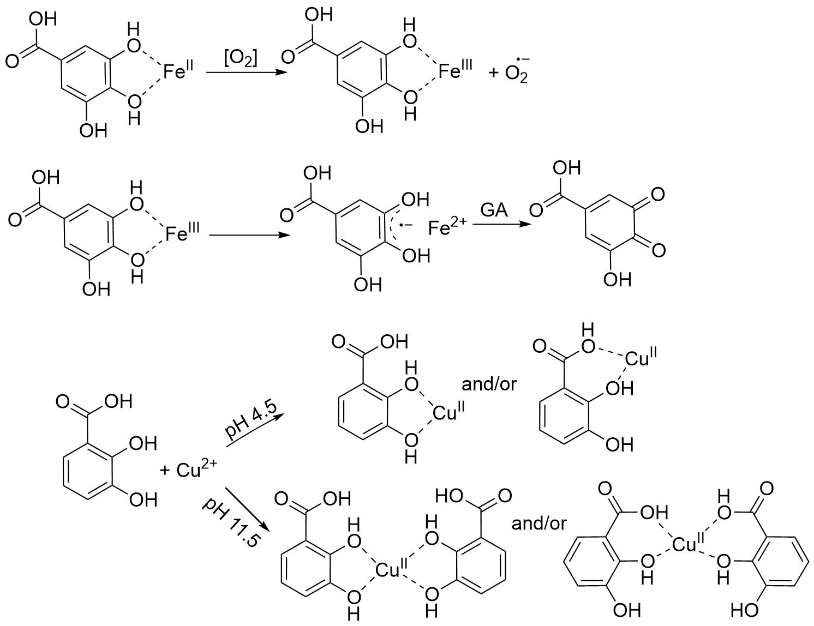
Figure 6. 2,3-dihydroxybenzoic acid (DA) binding sites in the DA-Cu²⁺ complexation in acidic and alkaline environment
On the contrary, the binding mechanism and therefore the stoichiometry of the final complexes seem to be independent from the iron to polyphenolic ligands concentration. In other words, the only visible effect related to changes in that ratio can be related just to the intensity of the colour.^{47,58} The interesting work of Malacaria collects several experimental and theoretical insights on the coordination properties Al³⁺ and Fe³⁺ towards numerous natural antioxidants revealing the complexity of the formation of these coordination compounds and underlining the importance of the multiple binding sites in the theoretical calculations -such as density function theory (DFT) calculations- and the interpretation of the experimental results.⁵⁶
- Due to its weak acidic character, Fe²⁺ does not form as stable complexes with deprotonated polyphenols as Fe³⁺does. This difference can be related to the different Lewis character of Fe³⁺. For instance, the pKs for iron(II)-monocatecholate is about 7.95, while the one for iron(III)-monocatecholate it is about 20.00.^{40,62,69} Therefore, as polyphenolic ligands strongly stabilize Fe³⁺ over Fe²⁺, Fe²⁺ in polyphenolic complexes is rapidly oxidized by atmospheric O₂ to give dark-bluish insoluble Fe³⁺-polyphenol complexes (Figure 7a). This process is commonly referred as autooxidation. Typically, Fe²⁺ oxidation occurs quite slowly under normal conditions, but because of the coordination of polyphenol ligands to Fe²⁺, the iron reduction potential is lowered, resulting in the enhancement of the autooxidation rate.^{40,49,62}
a)
b)
Figure 7. a) Autooxidation process, and b) Ligand oxidation process resulting in quinones formation

Some interesting relations between the polyphenols structure and the autoxidation rate of the complex have been obtained considering physiological pH solutions (pH 7.4). In particular, it has been confirmed that the negative charge of the conjugated bases of phenolic acids or carboxylate group itself, which are formed in the buffer with pH 7.4, accelerates the rate of autoxidation. Polyphenolic acids in fact promote an higher rate of autoxidation of the complexes if compared to their corresponding esters or phenols without carboxylic group.⁷⁰ Unambiguously, it has been observed that the oxidation of ferrous ions was more effectively facilitated by phenolic acids bearing catechol group than their counterpart with galloyl moiety.^{62,70} The complexes autoxidation kinetics have been studied from different prospective resulting the proposal of different kinetics equations.^{47,62}
- It has been observed that the Fe³⁺ resulting from the polyphenolic complexes autoxidation can be then reduced into Fe²⁺.^{40,53,71} This process involves the oxidation of the polyphenolic species into semiquinones which can be further oxidised to quinones (Figure 7b).^{40,72} Additionally, it has been also observed that the formation of quinones is favoured by low molar ratio [polyphenols]/[Fe³⁺].⁷¹ However, no Fe²⁺ accumulation due to this process has been noticed in the studied systems as its oxidation is promoted again by iron-polyphenolic interactions.^{40,47,70}
  - Variability elements in the iron-polyphenols complexes formation
IGI can be considered as complex systems whose formation is mainly influenced by four factors: tannin source and provenance, tannin extraction method, presence of additional cations over iron and presence and nature of additives and binders.
    - Tannin sources and their provenance
Gall extracts themselves can be considered as a complicated mixture of polyphenolic substances. High performance liquid chromatography (HPLC) analyses performed on gall extracts have revealed a relatively high concentration of phenolic acids such as gallic acid, ellagic acid, different isomers of dihydroxybenzoic acids, vanillic acid, caffeic acid, syringic acid, ferulic acid and chlorogenic.^{39,73} The range of possible phenolic compounds present in gall extracts is however much more extended including also tropolone-containing molecules such as purpurogallin and flavonoids such as catechin^{39,74}. Interestingly, recent studies performed on commercial gallnut extracts seem to suggest an higher content of GT and dimers and trimers of gallic acid while no significative amount of flavonoid has been detected (Figure 8).¹⁶
Figure 8. Some of the other polyphenolic compounds present in gall extracts

As already mentioned in the first paragraph, the original recipes involved different tannin sources. The structural differences in polyphenols deriving from various sources result in different binding capabilities and stabilities for the iron-polyphenols complexes. This element is important with respect to the conservation of the IGI. In fact, in iron-removal phytate treatments a different efficacy has been noticed among inks prepared using different tannin sources (this differences it is enhanced after artificial aging).⁴¹ An attempt to access to the proper binding capabilities of various polyphenolic acids was performed by spectrophotometric analyses. In particular, the linear correlation between absorbance and molar concentration has been employed to calculate the binding constants and to evaluate the ability of these compounds to bind the iron cations (Table 2). The study has been performed under oxygen-free conditions, avoiding the autooxidation of the iron(II)-polyphenols complexes.⁶⁷
Table 2. Binding constants for some polyphenolic acids
Polyphenol | Iron binding constant (L/mol)
Gallic acid | 4.78
Protocatechuic acid | 1.81
Caffeic acid | 8.12
Chlorogenic acid | 20.13
The binding constant has been defined as: $K=\frac{\left[Fe^{2+}complex\right]}{\left[Fe^{2+}\right]\left[polyphenols\right]};$ where [Fe²⁺complex], [Fe²⁺] and [polyphenols] are respectively the molar concentrations of the iron(II) complex, the free iron (II), and the free polyphenolic ligand in solution at the equilibrium conditions⁶⁷. Even if this approach has been successfully applied to obtain general information on the differences in complexes formation, unfortunately it does not allow to elucidate the real complexation mechanism for the different polyphenols. With regards to the structures reported in Figure 7 and their respective estimated binding constants, the differences in the binding capabilities of galloyl and catechol groups as well as the importance of the other functional groups in the polyphenol (in accordance with what mentioned before regarding the Lewis base behaviour of the polyphenols) can be highlighted.
Moreover, there is evidence that also the geographical provenance of the gallnuts can be associated with slight structural differences of the contained tannins. In particular, the role of these differences in terms of esterification degree and stereochemistry can be interesting for both a diagnostic and an archaeometric point of view. HPLC analyses performed on galls from different provenance contain different amount of gallo-tannins⁷⁵ and, more recently, 31-phosphorous nuclear magnetic resonance (³¹P NMR) analyses of Chinese and Turkish oak galls, have revealed structural differences on the extracted tannic acid.^{16,76}
    - Tannins extraction method
The methods used to obtain the tannins extract for the IGI preparation were extremely variable, as mentioned in the first paragraph. In fact, as reported by Teixeira,¹⁹ even if the same type of tannin source is used, extracts prepared using different extraction methods exhibit different ratios of hydrolysis products of the initial tannins.¹⁹ In this perspective, five Iberian recipes have been considered, and the HPLC coupled with mass spectrometry and diode array detector characterisations of the extracts are particularly relevant. In fact, not only the solvent used, but also the time of maceration, the temperature, the type of galls processing and the ratio between the solvent and the tannin source, turn out to be relevant parameters affecting the nature of the polyphenols contained in the extract.²⁰ Since this study has been conducted strictly following the historical recipes, the interpretation of the results has been quite difficult. However, in further studies this approach could be considered as a step-by-step methodology in order to evaluate the effect of each of the variables involved. This is one of the most underdeveloped aspects in the available literature on IGI characterization. The gallnut polyphenolic content analyses results are often referred to extracts obtained with alcoholic solution, acetone³⁹ and other modern extraction techniques which are significantly different from the traditional extraction methodologies employed for the preparation of gall inks. Ultrasonic bath, ultrasonic probe assisted extraction,⁷⁷ microwave assisted extraction and supercritical carbon dioxide polyphenolic extraction¹¹ are for instance important procedures used nowadays in the polyphenolic extraction and isolation at the industrial level.⁷⁸ As previously mentioned, under these conditions, the content of high molecular weight GT is very likely much higher than the one expected in aqueous extracts. Moreover, being a sub-group of HT, they can be easily hydrolysed with acid, alkali, hot water, and by enzymatic action;^{8,11} additionally, they can also be easily hydrolysed during the extraction.⁷ It is therefore necessary in further studies to quantify the content of the different polyphenolic fractions in the aqueous extracts strictly controlling the variables involved in the process.
    - Presence of copper and other metal cations
As already mentioned, copper and other metals have been often detected in historical IGI.⁵ Regarding to the formation of the iron-polyphenol complexes, it has been noticed that in presence of copper, the binding constant, calculated as mentioned above, is notably reduced. In addition, the rate of formation of the final complex (calculated by considering the changes in the main absorption band in time via spectrophotometric experiments) is reduced as well.⁴⁷ Jancovicova has reported that both spectrophotometric and electron paramagnetic resonance (EPR) measurements suggest that no Cu-polyphenol complex formation occurs in such systems.⁴⁷ In addition it has been suggested that the reduction in the binding constant for the iron-polyphenols complexes formation can be attributed to the oxidizing capability of Cu²⁺, which is able to oxidise polyphenols to quinones.⁴⁷ However, this conclusion is not in accordance with the majority of the most recent studies.^{40,49,79} In particular, the study of Perron¹² has highlighted that polyphenols have fairly stronger binding interactions with Cu²⁺, which is a borderline-hard Lewis acid, more similar to Fe³⁺, than Fe²⁺. In fact, the stability constants for Cu²⁺-catecholate complexes are bigger than those for the Fe²⁺ ones.⁴⁰ Even if it has been demonstrated that polyphenols have a stronger binding interaction with Cu²⁺ than with Fe²⁺, it is nowadays widely accepted that bivalent copper cations are easily reduced into Cu⁺ by polyphenolic ligands.^{40,47} Polyphenols, as well as their oxidation products, have a little affinity with Cu⁺ cations. Consequently, no Cu(I)-polyphenols binding constants are reported in literature.⁴⁰
Moreover, the results of X-ray fluorescence (XRF) measurements before and after the phytate treatment for the removal of the iron excess, show that the presence of copper induces an almost total reduction of the iron removal efficacy due to the preferential chelation of phytate by copper.⁴¹ Consequently, the preferential formation of Cu-phytate complexes can be attributed both to the strong interaction and stability of the Cu-phytate complexes and to the fact that reduced forms of copper are not strongly bonded by polyphenols and, therefore, more easily extractable from the ink than iron. Lastly, the co-presence of iron and copper enhances the degradation processes related to the Fenton-type mechanisms responsible for the high corrosion of the ink supports.⁴⁰ For all these reasons, the presence of copper is an important parameter to take into account in both conservation and archaeometrics.
    - Presence of additives and binding media
The last element of variability that can affect the formation of iron-polyphenols complexes is the well documented presence of additives and binding media (see paragraph 1.3). More specifically, the presence of Gum Arabic tuned out to inhibit the pH dropping resulting from the iron(II)-polyphenols complexes formation and increasing the stability of the inks.⁴⁷ However, neither the role of Gum Arabic during the complex formation nor the role of other organic and inorganic additives have been investigated yet.
  - General aspects regarding the iron-polyphenols complexes in iron-gall inks
A critical aspect of the studies focused on the complexes formation mechanism and structures, lies in the fact that they have been conducted just on gallic acid instead of considering also tannins. Furthermore, the gallate iron(III) complexes were often synthetized with methods far different from those used in the preparation of IGI. With respect to iron(III)-gallate complexes, in 1990s Wunderlich demonstrated that a dark insoluble polymer together with some dark polymeric crystals can be obtained from the reaction of FeCl₃ with gallic acid using a silica gel method at room temperature. The stoichiometry proposed for these complexes was 1Fe : 1C₇O₅H₃ : 2H₂O. Since the Wunderlich synthesis implies the direct use of an Fe³⁺ precursor, the results obtained have not been widely accepted in the cultural heritage science field.^{64,80} In 2006 Cheetham and Feller have been able to synthetize bluish-black rod-shaped crystals of iron(III) gallate from FeCl₂∙4H₂O, gallic acid monohydrate and NaOH using an hydrothermal method.^{64–66} The results of diffractometric analyses of some selected single crystals confirmed the Wunderlich structural model purposed.^{64,65,80} More specifically, it has been observed that the crystalline structure consists of hexagonal arrays of slightly twisting chains of MO₆ octahedra, connected by the organic groups forming a scaffold. Water molecules, acting both as donors and acceptors of hydrogen-bonds with the gallate oxygens, turned out to be present within the scaffold voids (channels) (Figure 9).^{65,66} More recently, Ponce demonstrated that the main colouring agent in IGI is indeed an amorphous form of the Wunderlich complex⁶⁴. In this case the synthesis has been carried out starting from FeSO₄∙7H₂O and gallic acid monohydrate using different molar ratios.
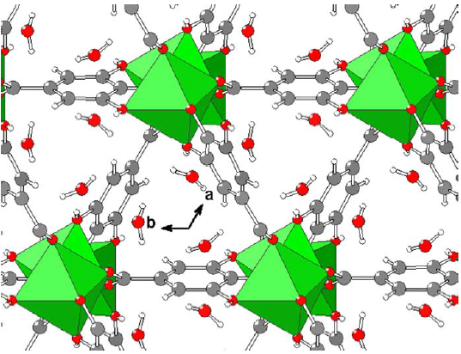
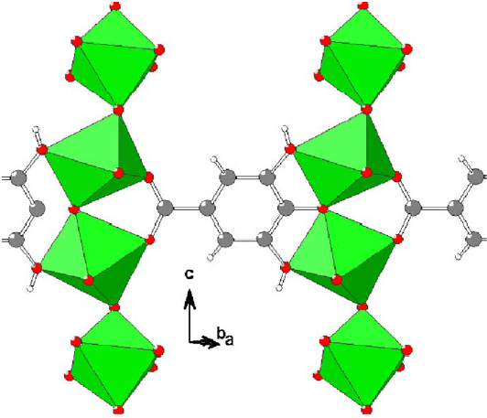
Figure 9 a) Section of the structure of Ni(II) gallate dihydrate in a plane containing the c axis. Chains of NiO₆ octahedra are connected by roughly planar gallate groups. The structures of the other gallates (such as the Fe(III) ones) are analogous. b) View down the c axis of the gallate structure. Unbound water molecules occupy trigonal channels between chains of MO₆ octahedra. Adapted from Feller, R. K. et al., 2006
a)
b)
The insoluble black iron gallate precipitate has been characterised resulting in a completely amorphous structure to X-rays majorly composed by Fe³⁺, intact gallate ligands, and water.⁶⁴ The disordered water content in the channels of the Fe(III) gallate framework structure varies from 10 to 21% in weight, but the structures are otherwise identical. Each gallate ligand is bound to three iron atoms via the acid functional group and all three alcohol moieties as previously described by Feller and Cheetham.⁶⁴ It is important to highlight that the carboxyl group participates in the formation of iron-gallate complexes. The paragraph regarding the formation of iron-polyphenols complexes was mainly focused on the role of catechol and galloyl groups in the formation of such complexes. This structural elucidation of iron-gallate insoluble complexes therefore reopens the debate on the actual formation of such complexes and the role of the carboxyl group in the binding mechanism and autooxidation processes.
Unfortunately, up to date relevant studies regarding the structure of iron(III) complexes with other polyphenolic ligands are not available in archival scientific literature. Further studies could give an important contribution in the understanding of formation mechanisms of such complexes and the role of the main variables involved.
  - The chemistry of the degradation patterns in iron-gall inks
The major degradation patterns of IGI have been studied from either the point of view of the ink stability or the one of the degradation issues caused to the support. Concerning this last point, the most well-known and cited degradative processes in manuscripts are related to hydrolysis reactions promoted by the ink acidity and the oxidative Fenton-type reactions which can cause severe damages to the ink support.^{81,82} In fact, Fe²⁺ or Cu⁺ cations, together with other transition metal species eventually present on the support, can undergo a series of redox and Fenton-type reactions catalysing the formation of reacting oxygen species (ROSs) such as the hydroxyl radical.^{40,71} Some of the main radicals formed during these processes are summarized below:
- Fe²⁺ + O₂ → Fe³⁺ + H₂O₂
- Fe²⁺ + H₂O₂ → Fe³⁺ + HO• + HO –
- Fe³⁺ + H₂O₂ → Fe²⁺ + HOO• + H⁺
- Fe²⁺ + O₂ → Fe³⁺ + O₂^{•-}
- Fe²⁺ + H₂O₂ → Fe(H₂O₂)²⁺ → Fe^{IV}O₂²⁺ + H₂O → Fe²⁺ + 2HO•
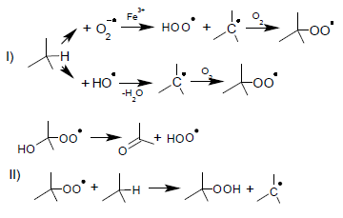
The so formed radicals rapidly react with the organic compounds present in the ink and/or in the support. The main steps of ROSs mediated oxidations are summarized in the following reactions.^{81,83}

Both oxygen and hydroxyl radicals can interact with trisubstituted carbon atoms resulting in hydrogen abstraction and the formation of a tertiary radical species. This radical is quite stable and can interact with additional molecular oxygen driving to the formation of peroxyl radicals. Peroxy radicals, finally, can generate additional radicals or undergo oxidation reactions forming carboxyl and carbonyl groups depending on the nature of carbon substituents.
It is also interesting to underline that several studies have demonstrated the possibility to observe autocatalytic oxidation processes via Fenton reactions in presence of quinones and semi-quinones, which are organic species that might be present in the system as previously reported (paragraph 2.1).^{84,85} However, the exact nature of the organic radicals formed is still matter of debate. Gimat has demonstrated by the use of EPR spectroscopy on radicals solutions quenched using the DMPO spin trap (5,5-dimthyl-pyrroline-N-oxyde) that HO• is not present in the tested iron-gall ink impregnated strips (or at least below the detection limits) while DMPO-CO₂^{•-} adducts have been found in relatively large amount.⁸³
In future studies therefore, it should be further investigated the whole variety of radicals present in these systems with special emphasis on the organic aromatic radicals, which may provide clues towards the on-going autocatalytic oxidation processes.
The ROSs formed in this type of reactions may oxidise in different ways the ink support. Cellulose oxidation for example can lead to two groups of effects: simple modification of the glucopyranose units with the formation of aldehyde, carboxyl, and keto groups (eventually associated with ring openings) and oxidative cleavage of the β-glycosidic bonds resulting in the breakdown of polysaccharide chains⁸¹. Parchment oxidation, instead, primarily involves modifications of the side chains of amino acids resulting in an alteration in the charge balance of the collagen tertiary structure.^{59,82,86} It should be underlined that oxidative processes and hydrolytic ones generally act synergistically and the study of the exact mechanisms of degradation is therefore quite complicated. In the scheme in Figure 10, the main degradation processes related to the presence of iron gall inks are summarized.
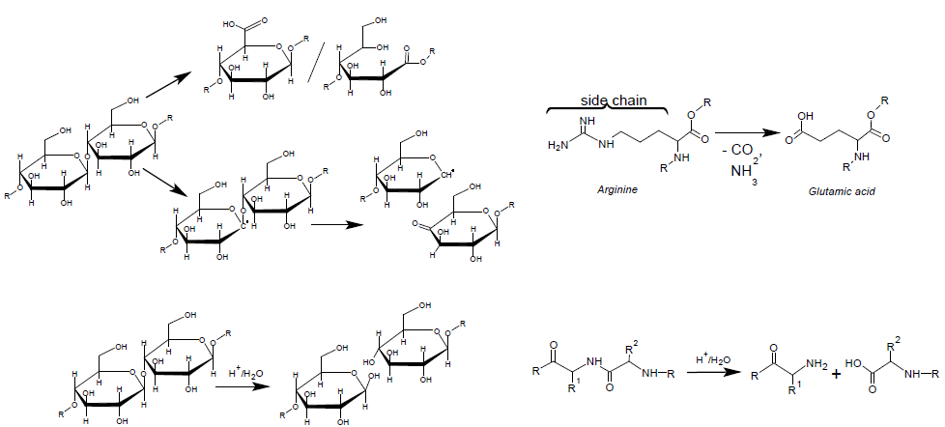

HYDROLISIS DUE TO INK ACIDITY
OXIDATION DUE TO ROSs FORMATION
PAPER
PARCHMENT

Figure 10. Some of the possible reaction mechanisms occurring during the two main degradative processes associated to the presence of IGI
- Analytical techniques for the study of iron-gall inks
In the study of IGI, conservation scientist and experts in archaeometry can nowadays take advantage of many sophisticated instrumental techniques. It should be remarked that, in this field, as well as in the Science for Cultural Heritage in general, non-invasive ore micro-invasive analytical techniques are preferred due to the artistic, historical and cultural value of the examined objects. In general, in order to properly interpret the analytical data, it is important to correctly correlate them with the physical portion of the manufact they are referred to. In non-invasive approaches, the data obtained can be referred to a material layer which varies in thickness according to the excitation source of the technique (sometimes defined as penetration-depth of the radiation).⁸⁷ In other words, analyses performed using a short wavelength excitation source (such as a x-ray beam or UV light) provide results referred just to the most superficial layers of the material under investigation, while spectroscopic techniques implementing longer wavelength radiations (such as the infrared ones) could provide results referred to a thicker portion of the manufact.
The most relevant non-invasive and micro-invasive techniques applied to obtain structural information of the iron-polyphenolic complexes in IGI are presented below.
  - Spectroscopic techniques
    - Atomic absorption
These techniques, now considered obsolete, have been used in the study of IGI due to the low limits of detection (LODs) which allow to identify the presence of elements even in traces. In these analytical methods the sample should be vaporized and atomised. In particular, the use of graphite furnace technique (GFAAS), also known as electrothermal atomic absorption (ETAAS), is preferred, since the LODs for most of the metals are in the order of ng/mL. The GFAAS technique, like all the other atomic absorption or emission ones, is destructive, but in this case the required sample is small and varies between 5 and 20μL. Since atomic absorption spectroscopy it is not a multi-elemental technique, the matrix effect should be taken into account and a proper calibration is required. Atomic absorption techniques have been used for the quantification of the total amount of iron in suitable pre-treated sample, as well as for the evaluation of the efficiency of iron extraction treatments (conservative treatments).^{88,89}
    - Laser induced breakdown spectroscopy (LIBS)
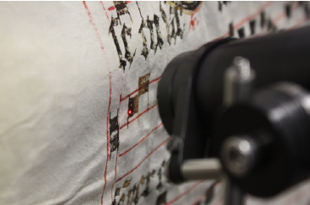
In this technique a monochromatic pulsed laser is used not only for sampling, but also to obtain a plasma. The excited atoms and ions in the plasma produce atomic emission lines which can be then revealed. Since it is a laser ablation technique, the invasiveness depends on the amount of material that is removed during the analysis, but it is commonly described as a micro-destructive technique (Fig. 11). Despite of that, LIBS has been successfully used in the study of pigments and inks.⁸⁸ For example, LIBS was used to identify the elements present in the iron-gall ink in discoloured and non-discoloured areas of the manuscript Gradual of Lviv Benedictines from Krzeszow, dated at the end of the 16th century. Thanks to LIBS measurements it has been also possible to study the migration of elements inside the parchment. Based on the observed changes in element concentration, it has been discovered that their amount decreases with subsequently deeper measurements (shots) of the examined material. For the majority of the elements (Fe, Cu, Ca, Al, Mg), the changes of concentration occur similarly. Copper and zinc instead display a different pattern of distribution and, in the first measurements (small depth), a larger abundance has been discovered in the discoloured ink.⁹⁰
Figure 11. LIBS examination of the Gradual of Lviv Benedictines from Krzeszow. Adapted from Surmak, A., 2016
    - X-rays analyses
They are probably the most used elementary analysis techniques in the study of samples of historical, cultural and artistic interest. The most common technique is the X-ray fluorescence (XRF), which has the advantage of being non-invasive and non-destructive while having good LODs (in the order of μg/mL for transition metals). Another advantage of the XRF technique is the ability to work in situ using portable instruments or to associate it with microscopes, such as electron scanning (SEM-EDXRF). In this case it would be possible to map or locate the analysis in very small areas.^{41,88,91–93} The major advantage in using XRF as an imaging technique, both at microscopic and macroscopic level (Scanning macro-X rays fluorescence), is represented by the possibility to obtain information about the spatial distribution of elements, that can be useful to better understand differences among inks used together but prepared in different ways.^{94–96} However, despite the possibility to use XRF as a semi-quantitative technique, it has been mostly used just as in a qualitative way.^{97–100}
A second X-ray technique that is commonly used, also in combination with XRF, is the proton/particle induced x-ray emission (PIXE). PIXE is more sensitive in detecting light metals (having a low x-ray emission energy) than the XRF, which otherwise has a higher sensitivity towards heavy metals. Furthermore, the PIXE technique is less affected by the interference of atmospheric gases during the analysis and, since the protons are considerably heavier than the electrons, the scattering phenomenon is also reduced with consequent improvement of the background signal. The main disadvantage of PIXE is related to the necessity of a proper source of accelerated protons beam.⁸⁸ It has been however successfully applied in different archaeometric studies on valuable medieval manuscripts.^{88,101,102} In one of these studies the inks’ composition of some Galileo’s manuscripts, which was accessed using PIXE, enabled the reconstruction of their chronological order.¹⁰²
In the X-rays absorption near-edge spectroscopy technique (XANES) the sample is irradiated, in a defined point, by a microscopic beam of monochromatic X-rays and the Kα transition of Fe is detected. The valence state of metal cations can be deduced from the energy shift of the absorption edge or from pre-edge absorption features, and for this reason XANES has been used to determine the Fe²⁺ to Fe³⁺ ratio in historical manuscript, which is a very good chemical indicator for the degree of IGI corrosion.^{88,103,104} It has been demonstrated that a proper choice of the Fe reference compounds with similar symmetry, same type of surrounding atoms in nearest coordination shells, arranged in a similar local structure is crucial for the absolute calibration of the Fe K-edge shift and thereby for a reliable determination of the Fe²⁺/Fe³⁺ molar ratio in the sample.¹⁰⁴ Promising perspectives come also from Scanning Transmission X-ray microscopy: as the XANES technique, it requires synchrotron facilities but allows to obtain chemical speciation-sensitive images together with the possibility to perform near edge X-ray absorption fine structure or XANES measurements. This technique has been used recently to understand the inhibition of the ink penetration inside single paper fibers due to the presence of gelatin.¹⁰⁵
Moreover, it should be taken into account that this technique requires synchrotron sources, which are not always accessible. In addition, it should be considered that the uses of a high-density flux of the micro-focused X-rays beam from synchrotron radiation sources can cause damage to the material and partial photo-reduction of iron due to the high absorbed dose of ionizing radiation. The use of this technique is also limited by the experimental difficulties in obtaining a good signal from minute amounts of IGI on tiny pieces of ancient manuscripts.¹⁰⁴
    - Mössbauer spectroscopy
This spectroscopic technique enables to obtain detailed information about the iron atoms valence state and their chemical environment.¹⁰⁶ However, there are several limitations to its practical use. Mössbauer spectroscopy requires in fact several hundred milligrams of paper in order to get an absorber with the necessary thickness to perform the analysis (several hundred milligrams per square centimetre). Even if it is not considered a destructive technique, this material has to be removed from the documents. To overcome this problem, it is possible to pass the gamma rays through several pages of an opened book, at least for measurements at ambient temperature. Moreover, measurements in the order of days or even 1-2 weeks are not uncommon. For these reasons just few documents have been analysed with this technique.^{88,107}
Most of the Mössbauer spectra reported in literature are dominated by the Fe³⁺ quadrupole doublet which, depending on the experimental condition, turned out to have a quadrupole splitting (QS) around 0.50 and 0.80 mm/s (Figure 11). Mock samples of Fe(III) gallate prepared by oxidizing a Fe(II) gallate exhibit just the ferric quadrupole doublet, which at 4.2 K (liquid He) is magnetically split into a magnetic sextet pattern with slightly broadened lines. However, most of the time a small quadrupole doublet related to Fe²⁺ nuclei is also observed (QS around 1.7 and 2.5 mm/s depending on the experimental conditions – Figure 12), and with a correct calibration it has been also possible in some cases to quantify a Fe(II)/Fe(III) ratio.^{64,104,107,108} Starting from the spectra acquired on samples prepared in different ways it has been also possible to access the crystallographic configuration of the Fe³⁺ gallates.⁶⁴
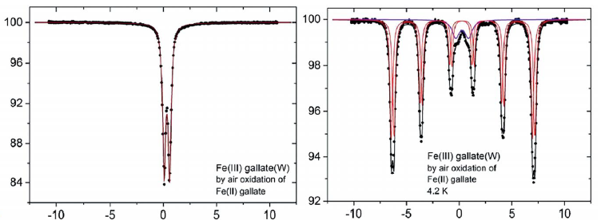
Velocity (mm/s)
Relative transmission (%)
Figure 12. Mössbauer spectra of Fe(III) gallate obtained by oxidation od Fe(II) gallate displaying the peaks characteristic of the Wunderlich structure. a) spectrum acquired at room temperature b) spectrum acquired at 4.2K. Adapted from Wagner et al. 2015.

    - UV-Visible spectroscopy
The use of the UV-vis absorption technique is not recommended in the study of real samples due to the necessity to solubilize the sample, but they are instead successfully applied in the study of the kinetics of formation of iron-gallic complexes thanks to their strong absorption in the visible region. Reflectance techniques are, on the contrary, non-invasive and non-destructive although they do not give precise information. However, it is a very useful tool for fast analysis of degradation monitoring or to have an initial surface mapping. The most commonly used reflectance technique is the one in which optical fibres are used to transmit a laser radiation reaching the sample. The beam of reflected light is then collected and transmitted to the detector which investigates the spectral region ranging from the near infrared to the visible (FORS-NIR-UV -Vis).⁸⁸ Moreover, reflectance techniques have the advantage of being able to be used in situ. The major disadvantage in the application of FORS is that, due to the darkness of the inks, the reflected portion of the light is very limited. For this reason, this approach often requires a relevant post elaboration of the resulting spectra, which generally do not display intense narrow peaks, and most of the time a suitable statistical treatment is needed.^{109–111}
In some cases, it can be useful to think in terms of colorimetric parameters, obtained starting from the UV-VIS reflection spectra processed with appropriate mathematical operations^{5,88,112}. However, it is important to underline that the colorimetric parameters resulting from the analysis are often influenced by several variables such as the support colour, the roughness of the surface itself and the humidity. Nevertheless, this technique, properly called colorimetry, is widely used for rapid non-invasive analyses and it is a powerful tool to monitor the efficacy of a restoring treatment.^{113,114}
Table 3. Characteristic UV-vis bands of IGI.
Method | Main signals | References
UV-vis spectra acquired on aqueous solutions | 560-590nm broad absorption band formed after the addition of the iron salt.  ~218nm and ~273nm contribution of gallic acid | ⁴⁷
UV-vis spectra acquired on aqueous solutions | 690nm broad absorption band of the Fe-gallate complexes  380nm+ 445nm (shoulder) absorption band due to quinones formed | ⁷¹

    - Infrared spectroscopy
Infrared spectroscopy techniques are used both in the study of iron gall complexes and in the investigation of the degradation of the supports caused by the presence of ink. In this study transmittance techniques are applied sparingly and mainly on standard samples prepared in the laboratory. On the other hand, non-destructive techniques working with attenuated total reflectance (ATR-FTIR) or in diffuse reflectance (DRIFTS) are more frequently used even on real samples and even coupling them to a microscope in order to focus the analysis in small areas.^{59,95}
However, it is important to remember that infrared spectroscopy is rarely used as the only investigation tool, on the contrary it is often used with multi-analytical approaches.^{5,88,99,100} In the interesting work of Díaz Hidalgo micro-FTIR has been used together with Raman, colorimetry and mass spectrometry techniques, in the study of inks prepared following historical Iberian recipes.⁵ FT-IR spectra acquired on real samples and pure complexes enable the authors to underline that, in agreement with other literature data¹¹⁵, more than one single iron-polyphenol complex is present in iron-gall inks and that, in agreement with Raman results, the best match for the iron-gall ink precipitate is with iron-pentagalloyl glucose.⁵
Table 4. Characteristic IR bands of IGI according to literature. Different assignments for the same signal are here reported.
Method | Main signals | References
Transmittance mode  (KBr pellets) | 1715-1730cm⁻¹ : ν_{as} C=O carboxylic acid  1605-1625cm⁻¹: νC-O, βCH, νC=C aromatic or νCOOH and crystallization H₂O vibrations contribution  1415-1430cm⁻¹: νC=C aromatic or νCOO⁻  1120-1040cm⁻¹: νC–O carboxylic acids, β OH carboxylic or νSO₄²⁻  1015cm⁻¹: ν ring C–C, νC–O carboxylic | ^{91,116,117}
Reflectance mode  (ATR and μ-FTIR) | 1685-1705cm⁻¹: ν_{as} C=O  1605-1625cm⁻¹: νC=C aromatic or νCOO⁻ and crystallization H₂O vibrations contribution  1430-1445cm⁻¹: νC=C aromatic or νCOO⁻  1330-1345cm⁻¹: ν_{as} C-O ester  1130-1145cm⁻¹: νCO  1080-1100cm⁻¹: νSO₄²⁻ overlapped with νCOO⁻ | ^{5,59}
ν= stretching, β=bending

    - Raman spectroscopy
This spectroscopic technique is widely used in the field of science related to cultural heritage. Non-invasiveness and non-destructiveness and the possibility of conducting in situ analyses with portable instruments are the major advantages and make this technique a very useful tool in the analysis of artefacts of historical, cultural and artistic interest.^{88,118} One of the problems that could be encountered in this field is the choice of the laser power. In fact, it must be sufficiently high to observe the signal despite the strong fluorescence that generally is observed, but at the same time it should be also modulated by considering the fragility of the support, especially in paper documents and manuscripts.
The most used laser in the study of iron-gall inks on real samples is the red laser with an excitation wavelength around 785nm¹¹⁹ (even if , in some cases, Raman spectra have been acquired also using a 632.8nm excitation source¹²⁰) while the laser’ power suggested is around 1mW at the sample.^{119,120} However, using low laser powers the fluorescence signals can dramatically compromise the spectrum quality. For this reason some attempts in the implementation of Surface Enhanced Raman Scattering (SERS) have been made: the first results however suggest that the interaction between the highly reactive metallic nanoparticles surface and the gallic acid units resulted in significant structural changes.¹²¹ In any case, traditional SERS approach should be considered invasive and destructive, even if just a small amount of sample is required to be adsorbed onto the enhancing noble metallic nanoparticle substrate or associated near the enhancing substrate with the use of a capture layer. An interesting and innovative approach is represented by the implementation of atomic force microscopy – tip enhanced Raman spectroscopy (AFM-TERS). TERS combines the high sensitivity of SERS and the precise spatial control and resolution of scanning probe microscopy (AFM for example) via a nanometre-scale noble metal scanning tip (Figure 13).¹²²
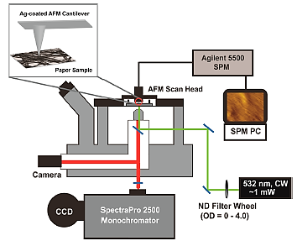
Raman spectroscopy, like the FT-IR, has been used in various studies for the characterization of IGI and iron-gall complexes together with other molecular and elementary techniques in a multi-analytical approach.^{5,64,91,123}
Figure 13 Schematic of home-built AFM-TERS instrument. Inset: Schematic of the interaction between the AFM tip and the sample. Adapted from Kurouski et al. 2014

For example, important structural information about the iron-gallate complexes have been deducted using Raman spectroscopy together with FT-IR, X-rays diffraction, Mössbauer and other techniques in an interesting work of Ponce. ⁶⁴ Most of the Raman spectra of IGI in literature have been acquired using micro-Raman equipment however, portable and compact Raman instruments are now largely available on the market. The possibility to perform Raman analyses in a complete non-invasive way makes this technique even more suitable for the analysis of historical manuscripts. In Table 5 the main Raman signals related to IGI are listed.

Table 5. Characteristic Raman bands of IGI. Also in this case, different assignments for the same signal are reported.
Method | Main signals | References
Micro-Raman  (782 and 785nm excitation source) | 1575-1580cm⁻¹: quadrant νC=C of aromatic rings or ν_{as}COO⁻  ~1470-80cm⁻¹: νC=C of aromatic rings, βCH  1430-1450cm⁻¹: related to ν_{s}COO⁻ or βC-OH and βCH  1320-1345cm⁻¹: νC=C, νCO  1230-1240cm⁻¹: νC=C of aromatic rings, νCO ester, βCH  1090-1115cm⁻¹: νCO alcohols  400-600cm⁻¹: broad bands without clear attributions | ^{5,64,91,115,119,124}

    - Terahertz spectroscopy
An under-exploited domain of the electromagnetic spectrum, known as the terahertz(THz) spectral region, has emerged in the last decades as a possible powerful tool for non-invasive and non-destructive investigation of cultural heritage materials. In many studies THz spectroscopy, and in particular time domain terahertz spectroscopy (THz-TDS), has been used for the identification of organic and inorganic art and/or historical materials, including pigments present in historical manuscripts and, using a THz-TDS imaging system, it has been possible to have non-invasive stratigraphic information.^{88,125–127}
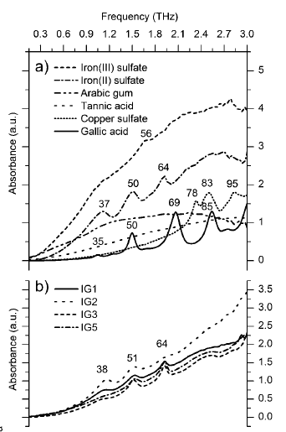
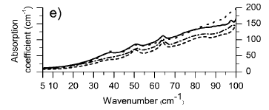
THz-TDS spectroscopy has been used to investigate the iron(II) sulphate crystalline structures, commonly present in IGI and more interestingly to study systematically THz features in aged and not aged IGI (Figure 14).^{128,129}

Figure 14. (a) Terahertz absorbance spectra of individual constituents of iron gall ink: gallic acid, tannic acid, copper sulphate, iron(II) sulphate and Gum Arabic, and a possible reaction product: iron(III) sulphate; (b) average absorbance spectra of 5 inks prepared using different ratios among the ingredients Adapted from Bardon et al. 2013

In the study of Bardon in particular both the singular inks components and the final iron gall inks have been studied using THz-TDS in transmittance mode, that turned out to provide clearer spectra than the attenuated total reflectance mode (ATR). An interesting comparison among the spectra acquired on inks prepared with different iron sulphate – tannic acid molar ratios and with or without the addition of copper sulphate has been proposed and a correlation among the peak intensities of THz spectra and the artificial aging times has been highlighted.¹²⁹ Further study however should be conducted to test if such interesting results can be obtained also in a non-invasive way on real samples.
Table 6. Characteristic TD-THz bands of IGI. The data are referred to room temperature measurements.
Method | Main signals | References
Transmittance mode (dry ink in polyethylene pellets). | 38cm⁻¹(sh), 50cm⁻¹(sh), 64cm⁻¹(sh)* mainly iron(II) sulphate contribution.  85cm⁻¹ is observed in high gallic acid content inks | ^{128,129}
sh: sharp peak
  - Mass spectrometry
Mass spectrometry (MS) can be considered both as an elemental and molecular analytical technique. Even if it is destructive technique, MS allows to reach low LODs for most of the metals (especially in the case of the use of a quadrupole spectrometer in which the LODs are in the order of ng / mL). The variant involving sampling by laser ablation and ionization with inductively coupled plasma (LA-ICP-MS), can be considered micro-invasive and micro-destructive and it has been successfully used for mapping small areas.⁸⁸ The major advantage in using LA-ICP-MS in the study of IGI is, in fact, the possibility to study the spatial distribution of iron and other elements such as copper, manganese and zinc, simultaneously. LA-ICP-MS has been used to evaluate the impact of a conservative treatment involving the extraction of iron and other metal both comparing the signal before and after the treatment (efficacy of the treatment) and comparing the spatial distribution of the same metals in order to exclude that a migration phenomenon has occurred during the treatment(Figure 15a).^{60,88,113,130,131} It must be underlined that LA-ICP-MS, as well as the techniques in which laser ablation is involved, cannot be considered strictly quantitative. The information which is possible to obtain using these techniques is related to the abundance of the analytes (grams or moles of analyte per unit of area) and indirectly related to their concentrations (grams or moles per unit of mass or volume).
As molecular technique, mass spectrometry could be theoretically useful in the study of the metal-polyphenol complexes. However, different authors have underlined the several limitations and drawbacks in the use of ESI-MS in the study of the iron-gall inks complexes. In fact, the ions produced can undergo chemical reaction in the gaseous phase, formation of several adducts, and change in pH and temperature conditions.^{132,133} However, if this technique would be considered suitable, it is recommended to perform the scanning in negative mode.¹³² Differently, interesting results can be obtained using nano-spray mass spectrometry(NSI-MS).^{134,135} In the study of different ancient inks, including also iron-gall inks, the use of direct analyte probe nano-extraction coupled NSI-MS enabled to perform localized chemical analysis of document inks provide the advantages of analysis with small sample volume, high resolution, low limits of detection, and direct analysis, eliminating further sample preparation and saving analysis time (Figure 15b).¹³⁵ With regard to the use of MS as molecular technique, mass spectrometers are often used as detectors in hyphenated techniques, such as HPLC-MS, which are described in the following paragraph.
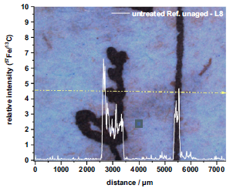
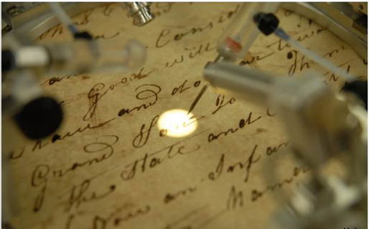
Figure 15 a) LA-ICP-MS results referred to an untreated and unaged sample. The line indicates the trace of the laser ablation. Adapted from Völkel et al. 2020 b) The document to be analysed with NSI-MS placed on the microscope stage with the nanopositioner maneuvered where the extraction is to be done. Adapted from Huynh V., 2014

  - Chromatographic techniques
There are several studies in which both liquid and gas chromatographic techniques, generally coupled with mass spectrometry, have been used for the characterisation of the organic components of IGI in historical manuscripts and documents. It must be underlined that chromatographic techniques are generally invasive, destructive and require a suitable pre-treatment of the sample that is quite time-consuming.
HPLC has been applied in several studies with moderate success: using a mass spectrometer as a detector (HPLC-MS), the content of gallic, ellagic and protocatechinic acid in real samples of ink subjected to appropriate pre-treatment has been determined.¹¹⁵ In a recent study, HPLC has been used to study in depth the phenolic content of different iron-gall inks: HPLC-DAD has been used to identify the different phenolic components while with an electron spray mass spectrometer system (HPLC-ESI-MS) it has been possible to quantify them..^{5,19} These studies reported that actually PGG and hexagalloylglucose (HGG) are the main polyphenolic components in several IGI prepared using Iberian historical recipes.
Very few studies have implemented the use of gas chromatography for the identification of iron gall inks; these data are summarised in Table 7. In these cases, the main problem is related to the necessary pre-treatment of the samples as to make them volatile. Pyrolysis coupled to a gas chromatography with mass spectrometric detector (Py–GC–MS) enables to obtain a qualitative characterization of organic and inorganic elements present in inks by using specific and well known chemical species easily detectable in the resulting chromatograms (which vary according to the pre-treatment method used).^{136,137}
Table 7. Main signals of iron-gall inks in HPLC and GC analyses
Technique | Method | Main signals | References
HPLC-MS | Electron spray ionisation (ESI) | m/z: 169 (gallic acid), 635 (trigalloylglucose), 787 (tetragalloilglucose), 939 (PGG), 1091 (or 545 m/2z, HGG ) all related to the main tannin source. | ¹⁹
GC-MS | Pyrolysis system  Pre-treatment with Tetrametilammonium hydroxide (TMAH) | m/z: 53 (phenol, dimethoxy), 125 (benzene, trimethoxy), 155 (permethilated gallic acid – other ions in mass spectrum are at m/z: 226, 211, 195), 165 (benzoic acid, 4-methoxy methyl ester) all related to the main tannin source.  m/z: 59 ( and m/2z: 75, saccharinic acids) derived both from cellulose and Gum Arabic TMAH pyrolysis | ^{136,137}

  - Electrochemical based techniques
Only a few reports are present in archival scientific literature on the use of electrochemical techniques in the study of IGI. A preliminary study was conducted using potentiometry for the determination of the Fe²⁺/Fe³⁺ ratio in ancient manuscripts. It is noteworthy that, thanks to the accurate methodology followed in the study, interesting aspects concerning the mechanism of formation of the complexes and the electrochemical behaviour of the various components on the inks have been highlighted.¹³⁸ In a study regarding the construction of a dye sensitized solar cell the electrochemical behaviours of tannins and their iron complexes have been investigated by cyclic voltammetry (CV). Starting from the observation of the oxidation and reduction potentials it has been possible to calculate the HOMO ad LUMO energies for different iron-tannin complexes and their relative band gap energy.¹³⁹ Classical electrochemical investigation techniques such as CV and chronoamperometry (CA) have been also applied in the study of gallic acid iron complexes nanoparticles oxidation and stability in the field of clinical biochemistry.¹⁴⁰ Further studies should be conducted to better understand the potentiality of these methods and to establish a micro-destructive analytical procedure that could be better applied on real samples in the field of Cultural Heritage material science.

- Conclusions
By critically reviewing the current literature various aspects to be further investigated have emerged. Firstly, a systematic study of the polyphenols obtained from different sources of tannins and/or using different extraction methods could be useful to better understand the variety of iron complexes present in IGI. In fact, this aspect is particularly relevant for both the evaluation of the most appropriate conservative strategies and to perform additional archaeometry studies. Secondly, with respect to the IGI formation mechanism, more efforts should be made to clarify the role of the binder and the additives. In particular, these studies should take into account the possible pH variations induced by these materials, as well as possible chemical interactions with tannins and Fe(II) cations. Thirdly, more detailed studies on the mechanism of formation of the complexes would be necessary to clarify the role of the carboxylic group in the formation of the 3D spatial organization of amorphous solids iron-polyphenolic complexes. Finally, further studies on the exploration of the actual range of organic radicals resulting from the oxidative degradation of IGI would be useful for a conservative point of view. In particular it would be important to understand which radicals are due to oxidations mechanism within the ink itself and which ones are instead attributable to the interaction ink-support.
Funding
This research did not receive any specific grant from funding agencies in the public, commercial, or not-for-profit sectors.

References
(1) Magdalena, P.-S. Cultural Heritage in EU Policies, 2018.
(2) Ghigo, T.; Albarrán Martínez, M. J. The Practice of Writing inside an Egyptian Monastic Settlement: Preliminary Material Characterisation of the Inks Used on Coptic Manuscripts from the Monastery of Apa Apollo at Bawit. Herit Sci 2021, 9 (1), 62. https://doi.org/10.1186/s40494-021-00541-0.
(3) Levey, M. The Manufacture of Inks, Līqs, Erasure Fluids, and Glues-A Preliminary Survey in Arabic Chemical Technology. Chymia 1961, 7, 57–72. https://doi.org/10.2307/27757205.
(4) Carvalho David Nunes. Forty Centuries of Ink Or, A Chronological Narrative Concerning Ink and Its Backgrounds, Introducing Incidental Observations and Deductions, Parallels of Time and Color Phenomena, Bibliography, Chemistry, Poetical Effusions, Citations, Anecdotes and Curiosa Together with Some Evidence Respecting the Evanescent Character of Most Inks of to-Day and an Epitome of Chemico-Legal Ink., First edition.; The bank law publishing Co.: New York, 1998.
(5) Díaz Hidalgo, R. J.; Córdoba, R.; Nabais, P.; Silva, V.; Melo, M. J.; Pina, F.; Teixeira, N.; Freitas, V. New Insights into Iron-Gall Inks through the Use of Historically Accurate Reconstructions. Herit Sci 2018, 6 (1), 63. https://doi.org/10.1186/s40494-018-0228-8.
(6) Fagan, M. M. The Uses of Insect Galls. The American Naturalist 1918, 52 (614), 155–176. https://doi.org/10.1086/279661.
(7) Serrano, J.; Puupponen-Pimiä, R.; Dauer, A.; Aura, A.-M.; Saura-Calixto, F. Tannins: Current Knowledge of Food Sources, Intake, Bioavailability and Biological Effects. Mol. Nutr. Food Res. 2009, 53 (S2), S310–S329. https://doi.org/10.1002/mnfr.200900039.
(8) Bravo, L. Polyphenols: Chemistry, Dietary Sources, Metabolism, and Nutritional Significance. Nutrition Reviews 56 (11), 17.
(9) Karamali, K.; Teunis, van R. Tannins: Classification and Definition. Nat. Prod. Rep. 2001, 18 (6), 641–649. https://doi.org/10.1039/b101061l.
(10) Wall-Medrano, A. TANINOS HIDROLIZABLES; BIOQUÍMICA, ASPECTOS NUTRICIONALES Y ANALÍTICOS Y. NUTRICION HOSPITALARIA 2015, No. 1, 55–66. https://doi.org/10.3305/nh.2015.31.1.7699.
(11) Brglez Mojzer, E.; Knez Hrnčič, M.; Škerget, M.; Knez, Ž.; Bren, U. Polyphenols: Extraction Methods, Antioxidative Action, Bioavailability and Anticarcinogenic Effects. Molecules 2016, 21 (7), 901. https://doi.org/10.3390/molecules21070901.
(12) Lopes, G.; Sousa, C.; Silva, L. R.; Pinto, E.; Andrade, P. B.; Bernardo, J.; Mouga, T.; Valentão, P. Can Phlorotannins Purified Extracts Constitute a Novel Pharmacological Alternative for Microbial Infections with Associated Inflammatory Conditions? PLoS ONE 2012, 7 (2), e31145. https://doi.org/10.1371/journal.pone.0031145.
(13) Le Bourvellec, C.; Renard, C. M. G. C. Interactions Between Polyphenols and Macromolecules: Effect of Tannin Structure. In Encyclopedia of Food Chemistry; Elsevier, 2019; pp 515–521. https://doi.org/10.1016/B978-0-08-100596-5.21486-8.
(14) Renard, C. M. G. C.; Watrelot, A. A.; Le Bourvellec, C. Interactions between Polyphenols and Polysaccharides: Mechanisms and Consequences in Food Processing and Digestion. Trends in Food Science & Technology 2017, 60, 43–51. https://doi.org/10.1016/j.tifs.2016.10.022.
(15) Zahida T.Maqsood; S. Arif Kazmi, S. A. K. Determination of Stability Constant, Enthalpy and Entropy of Formation of Iron(III) Complexes of Gallic Acid and Methyl Ester of Gallic Acid. Journal of the Chemical Society of Pakistan 1993, 15 (1).
(16) Watrelot, A. A.; Le Guernevé, C.; Hallé, H.; Meudec, E.; Véran, F.; Williams, P.; Robillard, B.; Garcia, F.; Poncet-Legrand, C.; Cheynier, V. Multimethod Approach for Extensive Characterization of Gallnut Tannin Extracts. J. Agric. Food Chem. 2020, 68 (47), 13426–13438. https://doi.org/10.1021/acs.jafc.9b08221.
(17) Oudane, B. Isolation, Characterization, Antioxidant Activity, and Protein-Precipitating Capacity of the Hydrolyzable Tannin Punicalagin from Pomegranate Yellow Peel (Punica Granatum). Journal of Molecular Structure 7.
(18) Saad, H.; Charrier-El Bouhtoury, F.; Pizzi, A.; Rode, K.; Charrier, B.; Ayed, N. Characterization of Pomegranate Peels Tannin Extractives. Industrial Crops and Products 2012, 40, 239–246. https://doi.org/10.1016/j.indcrop.2012.02.038.
(19) Teixeira, N.; Nabais, P.; de Freitas, V.; Lopes, J. A.; Melo, M. J. In-Depth Phenolic Characterization of Iron Gall Inks by Deconstructing Representative Iberian Recipes. Sci Rep 2021, 11 (1), 8811. https://doi.org/10.1038/s41598-021-87969-3.
(20) Rasines-Perea; Jacquet; Jourdes; Quideau; Teissedre. Ellagitannins and Flavano-Ellagitannins: Red Wines Tendency in Different Areas, Barrel Origin and Ageing Time in Barrel and Bottle. Biomolecules 2019, 9 (8), 316. https://doi.org/10.3390/biom9080316.
(21) Vanholme, R.; Demedts, B.; Morreel, K.; Ralph, J.; Boerjan, W. Lignin Biosynthesis and Structure. Plant Physiology 2010, 153 (3), 895–905. https://doi.org/10.1104/pp.110.155119.
(22) Haslam, E.; Cai, Y. Plant Polyphenols (Vegetable Tannins): Gallic Acid Metabolism. Nat. Prod. Rep. 1994, 11, 41. https://doi.org/10.1039/np9941100041.
(23) Serna, D.; Martínez, J. Phenolics and Polyphenolics from Melastomataceae Species. Molecules 2015, 20 (10), 17818–17847. https://doi.org/10.3390/molecules201017818.
(24) Takako Yamashita; Yosuke Matsuo, Y. M.; Yoshinori Saito, Y. S.; Takashi Tanaka, T. T. Formation of Dehydrohexahydroxydiphenoyl Esters by Oxidative Coupling of Galloyl Esters in an Aqueous Medium Involved in Ellagitannin Biosynthesis. Nat. Prod. Rep. 2001, 18 (6), 641–649. https://doi.org/10.1039/b101061l.
(25) Nonaka, G. Isolation and Structure Elucidation of Tannins. Pure and Applied Chemistry 1989, 61 (3), 357–360. https://doi.org/10.1351/pac198961030357.
(26) Melone, F.; Saladino, R.; Lange, H.; Crestini, C. Tannin Structural Elucidation and Quantitative ³¹ P NMR Analysis. 2. Hydrolyzable Tannins and Proanthocyanidins. J. Agric. Food Chem. 2013, 61 (39), 9316–9324. https://doi.org/10.1021/jf401664a.
(27) Melone, F.; Saladino, R.; Lange, H.; Crestini, C. Tannin Structural Elucidation and Quantitative ³¹ P NMR Analysis. 1. Model Compounds. J. Agric. Food Chem. 2013, 61 (39), 9307–9315. https://doi.org/10.1021/jf401477c.
(28) Okuda, T.; Yoshida, T.; Hatano, T. Classification of Oligomeric Hydrolysable Tannins and Specificity of Their Occurrence in Plants. Phytochemistry 1993, 32 (3), 507–521. https://doi.org/10.1016/S0031-9422(00)95129-X.
(29) Zhen, L.; Lange, H.; Zongo, L.; Crestini, C. Chemical Derivatization of Commercially Available Condensed and Hydrolyzable Tannins. 2021, 13.
(30) Li, C.; Leverence, R.; Trombley, J. D.; Xu, S.; Yang, J.; Tian, Y.; Reed, J. D.; Hagerman, A. E. High Molecular Weight Persimmon (Diospyros Kaki L.) Proanthocyanidin: A Highly Galloylated, A-Linked Tannin with an Unusual Flavonol Terminal Unit, Myricetin. J. Agric. Food Chem. 2010, 58 (16), 9033–9042. https://doi.org/10.1021/jf102552b.
(31) Xie, D.-Y.; Dixon, R. A. Proanthocyanidin Biosynthesis – Still More Questions than Answers? Phytochemistry 2005, 66 (18), 2127–2144. https://doi.org/10.1016/j.phytochem.2005.01.008.
(32) Jonker, A.; Yu, P. The Occurrence, Biosynthesis, and Molecular Structure of Proanthocyanidins and Their Effects on Legume Forage Protein Precipitation, Digestion and Absorption in the Ruminant Digestive Tract. IJMS 2017, 18 (5), 1105. https://doi.org/10.3390/ijms18051105.
(33) Crestini, C.; Lange, H.; Bianchetti, G. Detailed Chemical Composition of Condensed Tannins via Quantitative ³¹ P NMR and HSQC Analyses: Acacia Catechu , Schinopsis Balansae , and Acacia Mearnsii. J. Nat. Prod. 2016, 79 (9), 2287–2295. https://doi.org/10.1021/acs.jnatprod.6b00380.
(34) Ferreira, D.; Bekker, R. Oligomeric Proanthocyanidins: Naturally Occurring O-Heterocycles. NATURAL PRODUCT REPORTS 1996, 23.
(35) About insect galls. Brandeis University - Life sciences at Brandeis. http://www.bio.brandeis.edu/fieldbio/galls/galls.html (accessed 2021-07-24).
(36) Hartley, S. E. The Chemical Composition of Plant Galls: Are Levels of Nutrients and Secondary Compounds Controlled by the Gall-Former? Oecologia 1998, 113 (4), 492–501. https://doi.org/10.1007/s004420050401.
(37) Kot, I.; Jakubczyk, A.; Karaś, M.; Złotek, U. Biochemical Responses Induced in Galls of Three Cynipidae Species in Oak Trees. Bull. Entomol. Res. 2018, 108 (4), 494–500. https://doi.org/10.1017/S0007485317001055.
(38) Chen, H.; Liu, J.; Cui, K.; Lu, Q.; Wang, C.; Wu, H.; Yang, Z.; Ding, W.; Shao, S.; Wang, H.; Ling, X.; King-Jones, K.; Chen, X. Molecular Mechanisms of Tannin Accumulation in Rhus Galls and Genes Involved in Plant-Insect Interactions. Sci Rep 2018, 8 (1), 9841. https://doi.org/10.1038/s41598-018-28153-y.
(39) Azmaz, M.; Kilinçarslan Aksoy, Ö.; Katilmiş, Y.; Mammadov, R. Investigation of the Antioxidant Activity and Phenolic Compounds of Andricus Quercustozae Gall and Host Plant (Quercus Infectoria). International Journal of Secondary Metabolite 2020, 77–87. https://doi.org/10.21448/ijsm.674930.
(40) Perron, N. R.; Brumaghim, J. L. A Review of the Antioxidant Mechanisms of Polyphenol Compounds Related to Iron Binding. Cell Biochem Biophys 2009, 53 (2), 75–100. https://doi.org/10.1007/s12013-009-9043-x.
(41) Costa, A.; Fonseca, N.; Carvalho, S.; Santos, F.; Barki, L.; Freitas, D.; Herbst, M.; Lutterbach, M. Archaeometric Investigations on Naturally and Thermally-Aged Iron-Gall Inks Using Different Tannin Sources. Open Chemistry 2013, 11 (11), 1729–1739. https://doi.org/10.2478/s11532-013-0303-7.
(42) Ricardo Cordoba de la Llave. Un Recetario Técnico Castellano Del Siglo XV:El Manuscrito H490 de LaFacultad de Medicina de Montpellier. En la Espana Medieval 2005, No. 28, 7–48.
(43) Reverendo Alessio Piemontese. De’ Secreti del reverendo Donno Alessio Piemontese; Antonio degli Antoni: Venezia, 1610; Vol. Prima parte-Quinto Libro.
(44) Preparation of Black Ink. Harper’s Bazar. February 21, 1880, pp 113–114.
(45) William B. Dick. Inks. In Practical Recipes and Processing; Dick & Fitzgerald: New York, 1870; p 607.
(46) Zamorano, G. M. C. The Presence of Iron in Inks Used in Valencian Manuscripts from the 13th to 17th Century. Microchemical Journal 2018, 143, 484–492. https://doi.org/10.1016/j.microc.2018.07.043.
(47) Jančovičová, V.; Čeppan, M.; Havlínová, B.; Reháková, M.; Jakubíková, Z. Interactions in Iron Gall Inks. Chemical Papers 2007, 61 (5). https://doi.org/10.2478/s11696-007-0053-0.
(48) Giovanni Antonio. Thesauro de Scrittori, 1525.
(49) Nkhili, E.; Loonis, M.; Mihai, S.; El Hajji, H.; Dangles, O. Reactivity of Food Phenols with Iron and Copper Ions: Binding, Dioxygen Activation and Oxidation Mechanisms. Food Funct. 2014, 5 (6), 1186–1202. https://doi.org/10.1039/C4FO00007B.
(50) Ozkorucuklu, S. P.; Beltrán, J. L.; Fonrodona, G.; Barrón, D.; Alsancak, G.; Barbosa, J. Determination of Dissociation Constants of Some Hydroxylated Benzoic and Cinnamic Acids in Water from Mobility and Spectroscopic Data Obtained by CE-DAD. J. Chem. Eng. Data 2009, 54 (3), 807–811. https://doi.org/10.1021/je800595x.
(51) Tam, K. Y.; Takács-Novák, K. Multi-Wavelength Spectrophotometric Determination of Acid Dissociation Constants: A Validation Study. Analytica Chimica Acta 2001, 434 (1), 157–167. https://doi.org/10.1016/S0003-2670(01)00810-8.
(52) Jabbari, M. Solvent Dependence of Protonation Equilibria for Gallic Acid in Water and Different Acetonitrile–Water Cosolvent Systems. Journal of Molecular Liquids 2015, 208, 5–10. https://doi.org/10.1016/j.molliq.2015.03.055.
(53) Kim, J.; Lee, K.; Nam, Y. S. Metal-Polyphenol Complexes as Versatile Building Blocks for Functional Biomaterials. Biotechnol Bioproc E 2021, 26 (5), 689–707. https://doi.org/10.1007/s12257-021-0022-4.
(54) Frešer, F.; Hostnik, G.; Tošović, J.; Bren, U. Dependence of the Fe(II)-Gallic Acid Coordination Compound Formation Constant on the PH. Foods 2021, 10 (11), 2689. https://doi.org/10.3390/foods10112689.
(55) Galano, A.; Francisco Marquez, M.; Pérez-González, A. Ellagic Acid: An Unusually Versatile Protector against Oxidative Stress. Chem. Res. Toxicol. 2014, 27 (5), 904–918. https://doi.org/10.1021/tx500065y.
(56) Malacaria, L.; Corrente, G. A.; Beneduci, A.; Furia, E.; Marino, T.; Mazzone, G. A Review on Coordination Properties of Al(III) and Fe(III) toward Natural Antioxidant Molecules: Experimental and Theoretical Insights. Molecules 2021, 26 (9), 2603. https://doi.org/10.3390/molecules26092603.
(57) Hynes, M. J.; Ó Coinceanainn, M. The Kinetics and Mechanisms of the Reaction of Iron(III) with Gallic Acid, Gallic Acid Methyl Ester and Catechin. Journal of Inorganic Biochemistry 2001, 85 (2–3), 131–142. https://doi.org/10.1016/S0162-0134(01)00205-7.
(58) Bijlsma, J.; de Bruijn, W. J. C.; Hageman, J. A.; Goos, P.; Velikov, K. P.; Vincken, J.-P. Revealing the Main Factors and Two-Way Interactions Contributing to Food Discolouration Caused by Iron-Catechol Complexation. Sci Rep 2020, 10 (1), 8288. https://doi.org/10.1038/s41598-020-65171-1.
(59) Boyatzis, S. C.; Velivasaki, G.; Malea, E. A Study of the Deterioration of Aged Parchment Marked with Laboratory Iron Gall Inks Using FTIR-ATR Spectroscopy and Micro Hot Table. Herit Sci 2016, 4 (1), 13. https://doi.org/10.1186/s40494-016-0083-4.
(60) Völkel, L.; Prohaska, T.; Potthast, A. Combining Phytate Treatment and Nanocellulose Stabilization for Mitigating Iron Gall Ink Damage in Historic Papers. Herit Sci 2020, 8 (1), 86. https://doi.org/10.1186/s40494-020-00428-6.
(61) Ryan, P.; Hynes, M. J. The Kinetics and Mechanisms of the Complex Formation and Antioxidant Behaviour of the Polyphenols EGCg and ECG with Iron(III). Journal of Inorganic Biochemistry 2007, 101 (4), 585–593. https://doi.org/10.1016/j.jinorgbio.2006.12.001.
(62) Perron, N. R.; Wang, H. C.; DeGuire, S. N.; Jenkins, M.; Lawson, M.; Brumaghim, J. L. Kinetics of Iron Oxidation upon Polyphenol Binding. Dalton Trans. 2010, 39 (41), 9982. https://doi.org/10.1039/c0dt00752h.
(63) Lu, L.; Li, Y.; Lu, X. Kinetic Study of the Complexation of Gallic Acid with Fe(II). Spectrochimica Acta Part A: Molecular and Biomolecular Spectroscopy 2009, 74 (3), 829–834. https://doi.org/10.1016/j.saa.2009.08.025.
(64) Ponce, A.; Brostoff, L. B.; Gibbons, S. K.; Zavalij, P.; Viragh, C.; Hooper, J.; Alnemrat, S.; Gaskell, K. J.; Eichhorn, B. Elucidation of the Fe(III) Gallate Structure in Historical Iron Gall Ink. Anal. Chem. 2016, 88 (10), 5152–5158. https://doi.org/10.1021/acs.analchem.6b00088.
(65) Feller, R. K.; Cheetham, A. K. Fe(III), Mn(II), Co(II), and Ni(II) 3,4,5-Trihydroxybenzoate (Gallate) Dihydrates; a New Family of Hybrid Framework Materials. Solid State Sciences 2006, 8 (9), 1121–1125. https://doi.org/10.1016/j.solidstatesciences.2006.04.013.
(66) Russell Kenneth Feller. Dense Organic-Inorganic Framework Materials Containing Transition Metal Ions, UNIVERSITY OF CALIFORNIA Santa Barbara, 2008.
(67) Santoso, S. P.; Angkawijaya, A. E.; Ismadji, S.; Ayucitra, A.; Soetaredjo, F. E.; Lan, T. N. P.; Ju, Y.-H. Complex Formation Study of Binary and Ternary Complexes Including 2,3-Dihydroxybenzoic Acid, N-Acetylcysteine and Divalent Metal Ions. J Solution Chem 2016, 45 (4), 518–533. https://doi.org/10.1007/s10953-016-0452-3.
(68) McDonald, M.; Mila, I.; Scalbert, A. Precipitation of Metal Ions by Plant Polyphenols: Optimal Conditions and Origin of Precipitation. J. Agric. Food Chem. 1996, 44 (2), 599–606. https://doi.org/10.1021/jf950459q.
(69) Rizvi, M. A.; Mane, M.; Khuroo, M. A.; Peerzada, G. M. Computational Survey of Ligand Properties on Iron(III)–Iron(II) Redox Potential: Exploring Natural Attenuation of Nitroaromatic Compounds. Monatsh Chem 2017, 148 (4), 655–668. https://doi.org/10.1007/s00706-016-1813-8.
(70) Chvátalová, K.; Slaninová, I.; Březinová, L.; Slanina, J. Influence of Dietary Phenolic Acids on Redox Status of Iron: Ferrous Iron Autoxidation and Ferric Iron Reduction. Food Chemistry 2008, 106 (2), 650–660. https://doi.org/10.1016/j.foodchem.2007.06.028.
(71) Dong, H.; Sans, C.; Li, W.; Qiang, Z. Promoted Discoloration of Methyl Orange in H2O2/Fe(III) Fenton System: Effects of Gallic Acid on Iron Cycling. Separation and Purification Technology 2016, 171, 144–150. https://doi.org/10.1016/j.seppur.2016.07.033.
(72) Eghbaliferiz, S.; Iranshahi, M. Prooxidant Activity of Polyphenols, Flavonoids, Anthocyanins and Carotenoids: Updated Review of Mechanisms and Catalyzing Metals: Prooxidant Activity of Polyphenols and Carotenoids. Phytother. Res. 2016, 30 (9), 1379–1391. https://doi.org/10.1002/ptr.5643.
(73) Restivo, A.; Degano, I.; Ribechini, E.; Colombini, M. P. Development and Optimisation of an HPLC-DAD-ESI-Q-ToF Method for the Determination of Phenolic Acids and Derivatives. PLoS ONE 2014, 9 (2), e88762. https://doi.org/10.1371/journal.pone.0088762.
(74) Kelly-Hunt, A. E.; Mehan, A.; Brooks, S.; Leanca, M. A.; McKay, J. E. D.; Mahamed, N.; Lambert, D.; Dempster, N. M.; Allen, R. J.; Evans, A. R.; Sarker, S. D.; Nahar, L.; Sharples, G. P.; Drew, M. G. B.; Fielding, A. J.; Ismail, F. M. D. Synthesis and Analytical Characterization of Purpurogallin: A Pharmacologically Active Constituent of Oak Galls. J. Chem. Educ. 2022, 99 (2), 983–993. https://doi.org/10.1021/acs.jchemed.1c00699.
(75) Beasley, T. H.; Ziegler, H. W.; Bell, A. D. Determination and Characterization of Gallotannin by High Performance Liquid Chromatography. Anal. Chem. 1977, 49 (2), 238–243. https://doi.org/10.1021/ac50010a016.
(76) Argyropoulos, D. S.; Pajer, N.; Crestini, C. Quantitative 31P NMR Analysis of Lignins and Tannins. JoVE 2021, No. 174. https://doi.org/10.3791/62696.
(77) Sukor, N. F.; Jusoh, R.; Kamarudin, N. S.; Abdul Halim, N. A.; Sulaiman, A. Z.; Abdullah, S. B. Synergistic Effect of Probe Sonication and Ionic Liquid for Extraction of Phenolic Acids from Oak Galls. Ultrasonics Sonochemistry 2020, 62, 104876. https://doi.org/10.1016/j.ultsonch.2019.104876.
(78) Fraga-Corral, M.; García-Oliveira, P.; Pereira, A. G.; Lourenço-Lopes, C.; Jimenez-Lopez, C.; Prieto, M. A.; Simal-Gandara, J. Technological Application of Tannin-Based Extracts. Molecules 2020, 25 (3), 614. https://doi.org/10.3390/molecules25030614.
(79) Pirker, K. F.; Baratto, M. C.; Basosi, R.; Goodman, B. A. Influence of PH on the Speciation of Copper(II) in Reactions with the Green Tea Polyphenols, Epigallocatechin Gallate and Gallic Acid. Journal of Inorganic Biochemistry 2012, 112, 10–16. https://doi.org/10.1016/j.jinorgbio.2011.12.010.
(80) Wunderlich, C. H. Geschichte und Chemie der Eisengallustinte und Struktur des Eisen(III)-Gallussäure-Komplexes. PhD dissertation, Rheinischen Friedrich-Wilhelms-Universität Bonn, Bonn, Germany, 1990.
(81) Jablonsky, M.; Šima, J. Oxidative Degradation of Paper – A Minireview. Journal of Cultural Heritage 2021, 48, 269–276. https://doi.org/10.1016/j.culher.2021.01.014.
(82) Larsen, R. The Chemical Degradation of Leather. Chimia 2008, 62 (11), 899. https://doi.org/10.2533/chimia.2008.899.
(83) Gimat, A.; Kasneryk, V.; Dupont, A.-L.; Paris, S.; Averseng, F.; Fournier, J.; Massiani, P.; Rouchon, V. Investigating the DMPO-Formate Spin Trapping Method for the Study of Paper Iron Gall Ink Corrosion. New J. Chem. 2016, 40 (11), 9098–9110. https://doi.org/10.1039/C6NJ01480A.
(84) Duesterberg, C. K.; Waite, T. D. Kinetic Modeling of the Oxidation of P-Hydroxybenzoic Acid by Fenton’s Reagent: Implications of the Role of Quinones in the Redox Cycling of Iron. Environmental Science & Technology 2007, 41 (11), 4103–4110. https://doi.org/10.1021/es0628699.
(85) Chen, R.; Pignatello, J. J. Role of Quinone Intermediates as Electron Shuttles in Fenton and Photoassisted Fenton Oxidations of Aromatic Compounds. Environ. Sci. Technol. 1997, 31 (8), 2399–2406. https://doi.org/10.1021/es9610646.
(86) Vyskočilová, G.; Ebersbach, M.; Kopecká, R.; Prokeš, L.; Příhoda, J. Model Study of the Leather Degradation by Oxidation and Hydrolysis. Herit Sci 2019, 7 (1), 26. https://doi.org/10.1186/s40494-019-0269-7.
(87) Stuart, B. Analytical Techniques in Materials Conservation; John Wiley & Sons: Chichester, England ; Hoboken, NJ, 2007.
(88) Goltz, D. M. A Review of Instrumental Approaches for Studying Historical Inks. Analytical Letters 2012, 45 (4), 314–329. https://doi.org/10.1080/00032719.2011.644712.
(89) Wagner, B.; Bulska, E.; Meisel, T.; Wegscheider, W. Use of Atomic Spectrometry for the Investigation of Ancient Manuscripts. J. Anal. At. Spectrom. 2001, 16 (4), 417–420. https://doi.org/10.1039/b009465j.
(90) Surmak, A. Study of Discoloured Iron-Gall Ink Inscriptions – Case of the Gradual of Lviv Benedictines from Krzeszow. ceroart 2016, No. EGG 5. https://doi.org/10.4000/ceroart.4909.
(91) Bicchieri, M.; Monti, M.; Piantanida, G.; Sodo, A. Non-Destructive Spectroscopic Investigation on Historic Yemenite Scriptorial Fragments: Evidence of Different Degradation and Recipes for Iron Tannic Inks. Anal Bioanal Chem 2013, 405 (8), 2713–2721. https://doi.org/10.1007/s00216-012-6681-4.
(92) Wagner, B.; Donten, M. L.; Donten, M.; Bulska, E.; Jackowska, A.; Sobucki, W. Analytical Approach to the Conservation of the Ancient Egyptian Manuscript “Bakai Book of the Dead”: A Case Study. Microchim Acta 2007, 159 (1–2), 101–108. https://doi.org/10.1007/s00604-007-0732-0.
(93) Luízar Obregón, C.; Zamalloa Jara, M. A.; Rojas Arizapana, F. L.; Chura Huayllani, Y. J.; Gonzales Bellido, J. F.; Olivera Olivera, J. XRF Elemental Analysis of Inks in South American Manuscripts from 1779 to 1825. Herit Sci 2021, 9 (1), 147. https://doi.org/10.1186/s40494-021-00619-9.
(94) Codre, H.; Radepont, M.; Echard, J.; Belhadj, O.; Vaiedelich, S.; Rouchon, V. The Use of XRF Imaging for the Chemical Discrimination of Iron‐gall Ink Inscriptions: A Case Study in Stradivari’s Workshop. X‐Ray Spectrom 2021, 50 (4), 244–252. https://doi.org/10.1002/xrs.3160.
(95) Vetter, W.; Frühmann, B.; Cappa, F.; Schreiner, M. Materials and Techniques Used for the “Vienna Moamin”: Multianalytical Investigation of a Book about Hunting with Falcons from the Thirteenth Century. Herit Sci 2021, 9 (1), 87. https://doi.org/10.1186/s40494-021-00553-w.
(96) Pouyet, E.; Barbi, N.; Chopp, H.; Healy, O.; Katsaggelos, A.; Moak, S.; Mott, R.; Vermeulen, M.; Walton, M. Development of a Highly Mobile and Versatile Large MA‐XRF Scanner for in Situ Analyses of Painted Work of Arts. X‐Ray Spectrom 2021, 50 (4), 263–271. https://doi.org/10.1002/xrs.3173.
(97) Hahn, O.; Malzer, W.; Kanngiesser, B.; Beckhoff, B. Characterization of Iron-Gall Inks in Historical Manuscripts and Music Compositions Using x-Ray Fluorescence Spectrometry. X-Ray Spectrom. 2004, 33 (4), 234–239. https://doi.org/10.1002/xrs.677.
(98) Fierascu, I.; Fierascu, R. C.; Fistos, T.; Motelica, L.; Oprea, O.; Nicoara, A.; Ficai, A.; Stirban, A.; Zgarciu, M.-S. Non-Invasive Microanalysis of a Written Page from the Romanian Heritage “The Homiliary of Varlaam (Cazania Lui Varlaam).” Microchemical Journal 2021, 168, 106345. https://doi.org/10.1016/j.microc.2021.106345.
(99) Idjouadiene, L.; Mostefaoui, T. A.; Naitbouda, A.; Djermoune, H.; Mechehed, D. E.; Gargano, M.; Bonizzoni, L. First Applications of Non-Invasive Techniques on Algerian Heritage Manuscripts: The LMUHUB ULAHBIB Ancient Manuscript Collection from Kabylia Region (Afniq n Ccix Lmuhub). Journal of Cultural Heritage 2021, 49, 289–297. https://doi.org/10.1016/j.culher.2021.03.008.
(100) Oubelkacem, Y.; Lamhasni, T.; El Bakkali, A.; Lyazidi, S. A.; Haddad, M.; Ben-Ncer, A. Parchments and Coloring Materials in Two IXth Century Manuscripts: On-Site Non-Invasive Multi-Techniques Investigation. Spectrochimica Acta Part A: Molecular and Biomolecular Spectroscopy 2021, 247, 119093. https://doi.org/10.1016/j.saa.2020.119093.
(101) Duh, J. Non-Destructive Study of Iron Gall Inks in Manuscripts. 2018, 4.
(102) Giuntini, L.; Lucarelli, F.; Mandò, P. A.; Hooper, W.; Barker, P. H. Galileo’s Writings: Chronology by PIXE. Nuclear Instruments and Methods in Physics Research Section B: Beam Interactions with Materials and Atoms 1995, 95 (3), 389–392. https://doi.org/10.1016/0168-583X(94)00538-9.
(103) Kanngießer, B.; Hahn, O.; Wilke, M.; Nekat, B.; Malzer, W.; Erko, A. Investigation of Oxidation and Migration Processes of Inorganic Compounds in Ink-Corroded Manuscripts. Spectrochimica Acta Part B: Atomic Spectroscopy 2004, 59 (10–11), 1511–1516. https://doi.org/10.1016/j.sab.2004.07.013.
(104) Arčon, I.; Kolar, J.; Kodre, A.; Hanžel, D.; Strlič, M. XANES Analysis of Fe Valence in Iron Gall Inks. X-Ray Spectrom. 2007, 36 (3), 199–205. https://doi.org/10.1002/xrs.962.
(105) Gimat, A.; Michelin, A.; Massiani, P.; Rouchon, V. Beneficial Effect of Gelatin on Iron Gall Ink Corrosion. Herit Sci 2021, 9 (1), 125. https://doi.org/10.1186/s40494-021-00593-2.
(106) Casellato U.; Russo U.; Vigato P.A. Applicazione Della Spettroscopia Mössbauer Ai Beni Culturali. OPD Restauro 1999, 11, 9.
(107) Lerf, A.; Wagner, F. E.; Dreher, M.; Espejo, T.; Pérez-Rodríguez, J.-L. Mössbauer Study of Iron Gall Inks on Historical Documents. Herit Sci 2021, 9 (1), 49. https://doi.org/10.1186/s40494-021-00522-3.
(108) Wagner, F. E.; Lerf, A. Mössbauer Spectroscopic Investigation of Fe ^{II} and Fe ^{III} 3,4,5-Trihydroxybenzoates (Gallates) - Proposed Model Compounds for Iron-Gall Inks: Mössbauer Spectroscopic Investigation of Fe ^{II} and Fe ^{III} 3,4,5-Trihydroxybenzoates (Gallates). Z. anorg. allg. Chem. 2015, 641 (14), 2384–2391. https://doi.org/10.1002/zaac.201500532.
(109) Gál, L.; Čeppan, M.; Reháková, M.; Dvonka, V.; Tarajčáková, J.; Hanus, J. Chemometric Tool for Identification of Iron–Gall Inks by Use of Visible–near Infrared Fibre Optic Reflection Spectroscopy. Anal Bioanal Chem 2013, 405 (28), 9085–9091. https://doi.org/10.1007/s00216-013-7333-z.
(110) Reháková, M.; Gál, L.; Belovičová, M.; Oravec, M.; Dvonka, V.; Stojkovičová, D.; Čeppan, M. Identification of Iron-Gall Inks in Historical Drawings by Fibre Optics Reflection Spectroscopy – Extension to the NIR Spectral Range. Journal of Cultural Heritage 2017, 27, 137–142. https://doi.org/10.1016/j.culher.2017.03.005.
(111) Aceto, M.; Calà, E. Analytical Evidences of the Use of Iron-Gall Ink as a Pigment on Miniature Paintings. Spectrochimica Acta Part A: Molecular and Biomolecular Spectroscopy 2017, 187, 1–8. https://doi.org/10.1016/j.saa.2017.06.017.
(112) Goswami, B. R.; Chamuah, N.; Dutta, R. K. A Physicochemical Characterisation of a Medieval Herbal Ink, Mahī , of Assam, India. Coloration Technol 2018, 134 (6), 450–463. https://doi.org/10.1111/cote.12366.
(113) Malešič, J.; Šala, M.; Šelih, V. S.; Kočar, D. Evaluation of a Method for Treatment of Iron Gall Ink Corrosion on Paper. Cellulose 2014, 21 (4), 2925–2936. https://doi.org/10.1007/s10570-014-0311-6.
(114) Liu, Y.; Fearn, T.; Strlič, M. Photodegradation of Iron Gall Ink Affected by Oxygen, Humidity and Visible Radiation. Dyes and Pigments 2022, 198, 109947. https://doi.org/10.1016/j.dyepig.2021.109947.
(115) Piantanida, G.; Menart, E.; Bicchieri, M.; Strlič, M. Classification of Iron-Based Inks by Means of Micro-Raman Spectroscopy and Multivariate Data Analysis: Classification of Iron-Based Inks by Means of Micro-Raman Spectroscopy and Multivariate Data Analysis. J. Raman Spectrosc. 2013, 44 (9), 1299–1305. https://doi.org/10.1002/jrs.4351.
(116) Corregidor, V.; Viegas, R.; Ferreira, L. M.; Alves, L. C. Study of Iron Gall Inks, Ingredients and Paper Composition Using Non-Destructive Techniques. Heritage 2019, 2 (4), 2691–2703. https://doi.org/10.3390/heritage2040166.
(117) Senvaitiene, J.; Beganskiene, A.; Kareiva, A. Spectroscopic Evaluation and Characterization of Different Historical Writing Inks. Vibrational Spectroscopy 2005, 37 (1), 61–67. https://doi.org/10.1016/j.vibspec.2004.06.004.
(118) Rousaki, A.; Vandenabeele, P. In Situ Raman Spectroscopy for Cultural Heritage Studies. J Raman Spectroscopy 2021, 52 (12), 2178–2189. https://doi.org/10.1002/jrs.6166.
(119) Lee, A. S.; Mahon, P. J.; Creagh, D. C. Raman Analysis of Iron Gall Inks on Parchment. Vibrational Spectroscopy 2006, 41 (2), 170–175. https://doi.org/10.1016/j.vibspec.2005.11.006.
(120) Burgio, L.; Clark, R. J. H.; Hark, R. R. Raman Microscopy and X-Ray Fluorescence Analysis of Pigments on Medieval and Renaissance Italian Manuscript Cuttings. Proc. Natl. Acad. Sci. U.S.A. 2010, 107 (13), 5726–5731. https://doi.org/10.1073/pnas.0914797107.
(121) Espina, A.; Sanchez-Cortes, S.; Jurašeková, Z. Vibrational Study (Raman, SERS, and IR) of Plant Gallnut Polyphenols Related to the Fabrication of Iron Gall Inks. Molecules 2022, 27 (1), 279. https://doi.org/10.3390/molecules27010279.
(122) Kurouski, D.; Zaleski, S.; Casadio, F.; Van Duyne, R. P.; Shah, N. C. Tip-Enhanced Raman Spectroscopy (TERS) for in Situ Identification of Indigo and Iron Gall Ink on Paper. J. Am. Chem. Soc. 2014, 136 (24), 8677–8684. https://doi.org/10.1021/ja5027612.
(123) Henrik-Klemens, Å.; Bengtsson, F.; Björdal, C. G. Raman Spectroscopic Investigation of Iron-Tannin Precipitates in Waterlogged Archaeological Oak. Studies in Conservation 2021, 1–11. https://doi.org/10.1080/00393630.2020.1864895.
(124) Lee, A. S.; Otieno-Alego, V.; Creagh, D. C. Identification of Iron-Gall Inks with near-Infrared Raman Microspectroscopy. J. Raman Spectrosc. 2008, 39 (8), 1079–1084. https://doi.org/10.1002/jrs.1989.
(125) Picollo, M.; Fukunaga, K.; Labaune, J. Obtaining Noninvasive Stratigraphic Details of Panel Paintings Using Terahertz Time Domain Spectroscopy Imaging System. Journal of Cultural Heritage 2015, 16 (1), 73–80. https://doi.org/10.1016/j.culher.2014.01.006.
(126) Bessou, M.; Duday, H.; Caumes, J.-P.; Salort, S.; Chassagne, B.; Dautant, A.; Ziéglé, A.; Abraham, E. Advantage of Terahertz Radiation versus X-Ray to Detect Hidden Organic Materials in Sealed Vessels. Optics Communications 2012, 285 (21–22), 4175–4179. https://doi.org/10.1016/j.optcom.2012.07.007.
(127) Fukunaga, K.; Ogawa, Y.; Hayashi, S.; Hosako, I. Application of Terahertz Spectroscopy for Character Recognition in a Medieval Manuscript. IEICE Electron. Express 2008, 5 (7), 223–228. https://doi.org/10.1587/elex.5.223.
(128) Ruggiero, M. T. The Role of Terahertz Polariton Absorption in the Characterization of Crystalline Iron Sulfate Hydrates. 2015, 9.
(129) Bardon, T.; May, R. K.; Taday, P. F.; Strlič, M. Systematic Study of Terahertz Time-Domain Spectra of Historically Informed Black Inks. Analyst 2013, 138 (17), 4859. https://doi.org/10.1039/c3an00331k.
(130) Wagner, B.; Bulska, E. On the Use of Laser Ablation Inductively Coupled Plasma Mass Spectrometry for the Investigation of the Written Heritage. J. Anal. At. Spectrom. 2004, 19 (10), 1325. https://doi.org/10.1039/b408384a.
(131) Wagner, B.; Czajka, A. Non-Invasive Approximation of Elemental Composition of Historic Inks by LA-ICP-MS Measurements of Bathophenanthroline Indicators. Talanta 2021, 222, 121520. https://doi.org/10.1016/j.talanta.2020.121520.
(132) Lutui, M.-A.; Gilard, F.; Sablier, M. Can Electrospray Ionization Help the Characterization of Iron Gall Inks? Investigation on the Interactions of Gallic Acid with Iron Ions in Aqueous Solutions. J. Mass Spectrom. 2008, 43 (8), 1123–1131. https://doi.org/10.1002/jms.1396.
(133) Di Marco, V. B.; Bombi, G. G. Electrospray Mass Spectrometry (ESI-MS) in the Study of Metal–Ligand Solution Equilibria. Mass Spectrom. Rev. 2006, 25 (3), 347–379. https://doi.org/10.1002/mas.20070.
(134) Hsu, Y.-T.; Lee, W.-Z.; Lin, C.-H. Insights into the Chemistry and Structure of Iron Gall Ink Based on “Two-Step” Bamboo Nib-Spray/Mass Spectrometry. International Journal of Mass Spectrometry 2020, 451, 116325. https://doi.org/10.1016/j.ijms.2020.116325.
(135) Huynh, V.; Joshi, U.; Leveille, J. M.; Golden, T. D.; Verbeck, G. F. Nanomanipulation-Coupled to Nanospray Mass Spectrometry Applied to Document and Ink Analysis. Forensic Science International 2014, 242, 150–156. https://doi.org/10.1016/j.forsciint.2014.06.037.
(136) Chiavari, G.; Montalbani, S.; Prati, S.; Keheyan, Y.; Baroni, S. Application of Analytical Pyrolysis for the Characterisation of Old Inks. Journal of Analytical and Applied Pyrolysis 2007, 80 (2), 400–405. https://doi.org/10.1016/j.jaap.2007.04.011.
(137) Gambaro, A.; Ganzerla, R.; Fantin, M.; Cappelletto, E.; Piazza, R.; Cairns, W. R. L. Study of 19th Century Inks from Archives in the Palazzo Ducale (Venice, Italy) Using Various Analytical Techniques. Microchemical Journal 2009, 91 (2), 202–208. https://doi.org/10.1016/j.microc.2008.11.002.
(138) Burgaud, C.; Rouchon, V.; Wattiaux, A.; Bleton, J.; Sabot, R.; Refait, P. Determination of the Fe(II)/Fe(III) Ratio in Iron Gall Inks by Potentiometry: A Preliminary Study. Journal of Electroanalytical Chemistry 2010, 650 (1), 16–23. https://doi.org/10.1016/j.jelechem.2010.09.015.
(139) Çakar, S.; Güy, N.; Özacar, M.; Fındık, F. Investigation of Vegetable Tannins and Their Iron Complex Dyes for Dye Sensitized Solar Cell Applications. Electrochimica Acta 2016, 209, 407–422. https://doi.org/10.1016/j.electacta.2016.05.024.
(140) Yang, B.; Yao, H.; Tian, H.; Yu, Z.; Guo, Y.; Wang, Y.; Yang, J.; Chen, C.; Shi, J. Intratumoral Synthesis of Nano-Metalchelate for Tumor Catalytic Therapy by Ligand Field-Enhanced Coordination. Nat Commun 2021, 12 (1), 3393. https://doi.org/10.1038/s41467-021-23710-y.

Abbreviations related to iron-gall inks included in the text: IGI= iron-gall inks

