Distributional consequences of climate change impacts on residential energy demand across Italian households

Abstract

The paper evaluates the macroeconomic and distributional implications for Italian households and regions of both climate change impacts and a carbon tax. We use a recursive-dynamic general equilibrium model to evaluate aggregate changes in prices, income and expenditure, and a sequential arithmetic micro-simulation module to downscale them to the household level. Climate change impacts are regressive, adding to the already regressive effects of a carbon tax. Wealthy households reduce expenditure on gas and petroleum fuels the most, whereas households in the lowest deciles increase electricity expenditure relatively more. Climate and policy impacts differ significantly also within income groups, reflecting regional variations in the size of climate shocks, the prevalent climate conditions, and the energy mix. We highlight a new emerging risk related to those households that will be exposed to higher temperatures and will not be able to sustain the electricity expenditure needed for adaptation, and we emphasize the importance of accounting for the distributional consequences of climate change impacts when designing climate policies.
JEL Codes: D1, O52, Q43, C68
Keywords: Households, Climate Change, Energy Poverty, Computable Gen eral Equilibrium model.

Introduction
The recent Communication of the European Commission calls for a socially fair transition that tackles inequality and energy poverty through climate action (EU, 2021), underscoring the persistency of fuel poverty that in Europe still affects 10% to 15% of the population (Europe, 2014). The literature on energy poverty in developed countries has mostly focused on the concept of affordability of energy for satisfying heating needs. However, the ongoing trends of global average temperature are drawing attention to a new source of energy poverty that could emerge in relation to the need to allocate an increasing share of income to electricity for cooling, and studies linking energy poverty to cooling costs have just started to appear (Awaworyi Churchill & Smyth, 2021).
Energy demand is an important example in which mitigation, adaptation, and residual unavoidable impacts interact to induce behavioral adjustments in households’ energy expenditure patterns. Along with income and prices, changes in climate and meteorological conditions directly modify households’ energy demand. While heating and cooling are the most directly affected end-use energy services demanded by households, lighting, cooking, and other energy uses can also change as people spend more time at home due to weather conditions (Zivin & Neidell, 2014). Efficiency of appliances, such as refrigerators (Meier, 1995), is also sensitive to outdoor climate conditions. The reduced frequency of cold days lowers fuel expenditures for heating, but increased exposure to hot days has the opposite effect on electricity expenditures (van Ruijven et al., 2019). The response of different income groups depends on their willingness and, especially, their ability to adapt. Affluent households are more likely to increase energy demand for cooling compared to the low-income ones, which might be credit-constrained (Burgess et al. , 2014). At the household level, changes in energy expenditure can induce substitution effects that modify the overall pattern and composition of household expenditure, for example by reducing food (Bhattacharya et al., 2003) or education (Maccini & Yang, 2009) expenditure, with lasting effects on a household’s welfare and fuel poverty (Phoumin & Kimura, 2019).
A literature on the distributional implications of climate change impacts and the related adaptation responses in a context of climate policy has only recently started to emerge. There is a consensus that climate change will place a heavier burden on poor households (Hans-O. Pörtner et al. 2022), that outcomes will depend on how damage functions vary across geography and with population characteristics such as income and access to technology (Hsiang et al., 2019), and that the ability to adapt will also be unevenly distributed across and within world regions (Davis et al., 2021; Pavanello et al., 2021). An important gap in the mitigation pathways literature is the comparison of climate policy scenarios with baselines that account for neither the unavoidable impacts of unmitigated climate change nor climate adaptation.
This paper analyzes the distributional implications of climate change impacts on residential energy demand (excluding private transportation) at around the year 2050 when countries also implement a climate policy in the form of a carbon tax. Specifically, a high-end impact scenario (Representative Concentration Pathway 8.5) is compared with an intermediate level of warming achieved through a carbon tax (RCP4.5). We compare the response of households over the full income range across Italian regions characterized by different climate conditions. We also derive the implications on selected expenditure-based indicators of energy poverty. We evaluate to what extent macroeconomic adjustments mitigate the direct impacts of climate change and how the interaction between mitigation, impacts, and adaptation plays out across regions and income groups.
The analysis focuses on Italian households. Italy offers an interesting case study because it combines a highly diverse geography with heterogeneous socioeconomic conditions, as highlighted by recent studies on energy poverty in Italy (Besagni & Borgarello, 2019). We combine a macroeconomic model with a sequential, arithmetic micro-simulation approach to develop a modular set-up that analyzes how climate-induced changes in energy expenditures are distributed across regions and income groups.
To our knowledge, this paper is the first study that evaluates the distributional implications of climate change impacts together with mitigation policy. We contribute to the literature in four ways. First, by evaluating how the impacts of climate change on the use of petroleum products, natural gas, and electricity vary across households belonging to different income groups and regions and by examining whether they are regressive or progressive. Second, by evaluating the implications on selected indicators of energy poverty count and prevalence. Third, by investigating to what extent general equilibrium adjustments through income and price effects mitigate the initial, direct changes in demand; fourth, by evaluating the distributional implications of climate impacts when coexisting with a moderate global carbon tax.
Our results show that the direct impacts of temperature shocks are a good approximation of the final, general equilibrium effects at the country level as well as across income groups, but not in a scenario of moderate warming in which carbon pricing significantly modifies the distribution of changes in energy expenditure across regions, income groups, and fuels. The inflationary effect of the tax raises general and energy expenditure, attenuating the climate-induced energy saving in gas and petroleum products, and exacerbating electricity expenditure. Changes in energy expenditure lead to a reduction in the number of energy-poor households and in the intensity of energy poverty, whereas electricity poverty increases and becomes more severe.
The remainder of the paper is outlined as follows. Section 2 briefly reviews the relevant literature. Section 3 describes the methods and framework of the analysis. Section 4 presents the results. Section 5 concludes.

Literature review
Concerns about the inequitable consequences of climate change policies have motivated scholars and researchers to evaluate the distributional implications of carbon pricing (Baranzini et al., 2017) and mitigation policies (Fullerton, 2017). A broad literature investigates the distributional implications and the welfare incidence of policies such as fuel and carbon taxes, as reviewed by Fullerton & Muehlegger (2019) and Pizer & Sexton (2019). There are three main mechanisms that determine how a carbon or fuel tax affects the welfare of households. First, the direct or forward cost-shifting component, which refers to the direct increase in energy prices faced by consumers, leading to higher expenditure (also known as use-side effect). Second, the indirect component leading to changes in the production costs of all commodities. Third, the behavioral changes in consumption and production. On the consumption side, budget-constrained households adjust their consumption mix responding to changes in relative prices. On the production side, firms substitute the more expensive energy-intensive inputs with other inputs, including imported ones, a channel leading to carbon leakage. Behavioral responses on the production side can also affect the sectoral returns to the primary factors of production labor and capital, and so household income (source income effect). Indirect and behavioral responses are second-order effects that can be evaluated by general equilibrium analyses, such as those based on computable general equilibrium models. The indirect and economy-wide impacts of a consumer tax across income levels (vertical equity) can differ significantly from the direct impacts on energy, whose budget share is larger among the lowest deciles of income distribution. Indirect changes have a widespread effect on other goods/sectors, whose budget share is lower among poor people. Therefore, direct impacts are only a first approximation of the overall shock effects. Moreover, since the share of energy expenditure on overall expenditure is generally small, the direct component can be expected to be the main driver of distributional implications. Regressivity might also change over time, since in the long run demand is more elastic, leading to a larger fraction of the burden falling on producers and on capital and energy resource owners (Bovenberg & Goulder, 2001; Paltsev et al., 2007; Rausch et al., 2011).
Hassett et al. (2007) divide the burden of a carbon tax on consumers for the U.S. into the direct and indirect components. They conclude that the direct component, e.g. higher energy expenditure, is the main driver of the regressivity of a carbon tax. They also show how the extent to which the burden is disproportionately larger on poorer households depends on how welfare is measured. Using lifetime consumption or current consumption actually decreases the regressivity of the tax compared to calculations based on annual income. Income is subject to shocks and annual fluctuations, and its profile exhibit life-cycle patterns. Assuming households prefer to smooth consumption over time, current or lifetime consumption corresponds more closely to lifetime income (Poterba, 1989). Grainger & Kolstad (2009) come to similar conclusions. In addition, they show that the degree of regressivity depends on whether the burden is calculated at the household level or on a per-capita basis with equivalence scales. Accounting for different household size (in the U.S. larger households are found among the wealthier families) increases policy regressivity.
Pizer & Sexton (2019) show how the regressivity of energy taxes depends on the commodity that is being taxed. Electricity taxes are highly regressive compared to heating fuel taxes, whereas gasoline taxes can be neutral or even progressive, especially in less-developed countries (Flues & Thomas, 2015; Feindt et al., 2021; Mayer et al., 2021). While most literature has focused on vertical equity, only a few studies analyze horizontal equity impacts, i.e. how households with similar income levels are affected differently by an energy tax because of heterogeneity in geography driven by climate, location of residence in urban or rural areas, or housing conditions. The role of these factors appears more prominently in some of the most recent analyses developed for Europe (Feindt et al. 2021; Mayer et al., 2021).
The literature on the distributional implications of energy taxes and carbon pricing highlights that effects also depend on the welfare or income metrics used. One branch of the literature has actually analyzed how energy prices and mitigation policy can have a direct bearing on energy expenditure, energy and fuel poverty. Energy prices are often used as an instrumental variable for energy poverty (Llorca et al. , 2020; Zhang et al. , 2021). But in the case of energy poverty, results also depend on measurements, and the literature on fuel poverty offers a wide set of indicators (Faiella & Lavecchia, 2019). Monetary indicators compare the share of energy expenditure over income to thresholds that can be set based on normative or descriptive considerations. They are still used as policy targets in advanced economies due to their ease of tractability and measurement. However, they capture only one aspect of energy poverty: affordability of energy service. The concept of energy poverty is increasingly linked to the broader concept of energy needs for decent living conditions, and therefore has evolved from an indicator of energy use towards multidimensional indices accounting for subjective assessment of fuel deprivation, as well as material deprivation (Awaworyi Churchill et al. 2020, Pachauri et al. (2004).
Our analysis uses household expenditure data that do not report energy quantities, and a macroeconomic model that projects future expenditure pathways. Therefore, we can only rely on energy poverty measurements that use expenditure-based indicators. We follow the approach proposed by Miniaci et al. (2008b), who introduce two indicators based on the residual income approach, defining as in fuel or energy poverty households that cannot afford the necessary amount of energy services after purchasing the minimum quantity of other goods, or that cannot afford to buy the necessary amount of other goods after purchasing energy commodities. Regarding the methods that can be used in an ex-ante manner to evaluate the general equilibrium effects, also known as indirect or higher-order effects, of climate policies or energy price changes, different ways exist to represent heterogeneity across households in a general equilibrium setting (van Ruijven et al., 2015). First, computable general equilibrium models can include an explicit representation of multiple household types instead of only one representative aggregate regional household. Second, computable general equilibrium models can be coupled with micro-simulation. Third, income distribution based on historical data can be directly included in the models. The second approach, determined by the macroeconomic model, can simulate outcomes for a large number of households, consistent with aggregate changes in price, factor remuneration, and supplied and consumed quantities of energy and non-energy goods. The link between the two types of models can be sequential (top-down) or iterative (top-down/bottom-up), arithmetic and non-behavioral or it can account for behavioral changes. Long-term, global or multi-region analyses tend to use the arithmetic, sequential, micro-simulation approach, whereas multiple household models are more frequent in single-country studies (van Ruijven et al., 2015). A soft-link between macroeconomic and micro-simulation models has been used to analyze the distributional implications of long-term climate change impacts at global scale (Hertel et al., 2010) and to analyze the distributional implications of the recent climate policy in Europe with a multi-country analysis (Vandyck et al., 2021; Feindt et al., 2021). General equilibrium models with multiple households have recently been developed for country-level analyses of Austria (Mayer et al., 2021) and Brazil (Garaffa et al., 2021).

Data and methodology
Our methodological framework is divided into the four steps illustrated in Figure
1. The first module calculates the physical impacts by combining empirically-based estimates of income and temperature elasticities with socio-economic and climate projections. The second module combines the physical impacts from step one with household consumption expenditure data to evaluate the first-order, partial equilibrium distributional effects of climate change impacts. The third step sets up a multi-region, recursive-dynamic computable general equilibrium model to analyze the macroeconomic consequences of the climate-induced shocks in 2050. The last step is a downscaling module for analyzing distributional implications of the higher-order macroeconomic impacts on household income and welfare. Specifically, we use a sequential arithmetic micro-simulation approach (van Ruijven et al., 2015) that can characterize the distributional consequences of climate impacts across different household types. Our framework delivers a set of plausible scenarios to 2050, which are not to be considered forecasts and do not attempt at predicting future expenditure shares. While the most important macroeconomic trends are replicated up to 2016, household preferences are assumed to remain constant.
Figure 1: Methodological flow
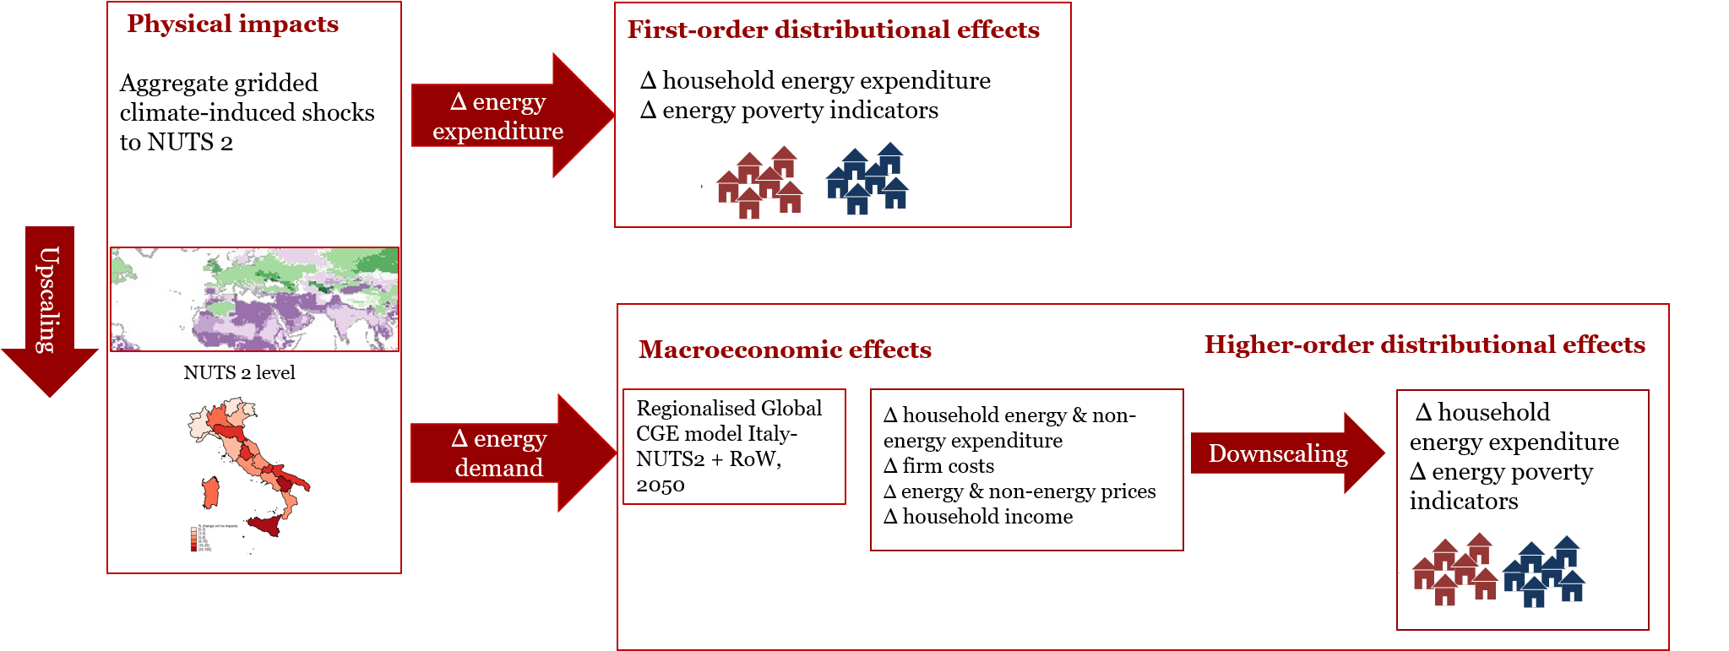

Physical climate change impacts
The physical climate change impacts on energy demand used in the first module of our methodological framework represent ex-ante changes in energy demand prior to any direct or indirect adaptation measure or behavioral change (Sue Wing, Fisher- Vanden, 2013). We obtain these changes with a top-down empirical approach that combines empirically estimated elasticities and semi-elasticities for income and temperature bins with future climate and socio-economic scenarios. Specifically, we rely on the shocks computed by De Cian & Sue Wing (2019), which use a panel data of national energy demand, energy prices, income per capita, and weather covariates (temperature and humidity) for hundreds of countries over the period 1970-2014 to derive income elasticities and temperature semi-elasticities of sectoral energy demand in tropical and temperate regions for three energy carriers (electricity, natural gas and petroleum products) in five sectors (residential, commercial, industry, agriculture and transport). In this analysis we only focus on the residential sector. Semi-elasticities to hot days (days with an average mean temperature of above 27.5◦C) and cold days (days with an average mean temperature of below 12.5◦C) are combined with projected changes in meteorology simulated by runs of the CMCC-CM Earth System Model (Scoccimarro et al. , 2011) as described in Appendix 2. Two warming scenarios leading to high (Representative Concentration Pathway - RCP8.5) and moderate temperature increase (RCP 4.5) are considered. Gridded shocks have been aggregated to the regional administrative units of the Italian household survey and the CGE model of NUTS2 by using the mean value computed for the grid-cells belonging to the same NUT region.

First-order distributional effects
First-order distributional effects are computed by combining the physical impacts on energy demand described in Section 3.1 at the NUTS2 level with a survey on household expenditure for the Italian economy. The way climate shocks will affect energy expenditure across households depends on i) the total and energy expenditure pattern of a given household or household groups, ii) the energy mix, and iii) the geography of the region in which the household lives.
By looking at how the distribution of energy expenditure for different energy commodities varies across regions and income deciles, we provide a first assessment of how different income groups across the geography of Italy will be affected by climate change impacts, highlighting the interplay among regional heterogeneity of climate impacts, energy consumption, and income structure. We use the ISTAT Household Budget Survey (HBS) describing consumption expenditure of Italian households. We focus on the 2007 wave because the micro data need to be consistent with the base year of the CGE model described in Section 3.3.
The critical assumptions behind the calculation of the first-order impacts are two. First, future climate shocks are imposed on the 2007 economy and energy mix, without considering variation in income and preferences. Second, there are no behavioral adjustments, since price changes are not taken into consideration. Climate impact shocks on residential energy demand at NUTS2 level are used to scale energy expenditure of Italian households of electricity, gas and petroleum products with respect to 2007 survey levels, on the assumption that there are no budget constraints. Finally, the effect of the carbon tax that would bring global warming to the moderate level of RCP 4.5 is not taken into account.
We directly attribute the climate change impacts on energy demand described in Section 3.1 to Italian households, depending on their location. The after-shock expenditure ${EXP}_{h,f,r}^{Climate}$ of household h, in fuel f, region r and scenario Climate, i.e. RCP4.5 or RCP8.5, is obtained by perturbing the HBS household expenditure ${EXP}_{h,r,f}^{HBS}= P_{h,r,f}^{HBS}*Q_{h,r,f}^{HBS}$with the percentage change in regional residential energy demand attributed to climate change, $φ_{r,f}^{Climate}$(as described in Appendix 2):
 | $${EXP}_{h,f,r}^{Climate}= {EXP}_{h,f,r}^{Climate}*(1+{φ_{r,f}^{Climate}}/{100})$$ | (1)
Households’ expenditure on electricity, gas, and petroleum products under climate change, ${EXP}_{h,f,r}^{Climate}$, is compared to the HBS levels and used to compute total household after-shock expenditure and new expenditure shares.

Higher-order macroeconomic and distributional effects
A computable general equilibrium framework can examine the higher-order, macroeconomic effects arising from the interactions between price and quantity changes following climate impact shocks, future baseline socioeconomic changes, and the implementation of a climate policy. For example, the systemic and general equilibrium features of these models make it possible to connect the fuel demand shift to energy price changes that, in turn, influence cost functions of all products and therefore their prices and supplied quantities. This leads to further adjustments in the household and government consumption bundle. Income generation is also affected by climate shocks because variations in firm costs and production choices determine shifts in the primary factor (labor, capital, and natural resources) remuneration owed by households, and therefore in their budget constraint. Finally, climate shocks can also modify the competitive advantages or disadvantages for different regions across sectors, with implications for international trade flows.
We use a multi-sector, multi-country recursive-dynamic computable general equilibrium model, ICES (Eboli et al. , 2010), enriched with a more detailed regional representation for the Italian economy at NUTS-2 region-level, as illustrated in Carrera et al. (2015). The description of the model and the underlying database can be found in Annex 1. Household preferences are represented with a Constant Differences of Elasticities implicitly additive expenditure function by Hanoch (1975), which is a flexible and well-behaved function assuming non-constant marginal budget shares. The linearized consumption demand has the following formulation:
 | $${qp}_{i,r}-{pop}_{r}=\sum_{k}{ε_{i,k,r}^{P}}*{pp}_{k,r}+ε_{i,r}^{Y}\left(y_{r}-{pop}_{r}\right)$$ | (2)
where the percentage change of per capita demand for good i in region r (${qp}_{i,r}-{pop}_{r}$) depends on the percentage change in consumer prices (${pp}_{k,r}$) and the cross-price elasticity ($ε_{i,k,r}^{P}$), where k are the goods and services different from i, plus the percentage change in per capita income ($y_{r}-{pop}_{r}$) multiplied by income elasticity ($ε_{i,k,r}^{Y}$). The percentage change in demand for a certain good is a mix of domestically produced and imported goods, where the proportion of these two sources is regulated by Armington elasticities (Corong et al., 2017). In the regionalized version of the model, we have region-specific demand functions, with the exception of Italy, where private demand is specified at NUTS2 level (see Appendix 1).
The structure of the economy that in 2050 will be affected by climate shocks will be different from that of the base year (2007), as population, income, techno- logical progress, and prices change over time, modifying household consumption choices (baseline scenario). The baseline scenario updates the socioeconomic picture of the base year (2007) in each region and country, according to the characteristics of a possible future scenario. For the 2007-2016 period we rely on historical data for population, employment, GDP growth, and CO2 emissions (see also Appendix 4). After 2016, the historical trends are extended up to 2050, as in the Middle of the Road Shared Socioeconomic Pathway 2 (SSP2). Climate impacts on residential energy demand at NUTS2 level, computed as in Section 3.1, are imposed in the baseline scenario as exogenous percentage changes, ($γ_{f,r,s}$), in regional private consumption, (${qp}_{f,r,s}$), of electricity, gas, and petroleum products:
 | $${qp}_{f,r,s}-{pop}_{r}=γ_{f,r,s}+\sum_{k}{ε_{f,k,r}^{P}}*{pp}_{k,r}+ε_{f,r}^{Y}\left(y_{r}-{pop}_{r}\right)$$ | (3)

 | $${qp}_{o,r,s}-{pop}_{r}=γ_{o,r,s}+\sum_{k}{ε_{f,k,r}^{P}}*{pp}_{k,r}+ε_{o,r}^{Y}\left(y_{r}-{pop}_{r}\right)$$ | (4)
 | $$γ_{f,r,s}=φ_{f,r,res}^{Climate}$$ | (5)

Finally, we introduce a global carbon tax reaching 150 US$2007/t CO2 in 2050, which brings CO2 emission pathways in line with moderate a warming scenario of RCP4.5 (around 33 GtCO2/yr in 2050). The mitigation scenario has been designed through a two-step procedure. In the first step, we set the emission reduction target coherently with RCP 4.5 scenario to get the endogenous global carbon price path with international carbon trading. In the second step, we impose the same carbon price as a national carbon tax applied to all countries. This scenario is called the RCP4.5-CTAX. Because of the current structure of the model, which aggregates government and households into one representative regional decision maker, the carbon tax revenues can only be directly transferred from government to households in a lump-sum way.
A micro-simulation module is sequentially used to arithmetically downscale the aggregate changes in prices and quantities obtained by the computable general equilibrium model to the level of households. When the macroeconomic changes generated by the computable general equilibrium model are applied to the expenditure of all households in the survey, the aggregation of modified household expenditure leads to a discrepancy with the percentage variation observed in the general equilibrium model at the national and regional level. The downscaling module minimizes this discrepancy by transforming the 2050 expenditure at the household level into an adjusted expenditure with the cross-entropy maximization method (McDougall, 1999; Golan & Judge, 1996). More details can be found in Appendix 3. The downscaling module yields a household-specific picture of consumption choices in 2050 under baseline and impact scenarios. The higher-order distributional implications of climate change impacts on energy demand are derived by comparing how energy expenditure shares change in both a mild and a severe global warming scenario, with respect to the baseline one. It is worth noting that the proposed methodology makes it possible to account for the behavioral response of household demand to price changes, but the optimization process takes place at the regional level. With these limitations in mind, this methodology makes it possible to compare the burden of direct and indirect climate change impacts on the energy used by Italian households, as well as its overall distributional implications. By looking at the distribution of this burden, we will highlight either the regressive, progressive or neutral implications of energy use for adaptation, highlighting the role of adjustment mechanisms induced by price changes and income effects.

Energy poverty indicators
We study the climate-related distributional implications on households by comparing energy expenditure shares before and after climate shocks across regions and expenditure deciles, and by considering two fuel poverty indicators from the literature on fuel poverty (Romero et al. 2018; Rademaekers et al. 2016; Miniaci et al. 2008).
A first indicator compares the actual fuel expenditure shares of households with the minimum affordable basket required in order not to be socially excluded, as defined in Miniaci et al. (2008). This index combines the concepts of absolute poverty with that of fuel poverty, and the resulting Fuel Poverty Prevalence index shares some features with the Low income/high cost (LIHC) indicator currently in use in the UK and other countries (Rademaekers et al. , 2016). Following Miniaci et al. (2008), we define the reference, minimum affordable budget share of fuels f in region r,${ r}^{rbs}=\frac{{\overline{P}}_{f,r}*{\overline{Q}}_{f,r}}{{\overline{EXP}}_{r}}*100$, as the median energy budget share of households below absolute poverty line in 2007 (2050 for future projections) in that region. We define energy-poor households, with respect to a specific energy vector (either gas and petroleum fuels or electricity), as those households whose actual expenditure share $\frac{P_{f,r}*Q_{h,f,r}}{{EXP}_{h,r}}$is higher than the reference, ${ r}^{rbs}$. The actual Fuel Poverty Prevalence index based on the minimum affordable basket reads as follows:
 | $${FPP}_{f,r}^{abs}=\frac{1}{n} \sum_{h=1}^{1}{1}\left(\frac{P_{f,r}*Q_{h,f,r}}{{EXP}_{h,r}}*100>\frac{{\overline{P}}_{f,r}*{\overline{Q}}_{f,r}}{{\overline{EXP}}_{r}}*100\right)$$ | (6)
This first indicator uses actual household energy expenditure shares, which on average are higher among poor households, and represent an upper boundary of energy poverty. As discussed in Miniaci et al. (2008b), there are many other causes that lead to high energy budget shares, including overconsumption due to preferences (e.g. a higher number of appliances) and technological constraints (e.g. poor housing conditions, inefficient heating and cooling systems). For this reason, we introduce a second indicator, which provides a more restrictive measure of fuel poverty, yielding a lower boundary estimate. It compares the potential budget devoted to purchasing the minimum necessary energy services, defined as the median regional expenditure of poor households below the absolute poverty line, ${\overline{P}}_{f,r}*{\overline{Q}}_{f,r}$, over the actual household expenditure with the reference minimum affordable budget share ${ r}^{rbs}$. The potential Fuel Poverty Prevalence index, ${FPP}_{f,r}^{pbs}$ is computed as follows:
 | $${FPP}_{f,r}^{pbs}=\frac{1}{n} \sum_{h=1}^{1}{1}\left(\frac{{\overline{P}}_{f,r}*{\overline{Q}}_{f,r}}{{EXP}_{h,r}}*100>\frac{{\overline{P}}_{f,r}*{\overline{Q}}_{f,r}}{{\overline{EXP}}_{r}}*100\right)$$ | (7)
Note that the difference between ${FPP}_{f,r}^{abs} and {FPP}_{f,r}^{pbs}$ is the numerator on the left-hand side. The first index uses actual expenditure and actual expenditure share, whereas the second uses the potential expenditure associated with the minimum energy bundle, divided by the actual total expenditure, yielding the potential expenditure share.
The two indices considered here, based on the actual and potential budget share, provide a lower and upper boundary estimate of fuel poverty, but they give no information about the severity of fuel poverty. We therefore consider a Fuel Poverty Gap index, ${FPG}_{f,r}^{pbs}$(Foster et al. , 2010) which, starting from the index ${FPP}_{f,r}^{pbs}$ described in Equation 7, ${FPG}_{f,r}^{pbs}$ considers an additional term that accounts for the depth of poverty, measured as the distance from the minimum affordable budget share (${ r}^{rbs}$):
 | $${FPG}_{f,r}^{pbs}=\frac{1}{n} \sum_{h=1}^{1}{1}\left(\frac{{\overline{P}}_{f,r}*{\overline{Q}}_{f,r}}{{EXP}_{h,r}}*100>{ r}^{rbs}\right){\left(\frac{{\overline{P}}_{f,r}*{\overline{Q}}_{f,r}}{{EXP}_{h,r}}*100-{ r}^{rbs}\right)}^{α}$$ | (8)
where${ r}^{rbs}=\frac{{\overline{P}}_{f,r}*{\overline{Q}}_{f,r}}{{\overline{EXP}}_{r}}*100$and $α$ describes the depth of concern for the affordability issue. When $α$ = 1 (poverty gap index), the indicator sums up the gaps in household energy budget shares from minimum affordable budget share ${ r}^{rbs}$, and therefore it may highlight a wider gap even if the number of households with affordability problems is reduced. When $α$ = 2, we have a Squared Fuel Poverty Gap, also called a poverty severity index, which attributes higher weights to wider poverty gaps.

Results

Energy expenditure and poverty in the base year
Energy expenditure represents a small share of the overall household budget for the average Italian family, about 5% of the overall consumption expenditure, whereas most of the budget goes to private services, followed by food and light industry. Italian regions show some heterogeneity in terms of energy expenditure mix reflecting whether the prevailing end-use is heating or cooling. The share of electricity varies between 1.8% in the Piedmont/Aosta Valley and 3.5% in Sicily, whereas that of other fuels (oil, gas, petroleum products) is between 1.6% in Sicily and 4.8% in Piedmont/Aosta Valley.
The expenditure mix across different deciles, Figure 2 (left), shows a non-linear increase in total expenditure per adult equivalent (pae) as we move from the bottom to the top expenditure deciles. Total monthly expenditure per adult equivalent is about 115 euros in the first decile and about 1150 euros in the top decile, 10 times higher. The expenditure pattern across the first nine deciles increases more gradually, from 115 to about 669 euros. Compared to total expenditure, energy expenditure increases in a more gradual way across deciles, with the top decile spending about 3.5 times the amount of the first decile. While energy expenditure increases from about 10 to 34 euros per adult equivalent (electricity expenditure per adult equivalent goes from 5 to 11 euros) across deciles, the share of energy expenditure (Figure 2- right) falls from about 9% to 3% (4% to 1% for electricity). The decline of heating fuel expenditure share across deciles is slower.

Figure 2: Mean monthly expenditure per adult equivalent (pae) across deciles (left) and energy expenditure per adult equivalent shares (right). Source: Istat HBS 2007.
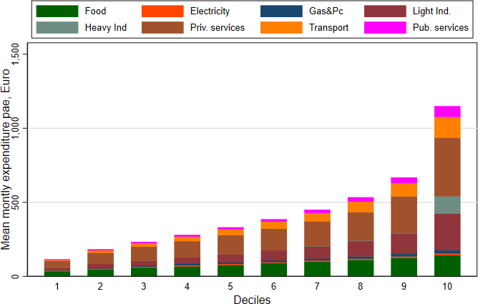
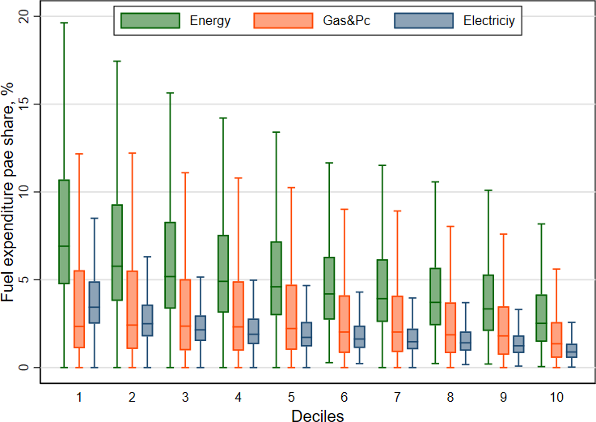

The energy expenditure is higher in northern and central regions, but the largest energy expenditure shares are observed in the South. In addition, the South devotes a higher share of its energy expenditure to electricity than the rest of Italy (Figure 3). On average, a higher portion of energy is used for heating (61%). The remainder goes to electricity, which provides a wider range of services. Air Conditioning (AC), which in Italy is still not widespread (28%), with some exceptions in Sicily and Sardinia (42 and 43%, respectively), is the type of final use expected to be most sensitive to weather and climate fluctuations.
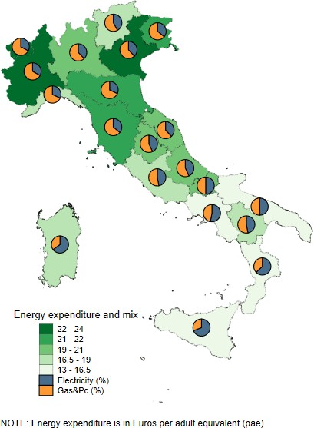
Figure 3: Mean monthly expenditure per adult equivalent (pae) across regions and fuel mix (%). Source: Istat HBS 2007.
In Italy, the average percentage of energy-poor households is 23% (FPP actual budget share) and 5% (FPP potential budget share). Poverty prevalence due to gas and petroleum fuels ranges between 41% and 5%. Poverty prevalence related to electricity ranges between 11% and 5%. The indicator based on actual budget shares, ${FPP}_{f,r}^{abs}$, cannot distinguish whether the energy expenditure share above the threshold is earmarked for purchasing necessary goods or other non-necessary energy services. Instead, the indicator based on potential budget share, (${FPP}_{f,r}^{pbs}$), which excludes overspending on unnecessary energy services, leads to much lower poverty estimates that affect only households in the first expenditure decile (Figure 4). In the poorest decile, the ${FPP}_{f,r}^{pbs}$is 45% for all energy, 52% for heating and 47% for electricity. Figure 4 also displays the energy poverty gap and severity indices for Italy in 2007. The highest poverty gap and severity indices are related to the use of gas and petroleum fuels. Energy poverty in Italy is polarized. It is low in the northern regions (less than 3%) and high in the southern ones (up to 14%). Gas and petroleum-related poverty prevalence does not display great differences across regions. What drives the heterogeneity is the electricity-related poverty prevalence, which mostly affects the southern regions (Figure A7).
Figure 4: Fuel poverty prevalence and severity across deciles and fuels. Boxplots show heterogeneity across regions.
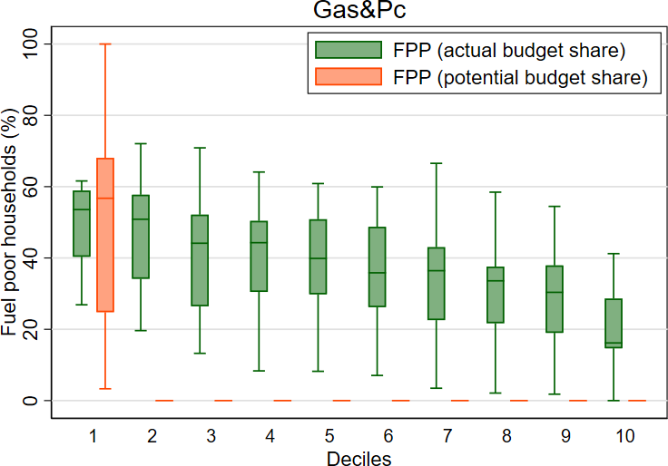
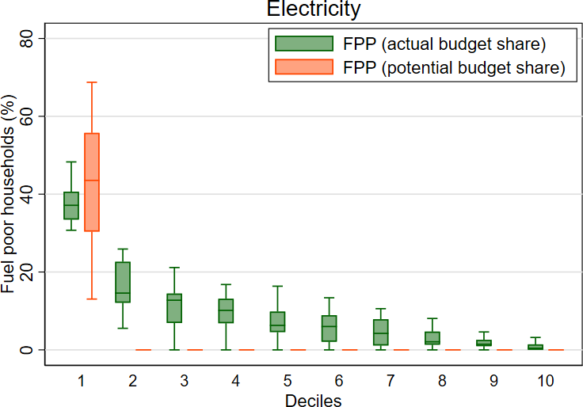
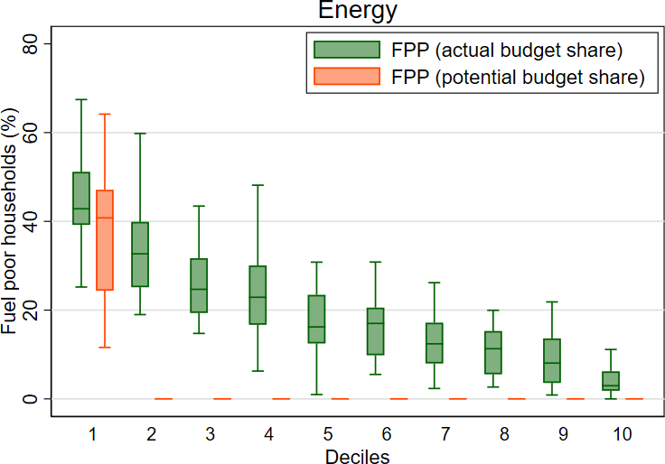
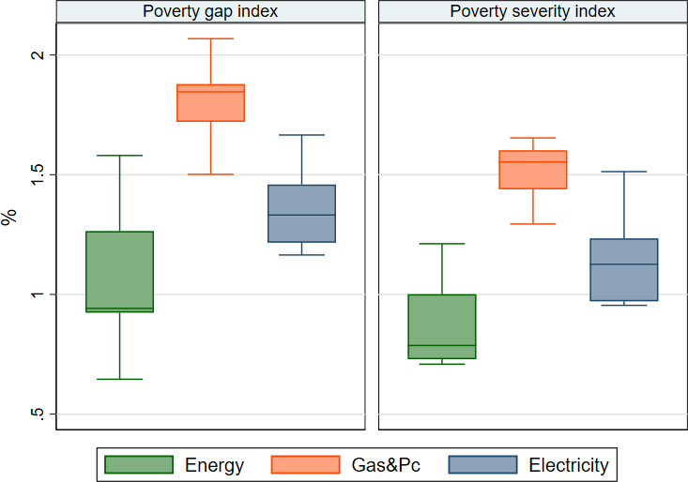

First-order distributional impacts of climate-induced energy shocks

The direction and magnitude of the impacts of climate change on energy demand depend on geographic location. Climate change reduces the frequency of cold days, and therefore energy needs for heating, especially at higher latitudes, and increases the occurrence of hot days, making cooling services more important. Climate-induced shocks derived according to the methodology of Section 3.1 reduce the use of heating fuels, such as natural gas, from -11 to -45% (-26 and -69%), and petroleum products from -10 to -41% (-23 and -66%) under moderate (severe) warming. Impacts on electricity go in the opposite direction and range from between 0 and +16% (0 and +28%) under moderate (severe) warming. Sicily, Basilicata and Apulia face the highest percentage increase in electricity demand.
Figure 5 shows the first-order effects of global warming on energy expenditure (computed as described in Section 3.2), with details on the main fuels used for heating and cooling across households and RCPs. Energy expenditure per adult equivalent unequivocally declines on average by 9.7% in RCP4.5 and 14.7% in RCP8.5, respectively between -3 and -4 euros per month. At the regional level, under moderate (intense) global warming, Piedmont gains the most, as energy expenditure falls by 25.3% (30.3%) compared to Sicily, where expenditure drops by only 2% (2.2%). Natural gas is the main fuel, used in 80.5% of heating systems, and its variations drive the overall reduction in energy consumption. On average, monthly expenditure per adult equivalent on gas and petroleum products drops by 23.8% (37%) in the moderate (severe) scenario. Fuel expenditure shrinks from 43.6% (68.8%) in Calabria to 11.3% in Abruzzo (25.2% in Umbria). Electricity expenditure per adult equivalent rises on average by 5.1% (8.2%) with moderate (intense) climate change, around 0.4 (0.7) euros per month. The largest increase is observed in Sicily and Basilicata, respectively by 16.3% (27.6%) and 12.8% (25.9%) under moderate (intense) global warming, because of the net increase in electricity demand and the relatively large share of electricity in these regions. Regions with milder climate conditions, such as Emilia-Romagna and Lombardy, also show significant increases in electricity demand due to the relatively large share of AC in the main urban centers.
The distribution of climate change impacts by decile, indicated in the bottom panel in Figure 5, shows a variation across households and Italian regions. Benefits - measured in terms of reduced energy expenditure - are larger among the richest layers of the population, ranging from a reduction of 13.5% (20.3%) in energy expenditure under moderate (intense) global warming, to 6.9% (10.7%) in the 1st decile. These changes imply a discount in the energy bill of 4.5(6.8) euros per month and per adult equivalent in 10th decile, and of 0.7 (1.1) euros in the 1st decile (regressive impact). This result mainly depends on the interaction of different impacts on heating and cooling across deciles. Gas and petroleum product bills drop by 25.2% (38.5%) in the richest decile and by 25.1% (40.5%) in the poorest, therefore slightly favoring the poorest layers of the population (progressive impact). There is instead a smaller, but regressive influence on electricity expenditure, which increases by 6.4% (11.3%) in the 1st decile and by 3.9% (6.3%) in the 10th decile.
The first-order implications of climate change impacts on fuel poverty are summarized in Table 1, showing the number of fuel poor households in each region in the base year (computed according to Equation 7), as well as the effects of climate change. Overall, climate change impacts reduce the number of energy poor households across Italian regions and across global warming scenarios (-104 thou- sands under RCP4.5 and -189 thousand under RCP8.5). Poverty prevalence goes from 4.5% to 4.1% (3.7%) under moderate (severe) climate change scenarios. This result can be broken down into a strong reduction of fuel poverty (-794 thousand under RCP4.5 and around -1 million under RCP8.5) and a rise in electricity poor households (+249 thousand under RCP4.5 and +446 thousand under RCP8.5. At the regional level, Piedmont, and Tuscany (Apulia) are the regions that benefit most from moderate (intense) climate shocks, with a reduction of 17 thousand (26 thousand) energy-poor households due to a contraction of gas
expenditure in this area. In Sicily (Emilia-Romagna) energy poverty slightly increases with a +18 thousand (+8 thousand) fuel-poor households under moderate (intense) climate change. This aggregate result combines a reduction in gas and petroleum-poor households of -210 (-82) thousands and a rise in electricity-poor households of +103 (+46) thousands.

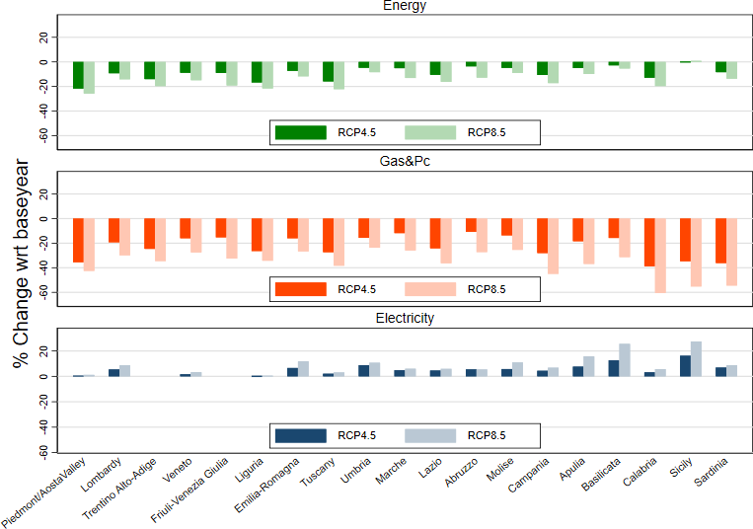
Figure 5: First-order effects of climate change on energy expenditure per adult equivalent (pae) by region (top) and by decile (bottom). Boxplots show the variation across regions.

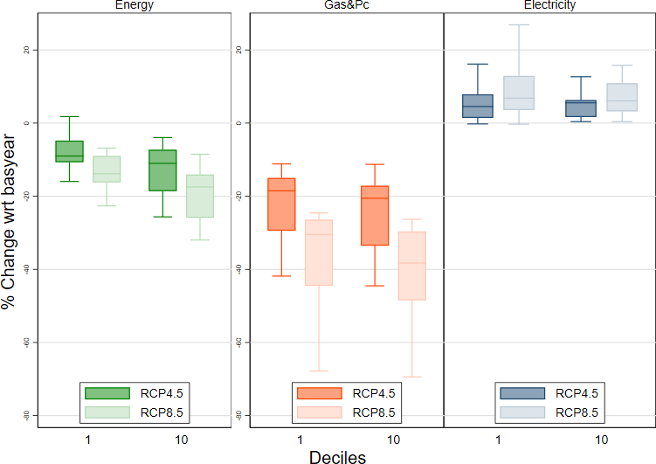
Table 1: Number of energy poor households in the base year (#) and first-order effects induced by climate change (∆), by region and scenario. Unit: thousands.

 |  | Energy |  |  | Gas&Pc |  |  | Electricity
2007 |  | RCP4.5 | RCP8.5 | 2007 | RCP4.5 | RCP8.5 | 2007 | RCP4.5 | RCP8.5
 | # poor | ∆ wrt 2007 | ∆ wrt 2007 | # poor | ∆ wrt 2007 | ∆ wrt 2007 | # poor | ∆ wrt 2007 | ∆ wrt 2007
Piedmont/AostaValley | 41 | -17 | -16 | 102 | -73 | -86 | 100 | 7 | 13
Lombardy | 105 | -12 | -12 | 113 | -60 | -84 | 113 | 22 | 35
Trentino Alto-Adige | 9 | -1 | -2 | 17 | -13 | -16 | 9 | 0.8 | 2
Veneto | 40 | -5 | -12 | 117 | -47 | -82 | 40 | 13 | 20
Friuli-Venezia Giulia | 35 | -8 | -22 | 66 | -25 | -53 | 40 | 0.9 | 3
Liguria | 39 | -9 | -17 | 42 | -30 | -35 | 39 | 3 | 3
Emilia-Romagna | 58 | 0 | 8 | 120 | -54 | -82 | 80 | 22 | 46
Tuscany | 41 | -17 | -20 | 69 | -50 | -60 | 13 | 4 | 6
Umbria | 7 | -1 | -3 | 14 | -7 | -10 | 6 | 1 | 2
Marche | 4 | 0 | 0 | 1 | 0 | 0 | 7 | 0 | 0
Lazio | 72 | -7 | -9 | 106 | -58 | -86 | 106 | 9 | 21
Abruzzo | 16 | -2 | -7 | 5 | -0.9 | -3 | 9 | 2 | 4
Molise | 3 | -0.4 | -0.5 | 8 | -5 | -6 | 8 | 0.7 | 2
Campania | 125 | -13 | -24 | 66 | -53 | -63 | 160 | 16 | 26
Apulia | 128 | -11 | -26 | 154 | -66 | -117 | 73 | 20 | 40
Basilicata | 15 | -2 | -0.9 | 4 | -2 | -4 | 17 | 8 | 14
Calabria | 29 | -4 | -6 | 16 | -15 | -16 | 40 | 5 | 10
Sicily | 260 | 18 | -4 | 241 | -210 | -241 | 208 | 103 | 187
Sardinia | 44 | -13 | -14 | 30 | -27 | -30 | 49 | 11 | 13
ITALY | 1073 | -104 | -189 | 1292 | -794 | -1074 | 1116 | 249 | 446

Figure 6 (left) synthesizes regional energy poverty count across scenarios and fuels. Figure 6 (center) highlights a decreasing pattern in the poverty gap index due to climate change. The strongest reduction is observable under RCP4.5 and is led by a drop in the number of heating-fuel poor and their larger distance from the poverty threshold. The effect is mitigated by the further increase in mean temperature that characterizes the RCP8.5. A similar pattern is observable for the poverty severity index (Figure 6 - right).

Figure 6: Energy-poor households (count), energy poverty gap and severity indices in the base year, and climate change scenarios: First-order effects. Boxplots show variation across regions.
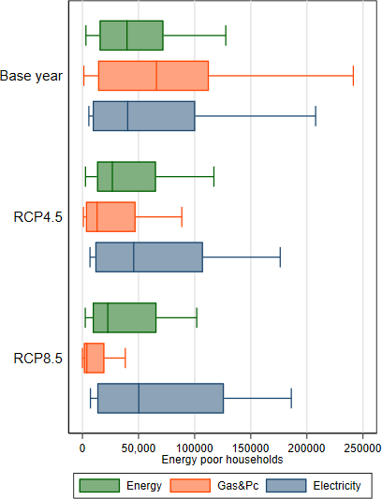
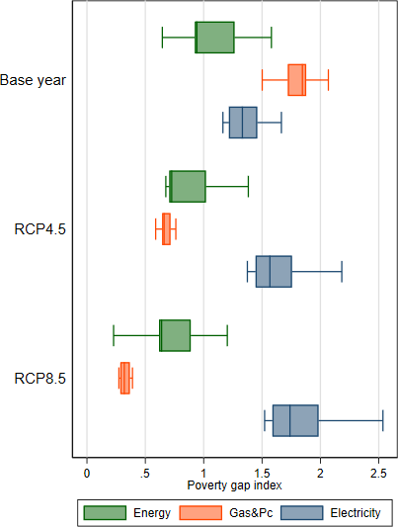
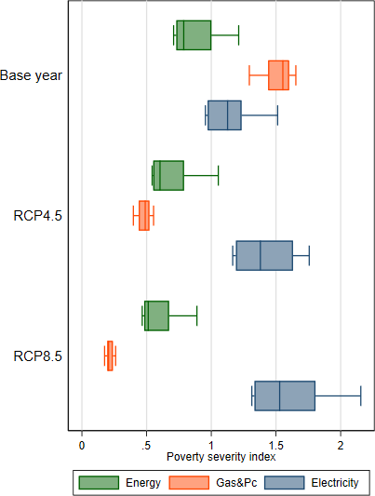

Higher-order macroeconomic and distributional impacts
The structure of the Italian economy in 2050 will be different from the one in 2007 because of: i) socioeconomic changes, ii) the intensification of climate change impacts, and iii) the implementation of mitigation policies. The higher order assessment (HO) aims to capture all these elements and their interactions. We first create a baseline (BAU) scenario up to 2050 based on possible socioeconomic and technological changes in terms of population, employment, income, and emission intensity. The baseline is not a forecast, but a hypothetical counterfactual future in which climate policies and climate impacts are not considered. This scenario relies on historical data up to 2016-17 and on the Shared Socioeconomic Pathways (SSPs) (O’Neill et al. 2017) afterwards. Specifically, we use the SSP2 "Middle of the Road" scenario, a pathway in which social, economic and technological trends follow historical patterns (Riahi et al. 2017).
In 2050, households’ aggregate demand for all goods across Italian regions increases by 40% and aggregate prices decrease by 30%, therefore keeping the expenditure quite stable. The downscaling module, described in Section 3.3, makes it possible to evaluate how the aggregate changes in prices and quantities affect individual household expenditure patterns across regions. Expenditure deciles in 2050 are then redefined and consumption patterns compared to those of the base year 2007. Baseline energy expenditure goes up in most of northern, central Italian regions, driven by the increase in gas and petroleum product demand and prices, and by the prevailing rise in electricity use that offsets the price reduction (Figure A6 - left). Lazio and Liguria experience the highest reduction in energy expenditure, driven by the prevailing contraction in fuel demand. In the bottom decile, baseline energy expenditure drops on average by 18% (-1 Euro per month) and increases by 11% (+3 Euro per month) in the top decile (Figure A6 - right). The prevalence of fuel poverty does not change significantly, and only small variations, in the range -0.7% and 0.8% percentage points with respect to 2007, are observed at the regional level (Figure A7). The number of poor slightly increases because of population growth (Table 2).
Climate change impacts on energy demand are simulated by imposing globally exogenous shifts (see Section 3.2) on households’ fuel consumption as described in Section 3.3. The outcome is a set of two impact scenarios of moderate (RCP4.5) and severe (RCP8.5) warming that are downscaled to the household level and com- pared to the baseline. The moderate climate change scenario (RCP4.5-CTAX) is a mitigation scenario requiring a global carbon tax that reaches 150 US$2007/tonne of CO2 (see Appendix 5).
Figure 7 (top panel) describes how energy expenditure changes with respect to the baseline in 2050 in each region and across impact scenarios. In 2050, all regions increase their expenditure on electricity and almost all reduce that of Gas and petroleum products with respect to the 2050 baseline. The more severe climate impact scenarios intensified the magnitude of change. Carbon taxation amplifies the rise in electricity expenditure, which ends up being greater in the RCP4.5 than in RCP8.5 for all regions, Sicily and Basilicata excluded. Instead, the increase of gas and petroleum product prices in the RCP4.5-CTAX scenario mitigates the expenditure drop, and a few regions (Abruzzo, Molise, and Marche) increase the amount of resources spent on these fuels. Whereas climate change impacts would lead to a generalized drop in energy expenditure across all RCP scenarios, the carbon price needed to moderate warming from RCP8.5 to RCP 4.5 raises expenditure, especially in the central and southern regions.
In Figure 7 - bottom panel, we see that climate change impacts are progressive on gas and petroleum product expenditure, which is reduced by 30 (47%) in the 1st decile and by 22 (34%) in the 10th decile under RCP4.5 (RCP8.5) with respect to the baseline scenario. The effect of the carbon tax on gas and petroleum products is also progressive, although it represents the smallest variation with respect to the baseline scenario. Impacts on electricity are instead regressive (expenditure increases more in the bottom, 6-11%, than in the top deciles, 4-7%) also in the case of carbon taxation. The outcome in terms of energy expenditure is also regressive: -9% (-13%) in the 1st decile and -12% (-19%) in the 10th decile under the moderate (severe) climate impact scenario. In the RCP4.5-CTAX scenario, the variation of expenditure has a positive sign but is again regressive: +6% in the 1st decile and +4% in the 10th.
Under moderate (intense) climate change the number of energy-poor households in Italy will be lower by 187 (371) thousand with respect to 2050 BAU under the RCP4.5 (RCP8.5) scenario (Figure 8, left panel and Table 2). The result stems from a strong reduction of the number of heating fuel-poor households due to global warming (1.1-1.5 millions) and to a moderate increase of electricity-poor households (270-462 thousand). When we consider the RCP4.5-CTAX scenario, the number of energy-poor households are reduced only by 6 thousand with respect to the baseline scenario.

Figure 7: Climate-induced changes in household energy expenditure across regions (top) and expenditure deciles (bottom) relative to 2050 baseline.
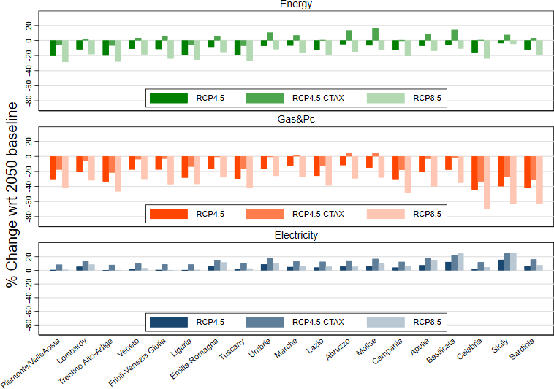

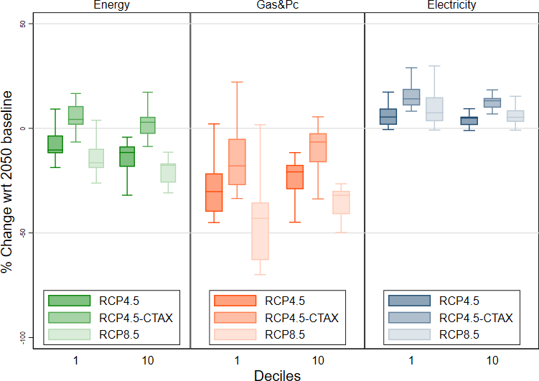

The poverty gap and the severity indices show similar patterns, and their values are reduced under climate change for energy and heating fuels but increase for electricity (Figure 8, central and left panels).
Table 2: Additional number of energy- poor households in the baseline (#) and higher-order effects induced by climate change (∆), by region and scenario. Unit: thousands.

 | 2007 # | 2050  poor | Energy RCP4.5 RCP4.5C  ∆ wrt BAU |  | RCP8.5 | 2007 # | 2050  poor | Gas&Pc RCP4.5 RCP4.5C  ∆ wrt BAU |  | RCP8.5 | 2007 # | 2050  poor | Electricity RCP4.5 RCP4.5C  ∆ wrt BAU |  | RCP8.5
Piedmont/Valle d’Aosta | 41 | 57 | -17 | -16 | -29 | 102 | 143 | -94 | -70 | -113 | 100 | 140 | 0 | 5 | 3
Lombardy | 105 | 139 | -16 | 11 | -36 | 113 | 163 | -88 | -54 | -122 | 113 | 163 | 21 | 36 | 42
Trentino Alto-Adige | 9 | 12 | -2 | -1 | -4 | 18 | 26 | -20 | -17 | -24 | 9 | 13 | -1 | 2 | -1
Veneto | 40 | 58 | -9 | -7 | -26 | 117 | 171 | -72 | -41 | -120 | 40 | 60 | 8 | 22 | 22
Friuli-Venezia Giulia | 35 | 42 | -9 | 3 | -25 | 66 | 89 | -36 | -16 | -72 | 40 | 55 | 0 | 3 | 0
Liguria | 39 | 54 | -13 | -10 | -24 | 42 | 55 | -43 | -27 | -48 | 39 | 51 | 0 | 4 | 0
Emilia-Romagna | 58 | 90 | -10 | 0 | 0 | 120 | 180 | -90 | -43 | -129 | 80 | 115 | 29 | 36 | 51
Tuscany | 41 | 66 | -32 | -25 | -36 | 69 | 84 | -69 | -52 | -75 | 13 | 19 | 6 | 6 | 6
Umbria | 7 | 9 | -1 | 0 | -5 | 14 | 20 | -10 | -6 | -14 | 6 | 8 | 1 | 1 | 1
Marche | 4 | 6 | 0 | 0 | 0 | 1 | 2 | 0 | 0 | 0 | 7 | 10 | 0 | 0 | 0
Lazio | 72 | 108 | -11 | 0 | -21 | 106 | 162 | -101 | -68 | -132 | 106 | 162 | 10 | 23 | 14
Abruzzo | 16 | 23 | -2 | 0 | -10 | 5 | 8 | -1 | -1 | -5 | 9 | 13 | 3 | 6 | 3
Molise | 3 | 5 | -1 | 2 | -2 | 8 | 10 | -7 | -1 | -9 | 8 | 11 | 1 | 1 | 2
Campania | 125 | 164 | -17 | -7 | -37 | 66 | 91 | -78 | -65 | -87 | 160 | 221 | 18 | 27 | 27
Apulia | 128 | 170 | -25 | 11 | -39 | 154 | 213 | -92 | -48 | -166 | 73 | 100 | 28 | 32 | 49
Basilicata | 15 | 21 | 0 | 8 | 1 | 4 | 6 | -2 | -2 | -5 | 17 | 24 | 9 | 12 | 18
Calabria | 29 | 43 | -16 | -12 | -17 | 16 | 19 | -19 | -18 | -19 | 40 | 50 | 4 | 6 | 5
Sicily | 261 | 332 | 18 | 55 | -38 | 241 | 303 | -265 | -228 | -302 | 208 | 257 | 130 | 144 | 214
Sardinia | 44 | 60 | -20 | -17 | -24 | 30 | 41 | -37 | -34 | -41 | 49 | 78 | 2 | 8 | 5
ITALY | 1073 | 1459 | -187 | -6 | -371 | 1292 | 1787 | -1125 | -791 | -1484 | 1116 | 1550 | 270 | 373 | 462

Note: RCP4.5C = RCP4.5+CTAX

Figure 8: Climate-induced changes in energy-poor households (count), poverty gap and severity by scenario compared to the 2050 BAU across regions.
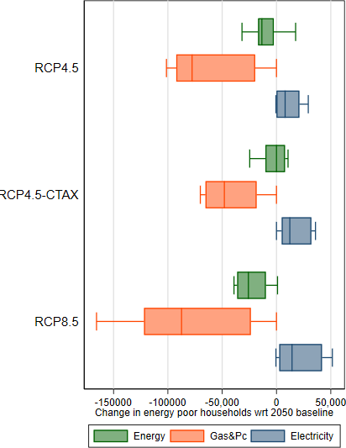
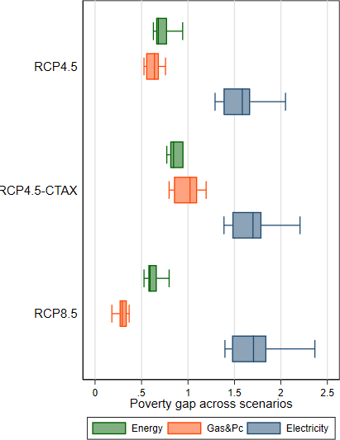
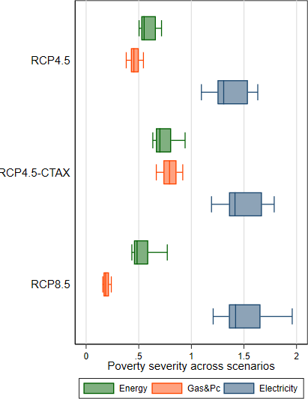

The implications of higher-order, macroeconomic adjustments
The higher-order (HO) assessment illustrates the full extent of the potential change in energy demand induced by temperature increase by considering the baseline socioeconomic changes up to 2050, the macroeconomic adjustments following the climate change impacts, and the adjustments induced by the mitigation policy.
The baseline changes in energy expenditure are quite heterogeneous across regions (see Appendix 4) and across income deciles, and they have only a negligible effect on poverty patterns. The macroeconomic adjustments following the climate change impacts slightly reduce electricity expenditure and slightly amplify the reduction of gas and petroleum products expenditure, leading to very small changes in total energy (Figure A9, top panel). Considering the HO effects does not reverse the distributional consequences of climate impacts (Figure A9, bottom panel). It only slightly increases the regressivity of the impacts on electricity and the progressivity on gas and petroleum products, with an overall effect on energy that is slightly less regressive.
The mitigation policy has a strong impact on fuel and electricity expenditure, as well as on the overall economy. Households face the agent price of gas and petroleum products, which is higher compared to the baseline because it includes a fraction of the carbon tax, although the world price decreases because of the contraction in overall energy demand. All goods produced by using fossil fuels are also more costly, generating an inflationary effect in the economy. At the same time, the carbon tax revenues are recycled in a lump sum to households, which therefore have higher income. The implications in terms of energy use at the regional level are that expenditure in electricity rises with respect to the RCP4.5 scenario, expenditure in gas and petroleum products is reduced in all regions except in Marche, Abruzzo, and Molise (Figure 7). Total energy expenditure rises in several Italian regions. In terms of variation by decile, we observe that the carbon tax amplifies the regressivity (progressivity) of climate change impacts on electricity (gas and petroleum products), leaving regressivity on total energy unchanged (Figure 7).
When we consider higher-order adjustments due only to the climate change impacts, we observe that the number of energy-poor households due to climate change is lower by 83 (182) thousand than first-order estimates under moderate (severe) climate change. With respect to first-order impacts, heating fuel-poor households falls by 331 (411) thousand while the number of electricity-poor increases by 21(16) thousand. Therefore, considering HO effects worsens (alleviates) energy poverty with respect to electricity (gas and petroleum products) and determines an overall reduction in total energy poverty.
The carbon tax with a lump-sum recycling of the revenues increases the number of electricity-poor households by 104 thousand, the number of gas and petroleum products poor households by 334 thousand, and the number of energy-poor households by 181 thousand with respect to the RCP4.5 scenario.
To sum up, in Italy, climate change impacts will likely decrease overall energy poverty through the reduction in gas and petroleum fuel poverty. Clearly, the country’s major risk as regards energy poverty is linked to the use of electricity for cooling. This is already evident when we consider the FO effects. However, when we consider the HO effects of climate change impacts and mitigation, the number of electricity-poor households increases between 373-462 thousand with respect to the 2050 baseline. It is also worth noting that even moderate climate change impacts - and not just vigorous climate change - will determine an increase in electricity poverty that will be amplified by the mitigation policy required to limit the increase in global mean temperature. The increase in electricity poverty is anyway lower compared to the unmitigated scenario (Fig. 8). Our findings highlight the key role that carbon revenue recycling mechanisms play in tackling the regressive effects of not only mitigation policies, but also of climate change impacts.
This aggregate outcome in terms of energy poverty conceals heterogeneous insights at the regional level, which are shown in Figure 9. When we consider overall energy poverty, our analysis highlights the fragility of Sicily (which increases under the HO assessment) under moderate climate change impacts, but also the susceptibility of several other regions (Lombardy, Friuli-Venezia Giulia, Molise, Apulia and Basilicata) to the regressivity of carbon taxation. However, the generalized drop in the number of gas and petroleum products poor households especially under the severe climate change scenario, more than compensates the rise of electricity poverty in Italy. In some regions, such as Lombardy, Emilia-Romagna, Apulia, and Sicily more than 5 thousand households become electricity poor under the HO assessment, as compared to the FO assessment, if we consider only the climate change impact component (RCP4.5 and RCP8.5). When we take into account that future moderate climate change impacts will imply mitigation efforts, the perspectives about energy poverty prevalence in 2050 worsens also under the RCP4.5 (RCP4.5-CTAX) in Lombardy, Veneto, Emilia-Romagna, Lazio, Campania, Apulia and Sicily.
These findings help identify regions where energy poverty is more prone to increasing in future because of climate changes and mitigation policies, and they stress the importance of creating adequate redistribution polices to address their distributional implications.

Figure 9: Climate-driven change in energy poor households. First and higher-order effects
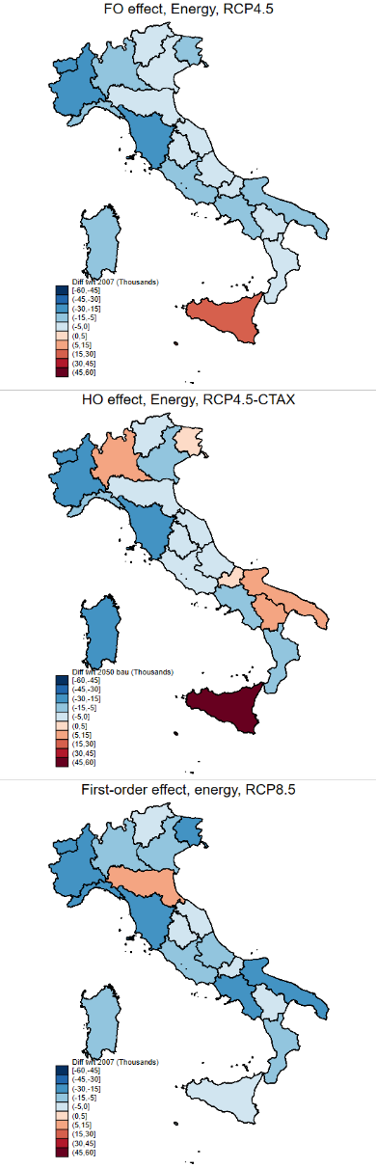
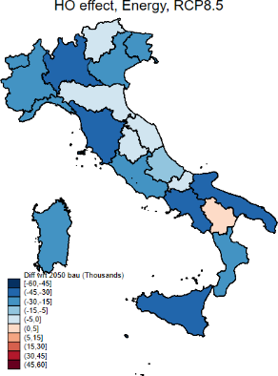
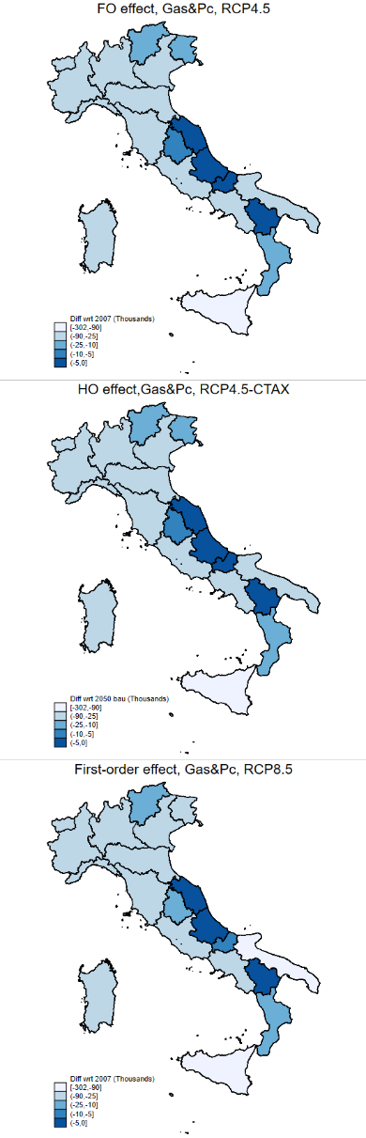
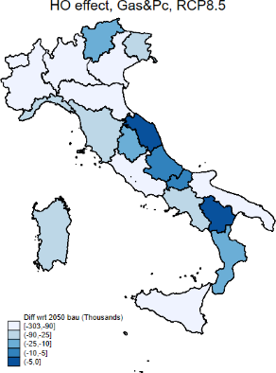
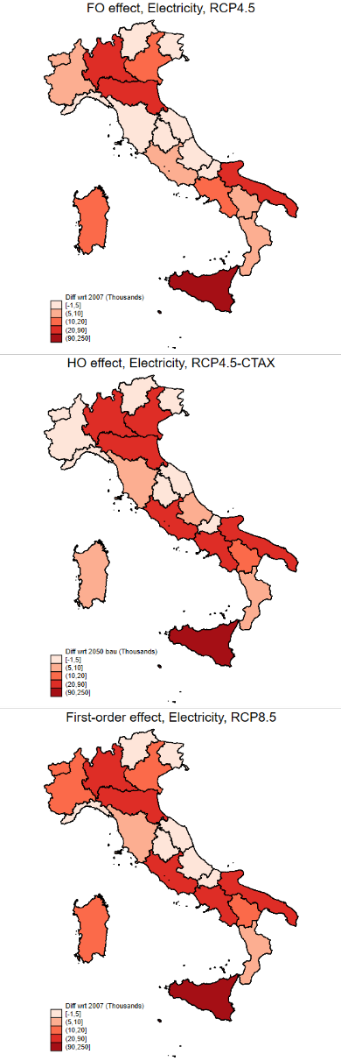
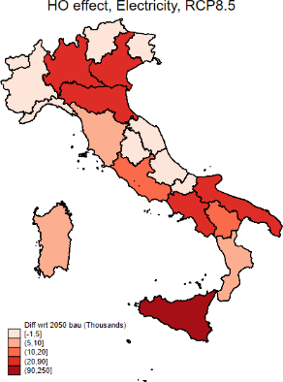

Conclusions
We have examined the macroeconomic and distributional implications of climate-induced changes in household energy expenditure in 2050. We have compared the response of different Italian regions, characterized by various climate conditions, and of different income groups. We have also derived the implications on selected expenditure-based indicators of energy poverty. We have evaluated to what extent the mitigation policy, implemented with a carbon tax, and macroeconomic adjustments modify the direct impacts of climate change.
We have shown that socioeconomic evolution and macroeconomic adjustments only marginally affect energy expenditure for adapting to climate change. Instead, including the carbon tax in the higher-order assessment significantly raises the expenditure on energy, though with regional differences. The implementation of the carbon tax increases the regressivity of climate change impacts. The price increase induced by the policy induces all deciles, but again the poorest ones relatively more, to spend more on energy (electricity, gas and petroleum products). However, even without considering any pro-poor recycling scheme of carbon revenues, a moderate mitigation policy reduces the number of electricity-related poor households by 88 thousand in 2050 (RCP4.5C), compared to unmitigated global warming scenario (RCP8.5). On average, Italian households decrease their energy expenditure under climate change due to the prevailing effect of reduced energy needs for heating, with a great deal of regional heterogeneity depending on the size of the shock, the region’s climate conditions, the energy mix, as well as other characteristics that we do not account for (e.g. housing quality, actual location).
Overall, results on aggregate indicators, such as nation-wide energy poverty, mask the fact that household energy poverty is heterogeneous across fuels and regions. Electricity-related poverty will likely be the key indicator to monitor in Italy because the reduction in heating will mute the impacts of climate change on energy poverty. Sicily will likely experience the highest growth in energy-poor households under moderate climate change. Other regions, also located in the northern part of Italy, may experience high energy poverty levels under moderate global warming, combined with a mitigation scenario. Considering that, more moderate warming and climate change impacts will entail a positive carbon pricing that will increase electricity poverty in Italy, re-distributive policies need to take into account the regional manifestation of the climate impacts and policy interaction. While the distributional implications of a carbon tax can be addressed by designing appropriate revenue recycling schemes, climate-driven energy shocks do not generate revenue and hinge upon characteristics such as geography and housing conditions that are more difficult to address.
The major caveat of this paper is the use of an arithmetic sequential micro- simulation approach that simply downscales the aggregate higher-order adjustments that take place at the regional (NUTS2) level. To what extent including heterogeneous behavioral adjustments across household groups widens the difference between first- and second-order climate change impacts is a topic to be explored in future research. It is also important to clarify that this paper looks at how households with different income levels and located across different regions respond to temperature and policy shocks by changing their energy expenditure. Therefore, it looks at the distributional implications of climate impacts on energy demand, which is a form of adaptation, without discussing the potential uneven distribution of the residual damages on health.
Future work should analyze the distribution of residual, unavoidable climate impacts when more ambitious objectives, such as achieving carbon neutrality by 2050, are considered. Notwithstanding these limitations, our results can contribute to informing the current debate on the Fit for 55 set of legislative proposals aimed at implementing the European Green Deal. Specifically, we bring evidence to the importance of a joint evaluation of climate impacts, adaptation, and mitigation policies when designing climate actions aimed at making the transition socially fair.

References
Awaworyi Churchill, S., & Smyth, R. 2021. Energy poverty and health: Panel data evidence from Australia. Energy Economics, 97, 105219.
Awaworyi Churchill, S., Smyth, R., & Farrell, L. 2020. Fuel poverty and subjective wellbeing. Energy Economics, 86, 104650.
Baranzini, A., Jeroen, C.J., Carattini, S., Howarth, R.B., Padillia, E., & Roca, J. 2017. Carbon pricing in climate policy: seven reasons, complementary instruments, and political economy considerations. WIREs Clim Change, 8, 1–17.
Besagni, G., & Borgarello, M. 2019. The socio-demographic and geographical dimensions of fuel poverty in Italy. Energy Research and Social Science, 49(November 2018), 192–203.
Bhattacharya, J., DeLeire, T., Haider, S., & Currie, J. 2003. Heat or Eat? Cold- Weather Shocks and Nutrition in Poor American Families. American Journal of Public Health, 93, 1149–1154.
Bovenberg, L., & Goulder, L.H. 2001. Environmental Taxation and Regulation.
NBER Working Papers.

Burgess, R., Deschenes, O., Donaldson, D., & M., Greenstone. 2014. The unequal effects of weather and climate change: evidence from mortality in India. Mas- sachusetts Institute of Technology, Working Paper.
Burniaux, J-M., & Truong, T.P. 2002. GTAP-E: An Energy-Environmental Version of the GTAP Model. GTAP Technical Paper, 16.
Carrera, L., Standardi, G., Bosello, F., & Mysiak, J. 2015. Assessing direct and indirect economic impacts of a flood event through the integration of spatial and computable general equilibrium modelling. Environmental Modelling & Software, 63, 109– 122.
Corong, E.L., Hertel, T.W., McDougall, R.A., Tsigas, M.E., & van der Mensbrugghe,
D. 2017. The Standard GTAP Model, Version 7. Journal of Global Economic Analysis, 2, 1–119.

Davis, Lucas, Gertler, Paul, Jarvis, Stephen, & Wolfram, Catherine. 2021. Air conditioning and global inequality. Global Environmental Change, 69(July 2020), 102299.
De Cian, E., & Sue Wing, I. 2019. Global Energy Consumption in a Warming Climate. Environmental and Resource Economics, 72, 365–410.
Eboli, F., Parrado, R., & Roson, R. 2010. Climate Change Feedback on Economic Growth: Explorations with a Dynamic General Equilibrium Model. Environment and Development Economics, 15, 515–533.
EU. 2021. COMMUNICATION FROM THE COMMISSION TO THE EURO- PEAN PARLIAMENT, THE COUNCIL, THE EUROPEAN ECONOMIC AND SOCIAL COMMITTEE AND THE COMMITTEE OF THE REGIONS. Fit for
55: delivering the EU’s 2030 Climate Target on the way to climate neutrality.
COM(2021) 550 final, July 14 2021.

Europe, Buildings Performance Institute. 2014. Alleviating Fuel poverty in the EU. Investing in Home renovation, a sustainable and inclusive solution. PIE.
Faiella, I., & Lavecchia, L. 2019. Energy Poverty Indicaors. In: Urban Fuel Poverty.
Elsevier.

Feindt, S., Kornek, U., Labeaga, J.M., Sterner, T., & Ward, H. 2021. Understanding regressivity: Challenges and opportunities of European carbon pricing. Energy Economics, 103, 105550.
Flues, F., & Thomas, A. 2015. The distributional effects of energy taxes. OECD Taxation Working Papers.
Foster, J., Greer, J., & Thorbecke, E. 2010. The Foster–Greer–Thorbecke (FGT) poverty measures: 25 years later. The Journal of Economic Inequality, 8(4), 491–524.
Fricko, O., Havlik, P., Rogelj, J., Klimont, Z., Gusti, M., Johnson, N., Kolp, P., Strubegger, M., Valin, H., Amann, M., Ermolieva, T., Forsell, N., Herrero, M., Heyes, C., Kindermann, G., Krey, V., McCollum, D.L., Obersteiner, M., Pachauri,

S., Rao, S., Schmid, E., Schoepp, W., & Riahi, K. 2017. The marker quantification of the Shared Socioeconomic Pathway 2: A middle-of-the-road scenario for the 21st century. Global Environmental Change, Volume 42, 2017, Pages 251–267.
Fullerton, D. 2017. Distributional effects of environmental and energy policy. New York: Routledge.
Fullerton, D., & Muehlegger, E. 2019. Who Bears the Economic Burdens of En- vironmental Regulations? Review of Environmental Economics and Policy, 13, 62–82.
Garaffa, R., Cunha, B.S.L., Cruz, T., Bezerra, P., Lucena, A.F.P., & Gurgel, A.C. 2021. Distributional effects of carbon pricing in Brazil under the Paris Agreement. Energy Economics, 101(November 2020).
Golan, A., & Judge, G. 1996. Recovering information in the case of underdetermined problems and incomplete economic data. Journal of Statistical Planning and Inference, 49(1), 127 – 136.
Grainger, C.A., & Kolstad, C.D. 2009. Who pays a price on carbon? NBER, 15239.

Hanoch, G. 1975. Production and Demand Models with Direct or Indirect Implicit Additivity. Econometrica, 43, 395–419.
Hassett, K.A., Mathur, A., & Metcalf, G.E. 2007. The incidence of a U.S. carbon tax: a lifetime and regional analysis. NBER, 13554.
Hertel, T.W., Burke, M.B., & Lobell, D.B. 2010. The poverty implications of climate-induced crop yield changes by 2030. Global Environmental Change, 20, 577–588.
Hsiang, S. P., Paulina, O., & Walke, R. 2019. The Distribution of Environmental Damages. Review of Environmental Economics and Policy, 13, 83–103.
Hans-O. Pörtner et al. (2022). Summary for policymakers. In: Climate Change 2022: Impacts, Adaptation and Vulnerability. Summary for policy makers. Working Group II Contribution to the Sixth Assessment Report of the Intergovernmental Panel on Climate Change.
Mastrandrea, T.E. Bilir, M. Chatterjee, K.L. Ebi, Y.O. Estrada, R.C. Genova, B. Girma, E.S. Kissel, A.N. Levy, S. MacCracken, P.R. Mastrandrea, and L.L. White (eds.)]. Cambridge University Press, Cambridge, United Kingdom and New York, NY, USA.
Kullback, S., & Leibler, R. A. 1951. On Information and Sufficiency. The Annals of Mathematical Statistics, 22(1), 79–86.
Llorca, Manuel, Rodriguez-Alvarez, Ana, & Jamasb, Tooraj. 2020. Objective vs. subjective fuel poverty and self-assessed health. Energy Economics, 87, 104736.
Maccini, S., & Yang, D. 2009. Under the weather: health, schooling, and economic consequences of early-life rainfall. American Economic Review, 99 (3), 1006–26.
Mayer, J., Dugan, A., Bachner, G., & Steininger, K.W. 2021. Is carbon pricing regressive? Insights from a recursive-dynamic CGE analysis with heterogeneous households for Austria. Energy Economics, 104(October), 105661.
McDougall, R.A. 1999. Entropy Theory and RAS are Friends. GTAP Working Papers.
Meier, A. 1995. Refrigerator energy use in the laboratory and in the field. Energy and Buildings, 22, 233–243.
Miniaci, R., Scarpa, C., & Valbonesi, P. 2008. Distributional Effects of Price Reforms in the Italian Utility Markets. Fiscal Studies, 29(1), 135–163.
Miniaci, R., Scarpa, C., & Valbonesi, P. 2008b. Measuring the affordability of basic public utility services in Italy. Giornale degli Economisti e Annali di Economia, 67(2), 185–2030.
Narayanan, G. and Aguiar, B.A., & McDougall, R. 2012. Global Trade, Assistance, and Production: The GTAP 8 Data Base. Center for Global Trade Analysis: Purdue University.
O’Neill, B.C., Kriegler, E., Ebi, K.L., Kemp-Benedict, E., Riahi, K., Rothman, D.S., van Ruijven, B.J., van Vuuren, D.P., Birkmann, J., Kok, K.and Levy, M., & Solecki, W. 2017. The roads ahead: Narratives for shared socioeconomic pathways

describing world futures in the 21st century. Global Environmental Change, 42, 169 – 180.
Pachauri, S., Mueller, A., Kemmler, A., & Spreng, D. 2004. Assessment of U.S. Cap-and-Trade Proposals. World Development, 32 (12).
Paltsev, S., Reilly, J., Jacoby, H., Gurgel, A., Metcalf, G., Sokolov, A., & Holak, J. 2007. Assessment of U.S. Cap-and-Trade Proposals. MIT Working Papers, 0705.
Pavanello, F., De Cian, E., Davide, M., Mistry, M., Cruz, T., Bezerra, P., Jagu, D., Renner, S., Schaeffer, R., & Lucena, A.F.P. 2021. Air-conditioning and the adaptation cooling deficit in emerging economies. Nature Communications, 12(1).
Phoumin, H., & Kimura, F. 2019. The impacts of energy insecurity on household welfare in Cambodia: Empirical evidence and policy implications. Economic Mod- elling, 83, 35–41.
Pizer, W. P., & Sexton, S. 2019. The Distributional Impacts of Energy Taxes.
Review of Environmental Economics and Policy, 13, 104–123.

Poterba, J. M. 1989. Lifetime incidence and the distributional burden of excise taxes. American Economic Review, 79, 325–330.
Rademaekers, K., Pye, S., & Karásek, J. 2016. Selecting indicators to measure energy poverty. Trinomics. Last accessed 16 September 2017.
Rausch, S., Metcalf, G.E., & Reilly, J.M. 2011. Distributional Impacts of Carbon Pricing: A General Equilibrium Approach with Micro-Data for Households. NBER Working Papers.
Riahi, K., van Vuuren, D.P., Kriegler, E., Edmonds, J., OrNeill, B.C., Fujimori, S., Bauer, N., Calvin, K., Dellink, R., Fricko, O., Lutz, W., Popp, A., Cuaresma, J.C., Samir, KC., Leimbach, M., Jiang, L., Kram, T., Rao, S., Emmerling, J., Ebi, K., Hasegawa, T., Havlík, P., Humpenoder, F., Da Silva, L.A., Smith, S., Stehfest, E., Bosetti, V., Eom, J., Gernaat, D., Masui, T., Rogelj, J., Strefler, J., Drouet, L., Krey, V., Luderer, G., Harmsen, M., Takahashi, K., Baumstark,

L., Doelman, J.C., Kainuma, M., Klimont, Z., Marangoni, G., Lotze-Campen, H., Obersteiner, M., Tabeau, A., & Tavoni, M. 2017. The Shared Socioeconomic Pathways and their energy, land use, and greenhouse gas emissions implications: An overview. Global Environmental Change, 42, 153–168.
Romero, J. c., Linares, P., & López, X. 2018. The policy implications of energy poverty indicators. Energy Policy, 115, 98–108.
Scoccimarro, E., Gualdi, S., Bellucci, A., Sanna, A., Fogli, P., Manzini, E., Vichi, M., Oddo, P., & Navarra, A. 2011. Effects of Tropical Cyclones on Ocean Heat Transport in a High Resolution Coupled General Circulation Model. Journal of Climate, 24, 4368–4348.
Standardi, G., Cai, Y., & Yeh, S. 2017. Sensitivity of modeling results to techno- logical and regional details: The case of Italy’s carbon mitigation policy. Energy Economics, 63, 116 – 128.
Thomson, H., Snell, C., & Liddell, C.. 2016. Fuel poverty in the European Union: a concept in need of definition? People Place and Policy Online, 10(1), 5–24.
van Ruijven, B., O’Neill, B.C., & Chateau, J. 2015. Methods for including income distribution in global CGE models for long-term climate change research. Energy Economics, 51, 530–543.
van Ruijven, B., De Cian, E., & Sue Wing, I. 2019. Amplification of future energy demand growth due to climate change. Nature Communication, 10, 1–12.
Vandyck, T., Weitzel, M., Wojtowicz, K., Los Santos, L.R., Maftei, A., & Riscado, S. 2021. Climate policy design, competitiveness and income distribution: A macro-micro assessment for 11 EU countries. Energy Economics, 103(December 2020), 105538.
Zhang, Q., Appau, S., & Kodom, P. L. 2021. Energy poverty, children’s wellbeing and the mediating role of academic performance: Evidence from China. Energy Economics, 97, 105206.

Zivin, J.G., & Neidell, M. 2014. Temperature and the allocation of time: Implications for climate change. Journal of Labor Economics, 32, 1–26.

Appendix

ICES model description
ICES is a recursive-dynamic multiregional Computable General Equilibrium (CGE) model developed to assess the impacts of climate change on the economic system and to study mitigation and adaptation policies (Eboli et al. , 2010). The core structure of ICES derives from the GTAP-E model (Burniaux & Truong, 2002), which in turn is an extension of the standard GTAP model (Corong et al., 2017). The General Equilibrium framework makes it possible to characterize economic interactions of agents and markets within each country (production and consumption) and across countries (international trade). Within each country the economy is characterized by a number of industries n, a representative household and the government. Industries are modelled as representative cost-minimizing firms, taking input prices as given. In turn, output prices are given by average production costs. The production functions (Figure A1) are specified via a series of nested Constant Elasticity of Substitution (CES) functions. In the first nest, a Value-Added-Energy nest (QVAEN ) (primary factors, i.e. natural resources, land and labor, and a Capital+Energy composite), is combined with intermediates (QF ), in order to generate the output. Perfect complementarity is assumed between value added and intermediates. This implies the adoption of a Leontief production function. For sector i in region r final supply (output) results from the following constrained production cost minimization problem for the producer:
min PVAEN_{i,r} * QVAEN_{i,r} + PF_{i,r} * QF_{i,r}
s.t. Y_{i,r} = min(QVAEN_{i,r}, QF_{i,r})

where PVAEN and PF are prices of the related production factors.
The second nested-level in FigureA1 represents, on the left hand side, the value added plus energy composite (QVAEN ). This composite stems from a CES function that combines four primary factors: land (LAND), natural resources (NR), labor
(L) and the capital-energy bundle (KE) using σ_{VAE} as elasticity of substitution. Primary factor demand on its turn derives from the first order conditions of the

Figure A1: ICES production tree

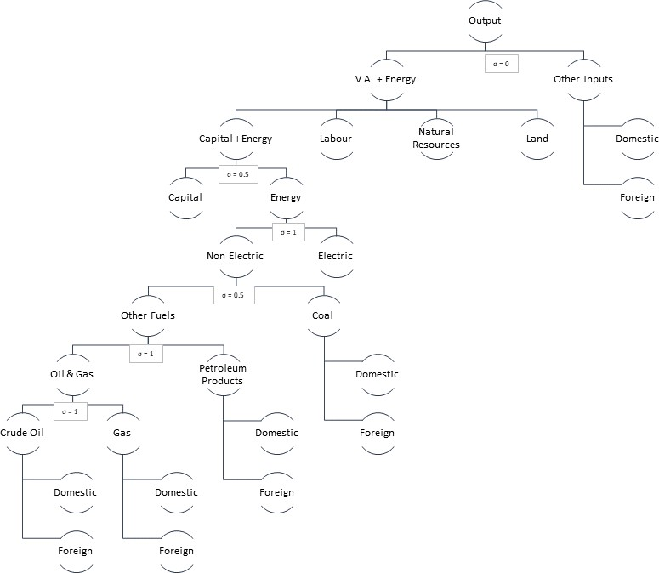

following constrained cost minimization problem for the representative firm:

$$\min{P_{i,r}^{LAND}*{LAND}_{i,r}}+P_{i,r}^{NR}*{NR}_{i,r}+P_{i,r}^{L}*L_{i,r}+P_{i,r}^{KE}*{KE}_{i,r}$$

$$s.t.{{QVAEN}_{i,r}=(}{{LAND}_{i,r}^{\frac{σ_{VAE-1}}{σ_{VAE}}}+{NR}_{i,r}^{\frac{σ_{VAE-1}}{σ_{VAE}}}+L_{i,r}^{\frac{σ_{VAE-1}}{σ_{VAE}}}+{KE}_{i,r}^{\frac{σ_{VAE-1}}{σ_{VAE}}})}^{\frac{σ_{VAE-1}}{σ_{VAE}}}$$

On its turn, the KE bundle combines capital with a set of different energy inputs. This is peculiar to GTAP-E and ICES. In fact, energy inputs are not part of the intermediates, but are associated to capital in a specific composite. The energy bundle is modelled as an aggregate of electric and non-electric energy carriers. In this version of the model, Electricity is a heterogeneous sector including electricity produced with fossil and clean energy sources. The Non-Electric bundle is a composite of sub-nests Coal, Natural Gas, Crude Oil and Petroleum Products. All elasticities regarding the inter-fuel substitution bundles are those from GTAP-E (Burniaux & Truong, 2002).
The demand of production factors (as well as that of consumption goods), can be met by either domestic or foreign commodities which are however not perfectly substitute according to the "Armington" assumption. In general, inputs grouped together are more easily substitutable among themselves than with other elements outside the nest. For example, the substitutability across imported goods is higher than that between imported and domestic goods. Analogously, composite energy inputs are more substitutable with capital than with other factors. In ICES, two industries are treated in a special way and are not related to any country, viz. international transport, and international investment production. International transport is a world industry, which produces the transportation services associated with the movement of goods between origin and destination regions. Transport services are produced by means of factors submitted by all countries, in variable proportions. In a similar way, a hypothetical world bank collects savings from all regions and allocates investments in order to achieve equality in the absolute change of current rates of return.
Figure A2 describes the main sources and uses of regional income. In each region, a representative regional household receives income, originated by the service value of national primary factors (natural resources, land, labor, and capital), and by direct and indirect taxation. The regional income is the constraint in the regional household utility maximization (Cobb-Douglas) from consumption, government spending and savings.
Figure A2: Sources and uses of regional household income
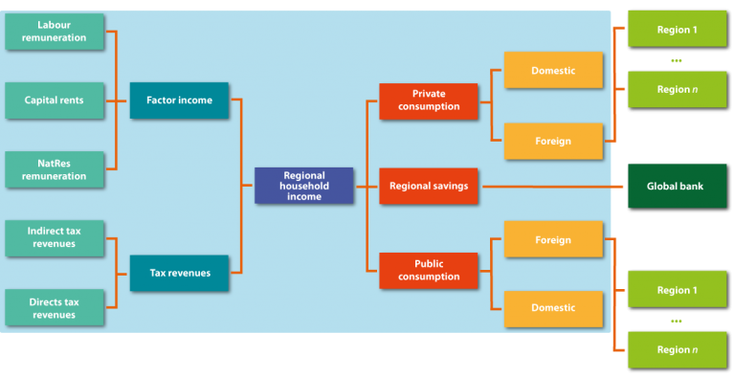

Public consumption is split into a series of alternative consumption commodities according to a Cobb-Douglas specification. However, almost all public expenditure is concentrated in the specific sector of Non-market Services, including education, defense, and health. Private consumption is analogously addressed towards alternative goods and services including energy commodities, that can be produced domestically or imported. The functional specification used at this level is the Constant Difference in Elasticities (CDE) form: a non-homothetic function, which is used to account for possible differences in income elasticities for the various consumption goods.
The recursive-dynamic feature is described in Figure A3. Starting from the picture of the world economy in the benchmark year, by following socioeconomic (e.g. population, primary factors stocks and productivity) as well as policy-driven changes occurring in the economic system, agents adjust their decisions in terms of input mix (firms), consumption basket (households) and savings. The model finds a new general (worldwide and economy-wide) equilibrium in each period, while all periods are interconnected by the accumulation process of physical capital stock, net of its depreciation. Capital growth is standard along exogenous growth theory models and follows:

$${Ke}_{r}=I_{r}+\left(1+δ\right){Kb}_{r}$$
where ${Ke}_{r}$is the end of period capital stock, ${Kb}_{r}$is the beginning of period capital stock, $δ$ is capital depreciation and $I_{r}$ is endogenous investment. Once the model is solved at a given step t, the value of ${Ke}_{r}$is stored in an external file and used as the beginning of period capital stock of the subsequent step t+1. The matching between savings and investments only holds at the world level; a fictitious world bank collects savings from all regions and allocates investments following the rule of highest capital returns.
As with capital, at each simulation step the government net deficit at the end of the period is stored in an external file and adds up to next year debt.
Figure A3: Recursive-dynamic feature of ICES model

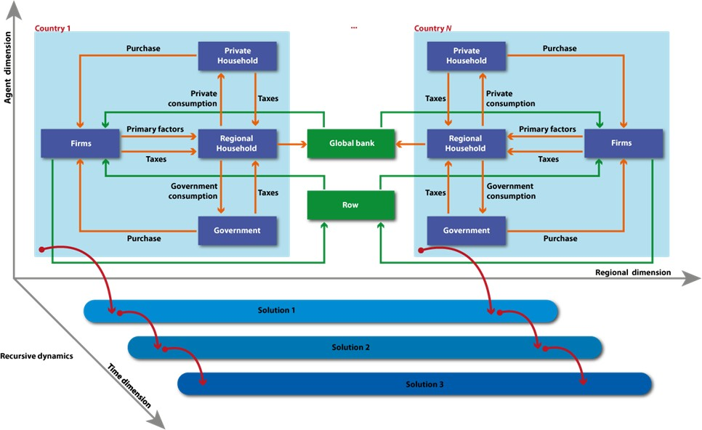

ICES is a Computable model: all the model behavioral equations are connected to the GTAP 8.1 database (Narayanan & McDougall, 2012), which collects national social accounting matrices from all over the world and provides a snapshot of all economic flows in the benchmark year (57 economic sectors and 134 countries). We aggregate countries into 19 regions and macro-regions, singling out only key EU countries (Table A1). Regarding Italy, we used the economic database at NUTS-2 level (20 regions) developed in Standardi et al. (2017) and Carrera et al. (2015). Energy volumes and CO2 emission for Italy are allocated to the different regions using economic value flows, and therefore assuming no price differentiation across Italian regions. The regional detail characterizing the final database is displayed in Table A1.
Table A1: Regional aggregation

N | Country/Region | N | Country/Region | N | Country/Region | N | Country/Region
1 | Asia | 11 | ITA - ValAosta | 21 | ITA - Lazio | 31 | Spain
2 | LACA | 12 | ITA - Lombardia | 22 | ITA - Abruzzo | 32 | Sweden
3 | OECD | 13 | ITA - TrentAdige | 23 | ITA - Molise | 33 | UK
4 | Benelux | 14 | ITA - Veneto | 24 | ITA - Campania | 34 | RoEU
5 | Czech_Rep | 15 | ITA -FriuliGiulia | 25 | ITA -Puglia | 35 | RoEurope
6 | Finland | 16 | ITA- Liguria | 26 | ITA -Basilicata | 36 | MENA
7 | France | 17 | ITA- EmiRom | 27 | ITA -Calabria | 37 | Africa
8 | Germany | 18 | ITA- Toscana | 28 | ITA -Sicilia | 38 | RoW
9 | Greece | 19 | ITA- Umbria | 29 | ITA -Sardegna
10 | ITA- Piemonte | 20 | ITA -Marche | 30 | Poland

Physical climate change impacts

Here we employ the ex-ante energy demand shocks from De Cian & Sue Wing (2019), which uses a panel data of national energy demand, energy prices, income per capita, and weather covariates (temperature and humidity) for hundreds of countries over the period 1970-2014 to derive income elasticities and temperature semi-elasticities of sectoral energy demand in tropical and temperate regions for three energy carriers (electricity, natural gas, petroleum products) in five sectors (residential, commercial, industry, agriculture, transport). Semi-elasticities to hot days (days with average mean temperature above 27.5◦C) and cold days (days with average mean temperature below 12.5◦C) are combined with projected changes in meteorology simulated by runs of the CMCC-CM Earth System Model (Scoccimarro et al., 2011) as follows:
 | $$φ_{c,f,s}^{Climate}=exp⁡\left\{\sum_{j=1}^{J}{{\hat{γ}}_{j,f,s}^{T}}({\tilde{ε}}_{j,c,Future}^{T}-{\tilde{ε}}_{j,c,Current}^{T})\right\}$$ | (9)
where ${\hat{γ}}_{j,f,s}^{T}$ are the estimated semi-elasticities of energy demand to different temperature intervals j, ${\tilde{ε}}_{j,c,Future}^{T} and {\tilde{ε}}_{j,c,Current}^{T}$is population-weighted temperature exposure over the current (2006-2015) and future (2046-2055) period for grid cell c, fuel f, and sector s. They describe the percentage change in sectoral demand for electricity, natural gas, heating oil due to changes in the frequency of hot and cold days. Here we only focus on the residential sector.
Gridded shocks have been aggregated to the regional administrative units of the Italian household survey and of the CGE model (see Section 2.3) of NUTS2. NUTS2-level climate shocks are the mean of the shocks across all grid-cells belonging to that specific NUTS region, $φ_{c,f,s}^{Climate}$, where r is the NUTS2 region:
 | $$φ_{c,f,s}^{Climate}=\sum_{c∈r}{\frac{φ_{c,f,res}^{Climate}}{N_{c∈r}}}$$ | (10)
where Nc is the number of grid cells in NUTS2 region r, and Climate is the climate scenario, Climate ∈ {RCP 4.5, RCP 8.5}, see Figure A4.

Figure A4: Climate change impacts on residential energy demand. Percentage changes in 2046-2055 compared to present climate (2006-2015). Source: Own calculations based on De Cian and Sue Wing (2017).
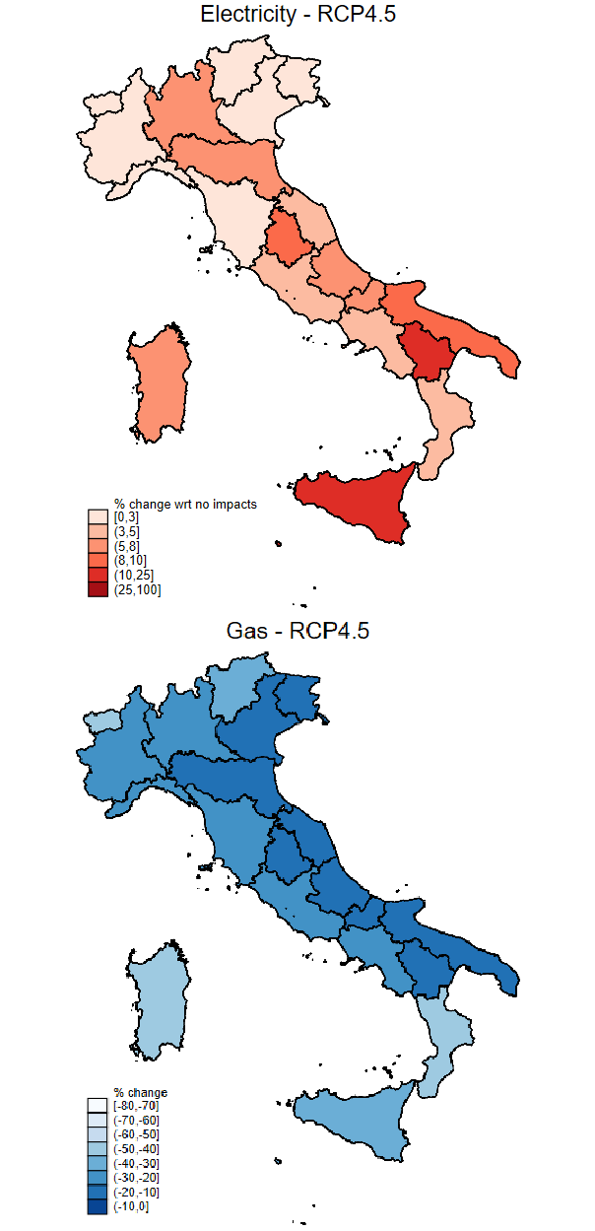
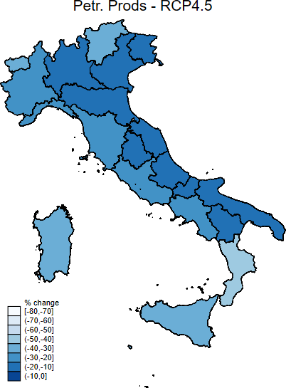
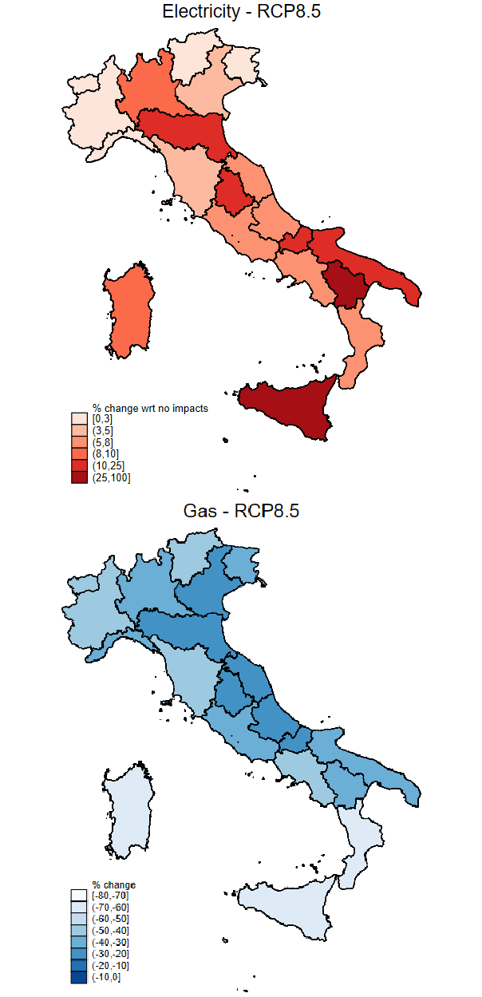
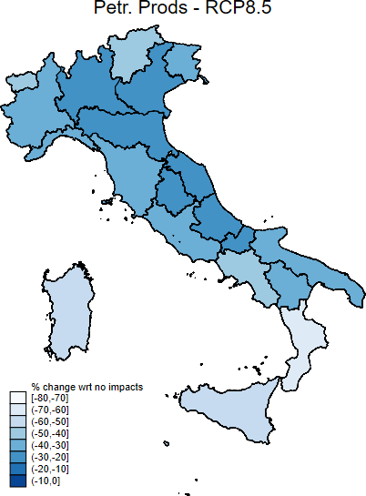

Downscaling module
Applying the macroeconomic changes generated by the ICES model (we use an overbar to distinguish variables output of ICES model from the others, and small letters to denote percentage changes) to the expenditure of all households in HBS,
HBS
EXP
h,i,r

$${EXP}_{h,i,r}^{ 2050,scen}={EXP}_{h,i,r}^{HBS}(1+{\overline{qp}}_{i,r}^{scen}/100)(1+{\overline{pp}}_{i,r}^{scen}/100)$$
would determine a discrepancy between the aggregate changes in household expenditure $\exp_{r}^{ 2050,scen}$ and the percentage variations observed in the ICES model ${\overline{exp}}_{r}^{ 2050,scen}$:
$$\exp_{r}^{ 2050,scen}≠{\overline{exp}}_{r}^{ 2050,scen}$$
as well as a discrepancy in 2050 levels:

${EXP}_{r}^{ 2050,scen}≠{\overline{EXP}}_{r}^{ 2050,scen} w$here ${EXP}_{r}^{ 2050,scen}= \sum_{h}{\sum_{i}{{EXP}_{h,i,r}^{ 2050,scen}}}$
The inconsistency when computing aggregate values emerges also at the regional level. The downscaling module minimizes this discrepancy transforming the 2050expenditure at household level (${EXP}_{h,i,r}^{ 2050,scen}$) into an adjusted one (${\tilde{EXP}}_{h,i,r}^{ 2050,scen}$) which satisfies the following constraint:
$$\sum_{h}{\sum_{i}{{\tilde{EXP}}_{h,i,r}^{ 2050,scen}}}={EXP}_{r}^{ 2050,scen}$$
The expenditure reconciliation is realized using the cross entropy maximization method (McDougall, 1999; Golan & Judge, 1996). We start by defining the normalized expenditure matrix $a_{h,i,r}^{scen}$:
 | $$a_{h,i,r}^{scen}=\frac{{EXP}_{h,i,r}^{ 2050,scen}}{\sum_{h}{\sum_{i}{{EXP}_{h,i,r}^{ 2050,scen}}}}$$ | (11)
The cross entropy method consists in minimizing the distance between a new matrix ${\tilde{a}}_{h,i,r}^{scen}$ and the original one $a_{h,i,r}^{scen}$ (equation 12), respecting consistency constraints on column (equation 14) and row total (equation 13) in the adjusted expenditure matrix (Kullback & Leibler, 1951). Equation 13 guarantees the identity between the adjusted total expenditure of each household ($\sum_{i}{{\tilde{a}}_{h,i,r}^{scen}}*{EXP}_{h,i,r}^{ 2050,scen}={\tilde{EXP}}_{h,i,r}^{ 2050,scen}$) and the reference household expenditure consistent with the total regional expenditure from the ICES model (${\overline{EXP}}_{r}^{ 2050,scen}$) and expenditure distribution across households in that region according to HBS ($δ_{h}=\sum_{i}{{EXP}_{h,i,r}^{ HBS}/\sum_{h,i}{{EXP}_{h,i,r}^{ HBS}}}$). The equation 14 secures the identity between the regional and scenario-specific aggregates new expenditure in a certain good i and the expenditure from ICES model.

The new matrix ${\tilde{a}}_{h,i,r}^{scen}$ solves the following problem:
 | $$Max-\sum_{h}{\sum_{i}{{\tilde{a}}_{h,i,r}^{scen}ln⁡(\frac{{\tilde{a}}_{h,i,r}^{}}{a_{h,i,r}^{}})}}$$ | (12)
 | $$s.t.\sum_{i}{{\tilde{a}}_{h,i,r}^{scen}*{EXP}_{h,i,r}^{ 2050,scen}=}\sum_{i}{δ_{h}^{}*{\overline{EXP}}_{i,r}^{ 2050,scen}}$$ | (13)
 | $$\sum_{h}{{\tilde{a}}_{h,i,r}^{scen}}=1$$ | (14)
The maximization is run independently and iteratively for each one of the 20 Italian regions and for each scenario (baseline, RCP4.5 and RCP8.5) and therefore lead to adjusted expenditure matrices for each region and scenario.
This simple downscaling method returns a household-specific picture of consumption choices in 2050 under baseline and impact scenarios. Comparing how energy expenditure shares change in a mild and severe global warming scenario with respect to the baseline one sheds light on the distributional implications of climate change impacts on energy demand, accounting for price-induced adaptation, as well as on the possible consequences in terms of energy poverty. In order to assess the downscaled second-order effects, we will apply the same metrics used for the first- order effect analysis, namely the change in household energy expenditure share, their distribution, and the fuel poverty prevalence measure described in Equation 7 .
It is worth noticing that the proposed methodology makes it possible to account for the behavioral response of household demand to price changes, but the optimization process takes place at regional level. This means that all households belonging to a specific NUTS2 region will be subject to the same commodity price and quantity percentage change. The downscaling module will apply the macroeconomic, regional variation in prices and quantities to different, household-specific, initial expenditure levels that will be adjusted at household level in order to solve the constrained optimization problem.
Bearing these limitations in mind, this methodology makes it possible to compare the burden of direct and indirect climate change impacts on the energy used by Italian households, as well as its overall distributional implications. By looking at the distribution of this burden, we will highlight the either regressive, progressive, or neutral implications of energy use for adaptation, highlighting the role of adjustment mechanisms induced by price changes and income effects.

Baseline scenario: calibration
The baseline scenario relies on historical data up to 2016-17 (WDI and ISPRA data integrated by Eurostat data at NUTS2 level for Italian regions) that are extended up to 2050 using a business-as-usual scenario (SSP2) (Riahi et al. , 2017). SSP2 is among the five shared socioeconomic pathways (SSPs) (O’Neill et al. , 2017) and is defined as the ’Middle of the road’ scenario being characterized by future trend reproducing those observed in the past decades with medium population and GDP growth, constant reduction of energy intensity and of dependence from fossil fuels and a slow convergence towards achieving SDGs that will not be met by 2030. This scenario does not consider any impact or mitigation policy and in fact is used as term of comparison for assessing impacts and mitigation scenarios.
Historical population, working age population, labor force and employment growths are considered up to 2016 (WDI and Eurostat), afterwards the growth of overall population and working age population (age 15-64 years) follows the projections from SSP2 (Riahi et al. , 2017). Furthermore, we computed the employment growth up to 2050, assuming the convergence of labor force participation rate to 70% in 2100 and that of unemployment rate to 2% (both assumptions are part of SSP2 storyline). For Italian regions, we applied the same rate of growth of population and employment of Italy.
The procedure for computing target GDP growth in the baseline was similar, we combined WDI and Eurostat data up to 2016 and afterwards we considered the GDP growth from SSP database (Riahi et al. , 2017). Italian GDP growth was applied uniformly to all regions after 2016. In Italy, per capita GDP, in purchase power parity, increases over time, with an evident North-South gap. Growth is characterized by a progressive reduction of the value added in agriculture and services and by an expansion in the industrial sector.
The Word price of primary energy sources (coal, oil and gas) is aligned to historical and SSP2 price changes (+16% for coal, +90% for oil and -11% for gas in 2050 with respect to 2007), as well as the trend of secondary energy demand (petroleum products and electricity). These two elements combined with progresses in energy efficiency allow mimicking the evolution of energy demand up to 2050. Particular attention was devoted to reproduce in Italy the evolution of total energy supply for the period 2007-2017 observed in the Eurostat data (Figure A5 - left) as well as the CO2 historical emission growth documented by ISPRA (Figure A5 - right). Global CO2 emission path is in line with the median of SSP2 baseline emissions from SSP database foreseeing a 116% rise of CO2 emission in 2050 with respect to 2007 (Riahi et al. , 2017).

Figure A5: Total energy supply (right) and CO2 emissions (left) in Italy, ICES output vs. Eurostat/ISPRA in 2007 and 2017.
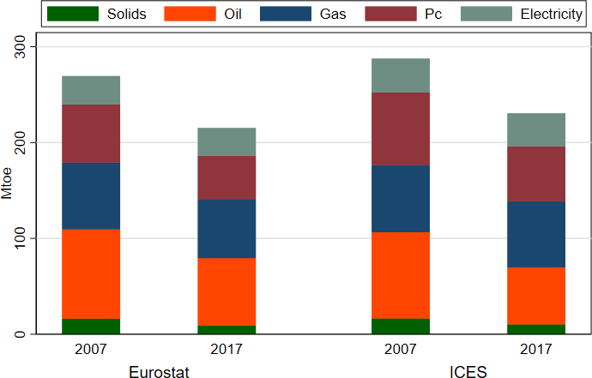
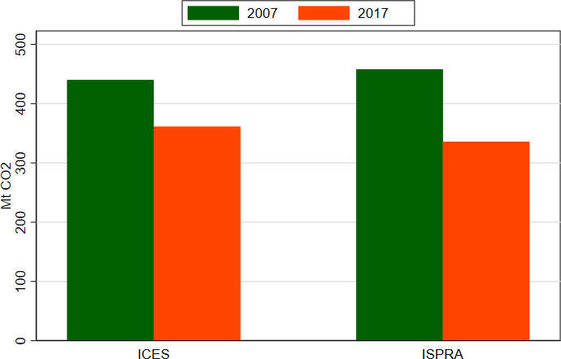

The baseline scenario is characterized by a global increase of energy expenditure with respect to 2007 due to the rise of demand of all fuels and of prices except electricity and gas ones (according to SSP2 scenario assumptions). In Italy, energy expenditure increases on average by 4% (8.5% for heat and -7.6% for electricity) that is the result of a 13.4% increase of energy demand (-2.1% for heat and 55% for electricity) and 8.3% drop of energy prices (+10.7% for heat and -40.5% for electricity). The change in energy expenditure is quite heterogeneous across Italian regions (Figure A6 - left) and reflects changes in consumption and prices (Gas&Pc consumption reduces in several regions and electricity use increases in all regions). The downscaling process described in Section 3.3 determines a reduction (increase) of energy expenditure in the lowest (top) deciles in 2050 baseline with respect to the base year (Figure A6 - right).

Figure A6: Change household energy expenditure across Italian regions (left) and by decile (right) in 2050 wrt 2007, baseline scenario.
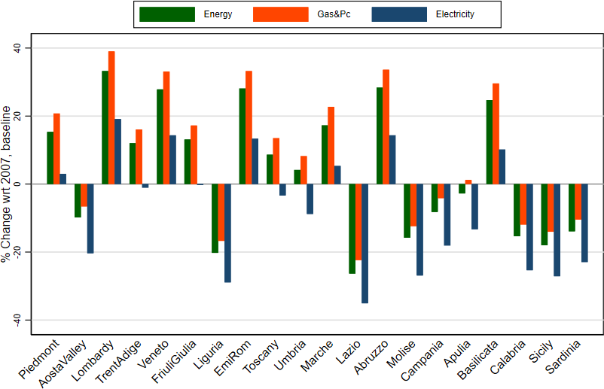
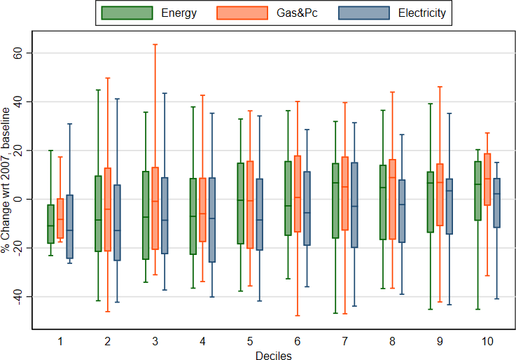

Poverty prevalence in 2050 baseline is computed updating the minimum affordable budget share of fuels (right-hand term in equation 7) with downscaled results of ICES model for 2050. The poverty prevalence in 2050 slightly reduces at country level (4.5% vs. 4.3% in 2007), there are some variations at regional level that remain in the range of -0.7 and 0.8 percentage points. Figure A7 gives a breakdown of fuel poverty prevalence across Italian regions in the base year and in 2050.

Figure A7: Poverty prevalence in 2007 and 2050, baseline scenario
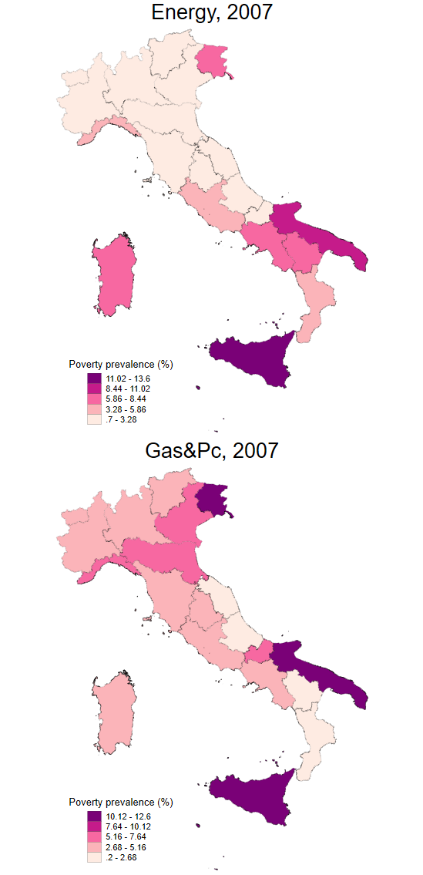
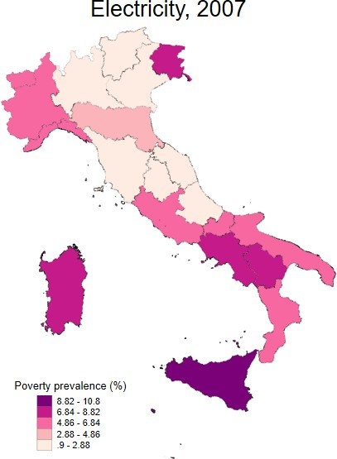
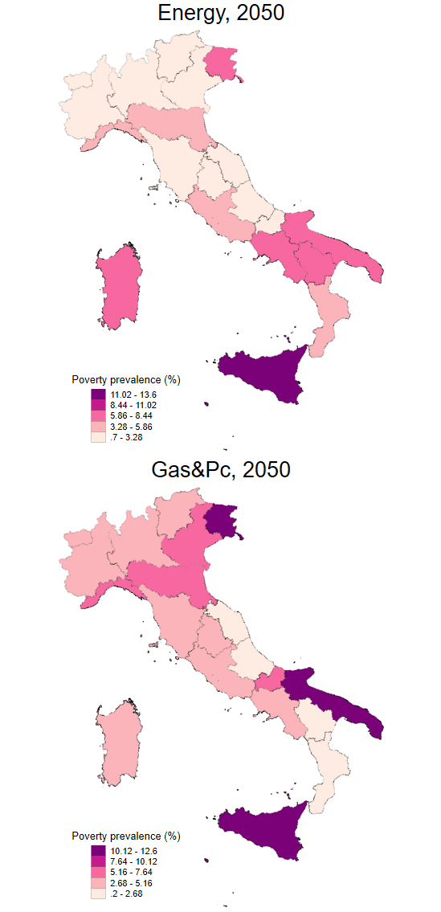
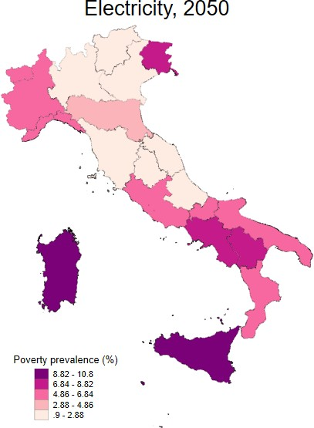

Impact and mitigation scenarios

The present work considers two impact scenarios: a severe global warming scenario (RCP8.5) and a moderate one (RCP4.5). The scenarios are performed starting from the baseline scenario and shifting exogenously household country and fuel-specific energy demand according to the computed physical climate change impacts (Section 3.1 and Annex 2). To increase the plausibility of the RCP4.5 scenario, we account for the fact that a moderate increase of global warming will be consistent to a mitigation effort. The CO2 emissions in 2050 baseline scenario are around 57 GtCO2/yr in the SSP2 range (Fricko et al. , 2017). We introduce a global carbon tax reaching 150 US$2007/t CO2 in 2050 that brings emission path in line with RCP4.5 scenario (around 33 GtCO2/yr in 2050). This scenario is named RCP4.5-CTAX.
Introducing a carbon tax generates a generalized decrease of world price of fossil resources and a rise of electricity prices (33% with respect to baseline). But the focus of this work is on households and their expenditure; households buy energy not at world price, but at the agent price in the region and these are inclusive of carbon tax. Consumption prices of energy decrease in the impact scenarios, we see a steep rise of prices when the carbon tax is added and coupled with RCP4.5 (Figure A8 left). When we analyze the household expenditure across scenarios (Figure A8 right), we see an increase of electricity expenditure proportional to the severity of global warming, Gas&Pc expenditure moves in the opposite direction. Overall energy expenditure drops in RCP4.5 and (more) in RCP8.5 because the effect on heating fuels prevails. If we consider the fact that a moderate level of climate change impacts will likely depend on mitigation efforts (RCP4.5-CTAX scenario), we observe an upward shift of expenditure, i.e. lower reduction of energy and Gas&Pc expenditure and stronger increase of electricity expenditure (higher than in RCP8.5 scenario).

Figure A8: Change household energy prices (left) and expenditure (right) wrt baseline scenario in 2050 in Italy, across impact scenarios.
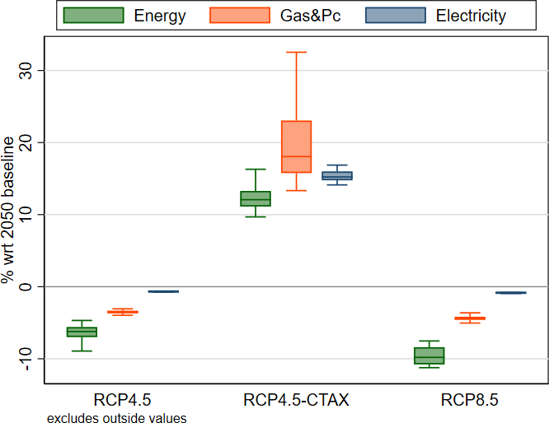
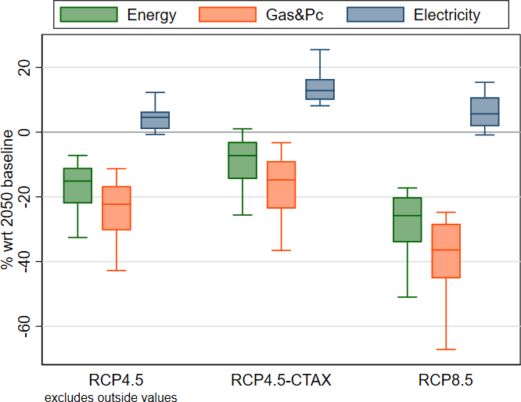

Figure A9: First and higher-order effects of climate change on households’ energy expenditure per adult equivalent (pae) by region and by decile.
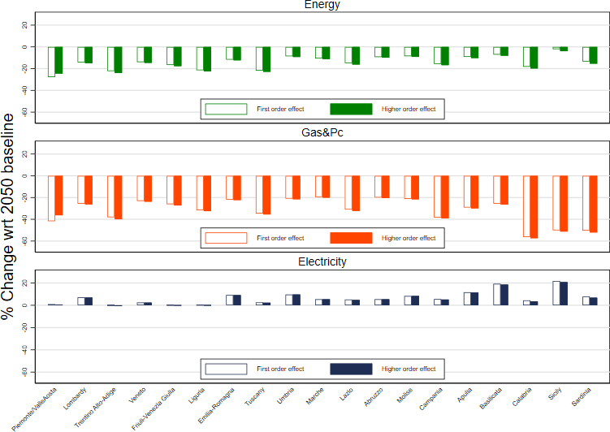
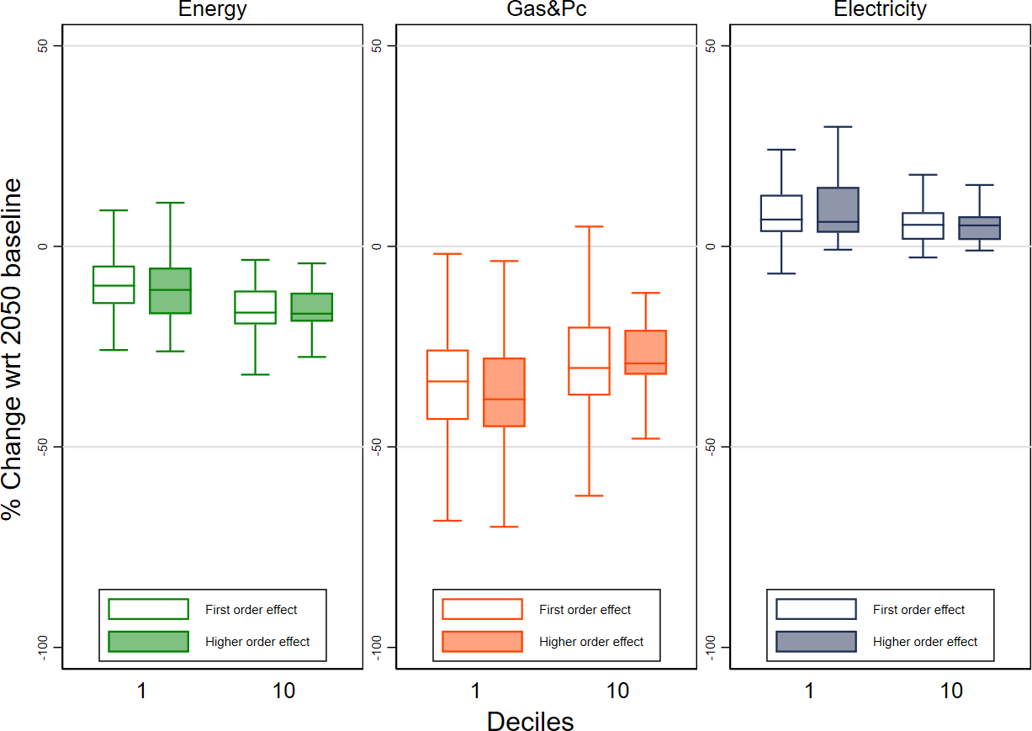

We use energy and fuel poverty interchangeably as referring to the lack or the inadequate availability of domestic energy services, although some scholars distinguish between the two concepts, with the former referring to energy access in developing countries the former, and the latter referring to affordability in developed countries (Thomson et al., 2016)
The necessary amount of goods is defined as the affordable expenditure for households below the poverty line.
We used the shape file for the political borders within Europe at NUTS2 to extract only the grid-cells of interest with the R package sp, https://www.rdocumentation.org/packages/sp/ versions/1.3-1/topics/sp. Grid cells have been aggregated by using the simple mean function. Grid-level impacts have been converted into spatial points, which have then been intersected with the EU NUTS2 polygons by using the point in polygon R function.
The HBS represents the Italian population with 28,000 households surveyed.
For privacy reasons, in the survey the highest level of detail about household location is represented by the 20 NUTS2 Italian regions.
All commodity prices remain unaltered, and the expenditure change is the result of a consumption quantity change. The same shock is imposed on all households falling within the same NUTS2. Results differ across households because of the different initial baseline expenditure.
Fuels are represented by set f, which is a subset of commodities i. The complementary set is called o.
All variables considered, i.e. household total and fuel-specific expenditures, are per adult equivalent.
LIHC considers as energy poor those households whose income share spent on energy is above the national median, and whose net energy income costs are below the national poverty line.
The use of a region-specific threshold acknowledges that independently of income availability, different Italian regions are characterized by heterogeneous climatic characteristics and, therefore, energy needs.
When computing the index with climate change impacts and in future periods, the potential expenditure on the left-hand side is updated by considering the median expenditure of poor households after imposing baseline changes and climate shocks. The threshold on the right is constant in the first-order impact assessment and is updated when considering higher-order impacts by acknowledging economic growth and a change in energy expenditure.
The two poverty prevalence indicators are described in Section 3.2
All households within the same region receive the same shock, in percentage changes, which modifies the 2007 consumption of electricity, gas and petroleum products.
The number of energy-poor households is not the sum of fuel-specific figures because the poverty thresholds are specified independently of heating, electricity, and overall energy.
The creation of a baseline scenario is an essential step in modelling exercises because it offers the correct term of comparison (i.e. the counterfactual) for assessing the implication of impacts and policies. Our baseline scenario mimics historical patterns of GDP, population, energy use and emissions up to 2016-17 and afterwards SSP2 evolution of the same variables. The calibration process is described in detail in Appendix 4.
All other household characteristics remain constant.
Capital and labor are perfectly mobile domestically but immobile internationally (investment is instead internationally mobile). Land and natural resources, on the other hand, are industry- specific.
Hanoch’s constant difference elasticity (CDE) demand system (Hanoch, 1975) has the following formulation: $1=\sum{B_{i}U^{Y_{i}R_{i}}{(\frac{P_{i}}{X})}^{Y_{i}}}$ where U denotes utility, P_{i} the price of commodity i, X the expenditure, B_{i} are distributional parameters, Y_{i} substitution parameters, and R_{i} expansion parameters. The CDE in principle does not allow to define explicitly direct utility, expenditure, or indirect utility functions. Accordingly, also explicit demand equations could not be defined. Fortunately, in a linearized equation system such as that used in GTAP, it is possible to obtain a demand function with price and expenditure elasticities.
We used the shape file for the political borders within Europe at NUTS2 to extract only the grid-cells of interest with the R package sp, https://www.rdocumentation.org/packages/sp/ versions/1.3-1/topics/sp. Grid cells have been aggregated using the simple mean function. Grid-level impacts have been converted to spatial points, which have then been intersected with the EU NUTS2 polygons using the point in polygon R function.
The mitigation scenario is performed in two steps; in the first step, we set the emission reduction target coherently with RCP 4.5 scenario and we derive endogenous global carbon price path with trade. In the second step, we impose the same carbon price as a national carbon tax to all countries.
Due to the current structure of the model, the revenues of carbon tax are directly transferred to households in a lump sum.

