Particle size distribution of inorganic and organic ions in coastal and inland Antarctic aerosol

Elena Barbaro^{1,2}, Sara Padoan¹, Torben Kirchgeorg¹, Roberta Zangrando², Giuseppa Toscano^{1,2}, Carlo Barbante^{2,1}, Andrea Gambaro^{1,2}

¹Department of Environmental Sciences, Informatics and Statistics, Ca’ Foscari University of Venice, Via Torino 155, 30172, Venice-Mestre, Italy
² Institute for the Dynamics of Environmental Processes CNR, Via Torino 155, 30172, Venice-Mestre, Italy.

Corresponding author: Elena Barbaro,Ca’ Foscari University of Venice, Via Torino 155, 30172, Venice-Mestre, Italy
Phone: +390412348545 E-mail: barbaro@unive.it

Keywords: aerosol, Antarctica, ions, carboxylic acids, particle size distribution, sea spray.

Abstract
The concentration and particle-size distribution of ionic species in Antarctic aerosol samples were determined to investigate their potential sources, chemical evolution and transport. We analyzed aerosol samples collected at two different Antarctic sites: a coastal site near Victoria Land close to the Italian Research Base “Mario Zucchelli”, and another site located on the Antarctic plateau, close to Italian-French Concordia Research Station. We investigated anionic compounds using ion-chromatography coupled to mass spectrometry, and cationic species through capillary ion chromatography with conductometry.
Aerosol collected close to the coast was mainly characterized by sea salt species such as Na⁺, Mg²⁺, SO₄²⁻. These species represented a percentage of 88% of the total sum of all detected ionic species in the aerosol samples from the coastal site. These species were mainly distributed in the coarse fraction, confirming the presence of primary aerosol near the ocean source.
Aerosol collected over the Antarctic plateau was characterized by high acidity, with nss-SO₄²⁻, NO₃- and methanesulfonic acid as the most abundant species. These species were mainly distributed in the <0.49 µm fraction and they had a behavior of a typical secondary aerosol, where several chemical and physical processes occurred.

Introduction
It is widely recognized that the study of climate change also requires the complete investigation of the chemical composition and physical features of atmospheric aerosol particles(Fiore et al. 2015). Aerosol can interfere with solar radiation by scattering and absorption, influencing the radiation energy balance of the earth system(IPCC 2007). Determining sources and emission of particles to the atmosphere is crucial, to better understanding their impact on climate change. Some chemical markers can describe chemical, physical or biological processes in the atmosphere. Their presence and concentration could give us some useful information about origin of aerosol and atmospheric long-range transport processes. Several studies investigated different ions in the Antarctic atmosphere(Fattori et al. 2005, Kawamura et al. 1996b, Minikin et al. 1998, Preunkert et al. 2008, Teinila et al. 2000, Udisti et al. 2012). Sea spray emitted by bubble bursting is the main source of aerosol in the coastal areas and salt crystals influence the climatic conditions, contributing to the formation of cloud condensation nuclei and altering the albedo and the optical properties of the aerosol(Udisti et al. 2012). Some cationic species, such as sodium, magnesium or potassium, derive mainly from this sea-air exchange(Udisti et al. 2012), while ammonium originates mainly from the decomposition of organic matter(Weller et al. 2008). Some anions, such as nitrate and sulfate, are part of important biogeochemical cycles and are able to participate in numerous reactions that influence the chemistry of the atmosphere.
Carboxylic acids (CA) may have different emission sources to the atmosphere. Some organic acids can be produced by photochemical reactions of oxidation of anthropogenic organic pollutants(Mochida et al. 2007). Once emitted in the atmosphere, CA precursors undergo oxidation or photochemical reactions or react with strong oxidants, e.g. ozone (Kawamura et al. 1996a).
The main aim of this study is to compare the composition and concentration of ionic compounds in the aerosol collected at an Antarctic coastal site in the vicinity of the Mario Zucchelli Station (MZS) and at an inland site close to Dome C (DC) in order to investigate different sources of aerosols and to understand possible chemical transformation processes during long range atmospheric transport.
Highly sensitive analytical methods were used to simultaneously determine several ionic compounds and CA in aerosols samples collected during three different Antarctic expeditions: the first, that occurred from November 2010 to January 2011, at MZS; two consecutive campaigns took at DC during the XXVII Italian Antarctic expedition from December 2011 to January 2012 (DC27) and during the XXVIII Italian Antarctic expedition from December 2012 to January 2013 (DC28). We investigated the nitrogen cycle components (nitrite (NO₂⁻), nitrate (NO₃⁻)and ammonium (NH₄⁺)), two components of the sulfur cycle (sulfate (SO₄²⁻) and methanesulfonic acid (MSA)), seven ions (chloride (Cl⁻), sodium (Na⁺), phosphate (PO₄³⁻), bromide (Br⁻), iodide (I⁻), potassium (K⁺) and magnesium (Mg⁺)) and 13 CA (C₂-oxalic, C₂-acetic, C₂-glycolic, C₃-malonic, C₄-succinic, hC₄-malic, cis-usC₄-maleic, trans-usC₄-fumaric, C₅-glutaric, C₆-adipic, C₇-pimelic, αC₇-benzoic, C₈-suberic acids).
Experimental section
Material and methods
Ultra pure water (18.2 MΩ cm, 0.01 TOC) was produced using a PURELAB flex ultra system (Elga, High Wycombe, U.K).The multi anion standard solution for ion chromatography(Cl⁻10 mg L⁻¹;NO₃⁻ 20 mg L⁻¹;Br⁻ 20 mg L⁻¹;PO₄³⁻ 30 mg L⁻¹;SO₄²⁻ 20 mg L⁻¹) and single standard solutions (all 1000 mg L⁻¹) of I⁻, NO₂⁻ and CA (C₂-oxalic, C₂-acetic, C₂-glycolic, C₃-malonic) were obtained from Sigma Aldrich. Standard solutions of other compounds (MSA, cis-usC₄-maleic, trans-usC₄-fumaric, hC₄-malic, C₄-succinic, C₅-glutaric, C₆-adipic, C₇-pimelic, αC₇-benzoic, C8-suberic) purchased from Sigma Aldrich, were prepared from the solid standard solved in ultrapure water. The multi cation standard solution for ion chromatography (K⁺, Li⁺, Mg⁺, Na⁺, NH₄⁺)at the concentration of 100 mg L⁻¹was obtained from Sigma Aldrich.
Sample collection and processing
Aerosol samples (n=14) were collected during three different Antarctic campaigns. Five samples were collected from 29 November 2010 to 23 January 2011 at Campo Faraglione (74° 42’ S-164° 06’ E), about 3 km south of the Italian research base MZS. Four samples were collected over the Antarctic plateau (75° 06’ S-123° 20’ E, 3233 m above sea level), near the Italian-French scientific base Concordia station (DC), from 19 December 2011 to 28 January 2012 (DC27) and from 7 December 2012 to 26January 2013 (DC28).
A multi-stage Andersen impactor (TE-6000 series, Tisch Environmental Inc.) was used to collect aerosol samples on six pre-combusted (4h at 400°C in a muffle furnace) quartz fiber filters. The sampler accumulated particles with 10.0 – 7.2 µm, 7.2 – 3.0 µm, 3.0 – 1.5 µm, 1.5- 0.95 µm, 0.95 – 0.49 µm on slotted filters and <0.49 µm particle cut-off diameters on backup filter. The frequency of sampling was every 10 days with a total air volume of ~ 15,000 m³ per sample. Blank samples were obtained using filters installed on the sampler with the air pump switched off. Samples and blanks were wrapped in a double layer of aluminum foil and stored at -20°C until analysis.
During sample preparation, the filters were handled under a laminar flow bench (class 100), where they were broken into small pieces and placed in polyethylene tubes, using steel tweezers. All materials were previously cleaned with ultrapure water by sonication for 30 minutes at room temperature. Slotted filters were ultrasonically extracted for 30 minutes with 7 mL of ultra-pure water, while backup filters with 15 mL of ultra-pure water. Extracts were filtrated through a 0.45 µm PTFE filter (ThermoFisher) to remove residues before the analysis.
Instrumental analysis
Anion determination was performed using an IC (ThermoScientificTM DionexTM ICS-5000, Waltham, US) equipped with an anionic exchange column (Dionex Ion Pac AS 11 2x250 mm) and a guard column (Dionex Ion Pac AG11 2x50 mm). Sodium hydroxide (NaOH), used as mobile phase, was produced by an eluent generator (Dionex ICS 5000EG, Thermo Scientific). The gradient with a 0.25 mL min⁻¹ flow rate was 0 min, 0.5 mM; 0-3.5 min gradient from 0.5 mM to 5 mM; 3.5-5 min gradient from 5mM to 10 mM; 5-25 min gradient from 10 mM to 38 mM; 25-30 min, column cleaning with 38 mM; 30-35min; equilibration at 0.5 mM. The injection volume was 100 µL. A suppressor (ASRS 500, 2 mm, Thermo Scientific) removed NaOH before entering the MS source. The IC was coupled to a single quadrupole mass spectrometer (MSQ Plus™, Thermo Scientific ™) with an electrospray source (ESI) that operated in negative modewith a temperature of 500°C and a needle voltage of 2.5 kV.Selected ion monitoring(SIM) was used for detection. Mass to charge ratios of [M-H]⁻, compound-specific cone voltageand acquisition timeare provided in Table 1.
To determine cationic species, a capillary ion chromatograph (Thermo Scientific Dionex ICS-5000), equipped with a capillary cation exchange column (Dionex IonPac CS19-4µm, 0.4 x250 mm) a guard column (Dionex Ion Pac CG19-4µm, 0.4x50 mm) was used. Methanesulfonic acid was used as mobile phase and was produced by an eluent generator (Dionex ICS 5000EG, Thermo Scientific). The gradient was: 0-17.3 min; 1.5 mM; 17.3-21.9 min gradient from 1.5 mM to 11 mM; 21.9-30 min equilibration at 1.5 mM. The injection volume was 0.4 µL and the flow rate was 13 µL min⁻¹. A suppressor (CCES 300, Thermo Scientific) removed MSA before entering the conductibility detector.Chromeleon6.8 Chromatography data system was used for data acquisition and elaboration.
Quality control
The analytical procedure was validated through measurement of procedural blanks, recoveries, errors, and repeatability. Trueness and repeatability were evaluated by analyzing cleaned quartz fiber slotted filters (n=3) and quartz fiber backup filters (n=3) spiked with a known quantity of multi-ion standard solution. 7 µg and 15 µg of the anionic standard solution were added on cleaned slotted filters and on backup filters, respectively. The analytical method was validated for almost all of the anions. Repeatability, based on relative standard deviation (RSD) of the three replicates ,which was always below 10%. Percent errors ranged between -9% and 10% (table S1).
For the cation method, a known amount (14 µg on slotted filters and 30 µg on backup filters) of the cationic standard solution was spiked. The analytical method was validated for almost the all of the cations with repeatability always below 10%. The accuracy of quantification demonstrated errors below ±10% (Table S2).We determined the instrumental detection limits (LOD) and the quantification limits (LOQ)for each compound (Table 2) by evaluating the signal-to-noise ratio of three and ten times, respectively, of a known absolute amount of the target compound(Bliesner 2006). The method detection limits (MDL), and method quantification limits (MQL) of the analytical procedure were determined as three and ten times the standard deviation of the average value of the field blank. They are also reported in Table 2. The MDL values reported in the present paper were similar to those reported by Morganti et al. (Morganti et al. 2007).

Results
Figure 1 shows the comparison between mean concentrations of anionic and cationic species in the aerosol samples collected at MZS during the 26th campaign and those determined in the samples collected at DC during the 27th campaign (DC 27) and during the 28th campaign (DC28).The ionic concentrations of the first sample (from 29 November to 9 December 2010) collected at MZS were excluded from the calculation of the mean values because they differ from the four next samples of the same campaign. The concentrations of chloride, nitrate and CA were between 3 and 10 times higher than those of the other four samples of the same campaign (figure S1). These high concentrations were probably due to a local biomass burning event as demonstrated by our previous studies on biomass burning markers, conducted on the same samples(Barbaro et al. 2015a, Zangrando et al. 2016).
The most abundant species found in the aerosol samples collected at MZS were Na⁺ (113 ng m⁻³as mean concentration; 45% of the total sum of all detected ionic species), SO₄²⁻ (90ng m⁻³, 26%), NH₄⁺ (38 ng m⁻³, 11%), MSA (24 ng m⁻³, 7%), Mg²⁺ (17 ng m⁻³, 5%). Figure 2 shows the percentage of ionic species of the samples collected at MZS and at DC, demonstrating that SO₄²⁻ was the main ionic compound on the aerosol samples collected over the plateau (DC) in both campaigns (45 and 37 ng m⁻³, 72% and 83% respectively). During DC27, higher percentages and concentrations of Cl⁻ were 11% and 7 ng m⁻³, while during DC28 Cl⁻ percentage and concentration were 2% and 0.8 ng m⁻³. The ionic composition of aerosol samples collected over the plateau (DC) was characterized by high percentage of anionic species (SO₄²⁻, NO₃⁻, Cl⁻, MSA, and CA) while aerosol samples collected near the coast (MZS) indicated a high contribution of cationic species, as demonstrated by a high percentage of Na⁺ and Mg²⁺ (figure 2). The concentration values of major ions on the MZS and DC samples were very similar to those reported by Fattori et al.(Fattori et al. 2005).
The composition of CA was quite similar between the samples collected at MZS and those sampled at DC (figure 3). The most abundant compound was C₂-oxalic acid, which had a mean PM₁₀ concentration of 2.7 ng m⁻³ at MZS, while the mean values of the DC samples were 1.5 and 1.2 ng m⁻³, respectively. The second most abundant CA was C₂-acetic acid, which had a higher concentration at MZS (2.6 ng m⁻³) compared to DC (0.7 and 0.6 ng m⁻³, respectively), while other CA demonstrated negligible concentrations. Our values of CA were comparable to those reported in literature from a different Antarctic site(Kawamura et al. 1996b) and from the Southern Ocean(Wang et al. 2006).
Discussion
The composition and particle size distribution of ionic species can be used to define aerosol sources and chemical and physical processes occurring during long range atmospheric transport. Aerosol samples collected at MZS were dominated by sea spray input, represented by high contents of Na⁺, Mg²⁺ and SO₄²⁻(Hillamo et al. 1998, Wyputta 1997). Na⁺ and Mg²⁺ were mainly distributed in the coarse fraction, with higher concentrations in the first four stages (0.95-1.5 µm, 1.5-3 µm, 3-7.2 µm and 7.2-10 µm) (figure 1). The concentration of these species in the aerosol samples collected over the plateau (DC) were 10⁴ times lower than those of MZS with an evident change in the particle size distribution: DC aerosol was characterized by Na⁺ and Mg²⁺mainly distributed in the <0.49 µm fraction. Fine particles of sea salt aerosol are less affected by the removal processes and eventually can move over Antarctica, where some air mass mixes down toward the surface(Cunningham &Zoller 1981).
Calculations based on the observed total sulfate, total sodium concentrations and the Na⁺/SO₄²⁻ ratio in bulk seawater show that non-sea salt sulfate (nss-SO₄²⁻) represented >90% of the total sulfate in the fine fraction (<0.49 and 0.49-0.95 µm) of the samples collected at MZS. Sea salt sulfate (ss-SO₄²⁻) was the only form of sulfate on the 3-7.2 µm and 7.2-10 µm fractions of MZS samples (figure S2), according to the other markers of sea salt input, Na⁺ and Mg²⁺. Negative nss-SO₄²⁻, observed on 3-7.2 µm fraction (figure S2) of MZS samples along with high salt concentrations, may suggest that air masses originate from frost flowers(Wolff et al. 2003). The sea salt contribution to the sulfate concentration was negligible over the plateau, because nss-SO₄²⁻ was the single species of sulfate presented in aerosol samples collected at DC and it was mainly distributed in the <0.49 fraction (figure S2).The main source of nss-SO₄²⁻ was marine biogenic sulfur produced by marine phytoplankton in the oceans. Dimethyl sulfide (DMS) was emitted in the atmosphere, where it was oxidized mainly to either MSA or SO₂, which is further oxidized to sulfate. In the polar summer, the contribution of non-biogenic sulfate (i.e. long-range-transported sulfur-containing species) was less than 10% of the total nss-SO₄²⁻ amount(Minikin et al. 1998). MSA and nss-SO₄²⁻showed high concentrations on the <0.49 µm fraction of MZS and DC samples with decreasing concentrations over the plateau, far from the ocean source. A strong correlation between MSA and nss-SO₄²⁻(r²=0.78) underline the same biogenic source(Fattori et al. 2005).
Ammonium was mainly distributed in the <0.49 µm fraction of both MZS and DC samples (figure1), but with lower concentrations at DC compared to MZS. This distribution suggests that the main source of NH₄⁺ was probably the ocean(Jickells et al. 2003, Johnson &Bell 2008, O'Dowd et al. 2004) or the emission of seabirds and penguin colonies or soils exposed to these colonies (Blackall et al. 2007, Legrand et al. 1998, Schmale et al. 2013). Due to the distance from this potential source, significantly lower ammonium concentration were observed in the DC samples.
Nitrate in aerosol samples collected near the coast was mainly found in the >1 µm fraction (63%), suggesting that the main formation pathway was the interaction of nitric acid or other reactive nitrogen compounds with sea-salt particles in the Antarctic atmosphere(Teinila et al. 2000). Indeed, nitrate is produced via the atmospheric oxidation of gaseous nitrogen oxides to nitric acid. The main sources of nitrogen oxide are nitrification in soils, biomass burning, fossil fuel and oxidation of atmospheric nitrogen by lightning strikes (Legrand &Delmas 1986, Legrand &Kirchner 1990). Nitric acid tends to condense onto existing particles such as sea salt or mineral particles, because it has a high saturation vapor pressure. Nitrate aerosol particles have a formation pathway completely different from MSA or nss-SO₄²⁻, that nucleate and originate new particles(Rankin &Wolff 2003).
Nitric acid may react with some species that are condensed on the same particles. An important example of these reactions is the chloride depletion. This is the reaction of sea salt particles, containing NaCl, with NO₃⁻, SO₄²⁻ and other organic acids to release HCl(Zhuang et al. 1999). The evaluation of chloride depletion allows us to estimate the amount of nitrate and sulfate formed on sea salt particles. The percentage of chloride depletion (%Cl_{dep} ) in sea-salt aerosols is defined as ([Cl_{ss}][Cl_{meas}])/[Cl_{ss}]100%, where [Cl_{ss}]=1.174 [Na⁺_{meas}] and [Cl_{meas}] and [Na⁺_{meas}]are the measured Cl- and Na⁺ equivalent concentrations(Yao et al. 2003). The percentage of chloride depletion ranged from 87 to 98% during the sampling period at MZS, near the marine source. Chloride depletion in the MZS samples was also evaluated by considering the particle size distribution. The highest values were observed in the fine fraction (<0.49 µm), where the highest concentration of sulfate was observed.
Chloride in the DC samples was mainly distributed in the fine fraction. The correlation with Na⁺ was disappeared due to an extra-sea spray contribution to the Cl⁻ concentration. The main source of chloride in the aerosol over the Antarctic plateau was the air masses originating from the ocean that transport fine particles, containing NaCl and HCl adsorbed on the particle surface(Traversi et al. 2009). Another possible source could be a slow reemission of HCl into the atmosphere from the snow layer, where NaCl and HCl were deposited(Becagli et al. 2012). Figure 1 shows that the particle size distributions of chloride in the DC campaigns were quite different: in the first samplings (DC27) chloride was also detected on the coarse fraction, while during DC 28 it was detected only in the fine fraction (<0.49 µm). Considering the backward trajectories of air masses calculated for the same sampling periods by Barbaro et al.(Barbaro et al. 2015b), we can establish that during DC27 air masses arrived at Dome C in about 36 hours while in the austral summer 2012-2013 (DC28) air masses took 4 to 7 days to reach the site. This may suggest that the time of the long-range transport processes is a key factor in the life duration of coarse particles and in the aerosol composition over the Antarctic plateau.
Despite their environmental and climatic importance(Spolaor et al. 2014, Spolaor et al. 2013), data regarding Br and I- in Antarctic aerosol are not often available due to their low concentrations. The main sources of bromide were biogenic emission such as phytoplankton(Hara 2004) or frost flowers(Rankin 2002). Iodide is also correlated with phytoplankton’s emissions, because it is present in the underside of sea ice (Saiz-Lopez et al. 2007). These halogens represented a low percentage of the total ionic content: 0.07% on the MZS samples and 0.2 and 0.5% on DC27 and DC28 samples, respectively. Bromide has a concentration 10 times higher than iodide at both sampling sites (figure 1). Both halogens were mainly distributed in the 0.49 µm fraction and the particle size distribution was very similar at MZS and DC.
CA with low molecular weight (C₂-C₈) were also investigated in this study, as they can provide information about the sources and formation of organic aerosol. Figure 3 shows the comparison of particle size distributions between samples collected at MZS and those sampled at DC during two consecutive campaigns (DC27 and DC28). The most abundant CA in both sampling sites was C₂-oxalic acid, the end-product of various oxidation/decomposition reactions in the atmosphere(Kawamura &Sakaguchi 1999).Photochemical production of alkenes released by phytoplankton produced mainly these compounds(Xu et al. 2013).All acids, except for C₂-acetic acid, were mainly distributed in the fine fraction (<0.49 µm) due to their nature of secondary aerosol products in the atmosphere. Instead, C₂-acetic acid has a different behavior than other acids, because it is concentrated in the coarse fraction. Due to its high vapor pressure, C₂-acetic acid is emitted as secondary product in the gas-phase and is then absorbed onto coarse particles, such as sea salt(Matsumoto et al. 1998). The concentration of C₂-acetic acid in the coarse fraction of the DC samples is lower probably due to the reduction of sea salt particles, where the organic acid adsorbs, confirming its secondary behavior.
To investigate the potential sources of CA in Antarctic aerosols, we used C₃-malonic/C₄-succinic ratio as indicator of enhanced photochemical production of diacids(Kawamura &Ikushima 1993). Indeed, C₄-succinic acid can be degraded to C₃-malonic acid by decarboxylation reactions activated by OH radicals(Fu et al. 2013). The mean C₃/C₄ ratio calculated for MZS samples was 1.5, which is very similar to ratios calculated for marine areas(Fu et al. 2013). Mean ratio values of 5 and 6, calculated for DC27 and DC28 samples, suggest that malonic acid (C₃) was photochemically produced during long-range atmospheric transport over the Antarctic plateau(Fu et al. 2013).
To compare the acidity of aerosols between the coastal and inland site, the ionic balance was evaluated considering the ionic concentrations in terms of equivalent of fine (<0.95 µm) and coarse (>0.95 µm) fraction of aerosol samples collected at MZS and DC (figure S3). An important anion deficit was observed in the MZS samples in both fractions. In order to neutralize the MZS aerosol on the coarse fraction, other anionic species were necessary but we did not identify them. A explanation about the occurrence of these unknown anionic species (X⁻) present in the MZS aerosol could be carbonate originating from the ice-free areas near the sampling site. The hypothesis of a local source of this unknown anionic species (X⁻) is also supported by particle size distribution: the higher concentration of X⁻ were present in the coarse fraction. Anionic deficit in the fine fraction could be due to the presence of other organic compounds emitted by the ocean nearby. An opposite situation was observed in DC samples (figure S3), where a deficit of cations relative to the measured anions was observed. This deficit was due to a significant concentration of hydrogen cations present in the aqueous solution associated with the aerosols(Traversi et al. 2009).

Conclusions
We investigated the particle size distribution of Antarctic aerosol was investigated, comparing aerosol samples from two different sites: a coastal site on Victoria Land near the Italian Mario Zucchelli Station and two consecutive campaigns carried out over the Antarctic plateau at Concordia Station.
Antarctica is an isolated system that allows investigating natural sources of aerosol and processes of chemical and physical transformation during long-range transport. Aerosol collected near the coast was characterized by sea salt input with Na+, Mg²⁺ and SO₄²⁻ as the main species. The study of sulfate concentrations allowed us to differentiate between sea salt sulfate and non-sea salt sulfate. The former species was mainly distributed in the coarse fraction, because it is a primary species, while the latter species is a secondary marine biogenic compound that characterizes the <0.49 µm fraction.
Two consecutive sampling campaigns confirmed that aerosol over the plateau presents high concentrations of anionic species such as non-sea salt sulfate, methanesulfonic acid and nitrate. The presence of these compounds, produced by chemical reactions in the atmosphere, was coupled with the high acidity of this inland aerosol. The determined ionic species were mainly distributed in the fine fraction due to the atmospheric processes of long range transport
Acknowledgements
This work was financially supported by the Italian National Program of Antarctic Research (PNRA) through the project ‘Studio delle sorgenti e dei processi di trasferimento dell’aerosol atmosferico antartico’ (no. 2009/ A2.11). The research was also supported by the National Research Council of Italy (Consiglio Nazionale delle Ricerche, CNR). The authors thank ELGA LabWater for providing the Pure-Laboratory Option-R and Ultra Analytic, which produced the ultrapure water used in these experiments.

Table 1. Summary of mass to charge ratio (m/z) of [M - H]⁻, instrumental parameters for
each compound.

Compounds | [M-H]⁻ | Cone (V) | Time range (min)
Inorganic ions
Cl⁻ | 35 | 90 | 5.00-8.00
NO₂⁻ | 46 | 100 | 5.00-7.50
NO₃⁻ | 62 | 70 | 7.00-10.00
Br⁻ | 79 | 40 | 7.00-9.50
PO₄³⁻, SO₄²⁻ | 97 | 60 | 10.00-20.00
I⁻ | 127 | 40 | 15.00-20.00
Organic acids
C₂-acetic | 59 | 40 | 3.00-6.00
C₂-glycolic | 75 | 40 | 3.50-5.50
C₂-oxalic | 89 | 100 | 11.00-14.00
MSA | 95 | 40 | 3.50-6.00
C₃-malonic | 103 | 70 | 9.00-12.00
cis-usC₄-maleic,, trans-usC₄-fumaric | 115 | 40 | 10.00-15.00
C₄-succinic | 117 | 30 | 8.00-12.00
αC₇-benzoic | 121 | 40 | 8.00-11.50
C₅-glutaric | 131 | 100 | 8.00-12.00
hC₄-malic | 133 | 40 | 8.50-11.00
C₆-adipic | 145 | 50 | 8.00-11.00
C₇-pimelic | 159 | 40 | 8.00-12.00
C₈-suberic | 173 | 40 | 9.00-14.00

Table 2. Instrumental detection limit (LOD) and quantification limit (LOQ) and method detection limit (MDL) and method quantification limit (MQL) for each anions in both slotted and backup filters
 |  |  |  |  |  | slotted filters |  |  |  |  |  | backup filters
 | Ionic Compounds |  | LOD  ng mL⁻¹ | LOQ  ng mL⁻¹ |  | Blank  pg m⁻³ | MDL  pg m⁻³ | MQL  pg m⁻³ |  | Blank  pg m⁻³ | MDL  pg m⁻³ |  | MQL  pg m⁻³
Cl⁻ |  |  | 11 | 37 |  | 46 | 29 | 292 |  | 51 | 32 |  | 318
Br⁻ |  |  | 3 | 10 |  | 4 | 3 | 26 |  | 3 | 1 |  | 8
I⁻ |  |  | 5 | 16 |  | 1 | 0.1 | 1 |  | 1 | 0.1 |  | 1
NO₂⁻ |  |  | 11 | 37 |  | 5 | 1 | 15 |  | 4 | 2 |  | 15
NO₃⁻ |  |  | 8 | 25 |  | 336 | 13 | 129 |  | 362 | 7 |  | 67
MSA |  |  | 0.4 | 1 |  | 46 | 5 | 48 |  | 47 | 13 |  | 127
SO₄²⁻ |  |  | 2 | 6 |  | 444 | 110 | 1103 |  | 870 | 206 |  | 2058
PO₄³⁻ |  |  | 9 | 30 |  | 28 | 0.5 | 5 |  | 166 | 5 |  | 45
C₂-oxalic acid |  |  | 1 | 4 |  | 34 | 1 | 12 |  | 32 | 11 |  | 110
C₂-glycolic acid |  |  | 1 | 5 |  | 6 | 3 | 26 |  | 6 | 2 |  | 19
C₂-acetic acid |  |  | 13 | 44 |  | 129 | 7 | 75 |  | 188 | 39 |  | 385
C₃-malonic acid |  |  | 1 | 3 |  | 3 | 1 | 6 |  | 5 | 2 |  | 16
cis-usC₄-maleic |  |  | 1 | 3 |  | 2 | 1 | 5 |  | 5 | 1 |  | 6
trans-usC₄-fumaric |  |  | 4 | 13 |  | 3 | 1 | 8 |  | 9 | 3 |  | 31
C₄-succinic acid |  |  | 1 | 3 |  | 4 | 1 | 12 |  | 7 | 3 |  | 30
αC₇-benzoic acid |  |  | 2 | 7 |  | 9 | 0.3 | 3 |  | 10 | 2 |  | 15
C₅-glutaric acid |  |  | 1 | 5 |  | 1 | 0.4 | 4 |  | 1 | 2 |  | 19
hC₄-malic acid |  |  | 1 | 3 |  | 2 | 1 | 13 |  | 1 | 1 |  | 11
C₆-adipic acid |  |  | 1 | 4 |  | 4 | 1 | 12 |  | 4 | 2 |  | 22
C₇-pimelic acid |  |  | 1 | 2 |  | 3 | 1 | 11 |  | 3 | 2 |  | 20
C₈-suberic acid |  |  | 3 | 9 |  | 4 | 1 | 7 |  | 7 | 2 |  | 18
Li⁺ |  |  | 0.1 | 0.3 |  | 1 | 1 | 3 |  | 1 | 1 |  | 2
Na⁺ |  |  | 0.4 | 1.3 |  | 51 | 42 | 139 |  | 112 | 119 |  | 398
NH₄⁺ |  |  | 0.2 | 0.9 |  | 13 | 4 | 13 |  | 10 | 2 |  | 8
K⁺ |  |  | 4 | 14 |  | 170 | 31 | 103 |  | 304 | 134 |  | 448
Mg⁺ |  |  | 1 | 3 |  | 24 | 38 | 125 |  | 15 | 22 |  | 74

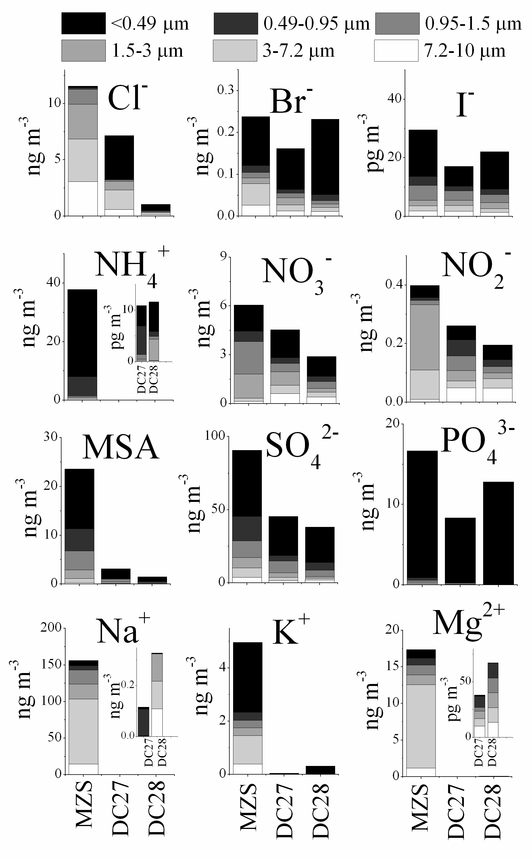
Figure 1. Average concentrations of major ions and relative particle size-distribution of aerosol samples collected at Mario Zucchelli Station (MZS) during the austral summer 2010-2011 and at Concordia Station, Dome C (DC27 and DC28) during two consecutive austral summers 2011-2012 and 2012-2013.

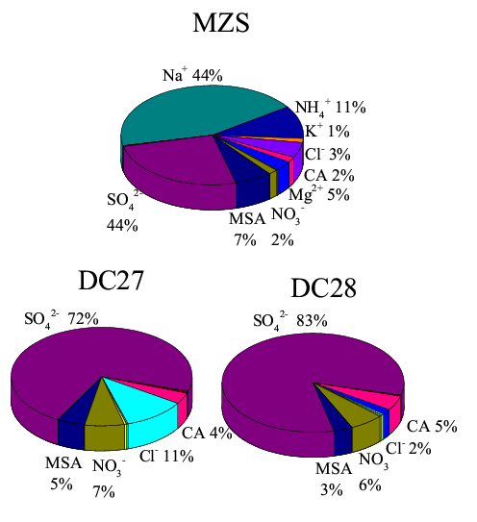

Figure 2.Percentage of ionic species on the samples collected at MZS during the austral summer 2010-2011 and over Antarctic plateau at Dome C during the austral summer 2011-2012 (DC27) and during the austral summer 2012-2013 (DC28).

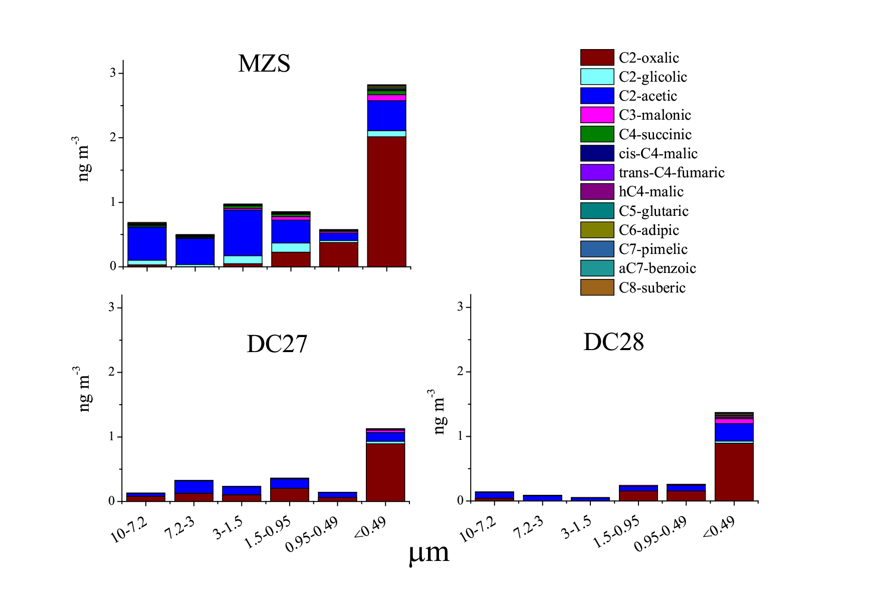
Figure 3.Particle size distribution of the mean concentration of carboxylic acids on the aerosol samples collected at MZS and over the Antarctic plateau (DC 27 and DC28).

References
Barbaro E, Kirchgeorg T, Zangrando R, Vecchiato M, Piazza R, Barbante C, Garnbaro A (2015a): Sugars in Antarctic aerosol. Atmospheric Environment 118, 135-144
Barbaro E, Zangrando R, Vecchiato M, Piazza R, Cairns WRL, Capodaglio G, Barbante C, Gambaro A (2015b): Free amino acids in Antarctic aerosol: potential markers for the evolution and fate of marine aerosol. Atmospheric Chemistry and Physics 15, 5457-5469
Becagli S, Scarchilli C, Traversi R, Dayan U, Severi M, Frosini D, Vitale V, Mazzola M, Lupi A, Nava S, Udisti R (2012): Study of present-day sources and transport processes affecting oxidised sulphur compounds in atmospheric aerosols at Dome C (Antarctica) from year-round sampling campaigns. Atmospheric Environment 52, 98-108
Blackall TD, Wilson LJ, Theobald MR, Milford C, Nemitz E, Bull J, Bacon PJ, Hamer KC, Wanless S, Sutton MA (2007): Ammonia emissions from seabird colonies. Geophysical Research Letters 34
Bliesner DM (2006): Validating chromatographic methods A Practical Guide. John Wiley & Sons, Inc.,, Hoboken, New Jersey
Cunningham WC, Zoller WH (1981): The Chemical Composition of Remote Area Aerosols. Journal of Aerosol Sciences 12, 367-384
Fattori I, Becagli S, Bellandi S, Castellano E, Innocenti M, Mannini A, Severi M, Vitale V, Udisti R (2005): Chemical composition and physical features of summer aerosol at Terra Nova Bay and Dome C, Antarctica. Journal of Environmental Monitoring 7, 1265-1274
Fiore AM, Naik V, Leibensperger EM (2015): Air Quality and Climate Connections. Journal of the Air & Waste Management Association 65, 645-685
Fu P, Kawamura K, Usukura K, Miura K (2013): Dicarboxylic acids, ketocarboxylic acids and glyoxal in the marine aerosols collected during a round-the-world cruise. Marine Chemistry 148, 22-32
Hara K (2004): Chemistry of sea-salt particles and inorganic halogen species in Antarctic regions: Compositional differences between coastal and inland stations. Journal of Geophysical Research 109
Hillamo R, Allegrini I, Sparapani R, Kerminen V-M (1998): Mass Size Distributions and Precursor Gas Concentrations of Major Inorganic Ions in'Antarctic Aerosol. International Journal of Environmental Analytical Chemistry 71, 353-372
IPCC 2007: Synthesis Report, Contribution of Working Groups I, II and III to the Forth Assessment Report of the Intergovernmental Panel on Climate Change, Intergovernmental Panel on Climate Change: Climate Change 2007, Geneva Switzerland
Jickells TD, Kelly SD, Baker AR, Biswas K, Dennis PF, Spokes LJ, Witt M, Yeatman SG (2003): Isotopic evidence for a marine ammonia source. Geophysical Research Letters 30
Johnson MT, Bell TG (2008): Coupling between dimethylsulfide emissions and the ocean-atmosphere exchange of ammonia. Environmental Chemistry 5, 259-267
Kawamura K, Ikushima K (1993): SEASONAL-CHANGES IN THE DISTRIBUTION OF DICARBOXYLIC-ACIDS IN THE URBAN ATMOSPHERE. Environmental Science & Technology 27, 2227-2235
Kawamura K, Kasukabe H, Barrie LA (1996a): Source and reaction pathways of dicarboxylic acids, ketoacids and dicarbonyls in arctic aerosols: One year of observations. Atmospheric Environment 30, 1709-1722
Kawamura K, Semere R, Imai Y, Fujii Y, Hayashi M (1996b): Water soluble dicarboxylic acids and related compounds in Antarctic aerosols. Journal of Geophysical Research-Atmospheres 101, 18721-18728
Kawamura K, Sakaguchi F (1999): Molecular distributions of water soluble dicarboxylic acids in marine aerosols over the Pacific Ocean including tropics. Journal of Geophysical Research-Atmospheres 104, 3501-3509
Legrand M, Ducroz F, Wagenbach D, Mulvaney R, Hall J (1998): Ammonium in coastal Antarctic aerosol and snow: Role of polar ocean and penguin emissions. Journal of Geophysical Research-Atmospheres 103, 11043-11056
Legrand MR, Delmas RJ (1986): Relative contributions of tropospheric and stratospheric sources to nitrate in Antarctic snow. Tellus, Ser. B 38
Legrand MR, Kirchner S (1990): ORIGINS AND VARIATIONS OF NITRATE IN SOUTH POLAR PRECIPITATION. Journal of Geophysical Research-Atmospheres 95, 3493-3507
Matsumoto K, Nagao I, Tanaka H, Miyaji H, Iida T, Ikebe Y (1998): Seasonal characteristics of organic and inorganic species and their size distributions in atmospheric aerosols over the northwest Pacific Ocean. Atmospheric Environment 32, 1931-1946
Minikin A, Legrand M, Hall J, Wagenbach D, Kleefeld C, Wolff E, Pasteur EC, Ducroz F (1998): Sulfur-containing species (sulfate and methanesulfonate) in coastal Antarctic aerosol and precipitation. Journal of Geophysical Research-Atmospheres 103, 10975-10990
Mochida M, Umemoto N, Kawamura K, Lim HJ, Turpin BJ (2007): Bimodal size distributions of various organic acids and fatty acids in the marine atmosphere: Influence of anthropogenic aerosols, Asian dusts, and sea spray off the coast of East Asia. Journal of Geophysical Research: Atmospheres 112
Morganti A, Becagli S, Castellano E, Severi M, Traversi R, Udisti R (2007): An improved flow analysis-ion chromatography method for determination of cationic and anionic species at trace levels in Antarctic ice cores. Analytica Chimica Acta 603, 190-198
O'Dowd CD, Facchini MC, Cavalli F, Ceburnis D, Mircea M, Decesari S, Fuzzi S, Yoon YJ, Putaud JP (2004): Biogenically driven organic contribution to marine aerosol. Nature 431, 676-680
Preunkert S, Jourdain B, Legrand M, Udisti R, Becagli S, Cerri O (2008): Seasonality of sulfur species (dimethyl sulfide, sulfate, and methanesulfonate) in Antarctica: Inland versus coastal regions. Journal of Geophysical Research 113
Rankin AM (2002): Frost flowers: Implications for tropospheric chemistry and ice core interpretation. Journal of Geophysical Research 107
Rankin AM, Wolff EW (2003): A year-long record of size-segregated aerosol composition at Halley, Antarctica. Journal of Geophysical Research-Atmospheres 108
Saiz-Lopez A, Mahajan AS, Salmon RA, Bauguitte SJ, Jones AE, Roscoe HK, Plane JM (2007): Boundary layer halogens in coastal Antarctica. Science 317, 348-51
Schmale J, Schneider J, Nemitz E, Tang YS, Dragosits U, Blackall TD, Trathan PN, Phillips GJ, Sutton M, Braban CF (2013): Sub-Antarctic marine aerosol: dominant contributions from biogenic sources. Atmospheric Chemistry and Physics 13, 8669-8694
Spolaor A, Vallelonga P, Plane JMC, Kehrwald N, Gabrieli J, Varin C, Turetta C, Cozzi G, Kumar R, Boutron C, Barbante C (2013): Halogen species record Antarctic sea ice extent over glacial-interglacial periods. Atmospheric Chemistry and Physics 13, 6623-6635
Spolaor A, Vallelonga P, Gabrieli J, Martma T, Bjorkman MP, Isaksson E, Cozzi G, Turetta C, Kjaer HA, Curran MAJ, Moy AD, Schoenhardt A, Blechschmidt AM, Burrows JP, Plane JMC, Barbante C (2014): Seasonality of halogen deposition in polar snow and ice. Atmospheric Chemistry and Physics 14, 9613-9622
Teinila K, Kerminen VM, Hillamo R (2000): A study of size-segregated aerosol chemistry in the Antarctic atmosphere. Journal of Geophysical Research-Atmospheres 105, 3893-3904
Traversi R, Becagli S, Castellano E, Cerri O, Morganti A, Severi M, Udisti R (2009): Study of Dome C site (East Antartica) variability by comparing chemical stratigraphies. Microchemical Journal 92, 7-14
Udisti R, Dayan U, Becagli S, Busetto M, Frosini D, Legrand M, Lucarelli F, Preunkert S, Severi M, Traversi R, Vitale V (2012): Sea spray aerosol in central Antarctica. Present atmospheric behaviour and implications for paleoclimatic reconstructions. Atmospheric Environment 52, 109-120
Wang HB, Kawamura K, Yamazaki K (2006): Water-soluble dicarboxylic acids, ketoacids and dicarbonyls in the atmospheric aerosols over the Southern Ocean and western Pacific Ocean. Journal of Atmospheric Chemistry 53, 43-61
Weller R, Woeltjen J, Piel C, Resenberg R, Wagenbach D, Koenig-Langlo G, Kriews M (2008): Seasonal variability of crustal and marine trace elements in the aerosol at Neumayer station, Antarctica. Tellus Series B-Chemical and Physical Meteorology 60, 742-752
Wolff EW, Rankin AM, Rothlisberger R (2003): An ice core indicator of Antarctic sea ice production? Geophysical Research Letters 30
Wyputta U (1997): On the transport of trace elements into Antarctica using measurements at the Georg-von-Neumayer station. Tellus B 49, 93-111
Xu G, Gao Y, Lin Q, Li W, Chen L (2013): Characteristics of water-soluble inorganic and organic ions in aerosols over the Southern Ocean and coastal East Antarctica during austral summer. Journal of Geophysical Research-Atmospheres 118, 13303-13318
Yao XH, Fang M, Chan CK (2003): The size dependence of chloride depletion in fine and coarse sea-salt particles. Atmospheric Environment 37, 743-751
Zangrando R, Barbaro E, Vecchiato M, Kehrwald NM, Barbante C, Gambaro A (2016): Levoglucosan and phenols in marine, coastal and inland Antarctic aerosols. Science of Total Environment 544, 606-616
Zhuang H, Chan CK, Fang M, Wexler AS (1999): Formation of nitrate and non-sea-salt sulfate on coarse particles. Atmospheric Environment 33, 4223-4233

