PRO-DROP AND TOPIC CONTINUITY IN ITALIAN AND MODERN HEBREW

ILARIA BACOLINI
CA’ FOSCARI UNIVERITY

This article is concerned with the interpretation and distribution of Null Subjects (NS) and silent topics in Modern Hebrew and Italian. It is widely recognized that the NS Parameter is not binary, since ‘micro-parametric’ diversifications emerge across languages, which mainly concern reference, phi features and morphological richness. The central idea is to explore the possibility of a unified explanation based on a comparative interface analysis. According to Shlonsky (2009), Hebrew lacks NSs referring to first, second and third person in the present tense. In the past and future tenses, only third person referential NSs - as opposed to first and second persons - are licensed, while expletive pro is always licit, leading to the assumption that Hebrew represents an intricate case of a semi pro-drop language. Instead I argue that pro is licensed in Hebrew by an agree relation (with a specific type of topic) only when occurring in an embedded domain. In main clauses a continuing topic is always realized by an overt pronoun. Adopting the hypothesis that overt pronouns and pros have the same function as resumptive pronouns (Frascarelli 2007), I show that an overt pronoun in Hebrew occurring in the same context where in Italian a pro would appear is a phonologically weak and destressed item. To sum up, evidence is provided that the Topic Criterion hypothesis (see Frascarelli & Hinterhölzl 2007) positively accounts for the distribution of third null pronouns not only in a pro-drop language as Italian, but also a semi pro-drop language like Modern Hebrew.
.
1. Introduction
Working within the Minimalist Program, Frascarelli (2007) proposes that the interpretation of third person null pronoun is closely linked to the realization of a specific type of topic: the Aboutness-shift Topic. According to Frascarelli & Hinterhölzl (2007), this Topic presents the function of introducing a new aboutness topic (or proposing a topic-shift) in the discourse: this pragmatic function is inherently associated with the item of which information is stored (Reinhart (1981)). From the prosodic point of view, it is signaled by a rise in the intonational contour that is aligned with the tonic vowel in its full extension and reaches its peak on the post-tonic syllable. Consider the following example provided by Frascarelli (2007: 7)

- Il materiale era tantissimo quindi all’inizio l’ho fatto tutto di corsa cercando di impiegarci il tempo che dicevate voi magari facendolo un po' superficialmente pur di prendere tutto- l’ultima unit la sto facendo l’avevo lasciata un po' da parte […]
“the material was quite a lot, so at the beginning I did it all in a rush, trying to do it in the time that you had fixed, perhaps a little superficially, so as to do everything- I’m doing the last unit now, I had put it aside before [...]”

Fig. 1: Aboutness-shift Topic in Italian

In (1) a student is speaking about the material of a language course she is attending to. At some point, she proposes a new topic, the DP l’ultima unit, and, as we can see in Figure 1, this DP “is signaled by a sharp rise on the tonic syllable - the diphthong [ju] - and likewise by a sharp fall after it”. The comment la sto facendo presents a low tone without particular peaks. Indeed, an intonational break after l’ultima unit signals the prosodic boundary between the Topic in question and the rest of the sentence. To resume, this topic is named Aboutness-shift Topic in Frascarelli & Hinterhölzl (2007) (from now onwards F&H 2007) as it combines its [+aboutness] feature with a topical shift in the discourse. Actually, the authors show the existence of different types of topic located in the C-domain and propose a Topic Hierarchy (cf. 2) based on a strict correlation between discourse functions of topics and their grammatical properties:

(2) Topic Hierarchy:
_{CP}[A-Top (Topic Shift [+aboutness]) > C-Top (Contrastive Topic) > G-Top (Familiar Topic)]

In particular, when the [+aboutness] feature is associated with given information and a low tone, a Familiar Topic is introduced for topic continuity (mainly in German - Left Periphery) or for the function of afterthought (Right Periphery). Whereas, when a Topic proposes a contrast between its comment and one or more other Topics, associated with an ascendant intonational contour, Contrastive Topics are realized
- THE IDENTIFICATION OF NULL SUBJECTS
  - The Silent Topic in Italian
As already mentioned in the foregoing section, the Aboutness-shift Topic is the constituent which identifies an argument pro, that is, provides a referential value for a third NS (through Agree). Indeed, pros have the same function as clitic/weak pronouns, it is to say, they serve as resumptive pronouns in Italian base generated topic constructions:

(3) [CP [{Topic di Aboutness-shift} . . . [IP [pro/weak pronoun…]]]]
AGREE
Moreover, Frascarelli (2007) points out that the Aboutness-shift Topic can also be silent. In fact, it is realized only when speakers want to propose a topical shift. In other words, if the current Aboutnes-shift Topic remains as “what a sentence is about” in the following sentences, then it presumably will be maintained as silent (cfr. Frascarelli 2007: 32):

(4) (a) Leo_{k}, onestamente, ha molto successo con gli studenti e [ogni studente]_{j} pensa che pro_{k/*j} è un genio!
(b) Leo_{k}, onestamente, ha molto successo con gli studenti e _{CP}[[_{A-Top Nullo} <Leo_{k}>]
Leo_{k} is very successful with students and [every students]_{J} thinks he_{k/*j} is a genius”
In (4a), it is shown that pro cannot be interpreted as [ogni studente], even though it is the nearest constituent that may act as an antecedent. Pro is necessarily identified as coreferent with the current topic Leo. (4b) illustrates Frascarelli’s idea that “the DP Leo is established as the Aboutness-shift Topic in the matrix clause and kept silent in the second conjunct”. According to the Topic Criterion, every sentence must have an [+aboutness] feature and it is licit to assume that the highest Spec,CP position is always occupied to identify this feature. Such a position indeed corresponds to the Aboutness-shift Topic position, on which the realization of NS in a pro-drop language as Italian depends. Lastly, when the Topic in question is silent, a familiar Topic (acting as a low copy of it) is necessary used for topic continuity in a language like German, but not obligatory in Italian. In spite of the fact the author first proposes the Topic Criterion for pro-drop languages like Italian, I will show that it is valid also for a partial pro-drop language such as Modern Hebrew.
2.2 The NS Parameter in Modern Hebrew
Hebrew represents an interesting case of semi pro-drop language that allows the dropping of the subject in some contexts not well-defined. Chomsky himself affirms that “Hebrew is another case” (1982: 241). In other words, the distribution of NSs appears to be complex. On the other hand, Shlonsky (2009) proposes the following picture to account for the distribution on NSs in Modern Hebrew:

(a) the expletive pro is always licensed;
(b) first and second person NSs simply do not exist, because there are some “clitic subjects” incorporated to the verb, that make the [Spec,IP] position appear empty;
(c) as for third person NSs, there is no difference between non-referential and referential covert subjects. However, the latter may appear but it “must be controlled” by the matrix subject, that can make it capable of reference. This can occur only in the past and future tense, because:
“present tense verbs in Hebrew are participles, not only morphologically but syntactically. [..] The Hebrew participle lacks a specification for [person] not because a [person] slot happens to be lexically absent from its phi set, but because there is a conflict between its nominal nature and the possession of such a slot” (Shlonsky 2009: 20).
I will focus on point (c), and present an alternative analysis.

3. THE ANALYSIS OF DATA
3.1. Method
An online test has been created using Google Drive in order to reach Hebrew native speakers who were in Israeli. This grammatical test contained 12 sentences preceded by a communicative situation (a context). Informants were asked to express their grammatical judgment for each sentence, specifying if sentences were grammatical (yes), ungrammatical (no) or marginal (??). In case they chose the last option, a further question asked them to provide a reason for the marginality. I have collected 22 fully answered tests. Participants are between the age of 23 to 55 years old and educational level was at least BA degree.
3.2. The Topic Criterion hypothesis in Modern Hebrew
The corpus consists of elicited sentences, grammatical judgments from the test and passages extrapolated from the Harry Potter novel (the translated version in Modern Hebrew). In particular, working with informants, I could collect data in which NSs are identified by the local Aboutness-shift Topic, in line with the Topic Criterion hypothesis. Consider the following example:

(5) [Ha-professor] hekhzir et ha-mivkhanim
the-professor take bake.PST-3MS ACC the-essays
metukanim, [ha-assistent] shelo natan otam
corrected the-assistant 3MS-GEN distribute.PST-3MS 3PL-ACC
aval hu itragez mipneishe pro
but he get angry.PST-3MS because
lo ratsa latet otam be-oto-ha-rega
NEG want.PST-MS give.INF 3PL-ACC in-this-in-moment
“The professor has corrected the essays, his assistant has distributed them, but he got angry because pro did not want that pro had immediately distributed them”

In (5), a NS is used in the underlined sentence and it has been accepted by all informants: the null pronoun can be identified because the reference is assigned by the current Aboutness-shift Topic (Frascarelli 2007), and the sentence obtains the Full Interpretation (Chomsky 1993). Let us analyse it in more detail. Firstly, the speaker introduces the referent haprofessor (“the professor”), afterward another referent appears, ie., haassistent (“the assistent”); the latter presents a rise in the intonation contour that “is aligned with the tonic vowel in its extension and reaches its peak on the post-tonic vowel” (Frascarelli and Hinterhölzl 2007) (see Figure 1). It qualifies as Aboutness-shift Topic. In other words, since the speaker wants to say something more about the first referent, he proposes a conversational shift, by using the strong pronoun hu (in bold). This pronoun now is the current Topic of the discourse and, as the consequence, it is also the antecedent that identifies the argument pro in (5).

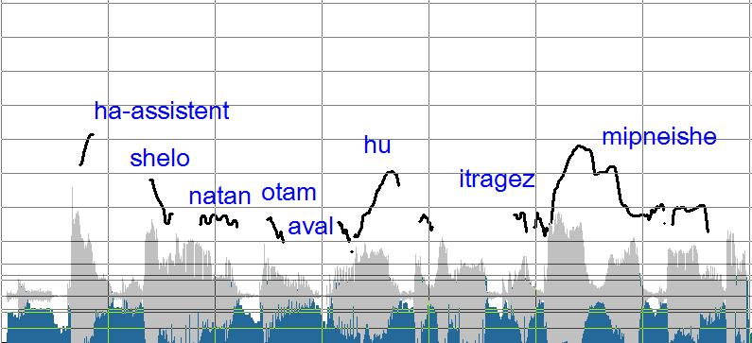
Fig. 2: Aboutness-shift Topic in Hebrew

As Figure 2 shows, the prosodic analysis confirms our analysis: both the DP haassistent that the pronoun hu have the same prosodic structure of the Aboutness-shift Topic, that is, a rising intonational contour. Let us now consider the following example from Shlonky (2009: 13):

(6) hem₁ kivu še pro_{1/*2} yelxu habayta mukdam
they hope.PST-3PL that go.FUT-3PL home early
“they hoped that (they) will go home early”

According to the author, a null pronoun is possible in (6), if it is correlated to the initial DP (ie, hem) which is the subject of the matrix clause. However, the DP in question could also be the topic of the sentence. Furthermore, it is worth noting that it might be a strong pronoun (ie., it may propose a shift of the topic of the conversation), or a weak pronoun (i.e., a resumptive pronoun). As a matter of fact, analyzing a sentence out of context can pose comprehension problems. Thus, imagine a context where two referents, call them Mary and Luis, are being discussed. One of the interlocutors utters (7B) as a contribution to the discussion:

(7) A: Yesterday at the party it was very obvious that [Mary e Luis]₁were in a hurry to leave! At some point [my parents]_{z} have thought that they wouldn’t even have waited for the cake cutting.
B: [in fact]…hem₁ kivu še pro₁ yelxu
they hope.PST-3PL that go.FUT-3PL
habayta mukdam
home early
“they hoped that (they) will go home early”
`
In (7), speaker A first wants to call the attention on Mary and Luis. Then another couple of referents are introduced, i.e., my parents. However, speaker B wants to say something more about the first referents, and he proposes a conversational shift by using the strong pronoun hem. This analysis is confirmed by the prosodic interface: as it can be seen in Figure 3, the pronoun under discussion presents a rise tone and reaches its pick on the post-tonic syllable, therefore, it qualifies as the Aboutness-shift Topic.

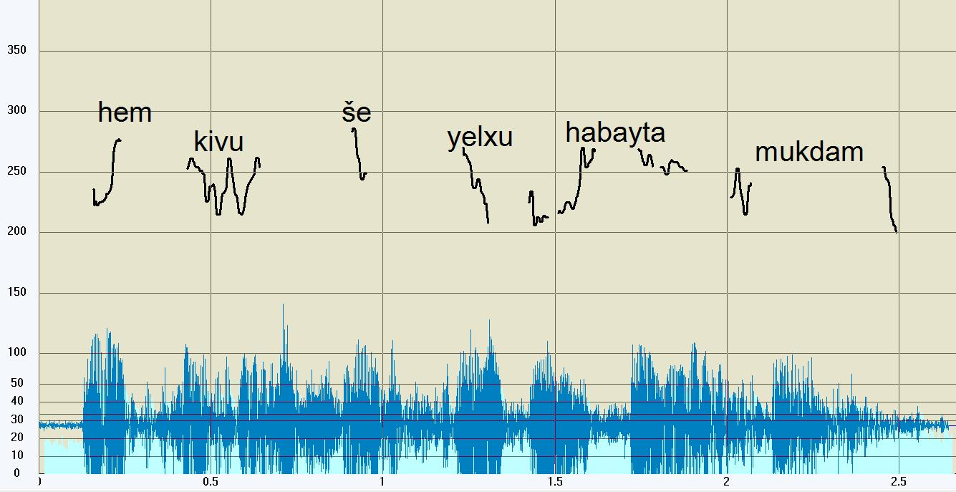
Fig.3: rise intonational countor of the pronoun hem in (7)

As counterproof, let observe the prosodic structure of the DP hem in a context where it has a different function , that is, maintaining the topic continuity:
(8) (context: some students are queuing in front of Students Office. The estimated waiting time is 1 hour):
A: [Giulia, Emma e Carlo]₁ should be here. They had to demand their academic degree, but I can’t see them with all these people…What you think? Could they have already done?
B: [uhm.. actually]… hem₁ kivu še pro₁ yelxu habayta muda
“they hoped that (they) will go home early”

In (8) the topic of the discourse is the DP Giulia, Emma e Carlo which remains the current Topic also in the following sentences. In other words, it is the constituent that can provide a referential value for the null pronoun. In this case, speaker B uses the pronoun hem in order to maintaining the topic continuity. In fact, it presents a low tone without any intonational peaks (Figure 4), thus it qualifies as Familiar Topic:

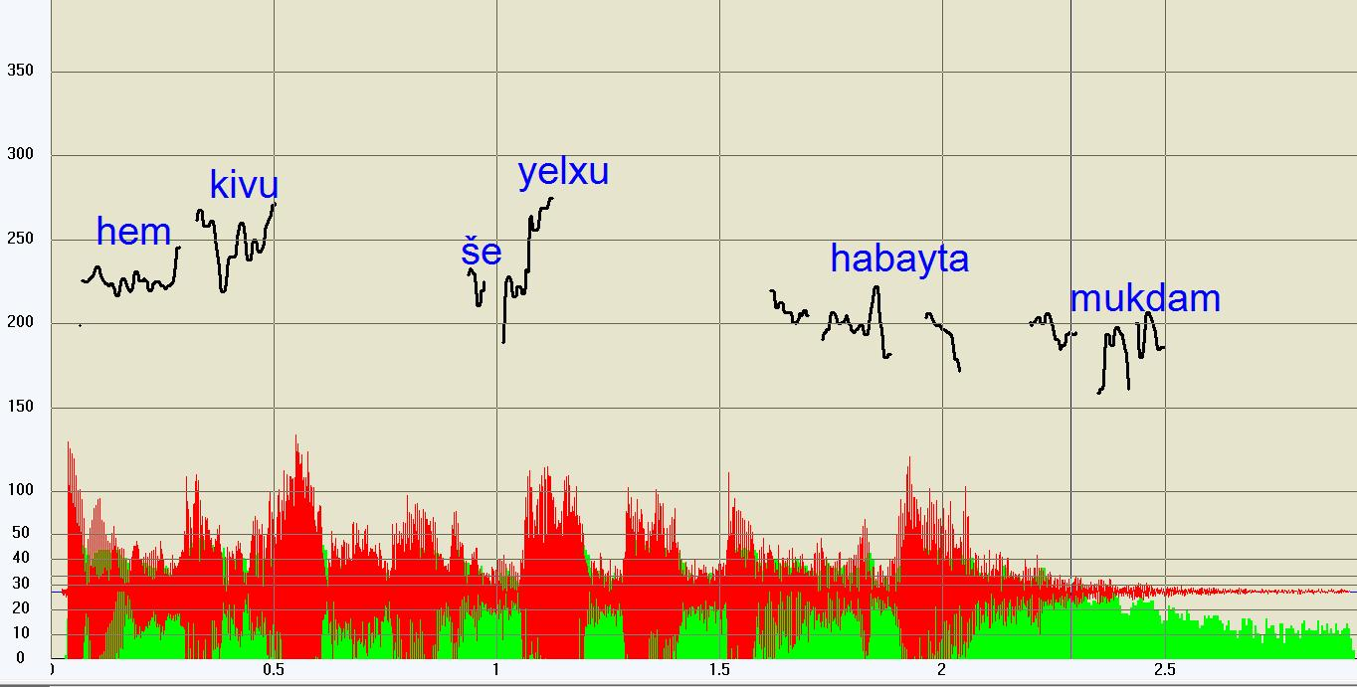
Fig.4: prosodic structure of the underlined sentence in (8)
To conclude, these first data show the applicability of the Topic Criterion even in Modern Hebrew. To put it differently, a null/weak pronoun is realized in the same context where it would appear in Italian too.
3.3. Third null pronouns in Hebrew present tense: a comparison with Italian
I will now discuss syntactic and prosodic proprieties of collected data where NSs appear in cases excluded by Shlonsky (2009), mainly in present tense:

(9) A: Ma im Gavriel?.
what with Gavriel
“What’s about Gavriel?”
B: Ah Gavriel! hu amar še pro mevale
ah Gavriel! he say.PST-3SM that enjoy.PRES.PART-SM
mehud ve pro rotse le-ishaver
a lot and want-PART.PRES-SM INF-stay
sham
there
“Ah Gavriel! he said that he is having fun and that he wants to stay there”

Speaker A asks news about Gavriel, introducing this referent in the discourse. Speaker B uses a weak pronoun (underlined) to provide the answer and only then NS_{s} are used (in bold). By contrast, only NSs appear in Italian language (10B):

(10) B: Ah Gabriele! pro ha dett-o che pro si sta
ah Gavriel! say.PST-3S that RIFL be.PRES-3S
divertendo molto e vuol-e riman-ere
enjoy-GER a lot and pro want.PRES-3S stay-INF
lì
there

However, the dropping of the subject in Modern Hebrew can present difficulties in some contexts, as the following:

- [context: a mom is making dinner, at some point turning towards her husband, who is playing video games, and looking at her unsupervised child, says:]
Mom: Takshiv hu omer she pro roce
Listen he say.PRES-3S that want.PRES-3S
lishtot
INF.drink
“Listen! He is saying that (he) wants to drink”

The NS in (11) is followed by a present tense verb (i.e., roce “wants”). However, the grammatical judgements are unexpected: this sentence has been rejected by 45.5% of informants, 22.7% have accepted it and 31.8% still accepts it, but marginally. In particular, although the topic of the discourse in (11) is present in the extralinguistic context (the child), the speaker choses to introduce it in the linguistic context by using the pronoun hu (in bold). Then, a pro appears. I believe that the 54.5 % of informants who consider this sentence grammatical or marginal should be noteworthy and investigated. To some extent, it has to deal with the partial-pro drop nature of this Semitic language. In the light of this, we assume that the Left Periphery in Hebrew is “more limited” compared to languages like Italian. In fact, when the local Aboutness-shift Topic has been just introduced in the discourse, a NS is the only possible choice if one wants to maintain as the current topic the topic just proposed:
(12) (previous context: Scrimgeour shook it for a moment, while his gaze ran through the room [..] “I prefer not to be interrupted” he said, “nor spied” he added, pointing his wand at the windows. Tends were closed immediately. “Well, then, [..] we need you safe”)
[rosh ha-memshala] natakh et atznò
head the-government rose.PST-3MS ACC PRO.RIFL-3S
le-govho ha-merabi ve- pro amar “ani samekh
of-stature the-height and say-PST-3MS I satisfied
ve-merutze
and-happy
“The Prime Minister rose to his full stature and pro said: “I am definitely satisfied”

The current topic in (12) is rosh hamemshala. As the previous context shows, it has been introduced to propose a conversational shift (the current Topics was Scrimgeour). Now that the local topic has been established, a NS is used in the coordinative sentence. I would like to conclude by outlining the Left Periphery of sentences like (10) and (11):

(13) [_{CP1} “activated” A-Top..[_{CP2} {null A-Top}..[_{IP} hu.. [_{CP2} ..{null A-Top}..[_{IP} pro

The “activated” Aboutness-shift Topic (A-Top) in (13) has been introduced in the previous context (CP1), thus it is silent in the following sentences (CP2 and CP3). In order to establish the linking between the null Aboutness-shift Topic and the subject in IP, an overt pronoun should be used. Once this linking is done successfully, the realization of a null pronoun in the following sentence (CP3) does not affect the FI.
4. Conclusion
In the light of what is claimed here, I argue that pro is licensed in Hebrew by an agree relation (with a specific type of topic) only when occurring in an embedded domain or adjunct sentences. In main clauses a continuing topic (cf. Frascarelli & Hinterhölzl 2007) is realized by an overt pronoun. Adopting the hypothesis that overt pronouns and pros have the same function as presumptive pronouns (Frascarelli 2007), I assume that an overt pronoun in Hebrew occurring in the same context where in Italian a pro would appear is a phonologically weak and destressed item. Furthermore, I would like to propose a Topic Criterion for Hebrew:

(14) Topic Criterion in Hebrew
A third NS is identified by the current Aboutness-shift Topic, on the condition that the latter is not silent and the NS is realized in a secondary clause (cf. 7; 11; 12). If the current topic is silent, a weak pronoun in [Spec,IP] is generally required to activate the [+aboutness] feature (cf. 8; 9; 10). Once this linking between the overt pronoun and the silent topic is successfully established, the realization of a NS is possible. Therefore, the Aboutness-shift topic cannot be maintained as the current topic across utterances.
It can be represented as in (15):
(15) S₁ Aboutness-shift, S₂ hu, S₃ hu

S₃ pro

In (15), the current Aboutness-shift Topic has been already established (S₁). It assigns the reference to the overt pronoun by the Agree relation (S₂); once this relation is defined, a pro can be licensed if it presumably is in an embedded clause (S₃). Otherwise, another overt pronoun is used. In this sense, I believe Hebrew is a pro-drop language.

References
CHOMSKY, Noam. (1982): Some concepts and Consequences of the theory of Government and Binding, Linguistic Inquiry Monograph Six. Cambridge: The MIT Press.
CHOMSKY, Noam. (1995): The Minimalist Program. Cambridge, Mass.: MIT Press.
CINQUE, Gugliermo. (1999): Adverbs and functional heads: A cross-linguistics perspective. NewYork: Oxford University Press.
FRASCARELLI, Mara. (2007): Subjects, topics and the interpretation of referential pro: An interface approach to the linking of (null) pronouns. Natural Language and Linguistic Theory 25, 691-734.
FRASCARELLI, Mara. and Roland HINTERLHOLZL. (2007): Types of Topics in German and Italian. In K. Schwabe & S. Winkler (Eds.), On Information Structure, Meaning and Form, 87-116. Amsterdam/Philadelphia: John Benjamins.
HOLMBERG, Anders. (2010): Null Subject Parameter. In T. Biberauer, A. Holmberg, I. Roberts & M. Sheehan (Eds.), Parametric variation: Null subjects in minimalist theory, 88-124. Cambridge: Cambridge University Press.
REINHART, Tanya. (1981): Pragmatics and Linguistics: An Analysis of Sentence Topics. Philosophica 27, 53-94.
SHLONSKY, Ur. (1990). Pro in Hebrew subject inversion. Linguistic Inquiry 21, 263-275.
SHLONSKY, Ur. (1997): Clause Structure and Word Order in Hebrew and Arabic. An Essay in Comparative Semitic Syntax. New York: Oxford University Press.
SHLONSKY, Ur. (2009). Hebrew as a partial null-subject language. Studia Linguistica, 63(1), 133-157.
SIGURDSSON, Halldór. Ármann. (2011): Conditions on Argument Drop. Linguistic Inquiry, 42, 267-304.

Cf. Reinhart (1981).
For further details, see the analysis proposed in Frascarelli (2007) where it is shown that strong pronouns have the function of proposing a shift in the conversation, when they present specific international proprieties.
To be more precise, “preverbal ‘subjects’ are merged as (Aboutness-shift) Topics in the C-domain and provide a referential value to a NS sitting in argument position” Frascarelli (2007: 22).
We asked our informants to read the sentences under discussion preceded by the contexts reported here.
We have asked to three Italian native speakers to judge the sentence in (10) and we can confirm that the use of the three pros is not optional. However, a weak pronoun (covert) – as in Hebrew - is possible, but it is not the immediate choice. Therefore, no relevant differences emerge since null and weak pronouns have the same function (see Frascarelli 2007).
Using Holmberg’s terminology.

