Influence of in-port ships emissions to gaseous atmospheric pollutants and to particulate matter of different sizes in a Mediterranean harbour in Italy

E. Merico ^{1, 2}, A. Donateo ¹, A. Gambaro ^{2, 3}, D. Cesari ¹, E. Gregoris ^{2, 3}, E. Barbaro ^{2, 3},
A. Dinoi ¹, G. Giovanelli ⁴, S. Masieri ⁴, D. Contini ^{1, *}

¹ Institute of Atmospheric Sciences and Climate, ISAC-CNR, Str. Prv. Lecce-Monteroni km 1.2, 73100 Lecce, Italy
² Department of Environmental Science Informatics and Statistics, Ca’ Foscari University of Venice, Via Torino 155, Venice Mestre, Italy
³ Institute for the Dynamics of Environmental Processes, National Research Council, Via Torino 155, Venice Mestre, Italy
⁴ Institute of Atmospheric Sciences and Climate, ISAC-CNR, Via P. Gobetti 101, 40129 Bologna, Italy

* Corresponding author
Daniele Contini
Tel. +39-0832298919
Fax +39-0832298716
E-mail: d.contini@isac.cnr.it

Abstract
Ship emissions are a growing concern, especially in coastal areas, for potential impacts on human health and climate. International mitigation strategies to curb these emission, based on low-sulphur content fuels, have proven useful to improve local air quality. However, the effect on climate forcing is less obvious. Detailed information on the influence of shipping to particles of different sizes is needed to investigate air quality and climate interaction. In this work, the contributions of maritime emissions to atmospheric concentrations of gaseous pollutants (NO, NO₂, SO₂, and O₃) and of particles (sizes from 0.009 µm to 30 µm) were investigated considering manoeuvring (arrival and departure of ships) and hotelling phases (including loading/unloading activities). Results showed that the size distributions of shipping contributions were different for the two phases and could be efficiently described, using measured data, considering four size-ranges. The largest contribution to particles concentration was observed for D_{p}<0.25 µm, however, a secondary maximum was observed at D_{p}=0.35 µm. The minimum contribution was observed at D_{p} around 0.8-0.9 µm with a negligible contribution from hotelling for size range 0.4-1 µm. The comparison of 2012 and 2014 datasets showed no significant changes of gaseous and particulate pollutant emissions and of the contribution to particle mass concentration. However, an increase of the contribution to particle number concentration (PNC) was observed. Results suggested that harbour logistic has a relevant role in determining the total impact of shipping on air quality of the nearby coastal areas. Additionally, future policies should focus on PNC that represents an important fraction of emissions also for low-sulphur fuels. DOAS remote sensing proved a useful tool to directly measure NO₂ and SO₂ ship emissions giving estimates comparable with those of emission inventory approach.

Keyword: Particle number concentration, ships emissions, DOAS, size distributions, shipping impacts

- Introduction
Harbours are important transport hubs contributing to social and economic development of coastal areas with an impact on both commerce and tourism. However, they are also an environmental burden, with potential effects on health and climate. The main pollutants emitted by ships are nitrogen oxides, sulphur oxides and particulate matter that represent, globally, 5-7 Tg/year, 4.7-6.5 Tg/year and 1.2-1.6 Tg/year respectively (Healy et al., 2009). It is estimated that about 3.3% of global CO₂ emissions and about 2% of global black carbon emissions are produced by shipping (Lack et al., 2012). Nearly 70% of the ship emissions occur within 400 km of land (Eyring et al., 2005). In-port ship emissions represent only a small fraction of the global emissions associated with shipping (Dalsøren et al., 2009). However, they can have important environmental effect on coastal regions in Europe, Asia and USA, which often have harbours located near urban and industrial centres (Pandolfi et al., 2011; Contini et al., 2011; Bove et al., 2014; Cesari et al., 2014; Donateo et al., 2014; Viana et al., 2014). In general, ship emissions will increase in next 10-40 years due to expansion of the international trade (Eyring et al., 2005). International strategies for mitigation of emissions, in harbour areas and in specific zones (SECA –Sulphur Emission Control Area), rely on the use of low-sulphur content fuels as agreed in 2008 in the new IMO (International Maritime Organization) provisions (EU-Directive 2005/33/CE). Reduction of NO_{X} emissions from marine diesel engines are also included in the regulations, but only for new ships with limits depending on speed and installation year. Therefore, the impact of regulation on NO_{X} is limited at present and will likely continue to be small in the near future (EEA, 2013). In addition, the EU-Directive 2014/94/EU on the deployment of alternative fuels infrastructure could have beneficial effects on shipping emissions in the next 10 years. In Mestl et al. (2013) an analysis of the benefits of decreasing sulphur content in ships fuels (from 4.5% to 3.5%) on global average concentration of SO₂ was presented. Results indicated that this was effective in reducing maximum sulphur concentrations rather than average concentration. There are evidences that this strategy brought to a reduction of SO₂ concentrations at local scale in some European harbours (Schembari et al., 2012) and in harbours along the California coastline (Tao et al., 2013). Recent studies showed that low-sulphur fuels could reduce the shipping contribution to primary (i.e. particles directly emitted at the source) PM_{2.5} at local scale (Contini et al., 2015) but with limited effects on metals and PAHs concentrations (Gregoris et al., 2015).
Heavy fuel oil (HFO) and cleaner diesel fuel shipping emissions have strong biological effects on human lungs (Oeder et al., 2015). However, several studies, done in different areas, showed that low-sulphur fuels could significantly reduce premature deaths associated with shipping (Winebrake et al., 2009; Viana e al., 2015; Broome et al., 2016).
The effect of low-sulphur fuels on climate is somewhat more complicated because of the simultaneous releases of pollutants having positive (CO₂, black carbon) and negative (SO₂) radiative forcing (RF). NO_{X} emission has both positive RF due to O₃ formation and negative RF due to enhancement in CH₄ loss. The net balance on short term is a negative RF, around -0.4 W/m² in 2005 (Eyring et al., 2009), however, on long term, the accumulation of CO₂ due to slow removal is expected to turn the cooling effect to a warming effect. Projections indicate that this change from negative to positive RF will accelerate with reduction of SO₂ emissions (Fuglestvedt et al., 2009).
To understand the complicated interaction between air quality and climate of this source and to investigate possible future scenarios for knowledge-based integrated policies, different from SO₂ reduction, it is necessary to have detailed information on the impact of low-sulphur fuels on gaseous pollutants and on particles of different sizes from ultrafine to coarse particles.
Detailed studies of size distributions of ship emissions are still scarce and most of them investigated particles up to the accumulation mode (diameter, D_{p}<0.5-0.6 µm) in ships plumes during navigation, in harbour or directly in engine emissions using test rigs. A bimodal shape in number size distributions (PNSD) of ship emissions was observed in several studies on different engines and ships with a first mode at 0.04-0.06 µm and a second mode at 0.1-0.2 µm (Kasper et al., 2007; Petzold et al., 2008; Kivekäs et al., 2014; Pirjola et al., 2014). A single mode for PNSD was observed in Gothenburg (Scandinavia) around 0.035 µm (Jonsson et al., 2011). An additional mode in nucleation range (around 0.01 µm) was observed in the ECA area at the banks of Elbe in Germany (Diesch et al., 2013). Particles with D_{p}<0.3 µm dominates ship emissions (Petzold et al., 2008; Diesch et al., 2013). Larger particles are more difficult to be detected and differentiated from ambient concentration by counting methods because even if they dominate mass size distribution (PMSD), they are relatively few in numbers (Fridell et al., 2008). For example, the mass concentration of particles with D_{p}<0.15 µm accounted for about 1-10% of the typical contribution of ship emission to PM_{2.5} (Kivekäs et al., 2014). Analysis of PMSD of ship emissions indicated a bimodal shape with a first mode located around 0.4-0.5 µm and a coarse mode at 7-10 µm (Lyyranen et al., 1999; Moldanovà et al., 2009) ; a third mode around 0.1-0.2 µm was found in Fridell et al. (2008). Murphy et al. (2009) observed an important contribution to PMSD of particles up to 6 µm.
Some of the variability observed in the typical size of the different modes could be related to the temperature of exhausts or to the aging of the plume. Little information regarding the variability of size distributions of emitted particles as a function of the sulphur content in fuels is available, especially for the coarse fraction, because most of the available studies are limited to HFO. The available information shows that sulphur content influences the size distribution of emitted particles (Kasper et al., 2007; Fridell et al., 2008). A comparison of emissions using HFO and MGO (marine gas oil) showed that particulate mass emissions were generally higher for HFO, however, for small particles (D_{p}<0.3-0.4 µm) the opposite trend was observed (Winnes et al., 2009). Comparison of emissions with four different fuels showed that particle emissions are larger, both in number and in mass, using HFO than using distillate fuels with lower sulphur content and the modes in the PNSD are shifted to larger diameters (Anderson et al., 2015).
In this work, an analysis of shipping contributions to atmospheric concentrations of gaseous pollutants and particles of different sizes (0.009-30 µm) was performed considering manoeuvring (arrivals/departures of ships) and manoeuvring+hotelling phases (thereby including time at berth and loading/unloading activities). Measurements were taken in Brindisi, an Adriatic Sea harbour (south-eastern Italy), after the enforcement of the low-sulphur EU-Directive (2005/33/CE) in European harbours. Shipping contributions were evaluated using high temporal resolution measurements to individuate and characterize the plumes released by ships. The primary shipping contributions to particles of different sizes were analysed and correlated with the contributions to gaseous pollutants. Differences in the size distributions of the contributions during manoeuvring and hotelling phases are discussed. The emission inventory results and the contributions of shipping to particle concentrations in summer 2012 and summer 2014 were compared and discussed. The good agreement between DOAS (Differential Optical Absorption Spectroscopy) measurements and emission inventory analysis suggests that remote sensing could be an efficient tool for direct measurement of NO₂ and SO₂ ships emissions.

- Methodology
2.1 Measurement area and emission inventory
The measurement area was located near the town of Brindisi (88,500 inhabitants) in south-eastern Italy (Fig. 1). The area includes three thermo-electric power plants, a large industrial zone, and an international airport (3 km NNE of the urban area). The harbour area, located E of the city, is divided in three zones. The internal zone (700,000 m², 2 km of docks) dedicated to tourist activities, the intermediate zone (1,200,000 m², 3 km of docks) dedicated to commercial ships, and the external zone dedicated to the traffic of coal-ships, bulk carriers and small general cargo. Harbour has a yearly traffic of more than 9.5 Mtons of goods, over 520,000 passengers and over 175,000 vehicles (source: Brindisi Port Authority).
The emission inventory, available from the Regional Agency for Environmental Protection (ARPA Puglia), was developed on the basis of the INEMAR database, produced by a consortium of Italian regions. The estimates were computed according to SNAP nomenclature (activity typology) and fuel type, based on the Corinair methodology (EEA, www.eea.europa.eu). The approach was mainly bottom-up and partially based on activity indicators and emission factors (diffuse sources and activities). Regarding shipping emissions, a specific analysis at municipality level (high resolution) was performed during this work for the year 2010 taking into account the 2005/33/EC Directive regarding use of low-sulphur fuels that was enforced in Italy on 01/01/2010. Calculations were done using the database of ship movements from Port Authority (2294 ships for 2010) using the Emission Inventory Guidebook (EMEP/EEA, 2013). The database included the arrival and departure time of each single ship, the typology of ship and its gross tonnage. Emissions during hotelling and manoeuvring phases were calculated separately, for each ships, using six categories: cargo (16.7%), passengers and Ro-Ro (50.0%), fishing boats (6.8%), tanker (20.4%), cruise (1.7%), and other (4.4%). Emission factors (kg/ton) used for NO_{X}, NMVOC, PM and CO are those proposed by EMEP/EAA for different combinations of engine types (gas and steam turbines, diesel engines at low, medium and high speed) and different fuels (HFO, Marine Diesel Oil (MDO), and MGO). Given the absence of detailed specification of the engine and fuel type used, the statistical distribution of the world fleet in 2010 was used (EMEP/EEA, 2013). Emission factors for SO₂ were calculated as EF = 20xS, where S was the percentage of sulphur by mass in the fuel. Uncertainties on emission factors are generally between 20% and 50% for the different pollutants (Cooper et al., 2004; ENTEC, 2002). Other uncertainties are related to ship traffic details, engines typologies, and fuels used. Considering that errors are random, some under-estimations could be balanced by other over-estimation so that a reasonable value of 30% was assumed as uncertainty as done in Broome et al. (2016).
Yearly shipping emissions were compared with road traffic emissions at municipality level in Fig. 2. Shipping represented 23% of total emissions of PM_{2.5}, 9% of NO_{X}, and 1% of SO₂. Maritime emissions were comparable with those of road transport, especially for PM and NO_{X}. Hotelling phase constituted over 90% of the estimated emissions, except for SO₂ for which the use of low-sulphur content fuel (limit at 0.1% in mass) during hotelling reduced the impact of shipping at berth (45% of total emissions).

2.2 Measurement campaign and instruments used
A mobile laboratory was used inside the harbour area (40°38′43.32″ N–17°57′36.39″ E) to perform an intensive observation period from 27/06/2014 to 13/10/2014. The site was facing (50 m from the water) the harbour water and ships docks. The mobile laboratory was equipped with a three-dimensional ultrasonic anemometer (R3, Gill Instruments), at 10 m above the ground on a telescopic mast, and a slow response thermo-hygrometer Rotronic MP100A (Campbell Scientific) to measure relative humidity (RH) and air temperature. Particle concentrations were measured using a condensation particle counter (CPC, Grimm Aerosol Model 5.403, 1 Hz), for total particle number concentration (PNC), an optical particle counter (OPC, Grimm 1.109, 31 channels) for PNSD and PMSD (1 minute resolution), and a fast-response (1 Hz) optical detector pDR-1200 (Personal Data logging Real-time Aerosol Monitor, by Thermo Electron Corp., Franklin, MA) to measure PM_{2.5} concentration (Donateo et al., 2014).
Aerosol was sampled through a 50 cm long sampling inlet using a flow rate of 30 l/min. A portion of 1.5 l/min of the main flow was injected into the CPC through a 50 cm long conductive silicon tube and a diffusion dryer (silica gel cartridges) to reduce water vapour concentration before the CPC. Particle losses were calculated using the formulation reported in Hinds (1999). The total counting efficiency was calculated as the product between the penetration factor and the counting efficiency of the CPC obtained from Heim et al. (2004). The cut-off diameter (50% efficiency) was 9 nm, thereby the system was measuring PNC in the range 0.009–1 µm (the latter is the upper limit of the CPC). The OPC used to measure PNSD (size range 0.25-32 µm, sizes given as optical equivalent diameter) was located in an outdoor box above the roof of the mobile laboratory and air was sampled (1.2 l/min) through a 50 cm long tube with a rain protection. The optical detector pDR-1200 was also located on the roof of the mobile laboratory in an outdoor box at the same height as the OPC.
Gaseous concentrations of O₃, NO, NO₂, NO_{X} and SO₂ were measured with a temporal resolution of 5 minutes. O₃ was measured using a Teledyne-API (400E analyzer); NO, NO₂, and NO_{X} with a Teledyne-API (200E analyzer); SO₂ with a Teledyne-API (M100E analyzer). These detectors were calibrated at the beginning of the measurement campaign and regular zero and span checks were performed every 2-3 days.
A videocamera collected photos (every 30s) to monitor departure/arrival of ships and vehicles passing in the area facing the dock. The complete dataset of ship traffic obtained from the Port Authority of Brindisi was synchronized with concentrations measurements using the videocamera images.
PM_{2.5} daily samples were also collected, for calibration purposes, on Teflon substrates (diameter 47 mm) using a sequential low-volume (2.3 m³/h) sampler (Zambelli Explorer plus). PM_{2.5} on collected filters was determined by gravimetric analysis using a microbalance (Sartorius Cubis MSA6.6S, sensitivity 1 μg).
An UV-Vis remote sensing DOAS system, developed at ISAC-CNR, was used to directly measure the flow-rate-emission (FRE) of NO₂ and SO₂ of ships in the harbour area (Masieri et al., 2009). The system included two parts: the rotating platform SODCAL (Scanning Optical Device Collecting Atmospheric Light), based on a mirror objective with a diameter of 60 mm resulting in a field-of-view of 1.5°, connected via a quartz optical fibre to the second part of the instrument that is the TROPOGAS spectrometer. The FRE of NO₂ and SO₂ of ships were measured using the approach developed in Premuda et al. (2011). Specifically, sunlight scattered radiation was used to retrieve the slant column densities (SCDs) from oblique measurements along a vertical plane intersecting the ship plume using different elevation starting from an elevation of 45° continuing down at steps of 5° and increasing the number of positions next to the horizon. Measured wind velocity and direction was used in the algorithm for evaluating FRE. Two spectral intervals were used: 308-328 nm for SO₂ and 436-460 nm for NO₂. The set of oblique measurements were performed during the day from one hour after sunrise to one hour before sunset. Outside this period, the FRE were estimated using diurnal measurements and the database of ship traffic. Uncertainties of estimated emissions were about 30% for SO₂ and 20% for NO₂ (Premuda et al., 2011). Results will be compared (Section 3.2) with those obtained in a previous measurement campaign done in the same site with the same mobile laboratory between 10/06/2012 and 22/10/2012. The main differences was that in the 2012 measurement campaign gaseous pollutants concentrations and particle size distributions were not measured (Donateo et al., 2014).

  - Calculation of ship traffic and harbour-related activities contributions
During the measurement campaign, the average daily gravimetric PM_{2.5} concentration was 12.7 µg/m³ (median 11.7 µg/m³, standard deviation 4.8 µg/m³) in good agreement that obtained using the OPC 12.6 µg/m³ (median 12.3 µg/m³, standard deviation 5.6 µg/m³). The Pearson correlation coefficients was 0.92. The statistical data of measured concentrations are reported in Table 1 for the different pollutants analysed.
The contributions of shipping to pollutants concentrations has a plume-like behaviour with relatively short and intense peaks modulated by the activities within the harbour (arrival, departure, and hotelling of ships) and by the local meteorology. These plumes were clearly visible on high temporal resolution measurements (Fig. 3). The plumes released during manoeuvring at arrival/departure of ships were distinctly visible on SO₂, however, the hotelling phase had limited effects on SO₂ due to the use of low-sulphur content fuels in harbour. Significant contributions to NO and NO₂ were also visible and not limited to the manoeuvring phases but extending for all the hotelling period and the corresponding harbour-related activities (loading/unloading of ships). In relative terms, the peaks were more evident on NO rather than on NO₂, as expected for fresh combustion products. Considering all the measurement period, the average NO/NO₂ ratio in plumes was 1.0, larger than the average value (0.35) observed when the plumes were not present but lower than the typical value (around 4) observed at ship exhausts (Alföldy et al., 2013). NO released by ships is quickly converted to NO₂ changing the NO/NO₂ ratio as function of distance from the release with a modulation depending on meteorological conditions that influence chemical transformations. The plumes detected at this site were slightly aged: considering the locations of the docks, of the ships paths and of the wind velocity, the age of observed plumes varied between 15s and 300s. The average duration of the ship plumes peaks was 40±15 minutes during manoeuvring and 8.5±6 hours during hotelling. The different behaviour of SO₂ compared to NO and NO₂ could be explained because the efforts of EU and IMO to curb shipping emissions are mainly focused on reduction of SO₂ emissions.
Titration of O₃ in correspondence of NO peaks was observed in both manoeuvring and hotelling phases. This is compatible with other observations at sites near ships emissions (Diesch et al., 2013; Eckhardt et al., 2013). This is a local scale effect because at larger distances from the emissions, in diurnal hours, the excess of NO₂ due to ships could actually increase the production of ozone, especially during summer. Large scale numerical modelling results indicated that shipping emissions enhance surface O₃ concentration by 5-10% in the Mediterranean Sea (Aksoyoglu et al., 2015), and, specifically, in the Adriatic Sea during summer (Gencarelli et al., 2014).
The shipping contribution to PNC was firstly investigated considering three size ranges (Fig. 3). The first range, PNC_{<0.25} (0.009<D_{p}<0.25 µm), was obtained as difference between particles counted by the CPC and by the OPC. This fraction represented the vast majority of particles in number, on average, 99%; however, it represented only 11.7% of the total mass concentration. The second was PNC_{1-0.25} (0.25<D_{p}<1.0 µm) and the third was PNC_{>1} (D_{p}>1 µm). The influences of ships emissions on the three size ranges were quite different during manoeuvring and hotelling phases. PNC_{<0.25} were well correlated with NO and NO₂ trends showing a relevant influence of both phases; PNC_{1-0.25} showed a trend much more similar to SO₂ with evident peaks due to manoeuvring phases but limited changes during hotelling. Large particles PNC_{>1} showed limited increase during manoeuvring but a larger increase during hotelling. PNC_{1-0.25} and PNC_{>1} represent a small share of PNC but they play an important role in the determination of mass concentrations PM_{2.5} and PM₁₀ that are included in European air quality standards (2008/50/EC). These results suggest that particles primary emissions have a strong dependency on size and that this dependency is different for the manoeuvring and hotelling phases. This is likely due to the differences in the emissions of auxiliary and main engines, to the different engine loads and to the use of low-sulphur content fuel mandatory during hotelling in European harbours.
The analysis for the statistical evaluation of the contributions was done using 30 minutes averages that was sufficiently brief time to allow an easy separation between the two phases and reasonably long time to have stable wind direction. The pollution roses, obtained from 30 minutes averages of measured PNC, PM_{2.5}, NO, and SO₂ concentrations, are reported in Fig. 4 comparing cases influenced and not influenced by shipping. In the plots the average concentration is reported as a colour scale, the distance from the centre is proportional to the wind velocity and the angular position represents the wind direction. The influence of ships in the wind directions sector between WNW and ENE, where the harbour is located, was statistically relevant and distributed at all wind velocities, with PNC and NO having a very similar pattern. SO₂ showed a marked increase especially in the WNW-N sector. Regarding PM_{2.5}, the increase downwind of the harbour was present; however, the largest concentrations were associated with winds from South, therefore maximum PM_{2.5} concentrations were not due to shipping or harbour activities.
A quantitative evaluation of the average primary contributions (ɛ_{C}) of ship traffic to gaseous and particles concentrations (both in mass and number) was obtained using the approach developed for the Venice harbour (Contini et al., 2011). This is based on simultaneous analysis of concentrations, wind directions, and ship traffic (departure/arrival) synchronized with the concentration measurements. The contributions are estimated comparing the average concentration in cases influenced by ships with the analogous average in cases not influenced for a specific wind direction sector (292.5°-67.5°, WNW-ENE):

$ε_{C}=\frac{\left(C_{DP}-C_{DSP}\right)F_{P}}{C_{D}}=\frac{∆_{P}F_{P}}{C_{D}}$ (1)

where C_{DP} was the average concentration in the sector WNW-ENE in periods potentially influenced by ship; C_{DSP} was the average concentration not significantly influenced by ship; C_{D} was the average concentration in the sector WNW-ENE; F_{P} was the fraction of cases influenced by ships.
To perform the evaluation, two cases were considered: only manoeuvring, in which the periods influenced by ships were only those during manoeuvring of ships; and manoeuvring plus hotelling in which hotelling periods were included in the periods potentially influenced by ships. The latter were determined when that the site was downwind of the different docks present in the area and a ship was actually at berth in one of the docks. Three wind direction sectors associated to docks were individuated: 292.5°-0°, 270°-345°, and 10°-45°.
The uncertainties of the estimated contributions were calculated by looking at the variability (maximum-minimum contribution) of the results obtained in different elaborations with slight changes (± 10°) in the wind direction sector definition and also eliminating data of wind calm (velocities<0.5 m/s) or low winds (velocities<1 m/s).

3 Results and discussion
3.1 Primary contributions to gaseous and particulate pollutants
The average primary contributions to the different atmospheric pollutants are reported in Fig. 5, separating two cases: ships manoeuvring in the harbour (arrivals and departures), and manoeuvring plus hotelling phases. The ratio between the contributions of the two cases (manoeuvring+hotelling/manoeuvring) is included. The contributions to gases (NO, NO₂, and SO₂) were larger compared to the contribution to particles (both in number and in mass). The hotelling phase added little to SO₂ contribution (due to the use of low-sulphur fuels at berth), however, it represented a relevant share (more than half of the total contribution) for NO, NO₂, and PNC. The contribution to NO was larger than that on NO₂ (for both phases) and this is compatible with the relatively “fresh” plumes observed at the site. The local-scale titration of O₃ (2.2% during manoeuvring) was relevant also during hotelling and this phase represented 56% of the total reduction of O₃ (about 5%). The local reduction of O₃ observed was similar to that measured at other sites (Diesch et al., 2013; Eckhardt et al., 2013).
The primary contributions of shipping (for both phases) to mass concentrations (PM₁ and PM_{2.5}) were significantly lower than the contribution to PNC confirming that the majority of the particles emitted were in the ultrafine size range. This was observed also in other harbours (Healy et al., 2010; Kivekäs et al., 2014; Contini et al., 2015) and suggests that PNC could be a more suitable metrics for investigating the impacts of shipping compared to mass concentrations. However, current legislation for particulate matter focuses on mass concentrations, so that coarse particles play an important role in defining the contributions of shipping for compliance with air quality standards. The size distribution of shipping contribution to particle number concentration is shown in Fig. 6a (absolute contribution) and in Fig. 6b (relative contribution). The filled marks at 0.13 µm were calculated by the differences in the concentrations measured with the CPC and the OPC and represented PNC_{<0.25}. The filled marks located at 4.2 µm were obtained summing the OPC concentrations in channels with D_{p}>3.25 µm. This was done because concentrations <1 particle per litre (#/l), observed in more than 30% of the measurements, were observed in these channels. The average diameter for these channels was evaluated as 4.2±0.6 µm. The size distribution of the primary contribution showed an absolute maximum for PNC_{<0.25} and a secondary maximum at diameters around 0.35 µm. The relative contribution was minimum at D_{p} around 0.8-0.9 µm and increased for super-micrometric particles.
The comparison of shipping contributions for manoeuvring and manoeuvring+hotelling cases showed that the size distributions of contributions had a broad similatity, however, some differences could be observed between the two phases, likely because of differences in the emissions due to the use of different engines and loads (main and auxiliary engines) or to different fuels used at berth. Hotelling phase did not increase the impact in the range of sizes 0.4-1.0 µm. This allowed individuating, with the available data, four size intervals to describe impact of primary emissions to number concentrations. PNC_{<0.25} and PNC_{>1} in which both phases have relevant importance, with hotelling weighting about 53% of the total contribution to PNC_{<0.25} and 61% to PNC_{>1}. Accumulation mode particles, PNC_{0.4-0.25}, in which hotelling weight is reduced to 23% of the total contribution and PNC_{1.0-0.4} in which hotelling phase did not contribute.
Number particle concentrations measured with the OPC were converted to mass concentrations using the instrument-specific calibration factors, applied when the instrument was run in mass mode, that added a virtual size channel by extrapolation of the size distribution with a nominal size cut at 0.225 µm (Burkart et al., 2010). This approach gave a good comparison with gravimetric PM_{2.5} measurements (Section 2.3). The cumulative size distributions for manoeuvring and manoeuvring+hotelling are reported in Fig. 6c. The distributions had a steep increase up to about 0.4 µm and reached a first plateau around 0.8-1.0 µm, where the contribution of ships was minimum. PM_{0.4} represented 71% (manoeuvring) and 64% (manoeuvring+hotelling) of the total contribution to PM, similar to the value observed in Kasper et al. (2007). For larger diameters, the distributions showed an increase, due to the massive contribution of the few coarse particles found in ship plumes, reaching a second plateau around 10 µm. Results suggest that the assumptions typically made that all mass contribution is limited to PM₁ or PM_{2.5} (Gregoris et al., 2015; Viana et al., 2015) actually leads to underestimate the shipping contribution. Rather, particles up to about 8-9 µm should be considered to estimate the total contribution to PM mass concentrations. Therefore, the absolute contribution to PM₁₀ could effectively be considered equivalent (within 3-4%) to the total contribution to PM mass concentrations. Instead, PM₁ corresponds, on average, to 80% (manoeuvring) of the total contribution to PM mass concentration and PM_{2.5} corresponds to 83.5%. If the hotelling phase is added these percentages reduce to 69.5% for PM₁ and 75.6% for PM_{2.5}.

3.2 Inter-annual changes of estimated emissions and contributions
The availability of data in 2012 and 2014 allowed to investigate the changes in the primary contributions of shipping to PM₁, PM_{2.5}, PNC, and effective ship traffic. The average temperature was 25.6 °C (inter-quartile range, IQR=22.9-28.2 °C) in 2012 and 23.6 °C (IQR=21.2-25.6 °C) in 2014. The average relative humidity was 68.0% (IQR=59.2-78.6%) in 2012 and 72.8% (IQR=65.3-82.4%) in 2014. The average wind velocity was 3.4 m/s (IQR 1.9-4.4 m/s) in 2012 with 47.8% of cases downwind of the harbour, and 3.3 m/s (IQR 1.9-4.2 m/s) in 2014 with 48.4% of cases downwind of the harbour. Therefore, the two campaigns were done in reasonably similar meteorological conditions.
Figure 7a shows the average daily pattern of ship traffic (gross tonnage) for the two periods. There was a slight increase of about 8%: from 172 ktons/day (2012) to 186 ktons/day (2014) but with a substantial similarity of ships typologies for the two years. Two clear peaks indicated departures (evening, 6 pm) and arrivals (morning, 8 am) in 2012 while multiple peaks were present in 2014 because of changes in the arrival/departure schedule.
The emission inventory estimates of SO₂, NO₂, and PM_{2.5} emissions for the two periods were compared in Fig. 7b considering ships docking at the three docks located around the site. Average emissions in 2012 and 2014 were essentially the same, considering the uncertainties, even if the average ship traffic increased in terms of gross tonnage. This could be due to the slight reduction (about 7.7%) of the average hotelling time in 2014 with similar average manoeuvring time. Emission inventory did not allow a direct determination of NO₂, so that the values were calculated from NOx emissions using the measured in-plume NO/NO₂ ratio (Section 2.3). Comparison of emission inventory estimates of NO₂ and SO₂ emissions with those measured by DOAS showed a very good agreement (better than the estimated uncertainties) suggesting that this remote sensing technique could be successfully employed to monitor gaseous emissions from ships.
The inter-comparison showed an almost constant average primary contribution (Fig. 7c) to mass concentrations (PM₁ and PM_{2.5}) and an increase of primary contribution to PNC. It has to be mentioned that the differences observed could be influenced by changes in quality of fuels and by differences in the meteorological conditions. The harbour logistic has a noticeable impact, especially on PNC, and its optimisation could be a useful tool to mitigate in-port shipping emissions and, consequently, air quality at local scale. In addition, emissions of ultrafine particles at low engine loads appears relevant also using low-sulphur fuels and this aspect should be considered in development of future policies to lower the impact of shipping emissions on air quality in coastal areas (Anderson et al., 2015).

4 Conclusions
The contributions of maritime emissions to atmospheric concentrations of gaseous pollutants (NO, NO₂, SO₂, and O₃) and of particles (sizes from 0.009 µm to 30 µm) were investigated, in a Mediterranean harbour, considering manoeuvring (arrival and departure of ships) and hotelling phases (including loading/unloading activities). The contributions to gases (NO, NO₂, and SO₂) were larger than the contributions to particles concentrations in number and in mass. Hotelling gave a contribution to SO₂ lower than those to NO and NO₂ because of the use of low-sulphur fuels at berth. The contribution to NO was larger than that to NO₂ (for both phases) and provoked a local-scale depletion of O₃.
Results showed that the size distributions of the contributions were different for the two phases and, with the data available, could be described using four size-ranges: D_{p}<0.25 µm; 0.25 µm<D_{p}<0.4 µm; 0.4 µm<D_{p}<1 µm; D_{p}>1 µm. The largest relative contribution to particle number concentrations was observed for D_{p}<0.25 µm, however, a secondary maximum was observed at 0.35 µm. The minimum contribution was at D_{p} 0.8-0.9 µm with a negligible fraction due to hotelling for size range 0.4-1 µm. In the coarse fraction, D_{p}>1 µm, both phases contributed to the total contribution. Despite that the large majority of particles were in the ultrafine range (D_{p}<0.25 µm), the contributions to mass concentrations were largely determined from accumulation and coarse particles. Particles up to about 8-9 µm should be considered to estimate the total contribution to PM mass concentrations. PM₁ corresponds, on average, to 69.5% of total contribution (manoeuvring+hotelling) to mass concentrations and PM_{2.5} to 75.6%.
The good agreement between emission inventory results and DOAS remote sensing measured emissions for 2012 and 2014 showed that remote sensing could be a useful tool to directly measure NO₂ and SO₂ ship emissions.
Harbour logistic has a relevant role in determining the total contributions of shipping to atmospheric pollution in the nearby coastal areas. Additionally, future policies should focus on PNC that are a significant fraction of particles emissions also for low-sulphur fuels.

Acknowledgements
This work was done during the POSEIDON Project “Pollution monitoring of ship emissions: an integrated approach for harbours of the Adriatic basin”, European Territorial Cooperation MED 2007-2013 (grant 1M-MED14-12, www.medmaritimeprojects.eu/section/poseidon). Authors acknowledge the support of the Regional Agency of Environmental Protection and Prevention (ARPA Puglia) and of the Brindisi Port Authority. Authors thank F.M. Grasso (ISAC-CNR) for his help during the measurement campaign.

References
Aksoyoglu, S., Prévôt, A. S. H., Baltensperger U., 2015. Contribution of ship emissions to the concentration and deposition of air pollutants in Europe. Atmos. Chem. Phys. Discuss. 15, 30959–30986. http://dx.doi.org/10.5194/acpd-15-30959-2015.
Alföldy, B., Lööv, J. B., Lagler, F., Mellqvist, J., Berg, N., Beecken, J., Weststrate, H., Duyzer, J., Bencs, L., Horemans, B., Cavalli, F., Putaud, J.-P., Janssens-Maenhout, G., Csordás, A. P., Van Grieken, R., Borowiak, A., Hjorth, J., 2013. Measurements of air pollution emission factors for marine transportation in SECA. Atmos. Meas. Tech. 6, 1777–1791. http://dx.doi.org/10.5194/amt-6-1777-2013.
Anderson, M., Salo, K., Hallquist, Å. M., Fridell, E., 2015. Characterization of particles from a marine engine operating at low loads. Atmos. Environ. 101, 65–71. http://dx.doi.org/10.1016/j.atmosenv.2014.11.009.
Bove, M. C., Brotto, P., Cassola, F., Cuccia, E., Massabò, D., Mazzino, A., Piazzalunga, A., Prati, P., 2014. An integrated PM2.5 source apportionment study: Positive Matrix factorization vs. chemical transport model CAMx. Atmos. Environ. 94, 274-286.
Broome, R. A., Cope, M. E., Goldsworthy, B., Goldsworthy, L., Emmerson, K., Jegasothy, E., Morgan, G. G., 2016. The mortality effect of ship-related fine particulate matter in the Sidney greater metropolitan region of NSW, Australia. Environ. Int. 87, 85-93. http://dx.doi.org/10.1016/j.envint.2015.11.012.
Burkart, J., Steiner, G., Reischl, G., Moshammer, H., Neuberger, M., Hitzenberger, R., 2010. Characterizing the performance of two optical particle counters (Grimm OPC1.108 and OPC1.109) under urban aerosol conditions. J. Aerosol Sci. 41 (10), 5751–5759. http://dx.doi.org/10.1016/j.jaerosci.2010.07.007.
Cesari, D., Genga, A., Ielpo, P., Siciliano, M., Mascolo, G., Grasso, F. M., Contini, D., 2014. Source apportionment of PM2.5 in the harbour–industrial area of Brindisi (Italy): Identification and estimation of the contribution of in-port ship emissions. Sci. Total Environ. 497–498, 392–400.
Contini, D., Gambaro, A., Belosi, F., De Pieri, S., Cairns, W. R. L., Donateo, A., Zanotto, E., Citron, M., 2011. The direct influence of ship traffic on atmospheric PM_{2.5}, PM₁₀ and PAH in Venice. J. Environ. Manage. 92, 2119-2129.
Contini, D., Gambaro, A., Donateo, A., Cescon, P., Cesari, D., Merico, E., Belosi, F., Citron, M., 2015. Inter annual Trend of the Primary Contribution of Ship Emissions to PM2.5 Concentrations in Venice (Italy): Efficiency of Emissions Mitigation Strategies. Atmos. Environ. 102, 183−190. http://dx.doi.org/10.1016/j.atmosenv.2014.11.065.
Cooper, D. A., Gustaffson, T., 2004. Methodology for calculating emissions from ships. 2. Emission factors for 2004 reporting: on behalf of the Swedish Environmental Protection Agency; Report series for SMED and SMED&SLU, 4.
Dalsøren, S. B., Eide, M. S., Endresen, Ø., Mjelde, A., Gravir, G., Isaksen, I. S. A., 2009. Update on emissions and environmental impacts from the international fleet of ships: the contribution from major ship types and ports. Atmos. Chem. Phys. 9, 2171–2194.
Diesch, J. M., Drewnick, F., Klimach, T., Borrmann, S., 2013. Investigation of gaseous and particular emissions from various marine vessel types measured on the banks of the Elbe in Northern Germany. Atmos. Chem. Phys. 13, 3603–3618.
Donateo, A., Gregoris, E., Gambaro, A., Merico, E., Giua, R., Nocioni, A., Contini, D., 2014. Contribution of harbour activities and ship traffic to PM2.5, particle number concentrations and PAHs in a port city of the Mediterranean Sea (Italy). Environ. Sci. Pollut. Res. 21, 9415-9429.
Eckhardt, S., Hermansen, O., Grythe, H., Fiebig, M., Stebel, K., Cassiani, M., Baecklund, A., Stohl, A., 2013. The influence of cruise ship emissions on air pollution in Svalbard – a harbinger of a more polluted Arctic? Atmos. Chem. Phys. 13, 8401-8409. http://dx.doi.org/10.5194/acp-13-8401-2013.
EEA, 2013. The Impact of International Shipping on European Air Quality and Climate Forcing; Technical report No 4/2013, p. 88, European Environmental Agency, Copenhagen, Denmark.
EMEP/EEA, 2013. EMEP/EEA air pollutant emission inventory guidebook 2013. Technical guidance to prepare national emission inventories; Technical report No 12/2013, European Environment Agency, Luxembourg, http://dx.doi.org/10.2800/92722.
ENTEC UK Limited, 2002. Quantification of Emissions from Ships Associated with Ship Movements between Ports in the European Community; Final Report, 3. http://ec.europa.eu/environment/archives/air/pdf/chapter1_ship_emissions.pdf
Eyring, V., Köhler, H. W., Van Aardenne, J., Lauer, A., 2005. Emissions from International Shipping: 1. The Last 50 years. J. Geophys. Res. Atmos. 110, No. D17305.
Eyring, V., Isaksen, I. S. A., Berntsen, T., Collins, W. J., Corbett, J. J., Endresen, O., Grainger, R. G., Moldanovà, J., Schlager, H., Stevenson, D. S., 2009. Assessment of Transport Impacts on Climate and Ozone: Shipping. Atmos. Environ. 45, 4735-4771. http://dx.doi.org/10.1016/j.atmosenv.2009.04.059.
Fridell, E., Steen, E., Peterson, K., 2008. Primary particles in ship emissions. Atmos. Environ. 42, 1160-1168.
Fuglestvedt, J., Berntsen, T., Eyring, V., Isaksen, I., Lee, D. S., Sausen, R., 2009. Shipping emissions: From cooling to warming of climates - and reducing impacts on health. Environ. Sci. Technol. 43 (24), 9057-9062.
Gencarelli, C. N., De Simone, F., Hedgecock, I. M., Sprovieri, F., Pirrone, N., 2014. Development and application of a regional-scale atmospheric mercury model based on WRF/Chem: a mediterranean area investigation. Environ. Sci. Pollut. Res. 21, 4095–4109.
Gregoris, E., Barbaro, E., Morabito, E., Toscano, G., Donateo, A., Cesari, D., Contini, D., Gambaro, A., 2015. Impact of maritime traffic on polycyclic aromatic hydrocarbons, metals and particulate matter in Venice air. Environ. Sci. Pollut. Res.http:\\dx.doi.org/10.1007/s11356-015-5811-x.
Healy, R. M., Hellebust, S., Kourtchev, I., Allanic, A., O'Connor, I. P., Bell, J. M., Healy, D. A., Sodeau, J. R., Wenger, J. C., 2010. Source apportionment of PM_{2.5} in Cork Harbour, Ireland using a combination of single particle mass spectrometry and quantitative semi-continuous measurements. Atmos. Chem. Phys. 10, 9593-9613.
Healy, R. M., O’Connor, I. P., Hellebust, S., Allanic, A., Sodeau, J. R., Wenger, J. C., 2009. Characterisation of single particles from in-port ship emissions. Atmos. Environ. 43, 6408-6414.
Heim, M., Kasper, G., Reischl, G. P., Gerhart, C., 2004. Performances of a new commercial electrical mobility spectrometer. Aerosol. Sci. Tech. 38 (S2), 3–14.
Hinds, W. C., 1999. Aerosol technology: properties, behaviour, and measurement of airborne particles; J. Wiley & Sons Inc., Hoboken, USA.
Jonsson, A. M., Westerlund, J., Hallquist, M., 2011. Size-resolved particle emission factors for individual ships. Geophys. Res. Lett. 38, L13809. http://dx.doi.org/10.1029/2011GL047672.
Kasper, A., Aufdenblatten, S., Forss, A., Mohr, M., Burtcher, H., 2007. Particulate emissions from a low-speed marine diesel engine. Aerosol Sci. Technol. 41 (1), 24−32.
Kivekäs, N., Massling, A., Grythe, H., Lange, R., Rusnak, V., Carreno, S., Skov, H., Swietlicki, E., Nguyen, Q. T., Glasius, M., Kristensson, A., 2014. Atmos. Chem. Phys. 14, 8255-8267.
Lack, D. A., Corbett, J. J., 2012. Black carbon from ships: a review of the effects of ship speed, fuel quality and exhaust gas scrubbing. Atmos. Chem. Phys. 12, 3985–4000.
Lyyranen, J., Jokiniemi, J., Kauppinen, E. I., Joutsensaari, J., 1999. Aerosol characterization in medium-speed diesel engines operating with heavy fuel oils. J. Aerosol Sci. 30 (6), 771−784.
Masieri, S., Premuda, M., Bortoli, D., Kostadinov, I., Petritoli, A., Ravegnani, F., Giovanelli, G., 2009. Cruise ships flow rate emission evaluated by means of a passive DOAS instrument. In: Remote Sensing for Environmental Monitoring, GIS Applications, and Geology IX. Ulrich, M., Civco, D. L., Eds.; Proceedings of SPIE, 7478. SPIE, Bellingham, WA.
Mestl, T., Løvoll, G., Stensrud, E., Le Breton, A., 2013. The Doubtful Environmental Benefit of Reduced Maximum Sulfur Limit in International Shipping Fuel. Environ. Sci. Technol. 47 (12), 6098–6101.
Moldanovà, J., Fridell, E., Popovicheva, O., Demirdjian, B., Tishkova, V., Faccinetto, A., Focsa, C., 2009. Characterisation of particulate matter and gaseous emissions from a large ship diesel engine. Atmos. Environ. 43, 2632-2641.
Murphy, S., Agrawal, H., Sorooshian, A., Padro, L. T., Gates, H., Hersey, S., Welch, W. A., Jung, H., Miller, J. W., Cocker, I. D. R., Nenes, A., Jonsson, H. H., Flagan, R. C., Seinfeld, J. H., 2009. Comprehensive simultaneous shipboard and airborne characterization of exhaust from a modern container ship at sea. Environ. Sci. Technol. 43 (13), 4626−4640.
Oeder, S., Kanashova, T., Sippula, O., Sapcariu, S. C., Streibel, T., Arteaga-Salas, J. M., Passig, J., Dilger, M., Paur, H. R., Schlager, C., Mulhopt, S., Diabate, S., Weiss, C., Stengel, B., Rabe, R., Harndorf, H., Torvela, T., Jokiniemi, J. K., Hirvonen, M. R., Schmidt-Weber, C., Traidl-Hoffmann, C., Berube, K. A., Wlodarczyk, A. J., Prytherch, Z., Michalke, B., Krebs, T., Prevot, A. S. H., Kelbg, M., Tiggesbaumker, J., Karg, E., Jakobi, G., Scholtes, S., Schnelle-Kreis, J., Lintelmann, J., Matuschek, G., Sklorz, M., Klingbeil, S., Orasche, J., Richthammer, P., Muller, L., Elsasser, M., Reda, A., Groger, T., Weggler, B., Schwemer, T., Czech, H., Ruger, C. P., Abbaszade, G., Radischat, C., Hiller, K., Buters, J. T. M., Dittmar, G., Zimmermann, R., 2015. Particulate Matter from Both Heavy Fuel Oil and Diesel Fuel Shipping Emissions Show Strong Biological Effects on Human Lung Cells at Realistic and Comparable In Vitro Exposure Conditions. PLoS ONE 10 (6), e0126536. http://dx.doi.org/10.1371/journal.pone.0126536.
Pandolfi, M., Gonzalez-Castanedo, Y., Alastuey, A., de la Rosa, J., Mantilla, E., Sanchez de la Campa, A., Querol, X., Pey, J., Amato, F., Moreno, T., 2011. Source apportionment of PM₁₀ and PM_{2.5} at multiple sites in the strait of Gibraltar by PMF: impact of shipping emissions. Environ. Sci. Pollut. Res. 28, 260-269.
Petzold, A., Hasselbach, J., Lauer, O., Baumann, R., Franke, K., Gurk, C., Schlager, H., Weingartner, E., 2008. Experimental studies on particle emissions from cruising ship, their characteristic properties, transformation and atmospheric lifetime in the marine boundary layer. Atmos. Chem. Phys. 8, 2387-2403.
Pirjola, L., Pajunoja, A., Jalkanen, J.-P., Rönkkö, T., Kousa, A., Koskentalo, T., 2014. Mobile measurements of ship emissions in two harbour areas in Finland. Atmos. Meas. Tech. 7, 149−161.
Premuda, M., Masieri, S., Bortoli, D., Kostadinov, I., Petritoli, A., Giovanelli, G., 2011. Evaluation of vessel emissions in a lagoon area with ground based Multi axis DOAS measurements. Atmos. Environ. 45, 5212-5219.
Schembari, C., Cavalli, F., Cuccia, E., Hjorth, J., Calzolai, G., Pérez, N., Pey, J., Prati, P., Raes, F., 2012. Impact of a European directive on ship emissions on air quality in Mediterranean harbours. Atmos. Environ. 61, 661–669.
Tao, L., Fairley, D., Kleeman, M. J., Harley, R. A., 2013. Effects of switching to lower sulphur marine fuel oil on air quality in the San Francisco Bay area. Environ. Sci. Technol. 47, 10171-10178.
Viana, M., Fann, N., Tobias, A., Querol, X., Rojas-Rueda, D., Plaza, A., Aynos, G., Conde, J. A., Fernandez, L., Fernandez, C., 2015. Environmental and health benefits from designating the marmara sea and the Turkish straits as an emission control area (ECA). Environ. Sci. Technol. 49 (6), 3304–3313. http://dx.doi.org/10.1021/es5049946.
Viana, M., Hammingh, P., Colette, A., Querol, X., Degraeuwe, B., de Vlieger, I., Van Aardenne, J., 2014. Impact of maritime transport emissions on coastal air quality in Europe. Atmos. Environ. 90, 96–105.
Winebrake, J. J., Corbett, J. J., Green, E. H., Lauer, A., Eyring, V., 2009. Mitigating the health impacts of pollution from oceangoing shipping: an assessment of low-sulfur fuel mandates. Environ. Sci. Technol. 43 (13), 4776– 4782.
Winnes, H., Fridell, E., 2009. Particle Emissions from Ships: Dependence on Fuel Type. J. Air Waste Manage. Assoc. 59, 1391–1398.

FIGURE CAPTIONS

Figure 1) Map showing the measurement site, the mobile laboratory, and some of the instruments used.

Figure 2) Comparison of shipping and road transport relative emissions at municipality level in Brindisi for the year 2010. The absolute emissions in tons/year are reported as numbers in the graph. Shipping emissions are separated in two phases: manoeuvring within the harbour and hotelling.

Figure 3) Concentration peaks (5-minute resolution) associated with manoeuvring and hotelling phases for gaseous pollutants and for particle number concentrations in different size ranges.

Figure 4) Pollution roses for PM_{2.5}, PNC, NO, and SO₂ (from top to bottom) comparing cases with and without influence of ships. The sector between WNW and ENE (harbour location) is shown.

Figure 5) Relative contributions to gaseous pollutants, PM₁, PM_{2.5}, and particle number concentration in four selected size ranges, for the two phases: manoeuvring and manoeuvring+hotelling. Ratios of the contributions in the two phases are also reported.

Figure 6) (a) Absolute and relative (b) contributions to particle number concentrations as function of size. (c) Cumulative mass contribution as function of particle diameter.

Figure 7) (a) Comparison of diurnal patterns of ship traffic for summer 2012 and 2014. (b) Trends in SO₂, NO₂ and PM_{2.5} emissions. Gaseous emissions estimated and measured with DOAS are compared. (c) Trends of the relative contributions to PM₁, PM_{2.5}, and PNC with indication of the average ship traffic (gross tonnage).

TABLE CAPTIONS

Table 1) Statistics of measured concentrations for the different atmospheric pollutants. PNC refers to particle number concentrations and IQR represents the inter-quartile range between 25th and 75th percentile.
TABLE 1

Table 1) Statistics of measured concentrations for the different atmospheric pollutants. PNC refers to particle number concentrations and IQR represents the inter-quartile range between 25th and 75th percentile.

 | Average | Standard deviation | IQR
PM₁ (µg/m³) | 11.0 | 6.7 | 5.7-14.9
PM_{2.5} (µg/m³) | 12.6 | 7.3 | 6.8-17.1
PNC (#/cm³) | 13120 | 15600 | 4920-14390
NO (µg/m³) | 11.4 | 28.2 | 0.5-6.9
NO₂ (µg/m³) | 18.8 | 20.8 | 5.4-23.9
O₃ (µg/m³) | 76.8 | 26.1 | 60.3-95.8
SO₂ (µg/m³) | 3.1 | 9.4 | 0.3-2.2

FIGURE 1
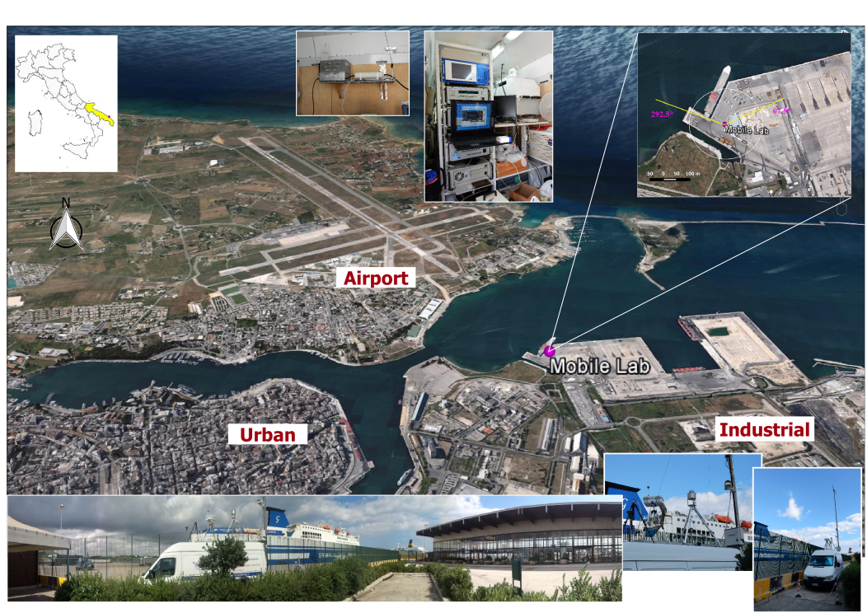
Figure 1) Map showing the measurement site, the mobile laboratory, and some of the instruments used.

FIGURE 2

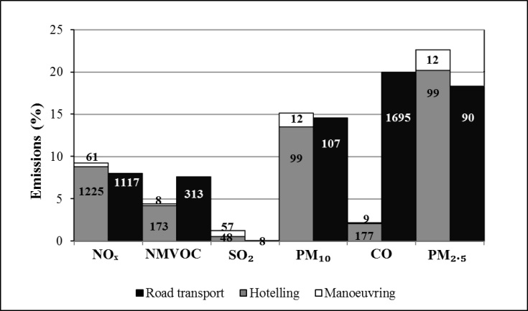
Figure 2) Comparison of shipping and road transport relative emissions at municipality level in Brindisi for the year 2010. The absolute emissions in tons/year are reported as numbers in the graph. Shipping emissions are separated in two phases: manoeuvring within the harbour and hotelling.
FIGURE 3

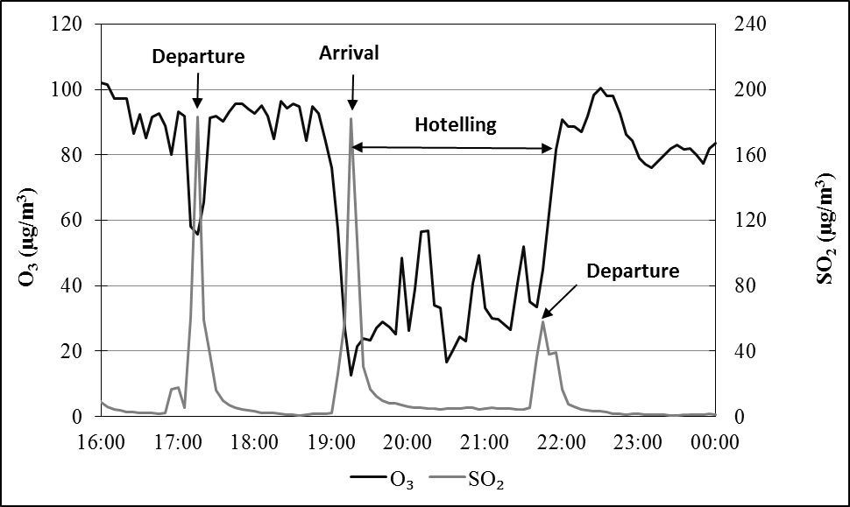
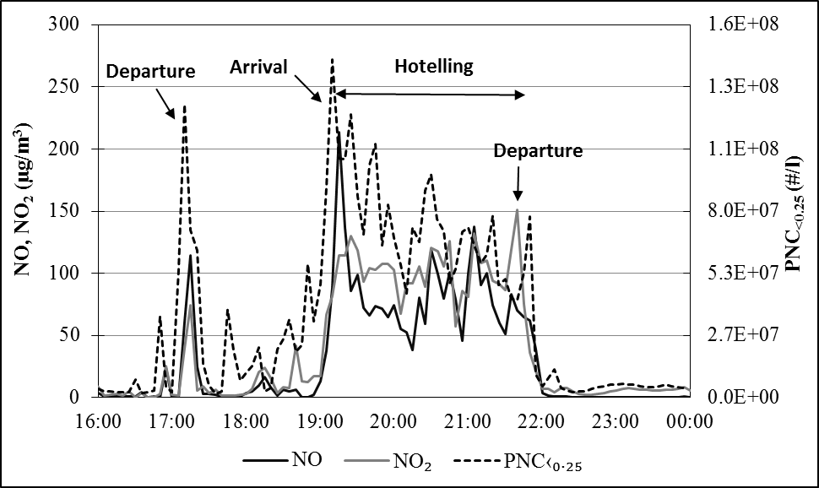
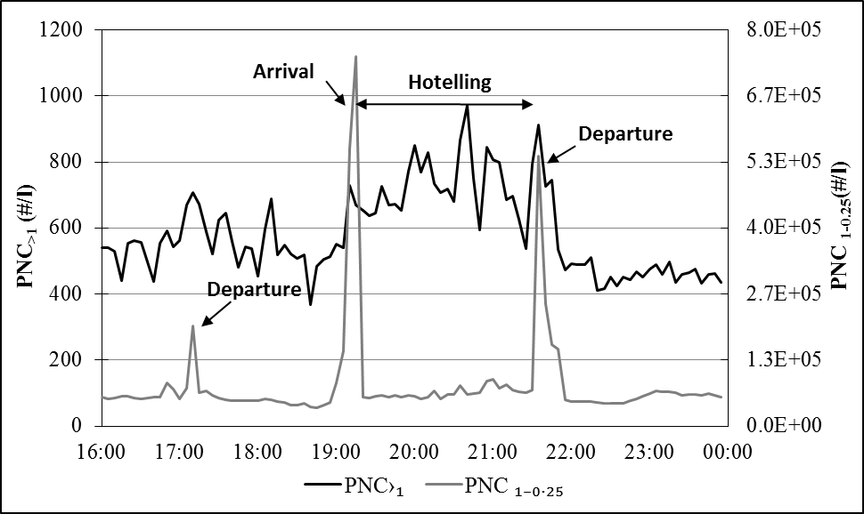
Figure 3) Concentration peaks (5-minute resolution) associated with manoeuvring and hotelling phases for gaseous pollutants and for particle number concentrations in different size ranges.

FIGURE 4

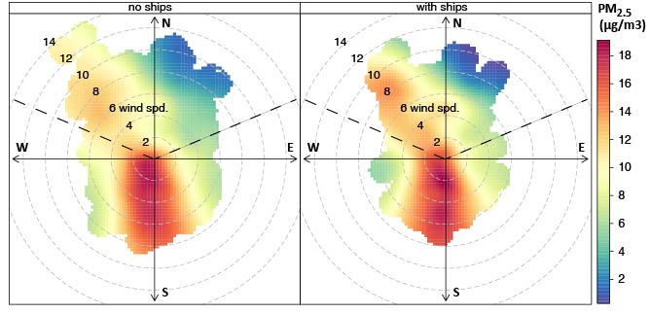
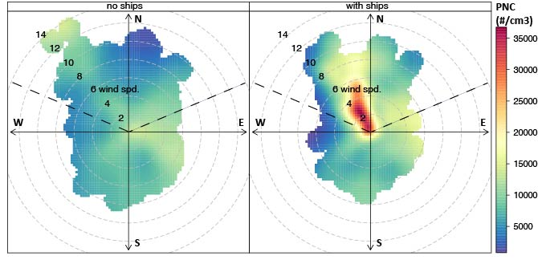
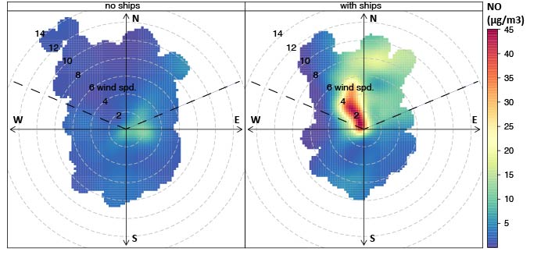
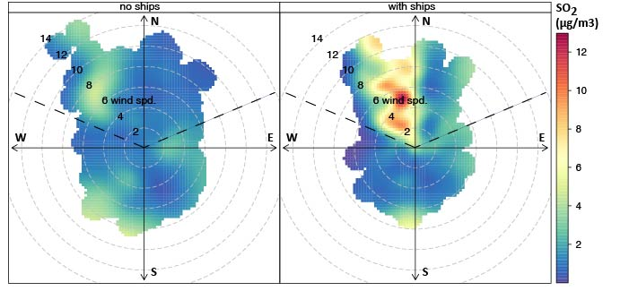

Figure 4) Pollution roses for PM_{2.5}, PNC, NO, and SO₂ (from top to bottom) comparing cases with and without influence of ships. The sector between WNW and ENE (harbour location) is shown.

FIGURE 5

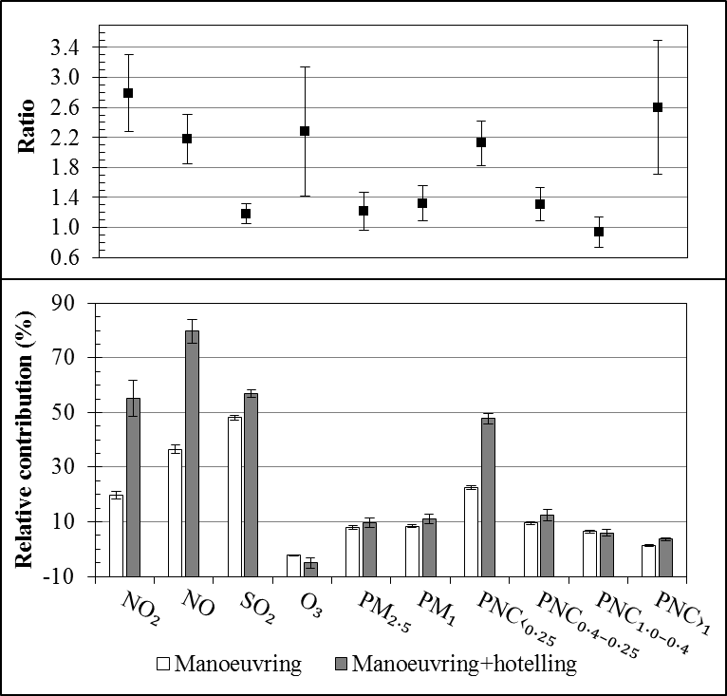

Figure 5) Relative contributions to gaseous pollutants, PM₁, PM_{2.5}, and particle number concentration in four selected size ranges, for the two phases: manoeuvring and manoeuvring+hotelling. Ratios of the contributions in the two phases are also reported.

FIGURE 6

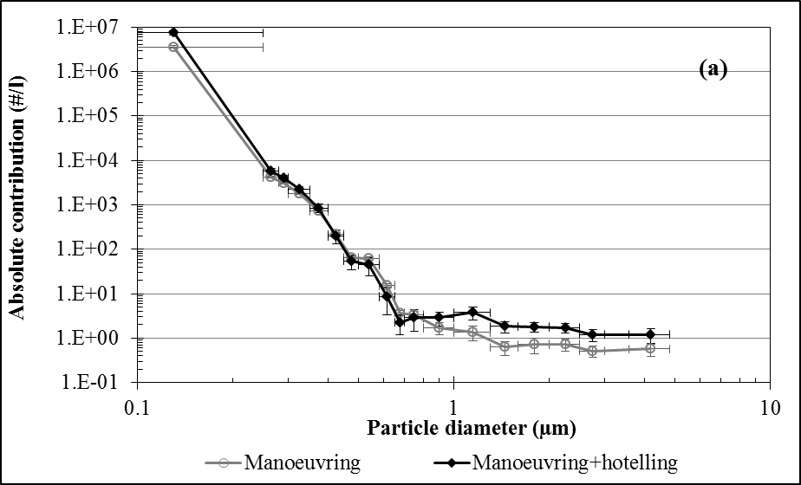
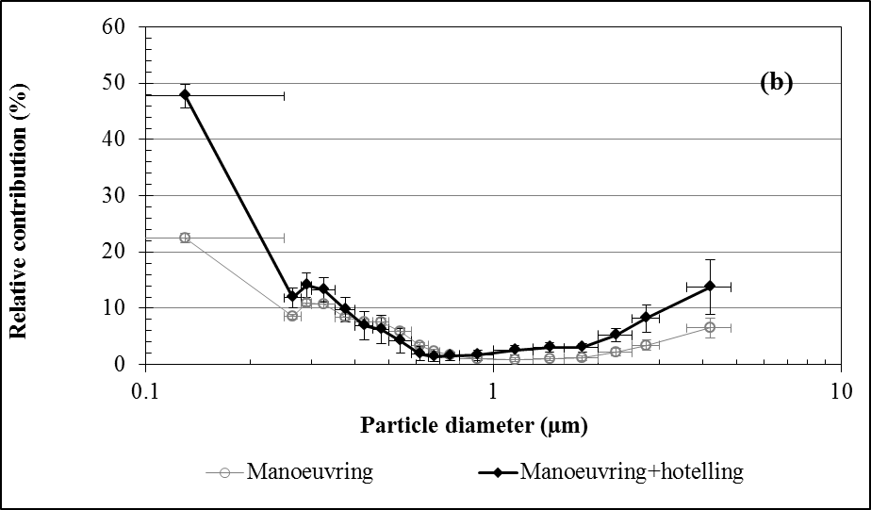
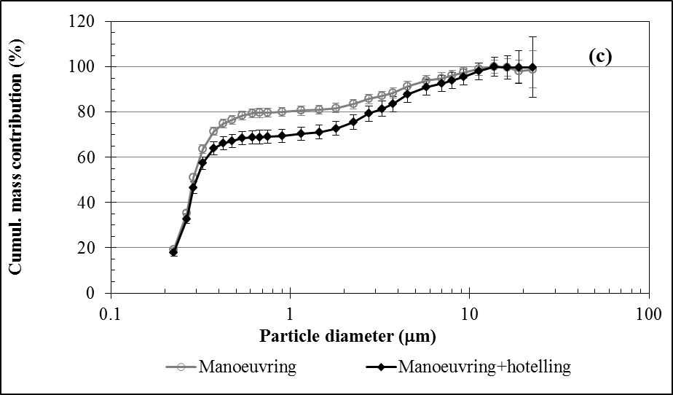

Figure 6) (a) Absolute and relative (b) contributions to particle number concentrations as function of size. (c) Cumulative mass contribution as function of particle diameter.

FIGURE 7

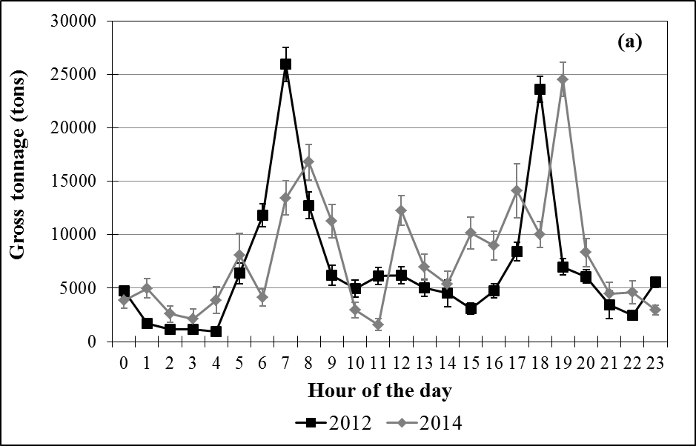
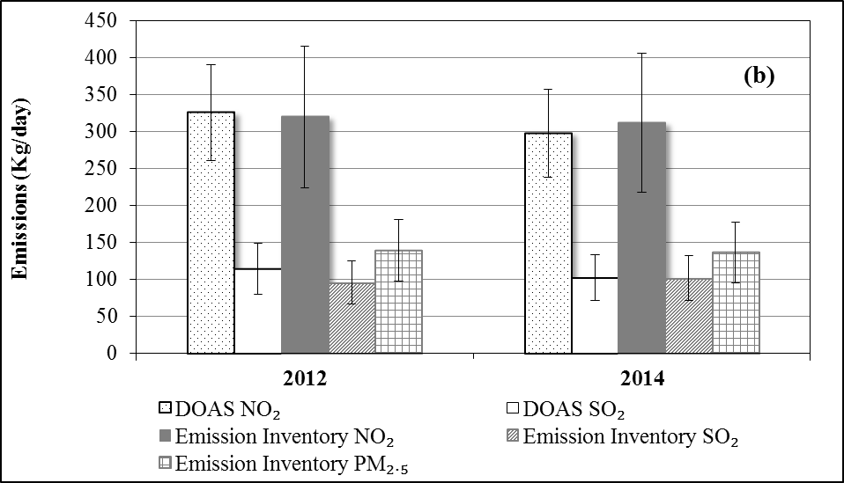
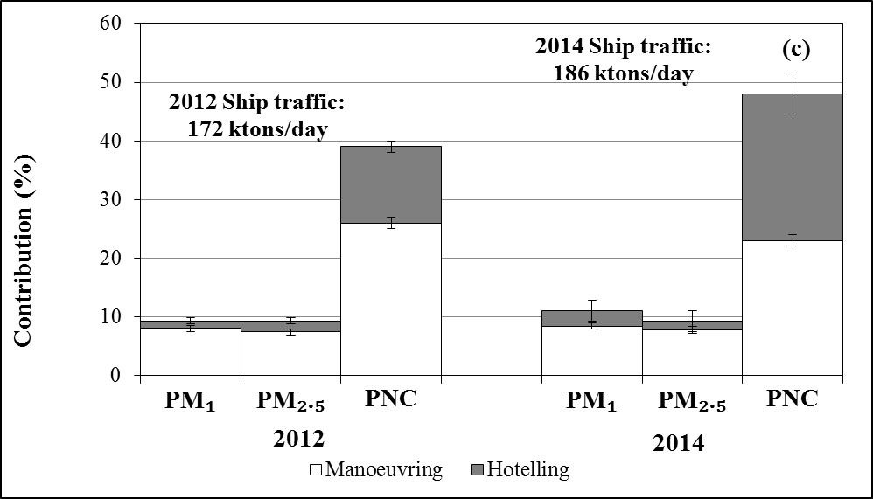

Figure 7) (a) Comparison of diurnal patterns of ship traffic for summer 2012 and 2014. (b) Trends in SO₂, NO₂ and PM_{2.5} emissions. Gaseous emissions estimated and measured with DOAS are compared. (c) Trends of the relative contributions to PM₁, PM_{2.5}, and PNC with indication of the average ship traffic (gross tonnage).

